  
Name: **________________________________**

Check out the [**Lab Set-Up Video**](https://vimeo.com/406308538) by scanning the   
QR Code or going to [**teachergeek.com/sailcar**](https://www.teachergeek.com/sailcar)

Track area 10 m (30 ft) long by 2 m (6 ft) wide. Uncarpeted area preferred.

Numbered pieces of tape mark every meter (3 ft).

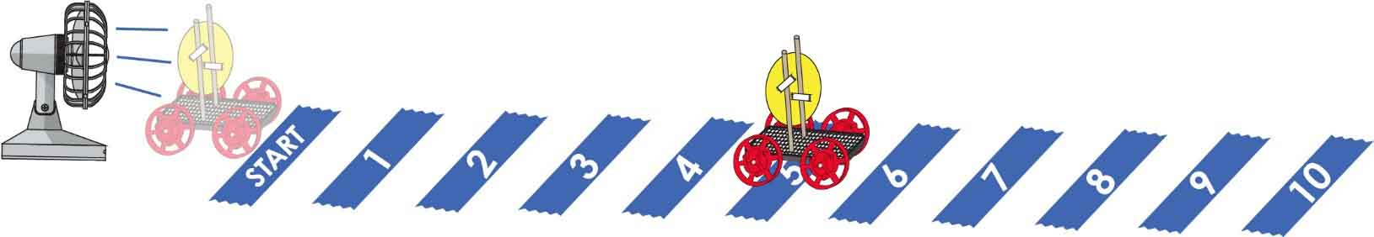

**Predict:** Circle how far you *think* it will go.



**Small**

|  |  |  |  |  |  |  |  |  |  |  |
| --- | --- | --- | --- | --- | --- | --- | --- | --- | --- | --- |
|  | **1** | **2** | **3** | **4** | **5** | **6** | **7** | **8** | **9** | **10** |

**Test:** Circle how far it goes?

|  |  |  |  |  |  |  |  |  |  |  |
| --- | --- | --- | --- | --- | --- | --- | --- | --- | --- | --- |
|  | **1** | **2** | **3** | **4** | **5** | **6** | **7** | **8** | **9** | **10** |

**Predict:** Circle how far you *think* it will go.



**Medium**

|  |  |  |  |  |  |  |  |  |  |  |
| --- | --- | --- | --- | --- | --- | --- | --- | --- | --- | --- |
|  | **1** | **2** | **3** | **4** | **5** | **6** | **7** | **8** | **9** | **10** |

**Test:** How far did it go?

|  |  |  |  |  |  |  |  |  |  |  |
| --- | --- | --- | --- | --- | --- | --- | --- | --- | --- | --- |
|  | **1** | **2** | **3** | **4** | **5** | **6** | **7** | **8** | **9** | **10** |

**Predict:** Circle how far you *think* it will go.



**Large**

|  |  |  |  |  |  |  |  |  |  |  |
| --- | --- | --- | --- | --- | --- | --- | --- | --- | --- | --- |
|  | **1** | **2** | **3** | **4** | **5** | **6** | **7** | **8** | **9** | **10** |

**Test:** How far did it go?

|  |  |  |  |  |  |  |  |  |  |  |
| --- | --- | --- | --- | --- | --- | --- | --- | --- | --- | --- |
|  | **1** | **2** | **3** | **4** | **5** | **6** | **7** | **8** | **9** | **10** |

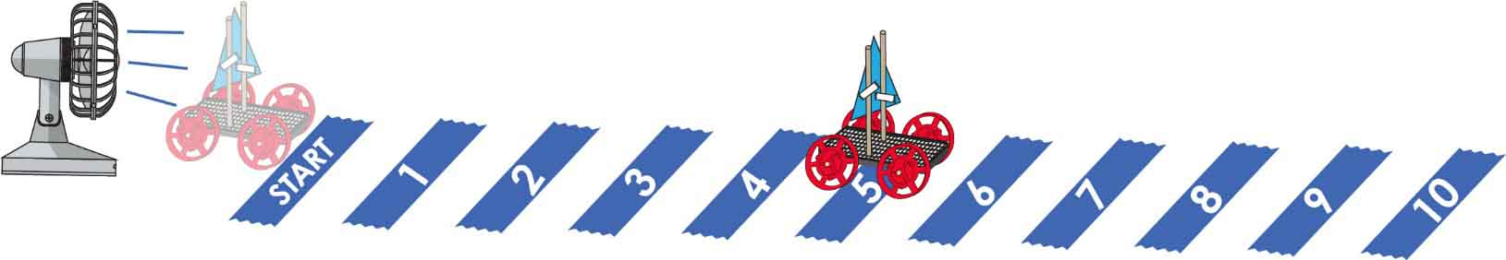  
Name: **____________________________________________**

**Predict:** Circle how far you *think* it will go.



**Small**

A

|  |  |  |  |  |  |  |  |  |  |  |
| --- | --- | --- | --- | --- | --- | --- | --- | --- | --- | --- |
|  | **1** | **2** | **3** | **4** | **5** | **6** | **7** | **8** | **9** | **10** |

**Test:** Circle how far it goes?

|  |  |  |  |  |  |  |  |  |  |  |
| --- | --- | --- | --- | --- | --- | --- | --- | --- | --- | --- |
|  | **1** | **2** | **3** | **4** | **5** | **6** | **7** | **8** | **9** | **10** |

**Predict:** Circle how far you *think* it will go.



**Medium**

B

|  |  |  |  |  |  |  |  |  |  |  |
| --- | --- | --- | --- | --- | --- | --- | --- | --- | --- | --- |
|  | **1** | **2** | **3** | **4** | **5** | **6** | **7** | **8** | **9** | **10** |

**Test:** How far did it go?

|  |  |  |  |  |  |  |  |  |  |  |
| --- | --- | --- | --- | --- | --- | --- | --- | --- | --- | --- |
|  | **1** | **2** | **3** | **4** | **5** | **6** | **7** | **8** | **9** | **10** |

**Predict:** Circle how far you *think* it will go.

|  |  |  |  |  |  |  |  |  |  |  |
| --- | --- | --- | --- | --- | --- | --- | --- | --- | --- | --- |
| **Large**  C | **1** | **2** | **3** | **4** | **5** | **6** | **7** | **8** | **9** | **10** |

**Test:** How far did it go?

|  |  |  |  |  |  |  |  |  |  |  |
| --- | --- | --- | --- | --- | --- | --- | --- | --- | --- | --- |
|  | **1** | **2** | **3** | **4** | **5** | **6** | **7** | **8** | **9** | **10** |

Name: **____________________________________________**

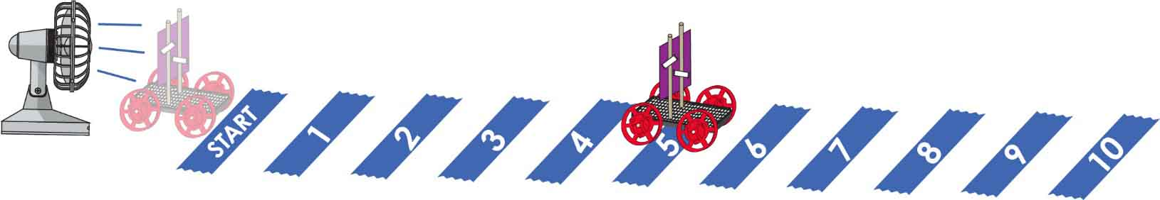

**Predict:** Circle how far you *think* it will go.



**Small**

A

|  |  |  |  |  |  |  |  |  |  |  |
| --- | --- | --- | --- | --- | --- | --- | --- | --- | --- | --- |
|  | **1** | **2** | **3** | **4** | **5** | **6** | **7** | **8** | **9** | **10** |

**Test:** Circle how far it goes?

|  |  |  |  |  |  |  |  |  |  |  |
| --- | --- | --- | --- | --- | --- | --- | --- | --- | --- | --- |
|  | **1** | **2** | **3** | **4** | **5** | **6** | **7** | **8** | **9** | **10** |

**Predict:** Circle how far you *think* it will go.



**Medium**

B

|  |  |  |  |  |  |  |  |  |  |  |
| --- | --- | --- | --- | --- | --- | --- | --- | --- | --- | --- |
|  | **1** | **2** | **3** | **4** | **5** | **6** | **7** | **8** | **9** | **10** |

**Test:** How far did it go?

|  |  |  |  |  |  |  |  |  |  |  |
| --- | --- | --- | --- | --- | --- | --- | --- | --- | --- | --- |
|  | **1** | **2** | **3** | **4** | **5** | **6** | **7** | **8** | **9** | **10** |

**Predict:** Circle how far you *think* it will go.



**Large**

C

|  |  |  |  |  |  |  |  |  |  |  |
| --- | --- | --- | --- | --- | --- | --- | --- | --- | --- | --- |
|  | **1** | **2** | **3** | **4** | **5** | **6** | **7** | **8** | **9** | **10** |

**Test:** How far did it go?

|  |  |  |  |  |  |  |  |  |  |  |
| --- | --- | --- | --- | --- | --- | --- | --- | --- | --- | --- |
|  | **1** | **2** | **3** | **4** | **5** | **6** | **7** | **8** | **9** | **10** |



Small Circle Sail



Cut the following sail shapes from cardstock, cardboard or stiff paper. The shapes can be re-used between sail car groups.



Medium Circle Sail



Large Circle Sail



Large Triangle Sail

C

Interesting Note: The large sails have twice the area of the medium sails. The medium sails have twice the area of the small sails. If you’re following the math… that makes the large sail FOUR times larger than the small sail.

Medium Triangle Sail

B



A

Small Square Sail



Small Triangle Sail

A





B

Medium Square Sail



C

Large Square Sail

