

Check out the [**Lab Set-Up Video**](https://vimeo.com/406308538) by scanning the   
QR Code or going to [**teachergeek.com/sailcar**](https://www.teachergeek.com/sailcar)

Name: **__________________________________**

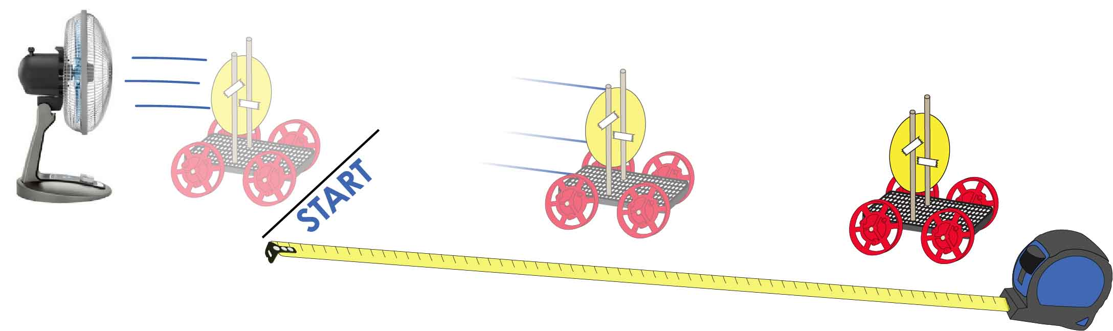

Track area 10 m (30 ft) long by 1 m (3 ft) wide. Uncarpeted area preferred.

**Circle the units you will be measuring in.**

|  |  |  |  |
| --- | --- | --- | --- |
| **Inches** (in) | **Feet** (ft) | **Centimeters** (cm) | **Meters** (m) |

**Predict:** How far do you *think* your car will go?

**Test:** How far did it go?

______________________________

______________________________



**Small**

**Predict:** How far do you *think* your car will go?

**Test:** How far did it go?

______________________________

______________________________



**Medium**



**Large**

**Predict:** How far do you *think* your car will go?

**Test:** How far did it go?

______________________________

______________________________

Name: **____________________________________________**

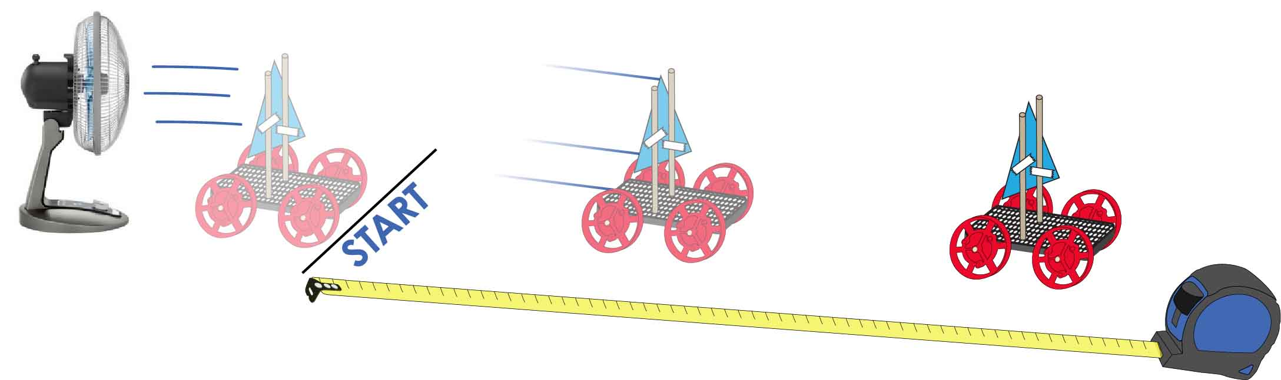

**Circle the units you will be measuring in.**

|  |  |  |  |
| --- | --- | --- | --- |
| **Inches** (in) | **Feet** (ft) | **Centimeters** (cm) | **Meters** (m) |



**Small**

A

**Predict:** How far do you *think* your car will go?

**Test:** How far did it go?

______________________________

______________________________



**Medium**

B

**Predict:** How far do you *think* your car will go?

**Test:** How far did it go?

______________________________

______________________________



**Large**

C

**Predict:** How far do you *think* your car will go?

**Test:** How far did it go?

______________________________

______________________________

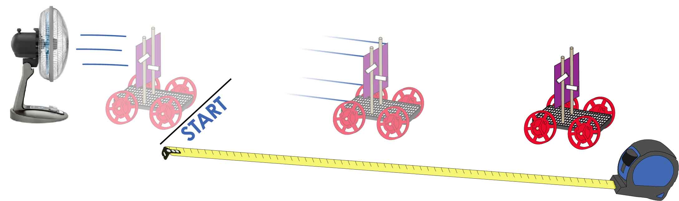



**Small**

A

**Predict:** How far do you *think* your car will go?

**Test:** How far did it go?

______________________________

______________________________

**Predict:** How far do you *think* your car will go?

**Test:** How far did it go?

______________________________

______________________________

**Predict:** How far do you *think* your car will go?

**Test:** How far did it go?

______________________________

______________________________



**Medium**

B



**Large**

C

**Circle the units you will be measuring in.**

|  |  |  |  |
| --- | --- | --- | --- |
| **Inches** (in) | **Feet** (ft) | **Centimeters** (cm) | **Meters** (m) |

Name: **____________________________________________**





Medium Circle Sail



Small Circle Sail

Cut the following sail shapes from cardstock, cardboard or stiff paper. The shapes can be re-used between sail car groups.



Large Circle Sail



Large Triangle Sail

C

Interesting Note: The large sails have twice the area of the medium sails. The medium sails have twice the area of the small sails. If you’re following the math… that makes the large sail FOUR times larger than the small sail.

Medium Triangle Sail

B



Small Triangle Sail

A



A

Small Square Sail





B

Medium Square Sail



C

Large Square Sail

