  
Nombre: **____________________________________________**

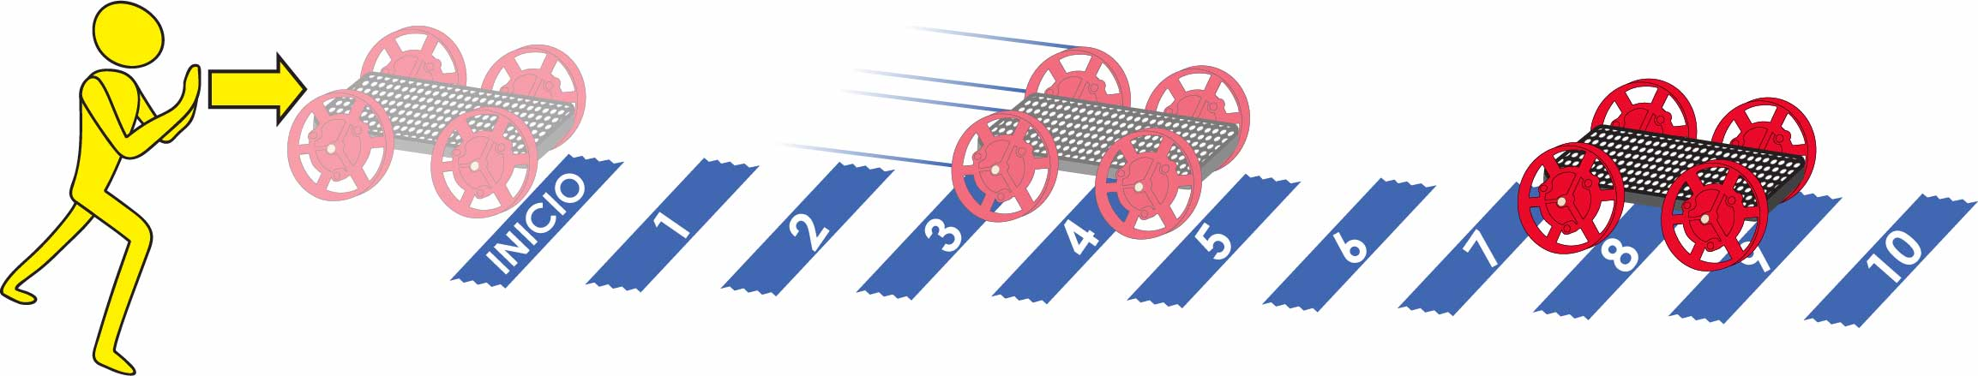

Área de la pista: 10 m (30 pies) de largo por 2 m (6 pies) de ancho. Se recomienda piso sin alfombra.

Marcas de cinta adhesiva cada metro (3 pies).

Revisa el [**Video**](https://vimeo.com/406308218) **del Laboratorio** escaneando el código QR o ingresando en [**teachergeek.com/sailcar**](https://www.teachergeek.com/sailcar)



**Predice:** Circula qué tan lejos crees que llegará.

**Empujón Ligero**



|  |  |  |  |  |  |  |  |  |  |  |
| --- | --- | --- | --- | --- | --- | --- | --- | --- | --- | --- |
|  | **1** | **2** | **3** | **4** | **5** | **6** | **7** | **8** | **9** | **10** |

**Prueba:** Circula, ¿Qué tan lejos llegó?

|  |  |  |  |  |  |  |  |  |  |  |
| --- | --- | --- | --- | --- | --- | --- | --- | --- | --- | --- |
|  | **1** | **2** | **3** | **4** | **5** | **6** | **7** | **8** | **9** | **10** |

**Predice:** Circula qué tan lejos crees que llegará.

|  |  |  |  |  |  |  |  |  |  |  |
| --- | --- | --- | --- | --- | --- | --- | --- | --- | --- | --- |
| **Empujón Medio** | **1** | **2** | **3** | **4** | **5** | **6** | **7** | **8** | **9** | **10** |

**Prueba:** Circula, ¿Qué tan lejos llegó?

|  |  |  |  |  |  |  |  |  |  |  |
| --- | --- | --- | --- | --- | --- | --- | --- | --- | --- | --- |
|  | **1** | **2** | **3** | **4** | **5** | **6** | **7** | **8** | **9** | **10** |

**Predice:** Circula qué tan lejos crees que llegará.

**Empujón Fuerte**



|  |  |  |  |  |  |  |  |  |  |  |
| --- | --- | --- | --- | --- | --- | --- | --- | --- | --- | --- |
|  | **1** | **2** | **3** | **4** | **5** | **6** | **7** | **8** | **9** | **10** |

**Prueba:** Circula, ¿Qué tan lejos llegó?

|  |  |  |  |  |  |  |  |  |  |  |
| --- | --- | --- | --- | --- | --- | --- | --- | --- | --- | --- |
|  | **1** | **2** | **3** | **4** | **5** | **6** | **7** | **8** | **9** | **10** |

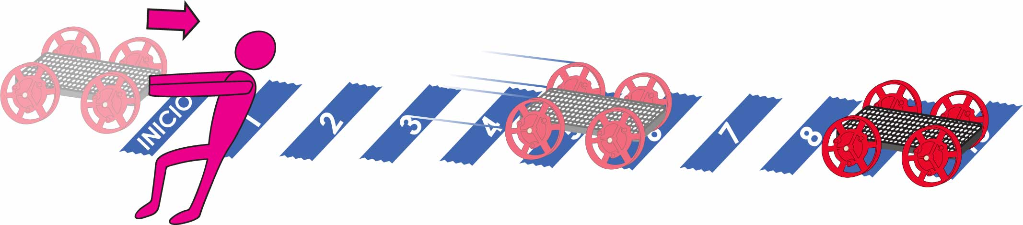  
Nombre: **____________________________________________**

**Predice:** Circula qué tan lejos crees que llegará.

|  |  |  |  |  |  |  |  |  |  |  |
| --- | --- | --- | --- | --- | --- | --- | --- | --- | --- | --- |
| **Jalón Ligero** | **1** | **2** | **3** | **4** | **5** | **6** | **7** | **8** | **9** | **10** |

**Prueba:** Circula, ¿Qué tan lejos llegó?

|  |  |  |  |  |  |  |  |  |  |  |
| --- | --- | --- | --- | --- | --- | --- | --- | --- | --- | --- |
|  | **1** | **2** | **3** | **4** | **5** | **6** | **7** | **8** | **9** | **10** |

**Predice:** Circula qué tan lejos crees que llegará.

|  |  |  |  |  |  |  |  |  |  |  |
| --- | --- | --- | --- | --- | --- | --- | --- | --- | --- | --- |
| **Jalón Medio** | **1** | **2** | **3** | **4** | **5** | **6** | **7** | **8** | **9** | **10** |

**Prueba:** Circula, ¿Qué tan lejos llegó?

|  |  |  |  |  |  |  |  |  |  |  |
| --- | --- | --- | --- | --- | --- | --- | --- | --- | --- | --- |
|  | **1** | **2** | **3** | **4** | **5** | **6** | **7** | **8** | **9** | **10** |

**Predice:** Circula qué tan lejos crees que llegará.

|  |  |  |  |  |  |  |  |  |  |  |
| --- | --- | --- | --- | --- | --- | --- | --- | --- | --- | --- |
| **Jalón Fuerte** | **1** | **2** | **3** | **4** | **5** | **6** | **7** | **8** | **9** | **10** |

**Prueba:** Circula, ¿Qué tan lejos llegó?

|  |  |  |  |  |  |  |  |  |  |  |
| --- | --- | --- | --- | --- | --- | --- | --- | --- | --- | --- |
|  | **1** | **2** | **3** | **4** | **5** | **6** | **7** | **8** | **9** | **10** |