  
Name: **____________________________________________**

Check out the [**Lab Set-Up Video**](https://vimeo.com/406308218) by scanning the   
QR Code or going to [**teachergeek.com/sailcar**](https://www.teachergeek.com/sailcar)

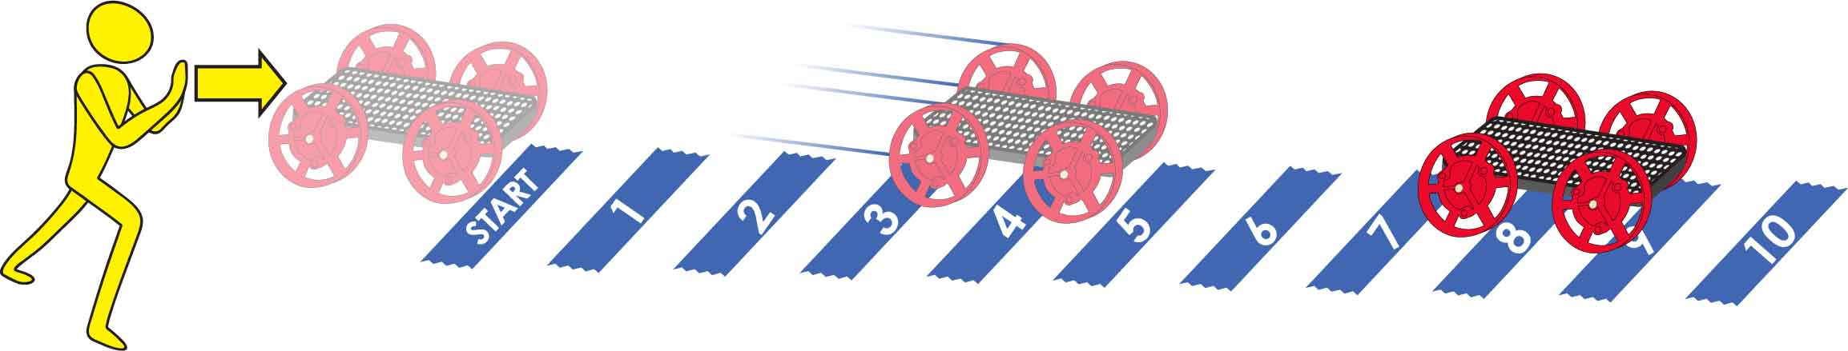

Track area 10 m (30 ft) long by 2 m (6 ft) wide. Uncarpeted area preferred.

Numbered pieces of tape mark every meter (3 ft).



**Predict:** Circle how far you *think* it will go.

|  |  |  |  |  |  |  |  |  |  |  |
| --- | --- | --- | --- | --- | --- | --- | --- | --- | --- | --- |
| **Light Push** | **1** | **2** | **3** | **4** | **5** | **6** | **7** | **8** | **9** | **10** |

**Test:** Circle how far it goes?

|  |  |  |  |  |  |  |  |  |  |  |
| --- | --- | --- | --- | --- | --- | --- | --- | --- | --- | --- |
|  | **1** | **2** | **3** | **4** | **5** | **6** | **7** | **8** | **9** | **10** |

**Predict:** Circle how far you *think* it will go.

|  |  |  |  |  |  |  |  |  |  |  |
| --- | --- | --- | --- | --- | --- | --- | --- | --- | --- | --- |
| **Medium Push** | **1** | **2** | **3** | **4** | **5** | **6** | **7** | **8** | **9** | **10** |

**Test:** How far did it go?

|  |  |  |  |  |  |  |  |  |  |  |
| --- | --- | --- | --- | --- | --- | --- | --- | --- | --- | --- |
|  | **1** | **2** | **3** | **4** | **5** | **6** | **7** | **8** | **9** | **10** |

**Predict:** Circle how far you *think* it will go.

|  |  |  |  |  |  |  |  |  |  |  |
| --- | --- | --- | --- | --- | --- | --- | --- | --- | --- | --- |
| **Strong Push** | **1** | **2** | **3** | **4** | **5** | **6** | **7** | **8** | **9** | **10** |

**Test:** How far did it go?

|  |  |  |  |  |  |  |  |  |  |  |
| --- | --- | --- | --- | --- | --- | --- | --- | --- | --- | --- |
|  | **1** | **2** | **3** | **4** | **5** | **6** | **7** | **8** | **9** | **10** |

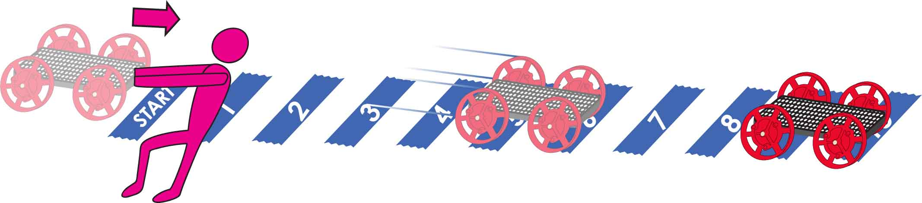  
Name: **____________________________________________**

**Predict:** Circle how far you *think* it will go.

|  |  |  |  |  |  |  |  |  |  |  |
| --- | --- | --- | --- | --- | --- | --- | --- | --- | --- | --- |
| **Light Pull** | **1** | **2** | **3** | **4** | **5** | **6** | **7** | **8** | **9** | **10** |

**Test:** Circle how far it goes?

|  |  |  |  |  |  |  |  |  |  |  |
| --- | --- | --- | --- | --- | --- | --- | --- | --- | --- | --- |
|  | **1** | **2** | **3** | **4** | **5** | **6** | **7** | **8** | **9** | **10** |

**Predict:** Circle how far you *think* it will go.

|  |  |  |  |  |  |  |  |  |  |  |
| --- | --- | --- | --- | --- | --- | --- | --- | --- | --- | --- |
| **Medium Pull** | **1** | **2** | **3** | **4** | **5** | **6** | **7** | **8** | **9** | **10** |

**Test:** How far did it go?

|  |  |  |  |  |  |  |  |  |  |  |
| --- | --- | --- | --- | --- | --- | --- | --- | --- | --- | --- |
|  | **1** | **2** | **3** | **4** | **5** | **6** | **7** | **8** | **9** | **10** |

**Predict:** Circle how far you *think* it will go.

|  |  |  |  |  |  |  |  |  |  |  |
| --- | --- | --- | --- | --- | --- | --- | --- | --- | --- | --- |
| **Strong Pull** | **1** | **2** | **3** | **4** | **5** | **6** | **7** | **8** | **9** | **10** |

**Test:** How far did it go?

|  |  |  |  |  |  |  |  |  |  |  |
| --- | --- | --- | --- | --- | --- | --- | --- | --- | --- | --- |
|  | **1** | **2** | **3** | **4** | **5** | **6** | **7** | **8** | **9** | **10** |