  
Name: **____________________________________________**

Check out the [**Lab Set-Up Video**](https://vimeo.com/406308218) by scanning the   
QR Code or going to [**teachergeek.com/sailcar**](https://www.teachergeek.com/sailcar)

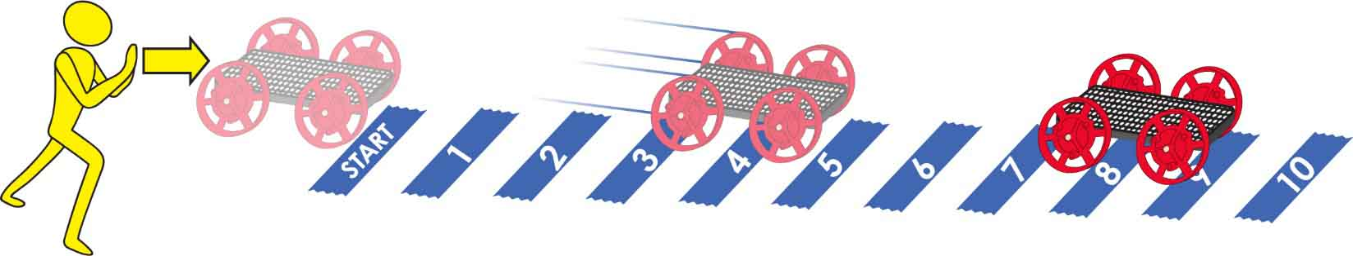

Track area 10 m (30 ft) long by 2 m (6 ft) wide. Uncarpeted area preferred.

Numbered pieces of tape mark every meter (3 ft).

**Predict:** How far do you *think* it will go?

**Test:** How far did it go?

**Light Push**



**Medium Push**



**Strong Push**



**Predict:** How far do you *think* it will go?

**Test:** How far did it go?

**Predict:** How far do you *think* it will go?

**Test:** How far did it go?

Name: **____________________________________________**

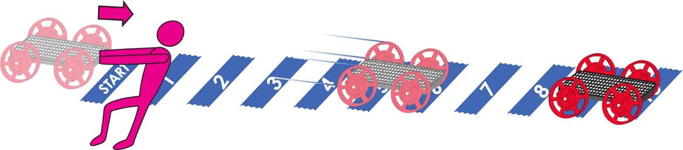

**Predict:** How far do you *think* it will go?

**Test:** How far did it go?

**Light Pull**

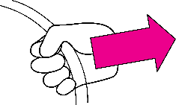

**Medium Pull**

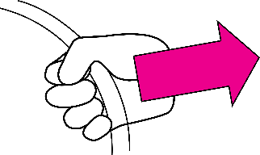

**Predict:** How far do you *think* it will go?

**Test:** How far did it go?

**Predict:** How far do you *think* it will go?

**Test:** How far did it go?

**Strong Pull**

