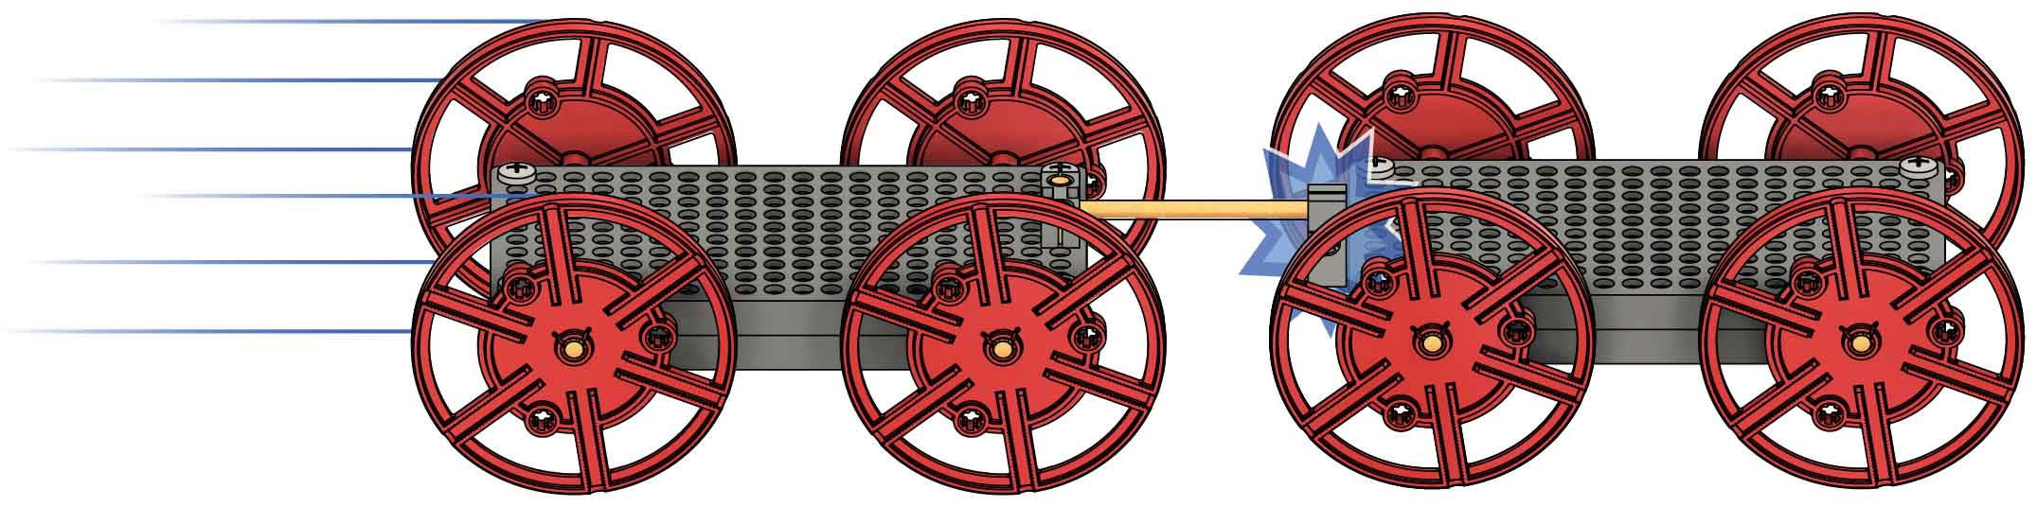

Check out the [**Lab Set-Up Video**](https://vimeo.com/406307342) by scanning the QR Code or going to [**teachergeek.com/sailcar**](https://www.teachergeek.com/sailcar)

**What’s momentum, and how does it affect collisions? Crash some cars to find out!**

Name:____________________________________

**Push** or tap another **block** **onto** the **dowel**,   
as shown.

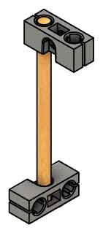

**Wiggle** or tap the cut **dowel** **into** a **block**.

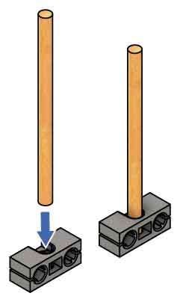

**• 2 velocity sensors  
 OR  
• 1 velocity sensor &  
 2 magnets** (to make the cars stick  
 together on impact)

**• Scale** grams (0.1 oz)

**• Tape**

**• 1 Weight** 100-200 g (4-7 oz)

**Push** the **dowels** **into** the **block**, as shown, to finish your ram.

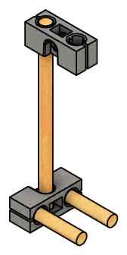

**Cut** an **8 cm** (3 in) **dowel**.

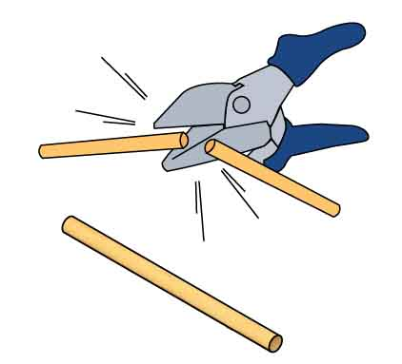

**8 cm** (3 in)

**Cut two 3 cm** (1 in) **dowels**.

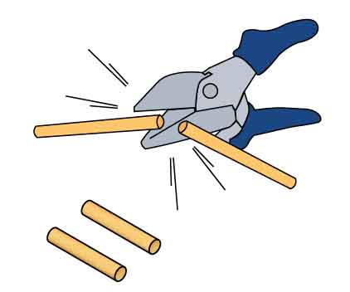

**3 cm** (1 in)

For recommended sensors, see p. 3.

Other Supplies

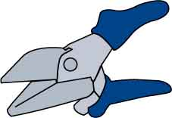

**Multi-Cutter**

TeacherGeek Supplies

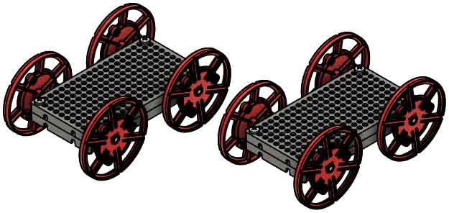

**2 Sail Cars**(no sails)

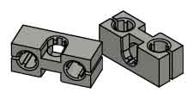

**2 Blocks**

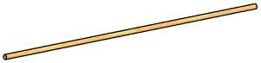

**1 Dowel**30 cm (12 in)

**Build a ram for one of your cars to get more accurate collision data.**



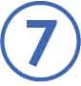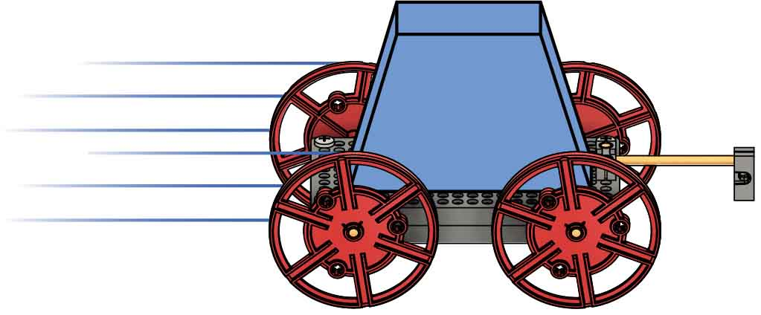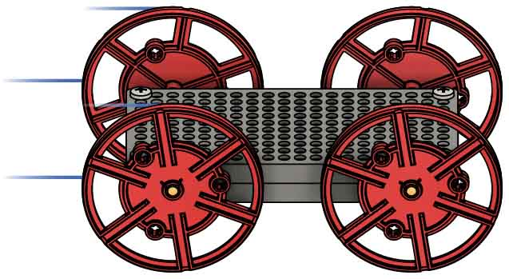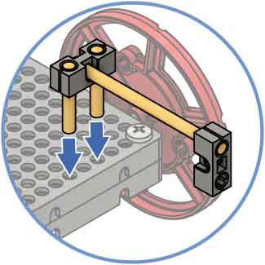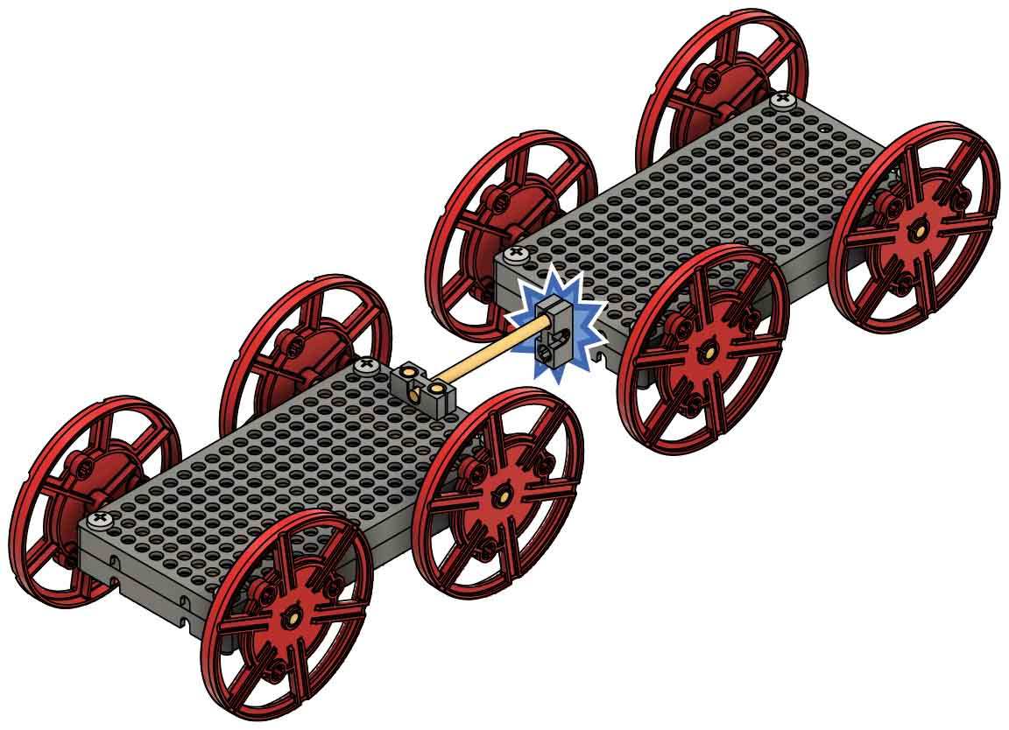

***Momentum* is how difficult it is to stop a moving object. It is based on how quickly an object is moving and how much mass it has.**

**Tape** a **magnet** **to** **each** **car** so they stick together when they collide.

SKIP IF USING 2 SENSORS

**Adjust** your **design** if necessary.

**Test** **the** **cars**. Push one into the other, making sure they **contact** **at** **the** **ram**, not the wheels.

**Add** the **ram** **to** **one** **car**.

momentum

This car has **little** **momentum** because it has little mass or velocity.

This car has **more** **momentum** because it has more mass and velocity.

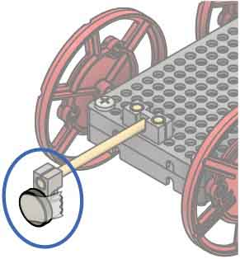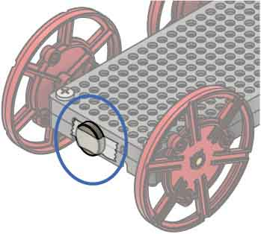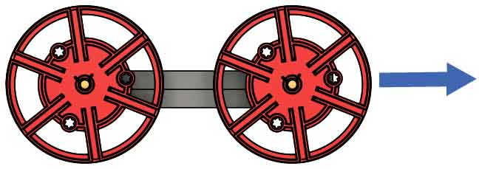

Calculating Momentum

Momentum is typically represented by the letter **p**. To calculate momentum, multiply mass and velocity.

Example

A 0.1 kg car is traveling East at 3 m/s.

Momentum is a vector quantity – it has both magnitude and direction. The direction of the momentum is the direction of the velocity.

Momentum has units of .



**What happens to momentum during a collision?**

Create a hypothesis about what happens to momentum during a collision.

____________________________________________________________________________________________________________________________________________________________________________________________________________________________________________________________

How did the collision affect the momentum of the car being struck? Explain.

_____________________________________________________________________________________________________________________________________________________________________

How did the collision affect the momentum of the striking car? Did momentum increase, decrease, or stay the same? Explain.

____________________________________________________________________________________________________________________________________________________________________________________

**Push** the **car** **with** the **ram** **into** the **other** **car**.

**Striking Car**

**Car Being Struck**

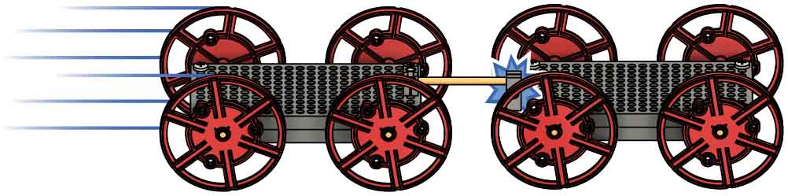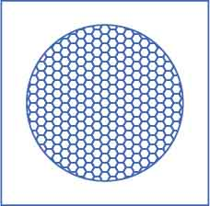

Ultrasonic or Infrared

Set up your sensors to measure the velocity of each car.

Option B: Two Sensors

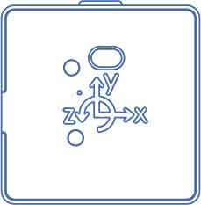

PocketLab

Avoid:

Recommended:

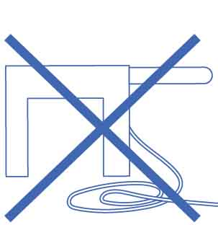

Photogates

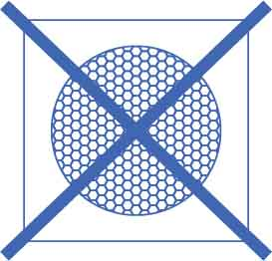

Ultrasonic or Infrared

Avoid:

Option A: One Sensor and Magnets

Set up the sensor to measure the velocity of the striking car. Be careful to keep the magnets away from the sensor and all other electronic devices.



PocketLab



Photogates

Recommended:



|  |  |  |
| --- | --- | --- |
|  |  |  |
|  | **0** |  |

|  |  |  |
| --- | --- | --- |
|  |  |  |
|  |  |  |

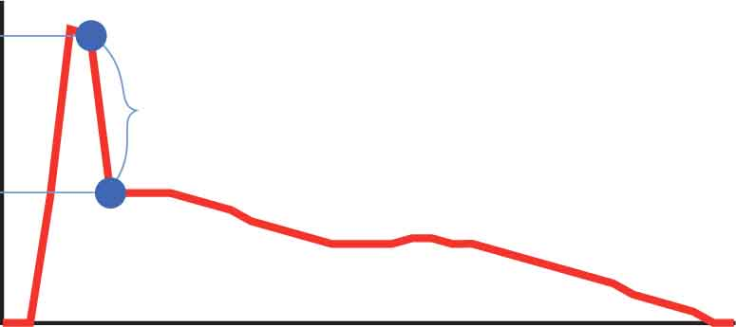

**Example Graph  
Striking Car**

collision

$v_{i}$

$v_{f}$

velocity

time

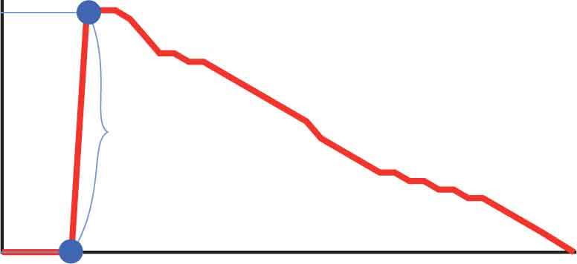

collision

$v_{i}=0$

$v_{f}$

velocity

time

**Example Graph   
Car Being Struck**

**Does the data support your hypothesis?**

Does the data support your hypothesis from Step 13? Explain.

___________________________________________________________________________________________________________________________________________________________________________________________________________________________

Finally, calculate the momentum and kinetic energy of the system.

To find the momentum of the system, add the momentum of its parts (the cars). Do the same for kinetic energy.

|  |  |
| --- | --- |
| $$K_{i}$$ | $$K_{f}$$ |
|  |  |

**System Kinetic Energy**

|  |  |
| --- | --- |
| $$p_{i}$$ | $$p_{f}$$ |
|  |  |

**System Momentum**

Now calculate each car’s momentum and kinetic energy.

**Striking Car**

|  |  |
| --- | --- |
|  |  |
|  |  |

|  |  |
| --- | --- |
|  |  |
|  |  |

**Car Being Struck**

|  |  |
| --- | --- |
|  |  |
|  |  |

|  |  |
| --- | --- |
|  |  |
|  |  |

Perform another collision between the cars, but this time, measure their velocities.

$v_{i}$– initial velocity before collision $v_{f}$ 
 – final velocity after collision (if using magnets, this is the same for both cars)

**Momentum**

**Kinetic Energy**



Elastic Collisions

If the kinetic energy of a system is conserved during a collision, the collision is elastic.

Inelastic Collisions

If the kinetic energy of a system is not conserved during a collision, the collision is inelastic.

Completely Inelastic Collisions

If the colliding objects stick together after the collision, the collision is completely inelastic.

In a collision, kinetic energy can be conserved or transformed into other forms of energy. Collisions are divided into three categories.

**Your data probably showed the system’s *kinetic* energy decrease, and that’s OK.**

As long as there’s no external force, a system’s momentum should be conserved during a collision. The total momentum should not change. This is called the Conservation of Momentum, and it comes from Newton’s Laws (shown on p. 6).

**Your data should have shown little change in the system’s momentum.**

Does the data from Trial 1 support Conservation of Momentum? Reference the percent change in your explanation.

____________________________________________________________________________________________________________________________________________________________________________________________________________

Find the percent change for the system’s momentum in Trial 1.

|  |
| --- |
| $$\% Change$$ |
|  |

$$\left(\% change\right)=\frac{p_{f}-p_{i}}{p_{i}}*100\%$$

Was the collision from Trial 1 elastic, inelastic, or completely inelastic? Explain.

____________________________________________________________________________________________________________________________________________________________________________________________________________

Find the percent change for the system’s kinetic energy in Trial 1.

|  |
| --- |
| $$\% Change$$ |
|  |



$$\left(\% change\right)=\frac{K_{f}-K_{i}}{K_{i}}*100\%$$

$$F=ma$$

$$F=m\frac{v_{f}-v_{i}}{t}$$

$$Ft=m(v_{f}-v_{i})$$

$$Ft=mv_{f}-{mv}_{i}$$

$$Ft=p_{f}-p_{i}$$

$$Ft=∆p$$

Acceleration is change in velocity over time.

Replace $a$ with $\frac{v_{f}-v_{i}}{t}$

Multiply both sides by $t$

Distribute $m$

Replace $mv$ with $p$

$mv$ is the formula for momentum ($p$).

Replace $p_{f}-p_{i}$ with $∆p$

$Final – Initial$ is how you calculate change. $∆$ represents change.

$$F_{1 on 2}={-F}_{2 on 1}$$

$${ F}_{1 on 2}t={-F}_{2 on 1}t$$

$$∆p_{1}={-∆p}_{2}$$

$$∆p_{1}+{∆p}_{2}=0$$

$$∆p_{system}=0$$

Multiply both sides by $t$

Replace $Ft$ with $∆p$

Add $∆p_{2}$ to both sides

Replace $∆p_{1}+{∆p}_{2}$ with $∆p_{system}$

The cars exert forces on each other for the same amount of time.

This is the relationship we found from Newton’s Second “Law.”

Our system is the two cars. So if you add the change in momentum for both cars, you get the change of the system.

OPTIONAL

So using Newton’s Laws, we see that the momentum of a system does not change during a collision inside that system.

Let’s start by looking at Newton’s Second “Law,” $F=ma$. If we do some algebra, this Law can give us information about momentum – we just need to make $mv$ show up in the equation.

So force multiplied by time, $Ft$, gives us the change in momentum, $∆p$,(called ***impulse***).

When your cars collide, they exert equal and opposite forces on each other   
(Newton’s 3rd “Law”), so the force of car 1 on car 2 equals the force of car 2 on car 1.

**Wonder how momentum comes from Newton’s Laws? Here’s the math!**



**What if the striking car has more mass?**



Secure weights to the striking car to increase its mass, then perform another trial. 100 to 200 g of weights is recommended (3.5 to 7.0 oz).

|  |  |  |
| --- | --- | --- |
| $$p_{i}$$ | $$p_{f}$$ | $$\% Change$$ |
|  |  |  |

**System Momentum**

|  |  |  |
| --- | --- | --- |
| $$m$$ | $$v_{i}$$ | $$v_{f}$$ |
|  |  |  |

**Striking Car**

|  |  |
| --- | --- |
|  |  |
|  |  |

|  |  |
| --- | --- |
|  |  |
|  |  |

|  |  |  |
| --- | --- | --- |
|  |  |  |
|  |  |  |

**System Momentum**

|  |  |  |
| --- | --- | --- |
| $$m$$ | $$v_{i}$$ | $$v_{f}$$ |
|  |  |  |

**Car Being Struck**

|  |  |
| --- | --- |
|  |  |
|  |  |

|  |  |
| --- | --- |
|  |  |
|  |  |



**What if the car being struck has more mass?**



Transfer the weights from the striking car to the car being struck, then perform the final trial.

|  |  |  |
| --- | --- | --- |
| $$p_{i}$$ | $$p_{f}$$ | $$\% Change$$ |
|  |  |  |

**System Momentum**

|  |  |  |
| --- | --- | --- |
| $$m$$ | $$v_{i}$$ | $$v_{f}$$ |
|  |  |  |

**Striking Car**

|  |  |
| --- | --- |
|  |  |
|  |  |

|  |  |
| --- | --- |
|  |  |
|  |  |

|  |  |  |
| --- | --- | --- |
|  |  |  |
|  |  |  |

**System Momentum**

|  |  |  |
| --- | --- | --- |
| $$m$$ | $$v_{i}$$ | $$v_{f}$$ |
|  |  |  |

**Car Being Struck**

|  |  |
| --- | --- |
|  |  |
|  |  |

|  |  |
| --- | --- |
|  |  |
|  |  |





When your cars collided inelastically, what happened to the kinetic energy? Be specific.

___________________________________________________________________________________________________________________________________________________________________________________________________________________________

Were any of your collisions elastic? If not, which was the closest to being elastic and why?

___________________________________________________________________________________________________________________________________________________________________________________________________________________________

What were some sources of error for your measurements?

___________________________________________________________________________________________________________________________________________________________________________________________________________________________

Did changing the mass of either car affect the conservation of momentum?

___________________________________________________________________________________________________________________________________________________________________________________________________________________________

Overall, does your data confirm the conservation of momentum? Justify your answer.

___________________________________________________________________________________________________________________________________________________________________________________________________________________________





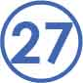





Fill in the blanks below.

Both momentum and kinetic energy are calculated using ____________ and ____________. Momentum is a ____________ quantity, while kinetic energy is a ____________ quantity.   
In a collision, ______________ is always conserved, while ______________ is not.