

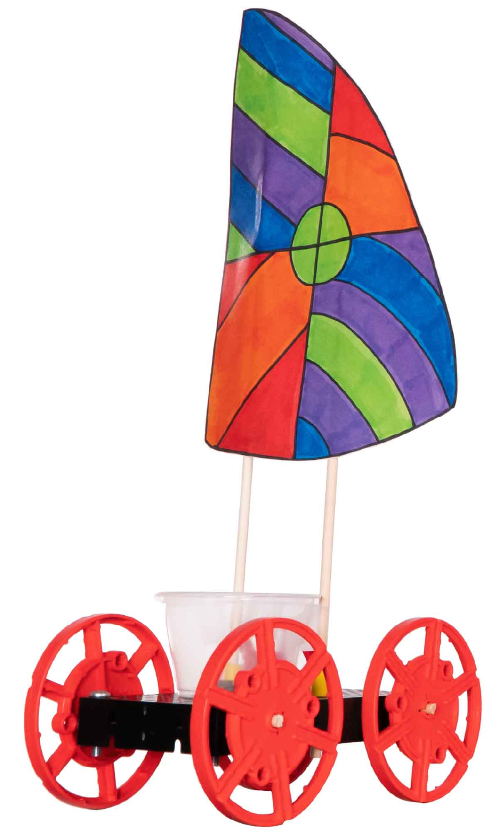

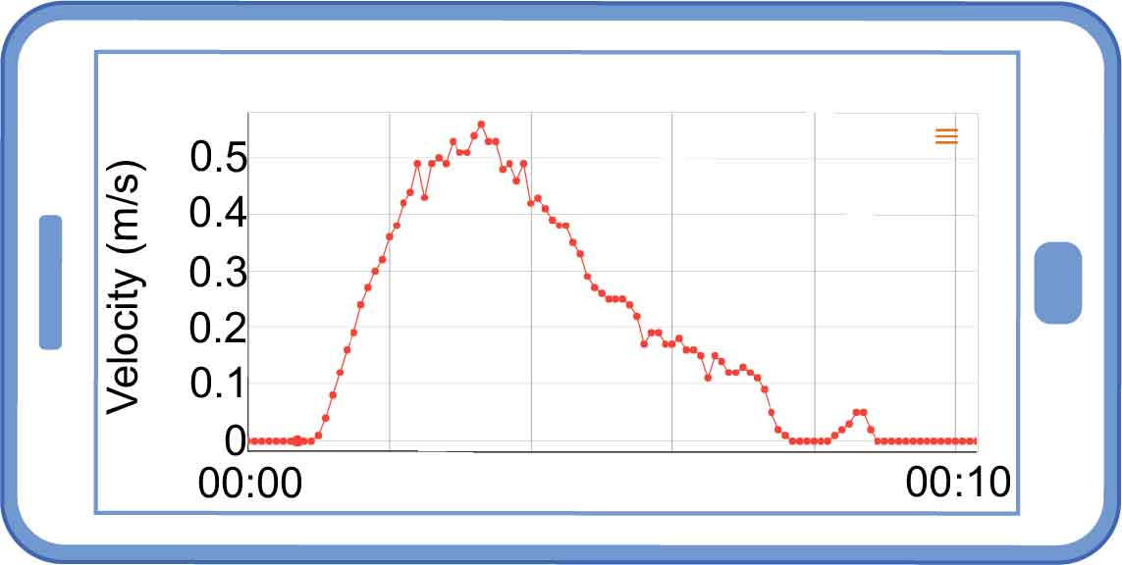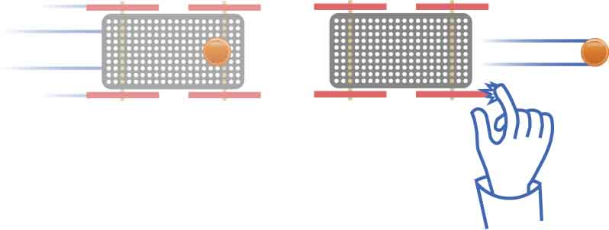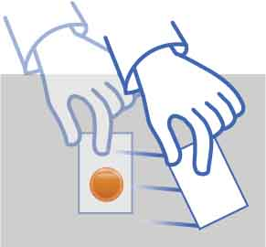

Check out the [**Lab Set-Up Video**](https://vimeo.com/406306552) by scanning the   
QR Code or going to [**teachergeek.com/sailcar**](https://www.teachergeek.com/sailcar)

Name:__________________________________________

**What’s inertia? Is it good or bad?**

**Experiment with your sail car to find out!**

**“Built” Sail Car**

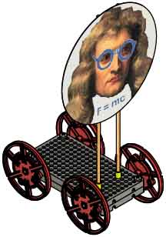

Get a PocketLab at [**thepocketlab.com**](https://thepocketlab.com)

The PocketLab must be paired with a compatible phone, tablet, Chromebook, or computer.

**PocketLab  
Sensor**

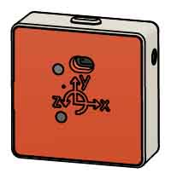

Build the Sail Car using the **Go Guide**, available at [**teachergeek.com/sailcar**](https://teachergeek.com/sailcar)

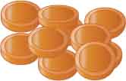

**100 Pennies**or 250 g (9 oz) of weights

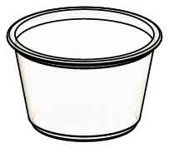

**Plastic Cup**

**Fan**

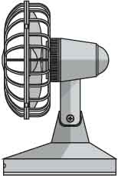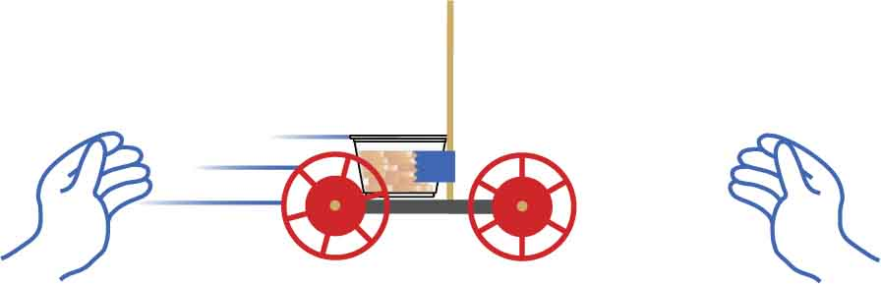

cup of pennies

tape

Tape a cup of pennies to your masts and roll it again. It should take more force to start and stop the car.

mast

**With no unbalanced forces, this penny will never stop.**

**With no unbalanced forces, this penny will never move.**

STATIONARY OBJECTS

Try placing a penny on a scrap of paper. If you quickly yank the paper out, the penny won’t move.



***Inertia* is an object’s resistance to changes in its motion. When the forces are balanced, objects will continue moving the same speed and direction.**

**Adding mass to the car adds inertia, so it takes bigger forces to speed it up or slow it down.**

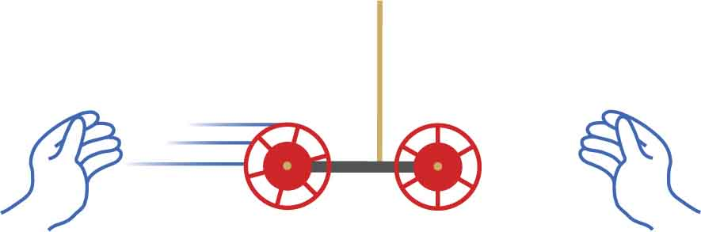

Gently roll a car back and forth between your hands. Notice how much force you are using to start and stop it.



MOVING OBJECTS

Place a penny on your car and push it fast. Stop the car with your hand, and the penny will continue moving.



Lots of mass (inertia) means your car won’t gain much speed from the fan’s wind…

…but it also means that it won’t lose much speed from air resistance.

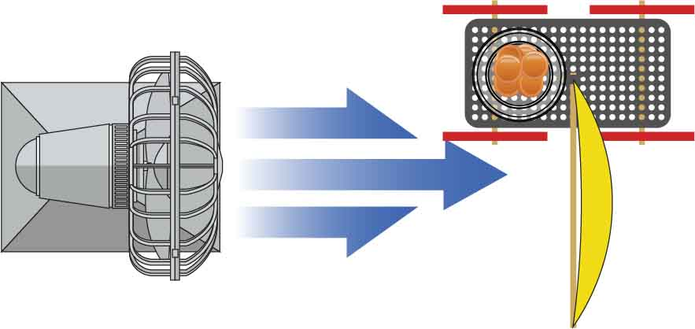

FAN WIND

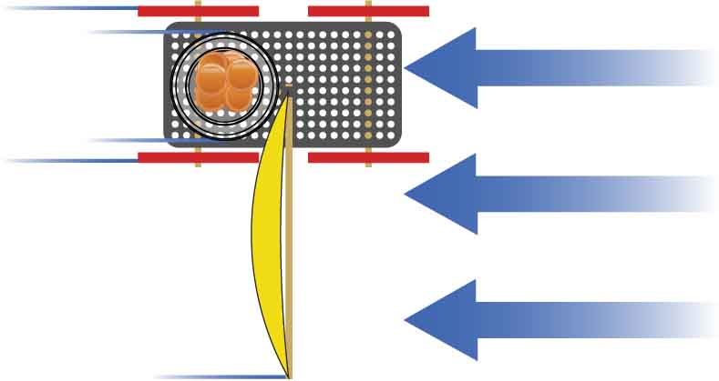

AIR RESISTANCE

Air resistance slows your car down as it gets far from the strong winds of the fan.



**You are going to use a PocketLab test inertia. But first, let’s see how it works.**

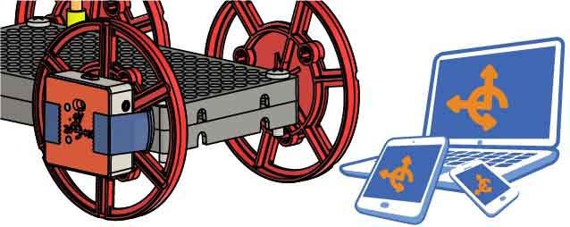

Set up your PocketLab.

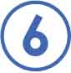

Use one choice **from each column** in   
your answers.

|  |  |
| --- | --- |
| Column 1 | Column 2 |
| Move backward  Move forward  Not moving | Constant speed  Speeding up  Slowing down |

WORD BANK

Play with your car! Then try to match the graphs.   
**Use the word bank to describe the motion   
each graph represents.**

____________________________

Velocity

Time

0

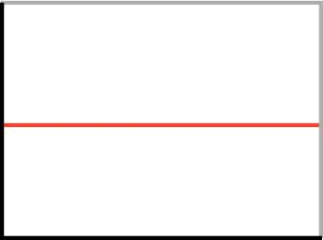

____________________________

Velocity

Time

0

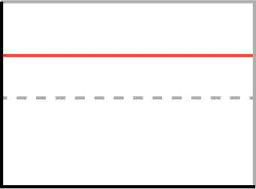

____________________________

Velocity

Time

0

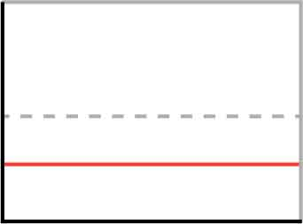

Velocity

Time

0

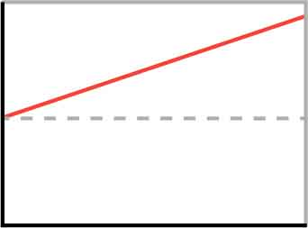

____________________________

It starts by _____________ ________________  
Then it ______________ _________________  
Lastly, it ______________ ________________

Velocity

Time

0

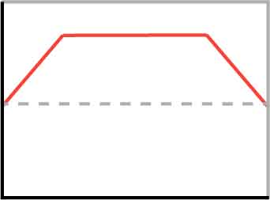

Velocity

Time

0

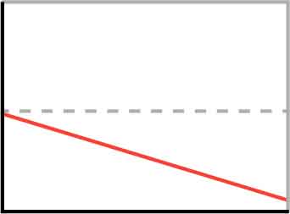

____________________________

**Now that you can measure motion, let’s use the PocketLab to explore inertia.**

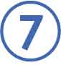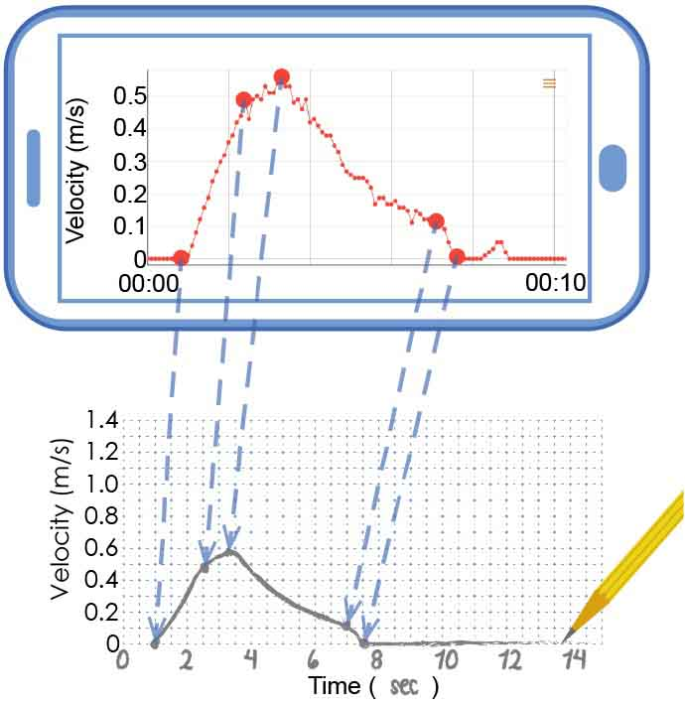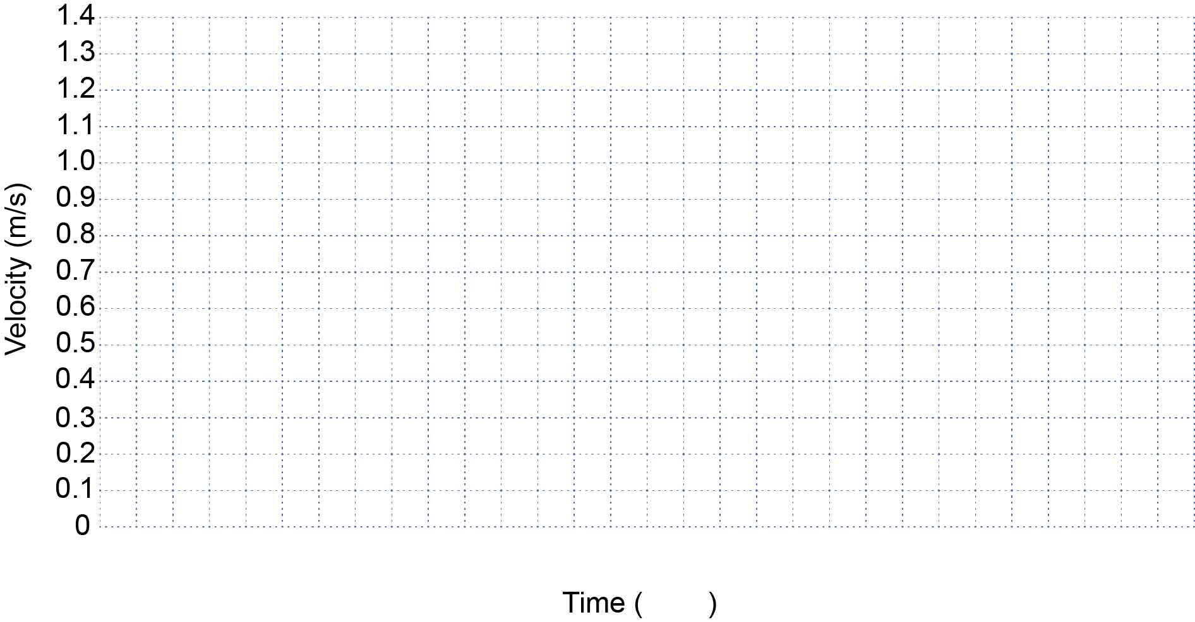

Now get data using only half of the pennies you used in Step 8. Then get data with no pennies. Fill in the legend so you can tell one experimental condition from the other.

Transfer your PocketLab’s velocity graph to the axes below. The graph doesn’t need to be perfect, but you should transfer over important points and match the general shape.

**Legend**

EXAMPLE

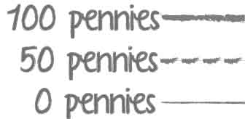

Using the most pennies your vehicle can haul, sail your car down the track. Record the velocity data using the PocketLab.

What variables do you need to keep track of?

**How does changing inertia (mass) affect your car’s velocity? Set up an experiment to find out!**

|  |  |  |
| --- | --- | --- |
| **Independent Variable(s)** | **Dependent Variable(s)** | **Control Variable(s)** |
|  |  |  |

**Legend**



Describe any unbalanced forces acting on the car and explain how you know forces are balanced/unbalanced.

____________________________________________________________________________________________________________________________________________________________________



Describe the sail car’s motion. Use one choice from each column of the word bank.  
__________________________________________

|  |  |
| --- | --- |
| Column 1 | Column 2 |
| Move backward  Move forward  Not moving | Constant speed  Speeding up  Slowing down |

WORD BANK

**Answer the questions below referencing the circled part of the graph.**

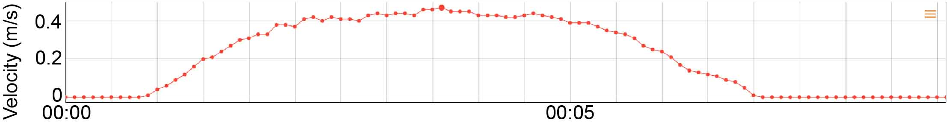

These questions focus on   
the circled part of this graph.

If you increased the mass of the sail car, how would this part of the graph change? Use your car’s data from p. 4 to justify your answer.  
____________________________________________________________________________________________________________________________________________________________________



**What does your data tell you about inertia and motion?**



**Answer the questions below referencing the circled part of the graph.**



These questions focus on   
the circled part of this graph.



Describe the sail car’s motion. Use one choice from each column of the word bank.  
__________________________________________

|  |  |
| --- | --- |
| Column 1 | Column 2 |
| Move backward  Move forward  Not moving | Constant speed  Speeding up  Slowing down |

WORD BANK

Describe any unbalanced forces acting on the car and explain how you know forces are balanced/unbalanced.

____________________________________________________________________________________________________________________________________________________________________



If you increased the mass of the sail car, how would this part of the graph change? Use your car’s data from p. 4 to justify your answer.  
____________________________________________________________________________________________________________________________________________________________________







Describe the sail car’s motion. Use one choice from each column of the word bank.  
__________________________________________

|  |  |
| --- | --- |
| Column 1 | Column 2 |
| Move backward  Move forward  Not moving | Constant speed  Speeding up  Slowing down |

WORD BANK

If you increased the mass of the sail car, how would this part of the graph change? Use your car’s data from p. 4 to justify your answer.  
____________________________________________________________________________________________________________________________________________________________________



Describe any unbalanced forces acting on the car and explain how you know forces are balanced/unbalanced.

____________________________________________________________________________________________________________________________________________________________________



**Answer the questions below referencing the circled part of the graph.**



These questions focus on the circled part of this graph.





Describe the sail car’s motion. Use one choice from each column of the word bank.  
__________________________________________

|  |  |
| --- | --- |
| Column 1 | Column 2 |
| Move backward  Move forward  Not moving | Constant speed  Speeding up  Slowing down |

WORD BANK

If you increased the mass of the sail car, how would this part of the graph change? Use your car’s data from p. 4 to justify your answer.  
____________________________________________________________________________________________________________________________________________________________________



Describe any unbalanced forces acting on the car and explain how you know forces are balanced/unbalanced.

____________________________________________________________________________________________________________________________________________________________________



**Answer the questions below referencing the circled part of the graph.**



These questions focus on the circled part of this graph.



**Identify patterns and use them to build a better sail car!**



What is inertia, and how is it related to mass?  
____________________________________________________________________________________________________________________________________________________________________



How does inertia affect the motion of your sail car?  
_____________________________________________________________________________________________________________________________________________________________________________________________________________



Do you want your sail car to have a lot or a little mass? Why?  
______________________________________________________________________________________________________________________________________________________________________________________________________________________________________________________