



Check out our immersive challenge videos by scanning the QR Code or going to [**teachergeek.com/sailcar**](https://www.teachergeek.com/sailcar)



There is no limit on recycling materials.

Components: The maximum number of TeacherGeek components that can be use on your racer.

* 4 Wheels
* 2 Hole Plates
* 4 Strips
* 9 Dowels
* 8 cm (3 in) Slide Stop
* 5 Blocks
* 4 Screws
* 4 Tire Rubber Bands

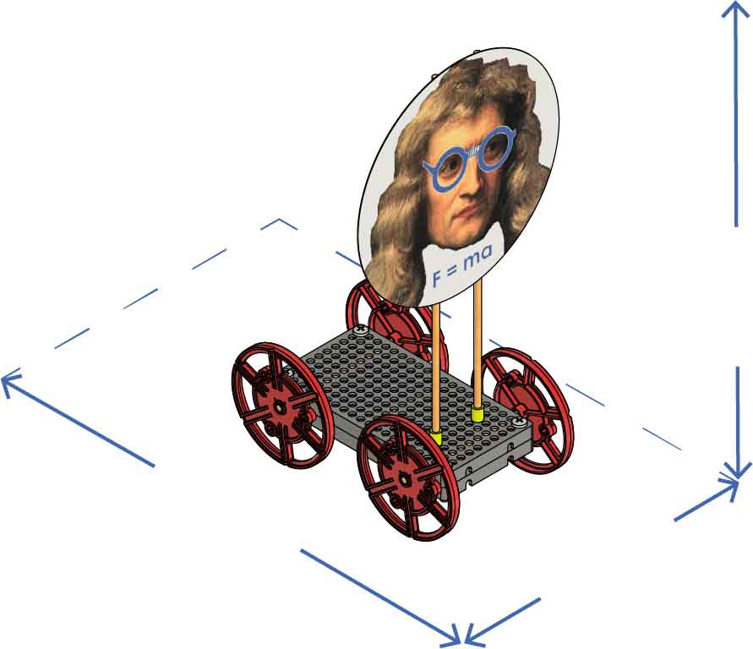

**45 cm**(18 in)

**Max Length**

**30 cm**(12 in)

**Max Width**

**Unlimited**

**Max Height**

Your sail car must travel down the track in the shortest time.

The fans must be the only power source for your car.

How fast can your sail car go?

Dimensions: The maximum size your racer can be.

(rules and limits for your design)

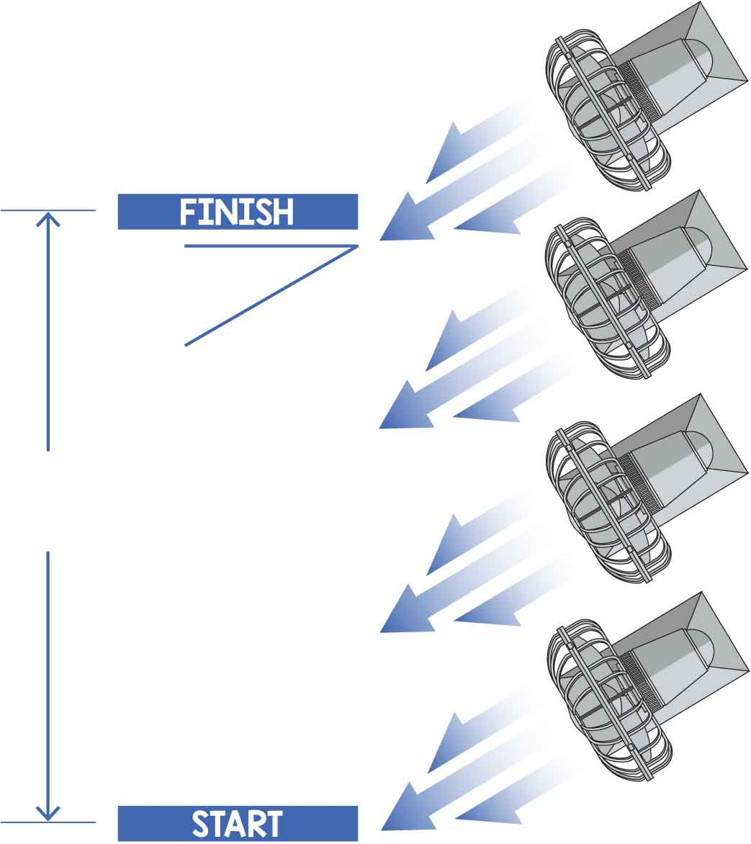

**3 m**  
(10 ft)

**30º**