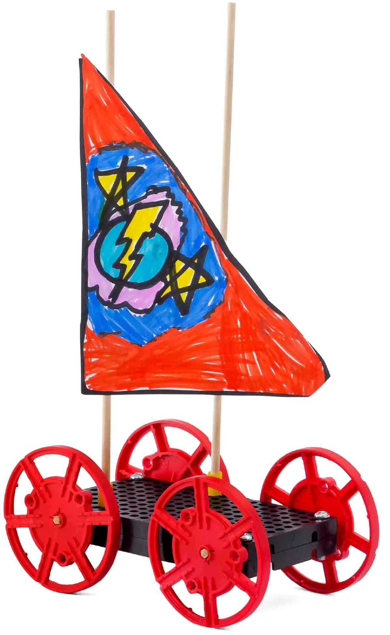

**Follow this guide to build your sail car body & masts, which you can use to complete labs and engineering challenges!**

Sail car bodies should be built with adult assistance and supervision. Once built, the cars can be reused while kids design and test new sails!

**[](https://teachergeek.com/collections/single-activity-packs)**

Start here! Build your example racer, learn sailing basics, and begin the tailwind challenge!

-Crosswind Challenge*   
-Headwind Challenge*

**Choose how you would like to complete this activity.  
Download documents & videos at** [**teachergeek.com/sailcar**](http://teachergeek.com/sailcar)

[-Push Pull (Ages 3-6)](https://www.teachergeek.com/sailcar)

[-Wind (Ages 3-8)](https://www.teachergeek.com/sailcar)

[-Balanced Forces (Ages 8-11)](http://teachergeek.org/sail_car_balanced_forces_lab.docx)

[-Forces & Motion (Ages 12+)](http://teachergeek.org/sail_car_forces_&_motion_lab.docx)

[-Inertia (Ages 12+)](http://teachergeek.org/sail_car_inertia_lab.docx)

*See Page 5

You Are Here

Go Guide

Optional Labs

Optional Challenges



Check out our [**build video**](https://vimeo.com/410370335) and [**immersive challenge videos**](https://vimeo.com/showcase/7037367) by scanning the QR Code or going to [**teachergeek.com/sailcar**](https://www.teachergeek.com/sailcar)

**These are the parts you need to build one sail car.**

MATERIALS YOU SUPPLY

SAIL CAR PARTS

Supplies



Have a Maker Cart? Use Multi-Cutters to   
cut your own dowels.

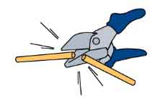

**Wheels**SKU 1821-30

**4**



**Dowels**various sizes  
SKU 1821-20

**Hole Plates**SKU 1821-32

**2**

**1**

**Slide Stop**8 cm (3 in)  
SKU 1821-49

**4**

**Screws**25 mm (1 in)  
SKU 1821-22

**5**

PICTURE

NAME

QTY

Dowel Sizes  
2x 30 cm (12”)  
3x 10 cm (4”)



* **Screw Driver**
* **Scissors**
* **Fan**
* **Tape**
* **Paper** (sail material)
* **Recycling Bin Materials**(what else can you   
  use as a sail)

Modify materials to make even more creative designs with the

**TeacherGeek / Maker Tool Set**

SKU 1823-84

OPTIONAL TOOLS

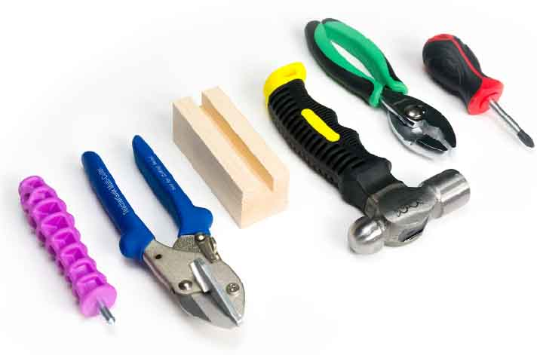

**Do you have more parts than pictured?**   
You may have the Advanced Sail Car kit.   
Download the [**Advanced Go Guide**](https://teachergeek.org/sail_car_go_guide_advanced.docx) at [**teachergeek.com/sailcar**](https://teachergeek.com/sailcar)

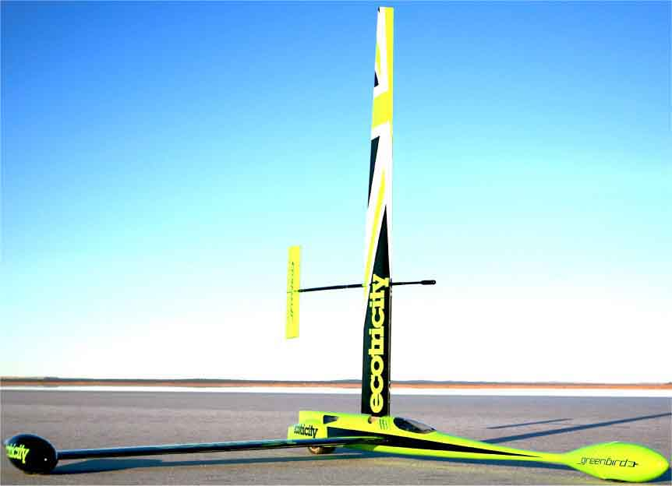

Can You Beat the Record?

In 2009, Richard Jenkins set the world record of 126.2 mph (202.9 km/h) for a wind-powered land vehicle. His sail car went over twice as fast as the speed of the wind, which was fluctuating between 30 and 50 mph (50 – 80 km/h).

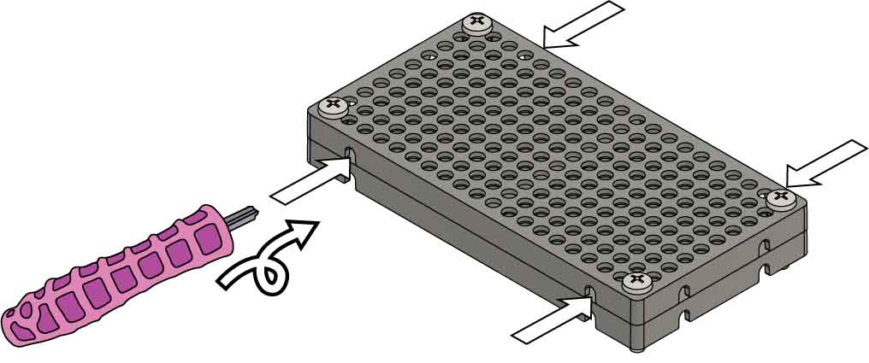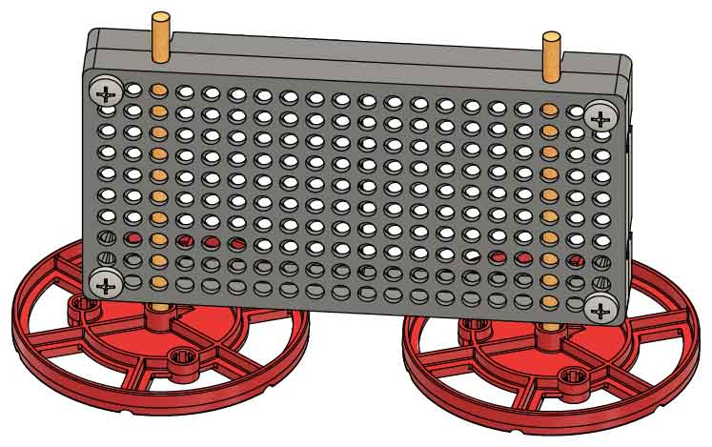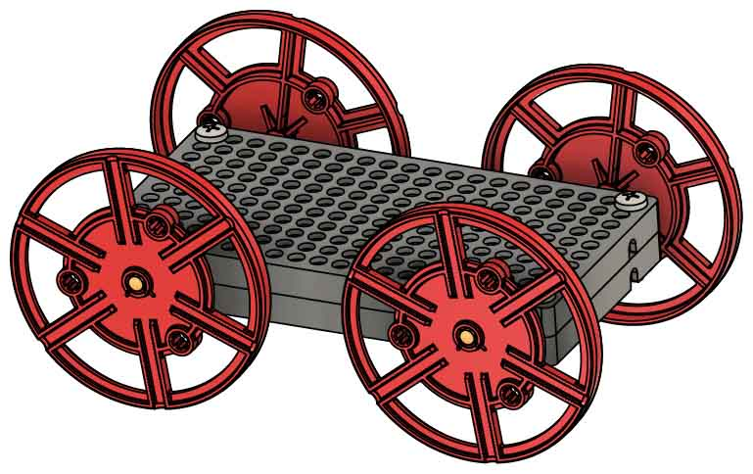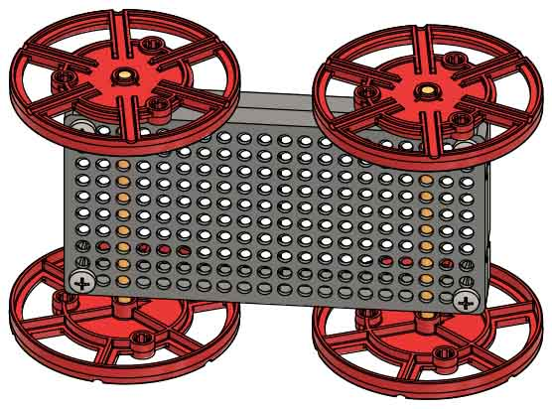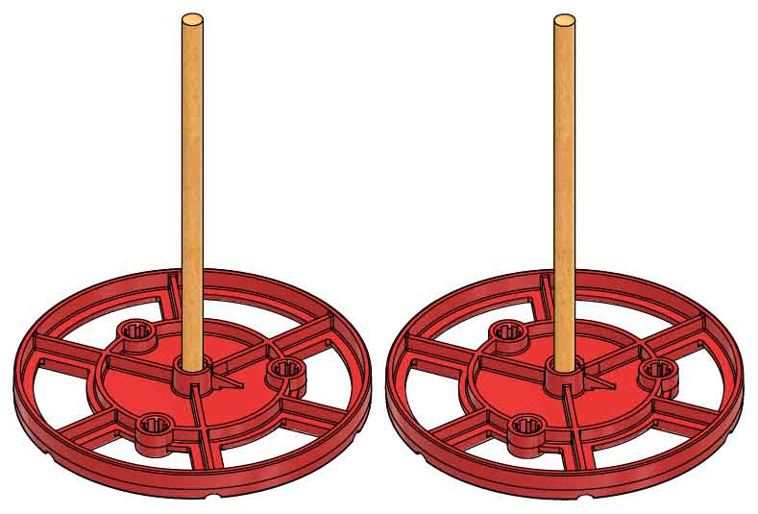**[](https://teachergeek.com/sailcar)**

Push & twist

**Ream** **the holes** between the hole plates.

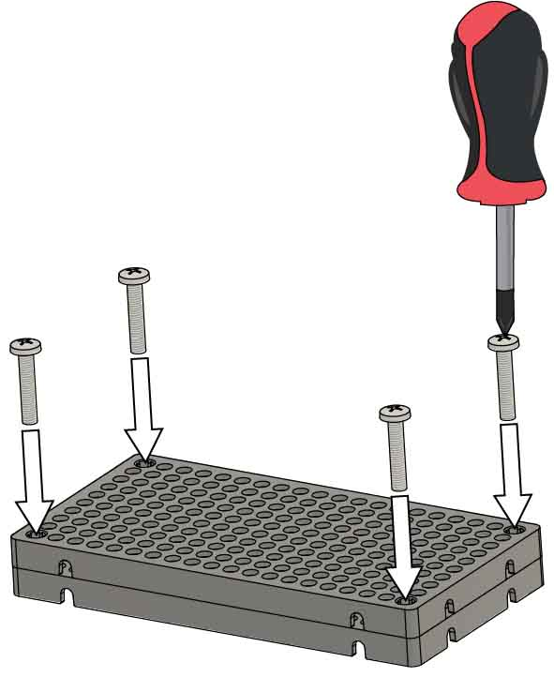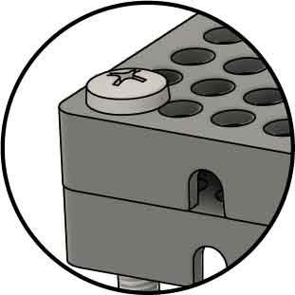

Check out our [**build video**](https://vimeo.com/410370335) scanning the QR Code or going to [**teachergeek.com/sailcar**](https://www.teachergeek.com/sailcar)

# 5

# 4

# 3

# 2

# 1

**Want to learn more about forces using your Sail Car?**

Download the **Push/Pull Lab** at[**teachergeek.com/sailcar**](http://teachergeek.com/sailcar) **Ages 3+**

The wheels should spin freely. If they don’t, repeat Step 3.

**Slide** the **wheels** with dowels **into** **the** **holes** between the holeplates.

SKIP IF YOU’RE USING A SINGLE KIT  
(this step has been done for you).

**Attach two hole plates** by driving **screws** into their corners.

Build the Body

**Add** **wheels** to the other side to finish your body.

**Wiggle** or tap the 10 cm (4 in) **dowels** **into wheels.**

# 7

# 6

Slide each **slide stop** section approximately 2 cm (3/4 in) **onto** each 30 cm (12 in) **dowel**.

**Cut** two 1 cm (3/8 in) sections of **slide stop**.

Add the Masts



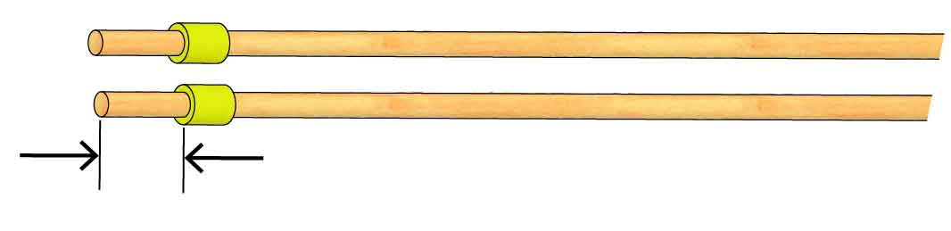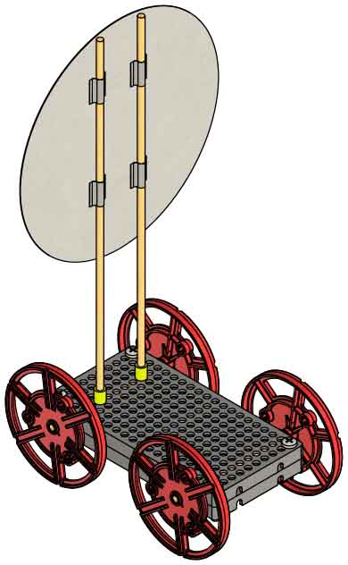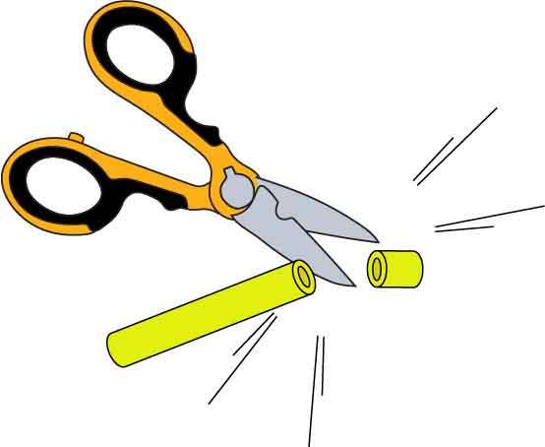

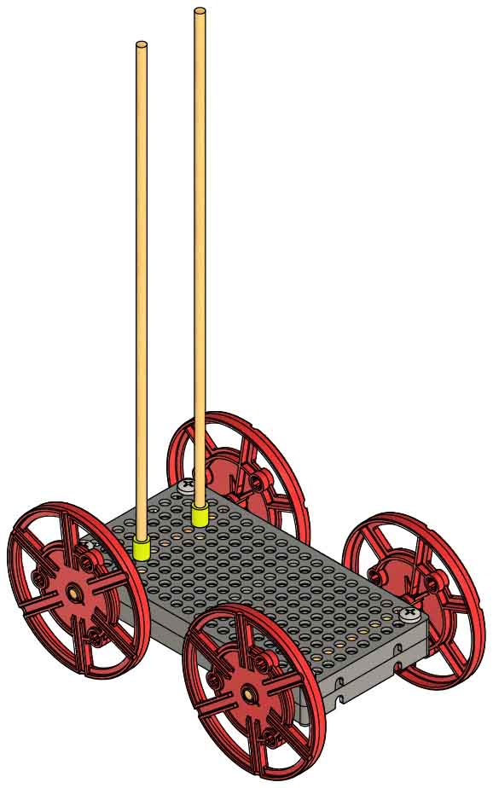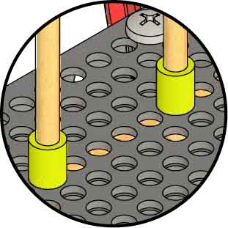

**2 cm**(3/4 in)

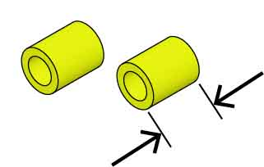

**1 cm**(3/8 in)

# 9

# 8

To finish the sail car, tape a sail to the masts.

Use paper, card stock, recycling bin materials… there are endless sail options. Test them all!

Place the **masts** **into** the Sail Car **body**. The masts will be used to attach the sails.

[Inertia Lab](http://teachergeek.org/sail_car_inertia_lab.docx)

[(Ages 12+)](http://teachergeek.org/sail_car_inertia_lab.docx)

Download these labsat [**teachergeek.com/sailcar**](http://teachergeek.com/sailcar)



[Balanced Forces Lab](http://teachergeek.org/sail_car_balanced_forces_lab.docx)

[(Ages 8-11)](http://teachergeek.org/sail_car_balanced_forces_lab.docx)

[Forces & Motion Lab](http://teachergeek.org/sail_car_forces_&_motion_lab.docx)

[(Ages 12+)](http://teachergeek.org/sail_car_forces_&_motion_lab.docx)

[Wind Lab(Ages 3-8)](https://teachergeek.com/sailcar)

Versions: [Pre-K](http://teachergeek.org/sail_car_wind_lab_preK.docx) | [K-1](http://teachergeek.org/sail_car_wind_lab_k_1.docx) | [Gr 2-3](http://teachergeek.org/sail_car_wind_lab_2_3.docx)

[Push/Pull Lab(Ages 3-6)](https://teachergeek.com/sailcar)

Versions: [Pre-K](http://teachergeek.org/sail_car_push_pull_lab_preK.docx) | [K-1](http://teachergeek.org/sail_car_push_pull_lab_k_1.docx)

Optional Labs:

**It’s time for labs and/or challenges!** Complete one of the optional labs below or continue on to set up for the engineering challenge!

How far can you make your sail car go?

Check out [**Tailwind Challenge Scenario Video**](https://vimeo.com/410371528)by scanning   
the QR Code or going to [**teachergeek.com/sailcar**](https://www.teachergeek.com/sailcar)



Tailwind Challenge

**Keep track of your designs in an Engineering Notebook.**

Download it at [**teachergeek.com/sailcar**](http://teachergeek.com/sailcar)



Follow the instructions below to set up your track. Then design and refine sails your sail car, seeing which sail can go the farthest!

Track Setup

Sail cars can go 10 m (30 ft) on uncarpeted floors (less on carpeting). Long, uncarpeted areas are preferred for tracks, but you can sail your car almost anywhere! Set down your fan, then set up your measuring system.

Option 1: Place numbered pieces of tape every meter (3 ft). Use these to measure how far the sail car travelled.

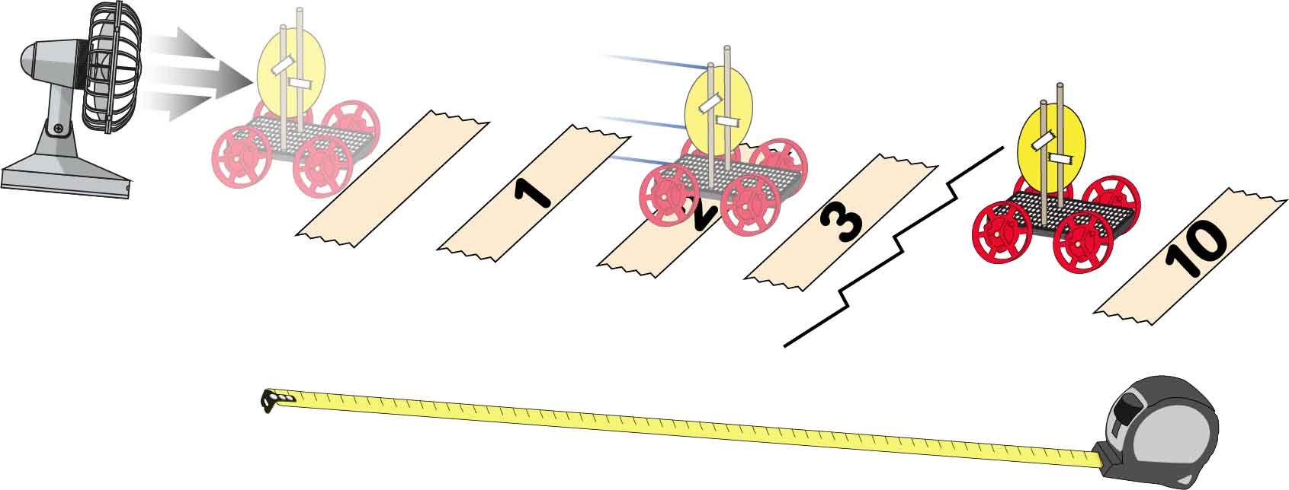

Start



Do not move the fan during competition.

Option 2: Use a measuring tape, meter stick, etc. to measure the distance sail cars travel.



Optionally increase the challenge by carrying weights   
or passengers.

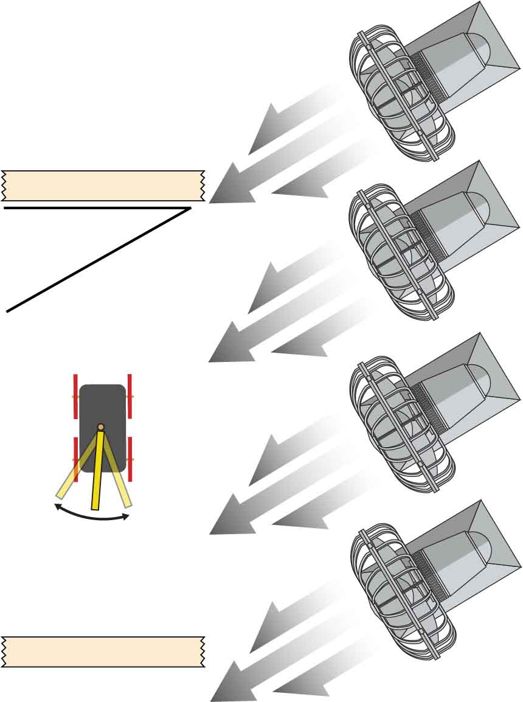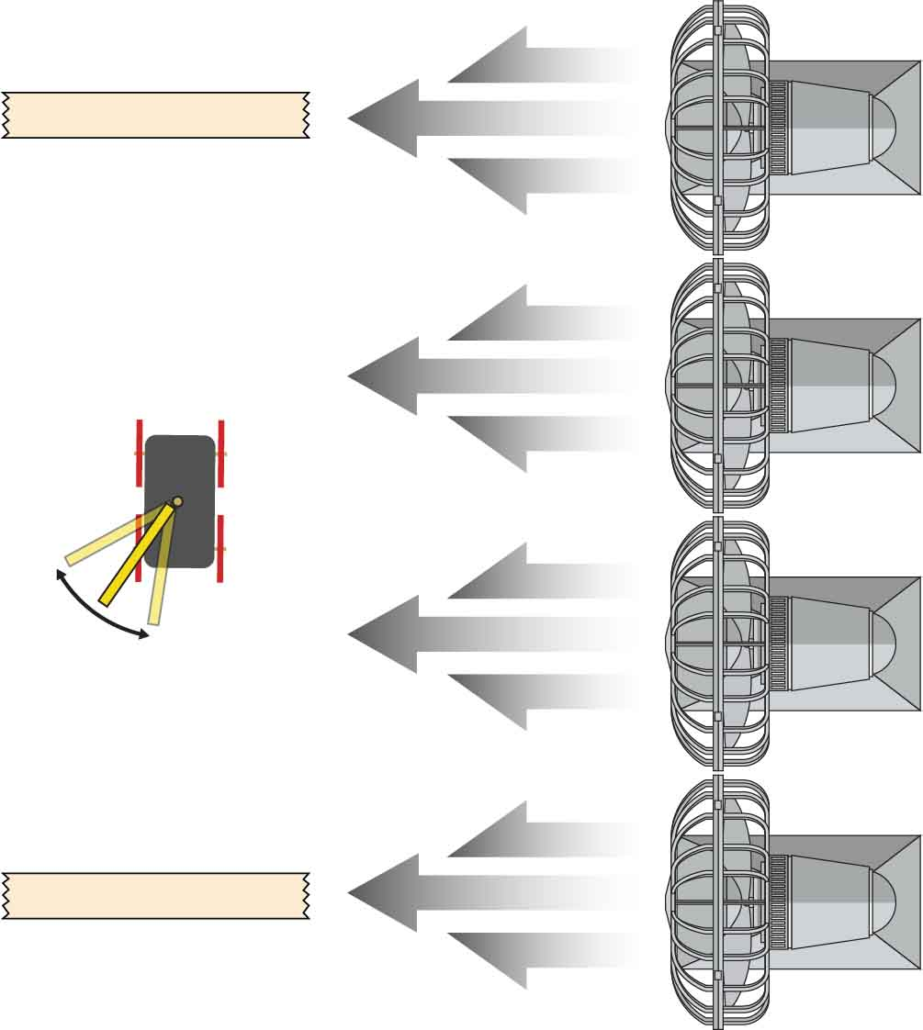

**30º**

Change the angle of your sail   
to capture   
the wind.

Make sure wind will hit the sail before the start line and after the finish line.

Start

Finish

Change the angle of your sail to capture the wind.

Make sure wind will hit the sail before the start line and after the finish line.

Finish

Start

Do not move   
the fans during competition.

Sail “into” the wind!

Sail across the wind!

Check out the [**Crosswind Challenge Scenario Video**](https://vimeo.com/410371377) by scanning the QR Code or going to [**teachergeek.com/sailcar**](https://www.teachergeek.com/sailcar)



Check out the [**Headwind Challenge Scenario Video**](https://vimeo.com/410371448) by scanning the QR Code or going to [**teachergeek.com/sailcar**](https://www.teachergeek.com/sailcar)



Place fans along each side of your track, so that they blow at a 30° angle to the finish line.

Your sail car must travel down the track in the shortest time.

The fans must be the only power source for your car.

Place fans along each side of your track, so that they blow across it.

Your sail car must travel down the track in the shortest time.

The fans must be the only power source for your car.

Headwind Challenge

Crosswind Challenge

Sail Shape & Location  
Try different sail shapes to see which works best, then try moving it to a new spot on the car’s body.

Sail Size   
Will a bigger or smaller sail make your car go farther?

Change the Design

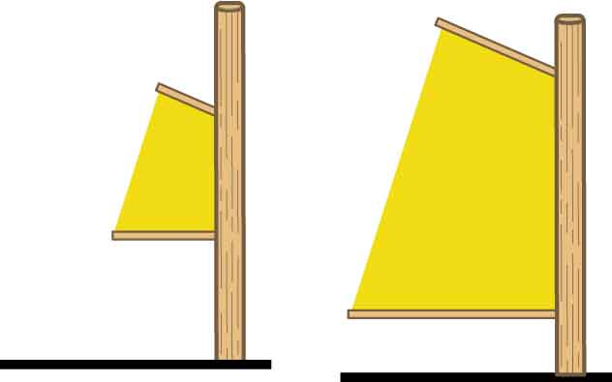

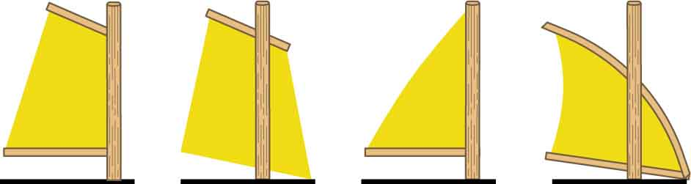

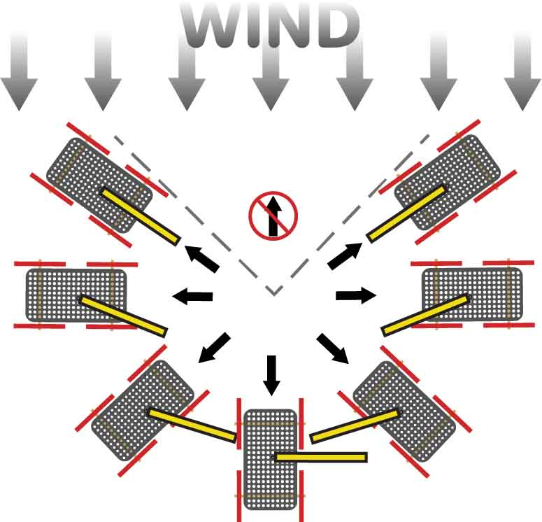

Sail Angle  
If the wind isn’t coming from behind your car, change the angle of the sail!

Can’t sail into the wind

Mass  
Does a heavy or light car go the farthest?

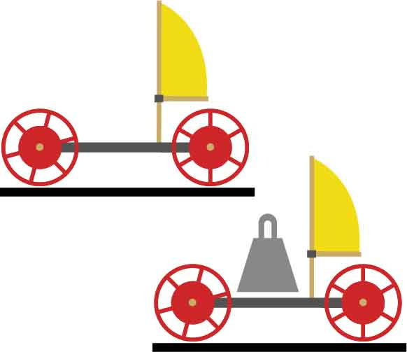

## Design

## Process

## Design

## Redesign

## Test

## Evaluate

**The Design Process never ends! There is no perfect design.**

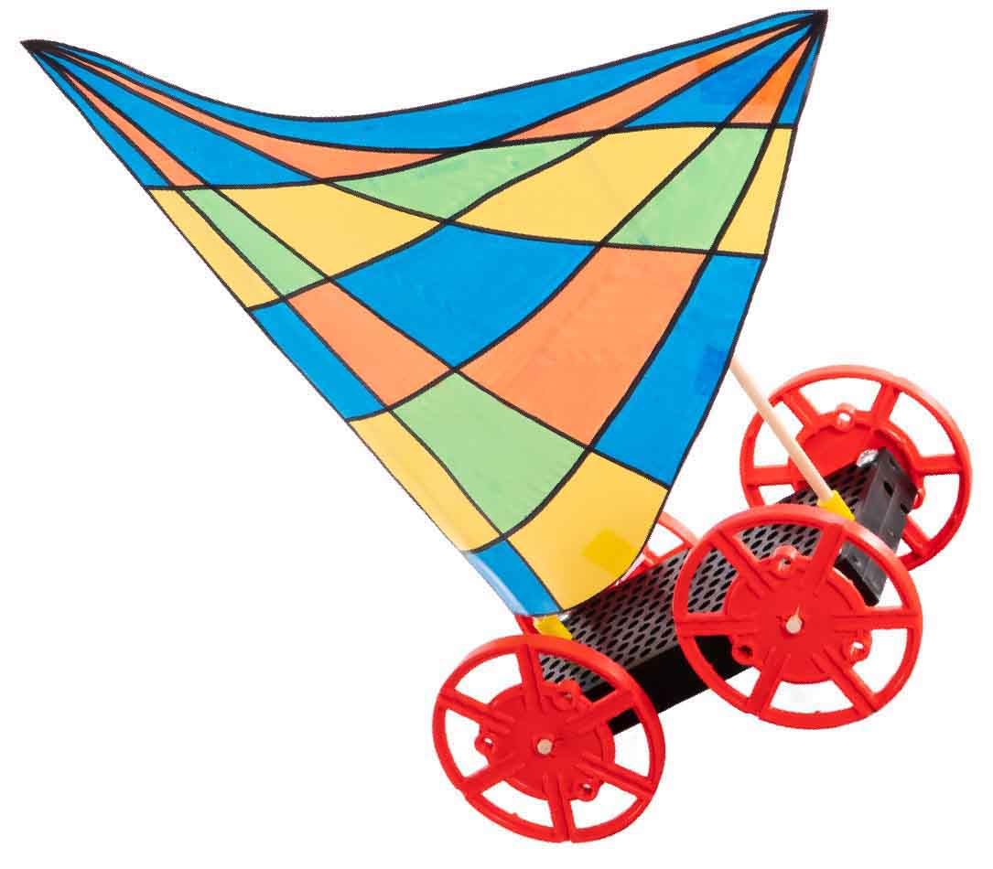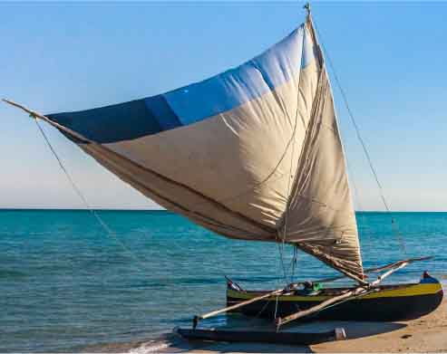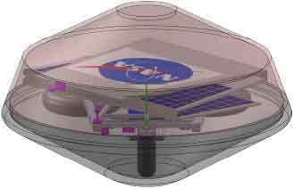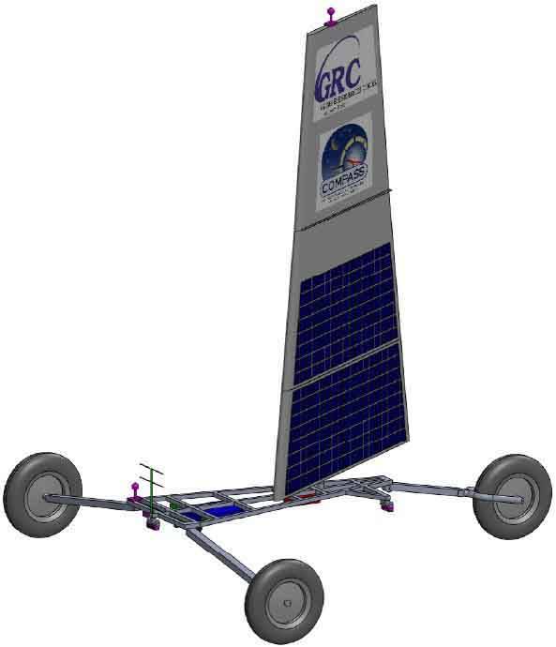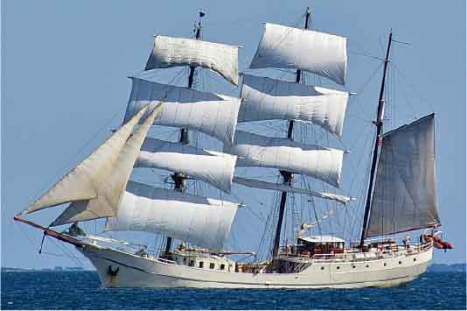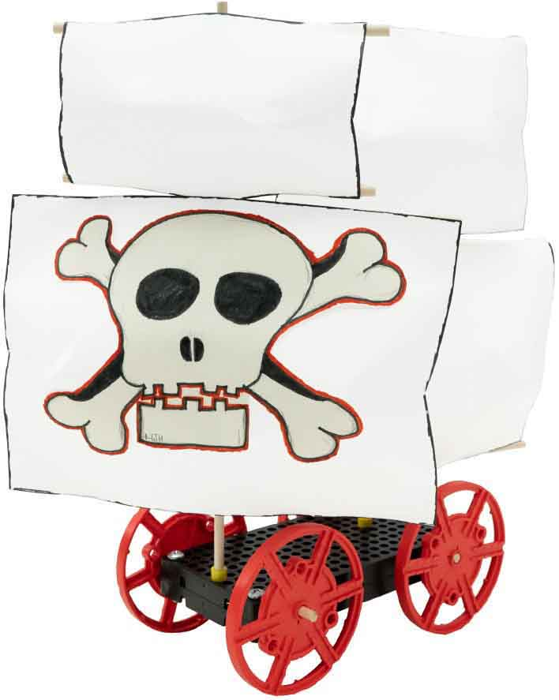

Dhows have been used for thousands of years as trading vessels along the coasts of Arabia, East Africa, and India, where they are believed to have originated.

Historical Vessels

The Zephyr Venus Landsailer was designed by NASA to explore Venus. Its main source of   
propulsion is its sail, which is   
covered in solar panels to   
power the steering systems   
and scientific equipment.   
The vessel folds into a   
protective shell for landing.

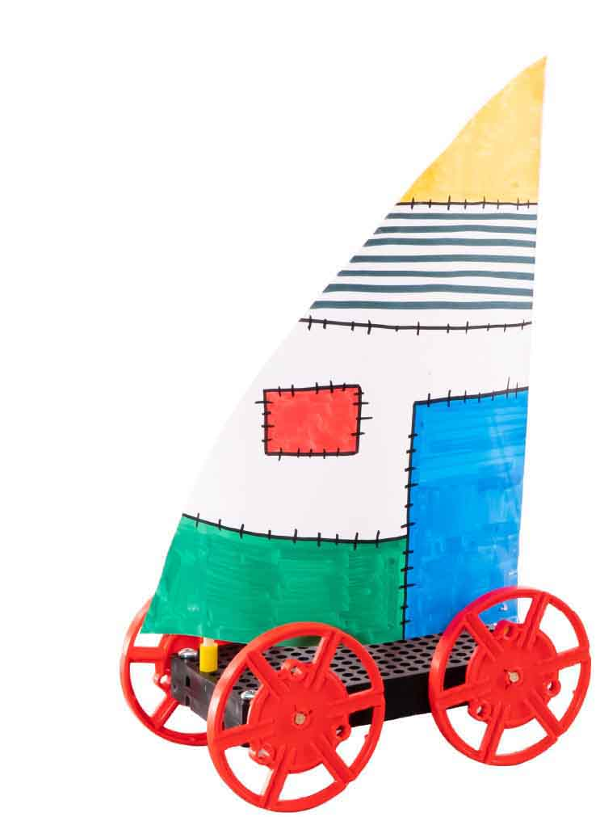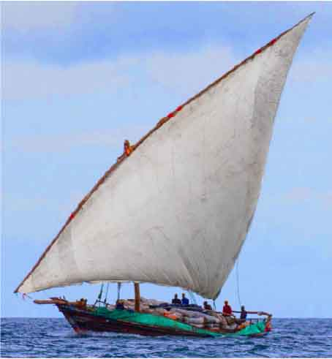

Outrigger Canoes   
are fast and maneuverable. Developed in the islands   
of South East Asia, Pacific Islanders used them to settle the islands of Oceana as far as Hawaii.

Brigs were popular among   
Europeans in the 18th & 19th   
centuries due to their speed   
and maneuverability. They   
were often used by pirates, merchants, and navies.

Sail into the Future