­­­

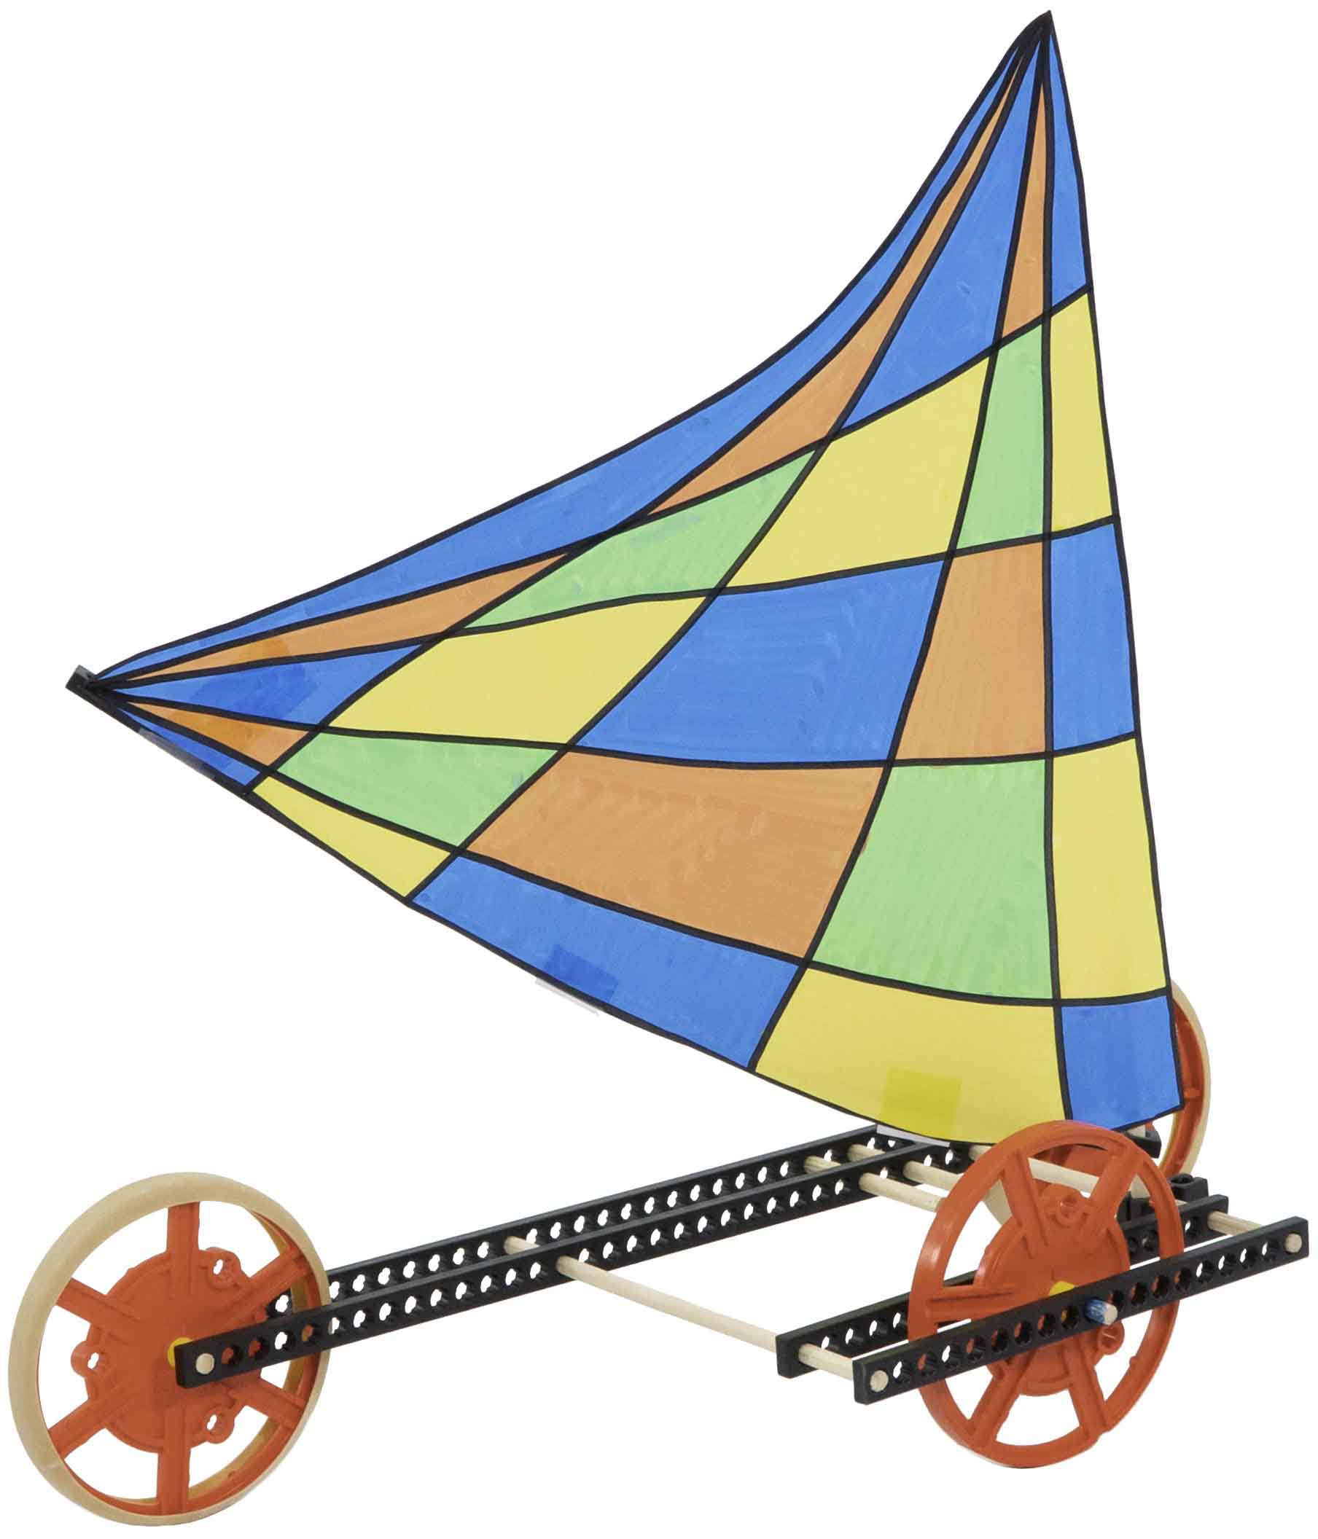

**Wind power makes racing a breeze!**

This guide will help you create your   
own wind powered sail car!

wind powered sail car!

sail car.

Check out our [**build video**](https://vimeo.com/410370335) and [**immersive challenge videos**](https://vimeo.com/showcase/7037367) by scanning the QR Code or going to [**teachergeek.com/sailcar**](https://www.teachergeek.com/sailcar)



**[](https://teachergeek.com/collections/single-activity-packs)**

­

­

[-Forces & Motion (Ages 12+)](http://teachergeek.org/sail_car_forces_&_motion_lab.docx)

[-Inertia (Ages 12+)](http://teachergeek.org/sail_car_inertia_lab.docx)

[-Atwood’s Machine](http://teachergeek.org/half_atwoods_lab.docx) (Ages 14+)  
[-Momentum](http://teachergeek.org/sail_car_momentum_lab.docx) (Ages 14+)

Start here! Build your example racer, learn sailing basics, and begin the tailwind challenge!

-Crosswind Challenge*   
-Headwind Challenge*

**Choose how you would like to complete this activity.  
Download documents & videos at** [**teachergeek.com/sailcar**](http://teachergeek.com/sailcar)

[-Push Pull (Ages 3-6)](https://www.teachergeek.com/sailcar)

[-Wind (Ages 3-8)](https://www.teachergeek.com/sailcar)

[-Balanced Forces   
 (Ages 8-11)](http://teachergeek.org/sail_car_balanced_forces_lab.docx)

*See Page 3

You Are Here

Go Guide

Optional Labs

Optional Challenges

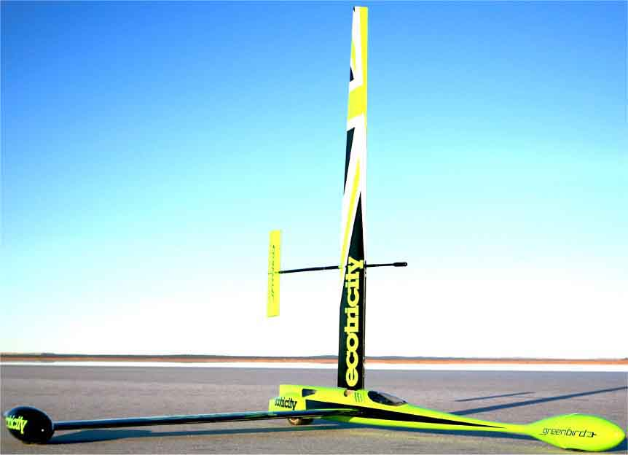

**Can You Beat the Record?**

* **Screwdriver** (Phillips)
* **Scissors**
* **Fan**
* **Tape**
* **Paper** (sail material)
* **Recycling Bin Materials**(what else can you use as a sail)

Do you have fewer parts than pictured?   
You may have ordered the Basic Sail Car kit. Download the [**Basic Go Guide**](https://teachergeek.org/sail_car_go_guide_basic.docx) at [**teachergeek.com/sailcar**](http://teachergeek.com/sailcar)

**Wheels**SKU 1821-30

**Dowels**various sizes  
SKU 1821-20

**Hole Plates**SKU 1821-32

**Slide Stop**8 cm (3 in)  
SKU 1821-49

**Screws**25 mm (1 in)  
SKU 1821-22

**Strips**

30 cm (12 in)

SKU 1821-31

**Blocks**SKU 1821-34

**4**

**15**

**2**

**1**

**4**

**4**

**5**

**NAME**

**QTY**

**PICTURE**

**Tire Rubber Bands**  
SKU 1821-64

**4**

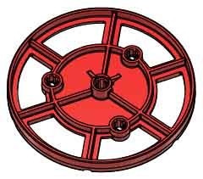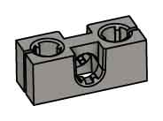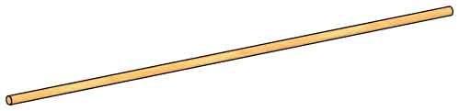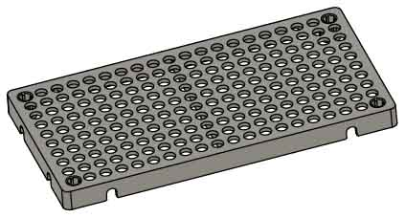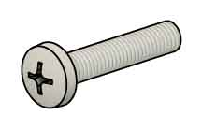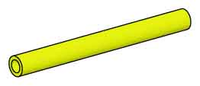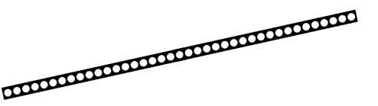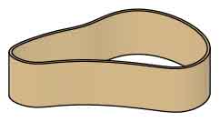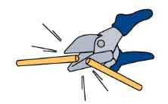

Have a Maker Cart? Use Multi-Cutters to cut your own dowels.

Dowel Sizes

4x 7.5 cm (3”)  
3x 10 cm (4”)

2x 7.5 cm (5”)  
2x 15 cm (6”)  
4x 30 cm (12”)

In 2009, Richard Jenkins set the world record of 126.2 mph (202.9 km/h) for a wind-powered land vehicle.

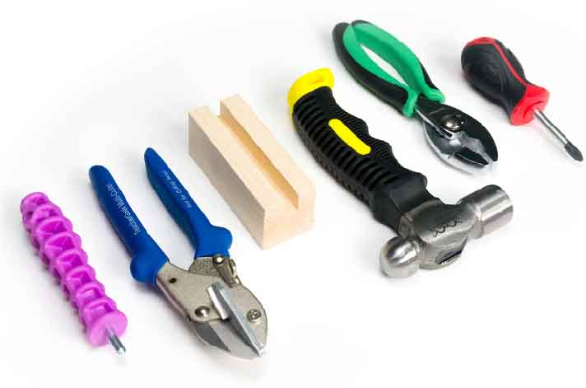

Modify materials to make even more creative designs with the

**TeacherGeek / Maker Tool Set**

SKU 1823-84

Optional Tools

Materials You Supply

Sail Car Parts

The list includes extra parts so you can experiment and create your own designs.

Supplies

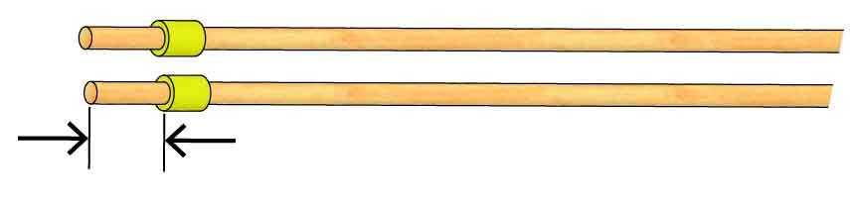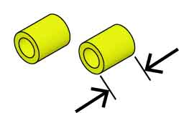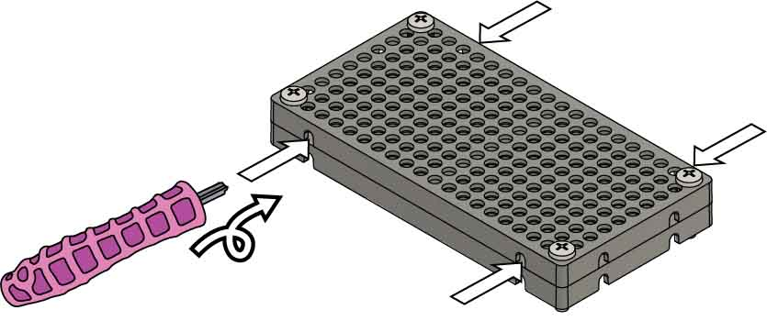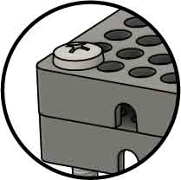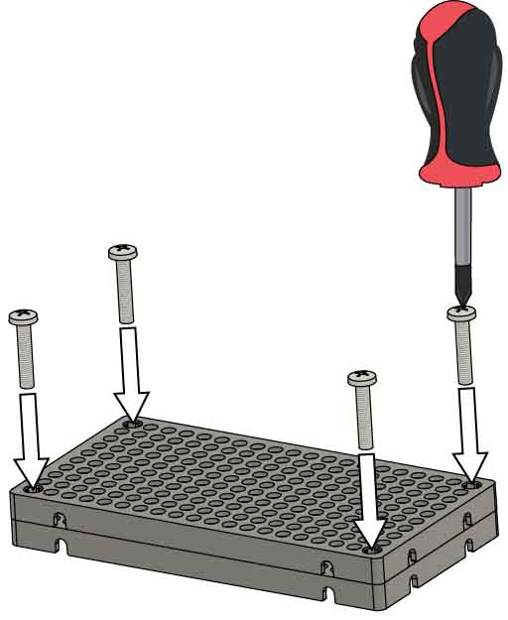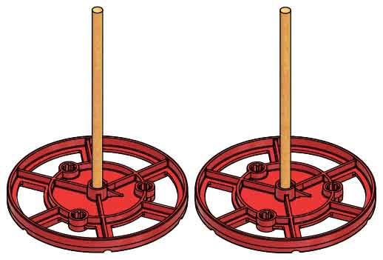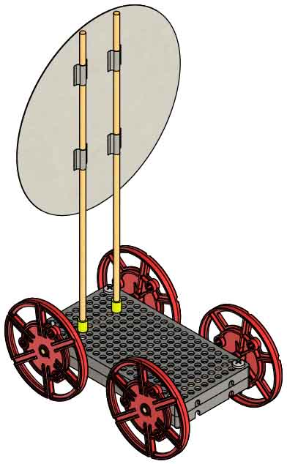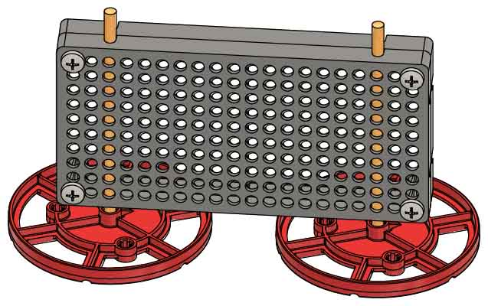

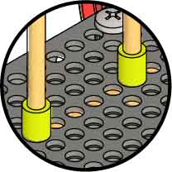

Slide each **slide stop** section approximately 2 cm (3/4 in) **onto** each 30 cm (12 in) **dowel**.

**2 cm**(3/4 in)

**Cut** two 1 cm (3/8 in) sections of **slide stop**.

**1 cm**(3/8 in)

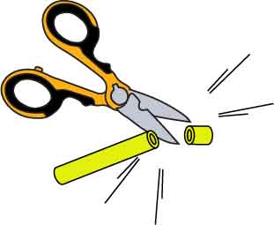

2x

Push & twist

**Ream** **the holes** between the hole plates.

Check out the [**Build Video**](https://vimeo.com/410370335) scanning the QR Code or going to [**teachergeek.com/sailcar**](https://www.teachergeek.com/sailcar)

9

8

7

6

5

**Add** **wheels** to the other side to finish your body.

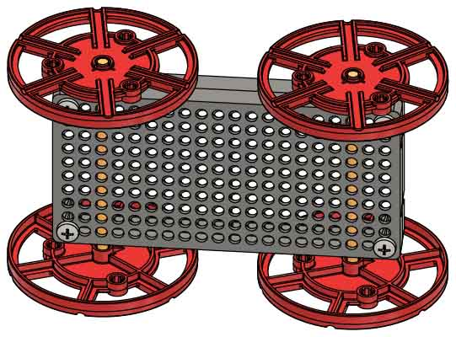

4

3

2

1

**It’s time for labs and/or challenges!** Complete one of the optional labs below or continue on to set up for the engineering challenge!

Place the **masts** **into** the Sail Car **body**. Then, tape on   
your sails.

The wheels should spin freely. If they don’t, repeat Step 3.

**Wiggle** or tap the 10 cm (4 in) **dowels** **into wheels.**

Download these labsat [**teachergeek.com/sailcar**](http://teachergeek.com/sailcar)

Optional Labs:

Build a Sail Car

[Wind Lab(Ages 3-8)](https://teachergeek.com/sailcar)

Versions: [Pre-K](http://teachergeek.org/sail_car_wind_lab_preK.docx) | [K-1](http://teachergeek.org/sail_car_wind_lab_k_1.docx) | [Gr 2-3](http://teachergeek.org/sail_car_wind_lab_2_3.docx)

[Push/Pull Lab (Ages 3-6)](https://teachergeek.com/sailcar)

Versions: [Pre-K](http://teachergeek.org/sail_car_push_pull_lab_preK.docx) | [K-1](http://teachergeek.org/sail_car_push_pull_lab_k_1.docx)

[Balanced Forces Lab](http://teachergeek.org/sail_car_balanced_forces_lab.docx)

[(Ages 8-11)](http://teachergeek.org/sail_car_balanced_forces_lab.docx)

[Forces & Motion Lab](http://teachergeek.org/sail_car_forces_&_motion_lab.docx)

[(Ages 12+)](http://teachergeek.org/sail_car_forces_&_motion_lab.docx)

[Inertia Lab](http://teachergeek.org/sail_car_inertia_lab.docx)

[(Ages 12+)](http://teachergeek.org/sail_car_inertia_lab.docx)

[Atwood’s Machine](http://teachergeek.org/half_atwoods_lab.docx) Lab  
(Ages 14+)

[Momentum](http://teachergeek.org/sail_car_momentum_lab.docx) Lab  
(Ages 14+)

SKIP IF YOU’RE USING A SINGLE KIT  
(this step has been done for you).

**Slide** the **wheels** with dowels **into** **the** **holes** between the holeplates.

**Attach two hole plates** by driving **screws** into their corners.

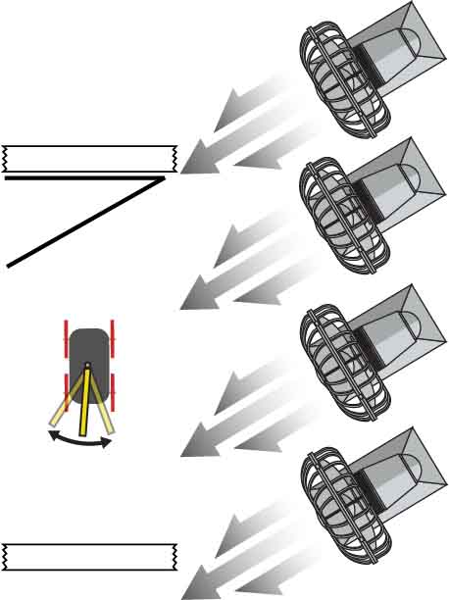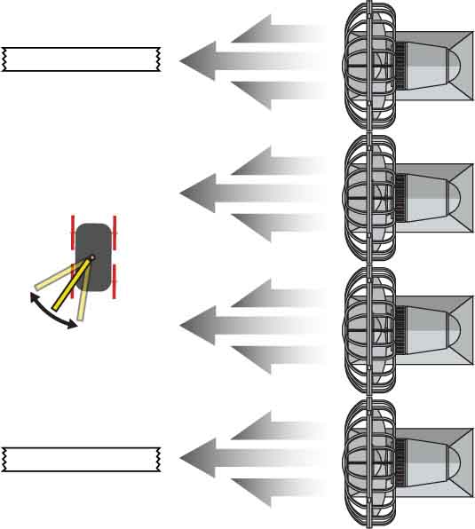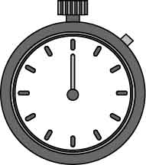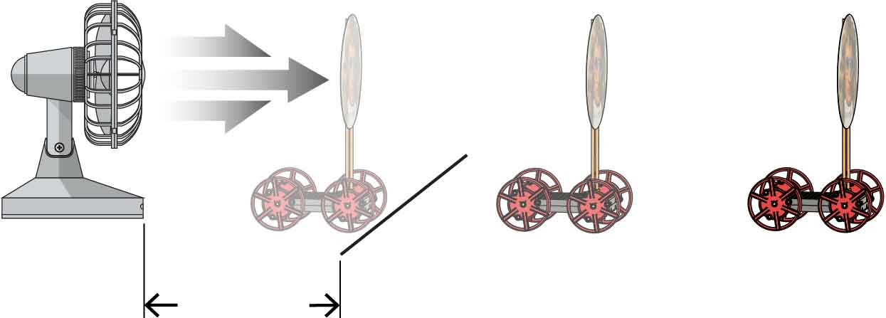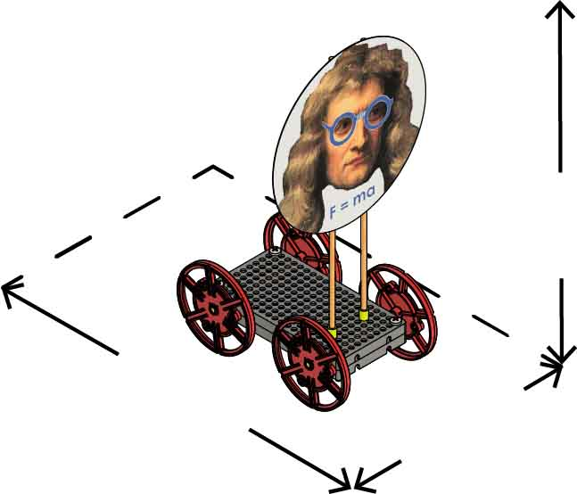

Place fans along each side of your track to create a crosswind or headwind.

Crosswind:

**30º**

Headwind:

Add start and finish lines (tape).   
Be sure that the wind blows continuously from before the start to after the finish.

Your sail car must travel down the track in the shortest time.

Try different sail angles.

START

START

FINISH

FINISH

**45 cm**(18 in)

**Max Length**

**30 cm**(12 in)

**Max Width**

**Unlimited**

**Max Height**

Dimensions:

There is no limit on recycling materials.

Components:

You may only use the TeacherGeek components listed on Page 1.

Set down your fan, then mark your start line using a piece of tape.

**Start**

**60 cm**  
(2 ft)

Use a piece of tape to mark your farthest distance.

Leave as much room as possible for your track. Sail cars can go 10 m (30 ft) on uncarpeted areas (less on carpeting).

Do not move the fan during competition.

Tailwind Challenge

Check out [**Challenge Videos**](https://vimeo.com/410371528)by scanning the   
QR Code or going to [**teachergeek.com/sailcar**](https://www.teachergeek.com/sailcar)



(rules and limits for your design)

Constraints:

Optional Challenges:

How far can you make your sail car go?

Variables

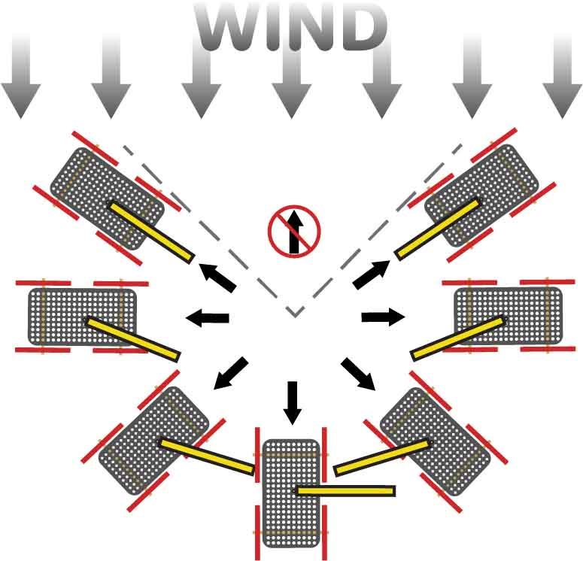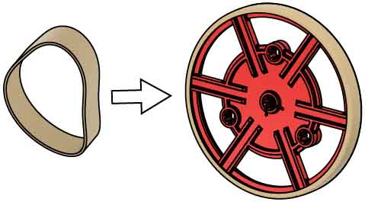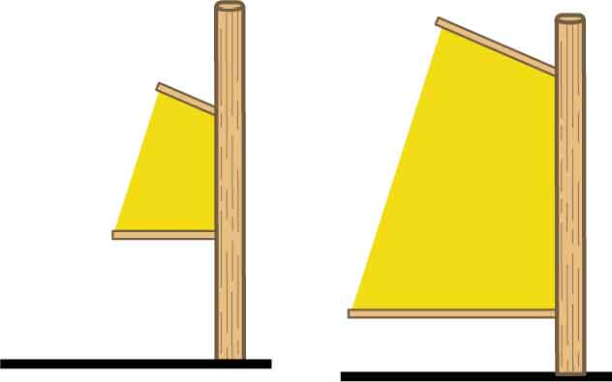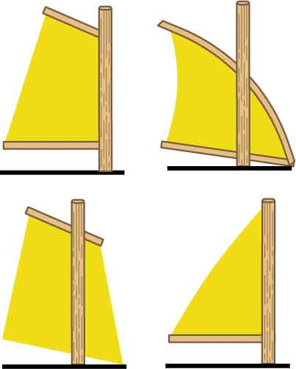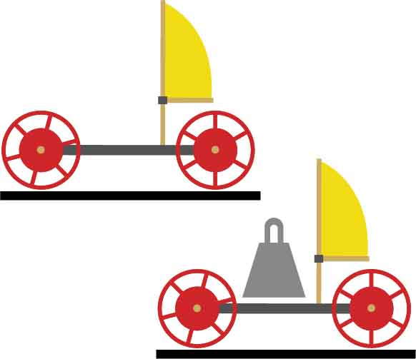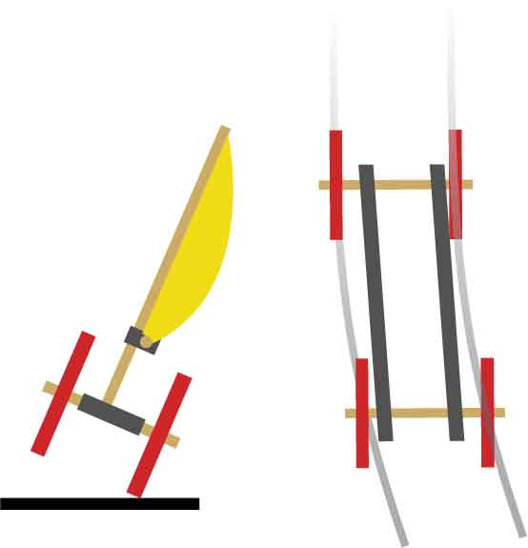

## Design

## Process

## Design

## Redesign

## Test

## Evaluate



**Friction**  
Friction can be your friend (traction) or your enemy (axle sticking). Rubber bands, wax (crayons), and graphite (pencil “lead”) can be used to change friction.

**Sail Shape**  
Different shapes interact with the wind in different ways. Each shape has its own strengths   
and weaknesses.

**Sail Angle**  
Changing the sail angle also allows you to adapt to different wind directions.

**Inertia**  
More mass means your racer needs more wind force   
to move, but also more air resistance to slow down.

F=ma

Can’t sail into the wind

**Sail Size**   
Bigger sails will harness more energy from the fan/wind, but they also create more air resistance.

**Frame**   
The dimensions of   
your frame and the location of the sail have big effects on the stability and tracking of   
your racer.

**Stability** Does it stay up?

**Tracking**  
Does it go straight?

The Design Process never ends! There is no perfect design.

Tire rubber bands can be added to wheels to give more traction.

Experiment with your sail

Experiment with your car

Historical Vessels

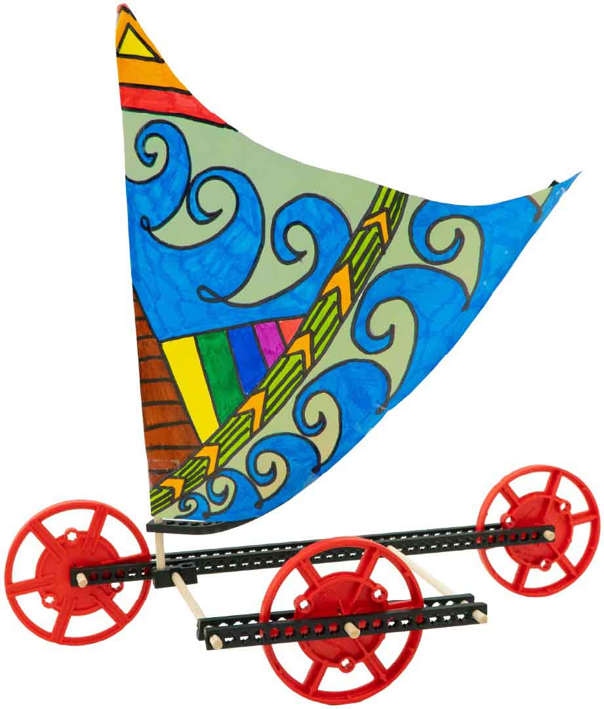 ­­­

**Dhows** have been used for thousands of years as trading vessels along the coasts   
of Arabia, East Africa, and India,   
where they are believed   
to have originated.

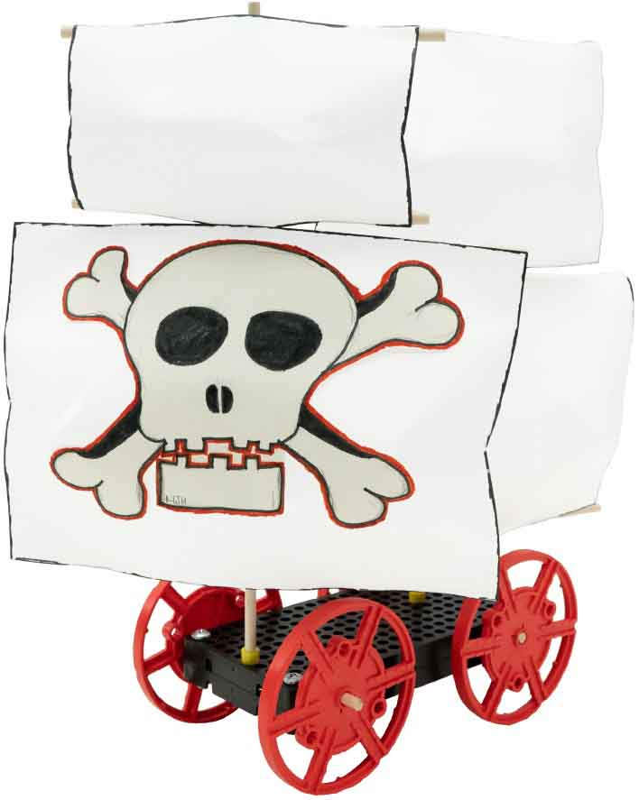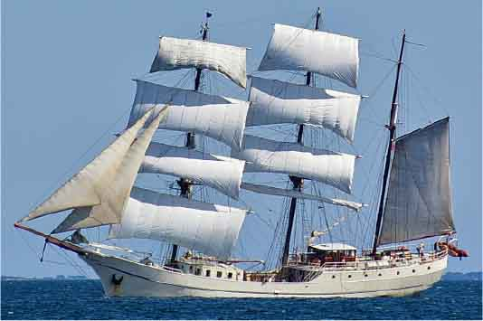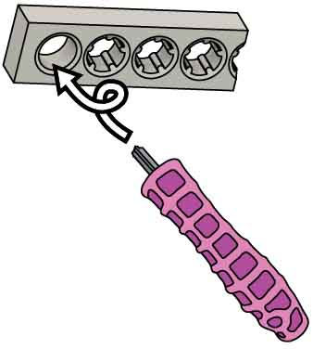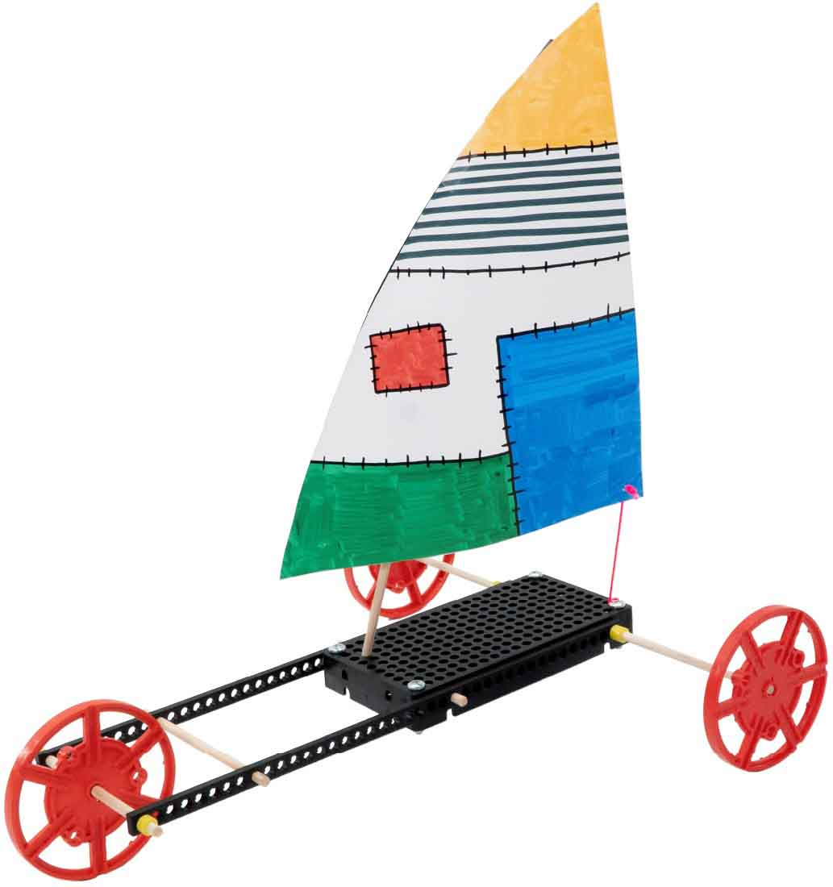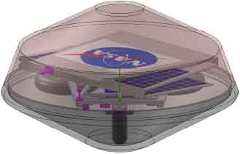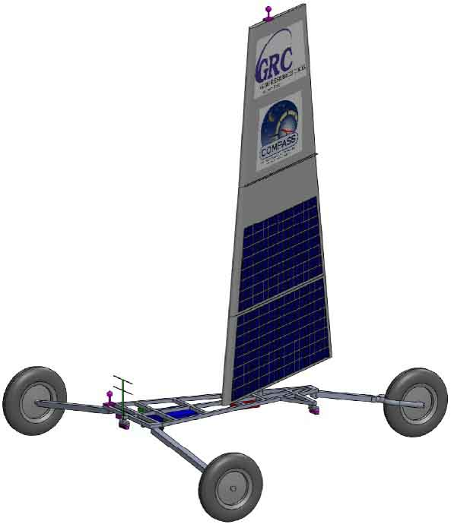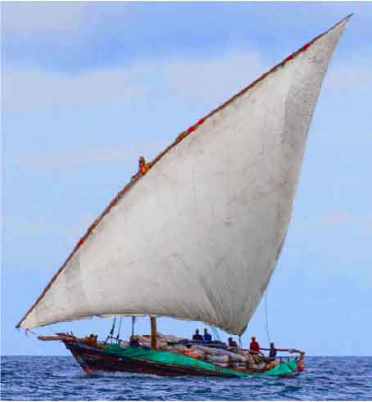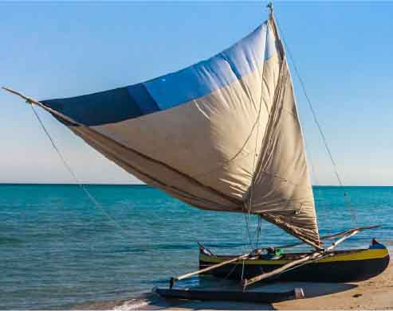

**Brigs** were popular among   
Europeans in the 18th & 19th   
centuries due to their speed   
and maneuverability.   
They were often used   
by pirates, merchants,   
and navies.

Push & Twist

Ream the teeth out of holes to let dowels spin freely.

**Sail into the Future**

**The Zephyr Venus Landsailer** was designed by NASA to explore Venus. Its main source of propulsion   
is its sail, which is covered   
in solar panels to power   
the steering systems and   
scientific equipment.   
The vessel folds into a   
protective shell   
for landing.

**Outrigger** **Canoes** are fast and maneuverable. Developed in the islands   
of South East Asia, Pacific Islanders used them to settle the islands of Oceana as far as Hawaii.