­

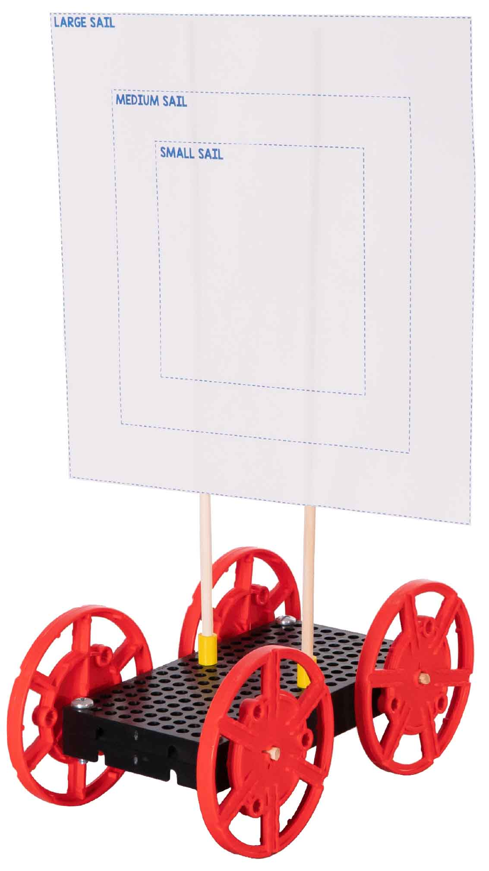

Name:_________________________________



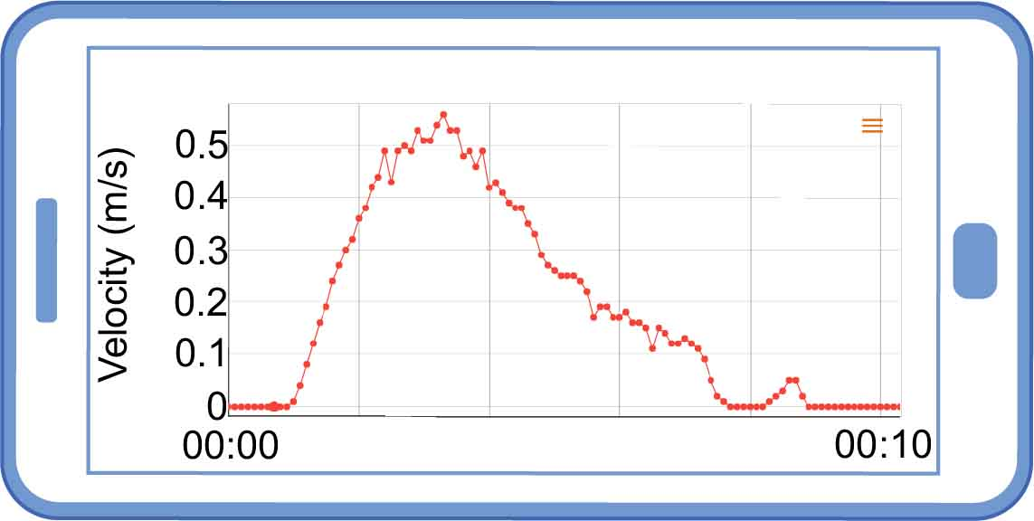

Check out our [**Lab Set-up Video**](https://vimeo.com/407113491) by scanning the QR Code or going to [**teachergeek.com/sailcar**](https://www.teachergeek.com/sailcar)

**Learn about the drag force.**

**Then use it to make the best sail car!**

Build the Sail Car using the **Go Guide**, available at [**teachergeek.com/sailcar**](https://teachergeek.com/sailcar)

Get a PocketLab at [**thepocketlab.com**](https://thepocketlab.com)

The PocketLab must be paired with a compatible laptop, Chromebook, tablet, or phone.

**PocketLab  
Sensor**

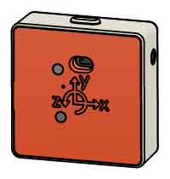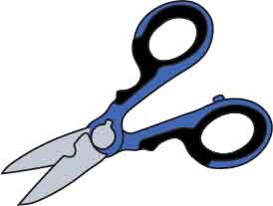

**Scissors**

**Tape**

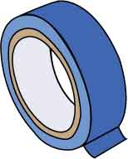

**Fan**

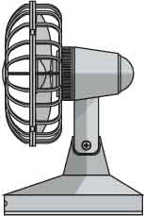

**“Built” Sail Car**

v

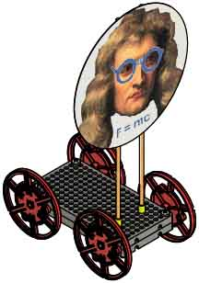



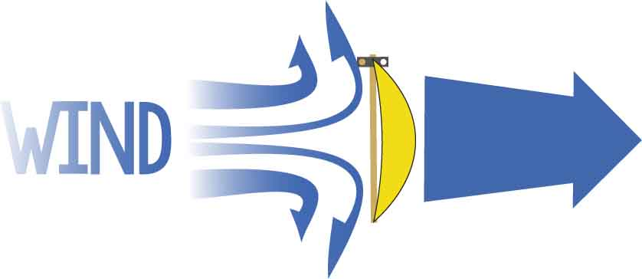

DRAG

**SAIL**

***Drag*** is the force of the wind pushing your sail car. Forces like drag change your car’s velocity.

**How does drag affect the motion of your car?**

Cut out the 3 sails on the last page of this guide, or make your own. If making your own sails, the same shape but different sizes.

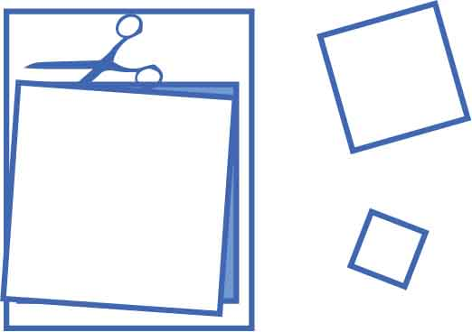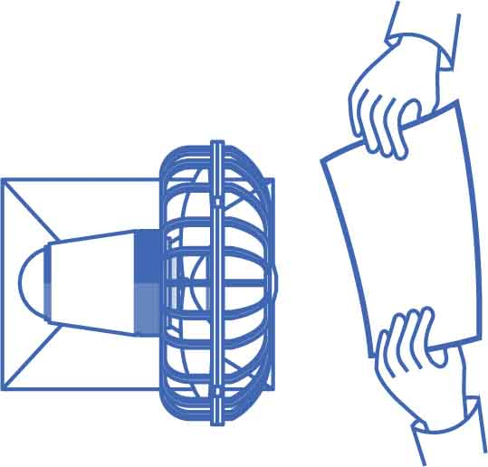

Now hold the largest sail still in front of the fan.

Is the drag force speeding up or slowing down your sail?



Wave the largest sail through the air.

Is the drag force speeding up or slowing down your hand?



Move the sail farther from the fan.

What happens to the drag force as distance increases?

Move from very close to very far.



Use the fan to compare the differently sized sails.

Which sail has the most drag?



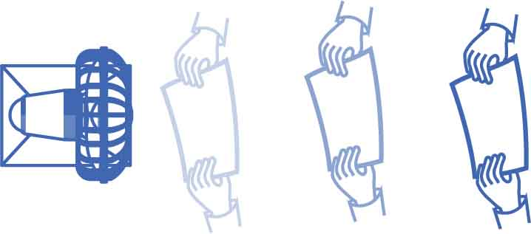

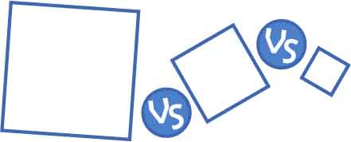



Close to the fan, the wind moves faster than your car, so drag speeds up your car.

Your car will eventually go the same speed as the wind, so there is no drag.

Far from the fan, the wind slows down more than your car, so drag will slow your car.

GOOD DRAG

NO DRAG

BAD DRAG

speeds you up!

no effect…

slows you down!

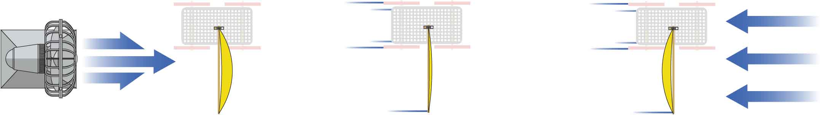

**Overall, will more drag make your car faster or slower?**



**You are going to use a PocketLab to test drag. But first, let’s see how PocketLab works.**

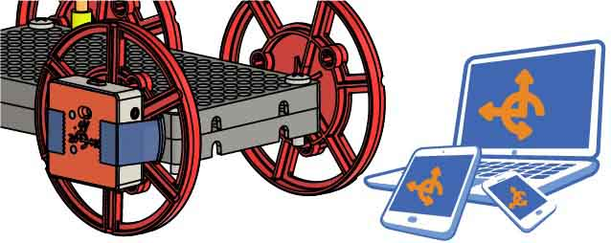



Set up your PocketLab.



Play with your car! Then match the descriptions to the graphs**.**

1.

2.

3.

4.

5.

Velocity

Time

0

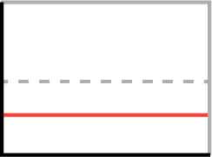

Velocity

Time

0

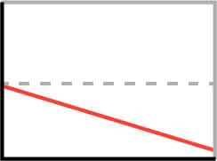

Velocity

Time

0

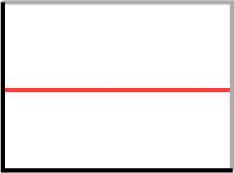

Velocity

Time

0

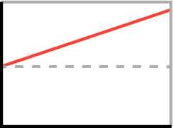

Velocity

Time

0

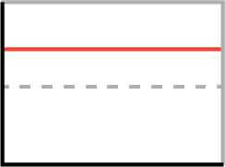

______Not moving



______Moving forward with constant speed



______Moving backward with constant speed



______Moving forward and speeding up



______Moving backward and speeding up



Describe the motion this graph represents.

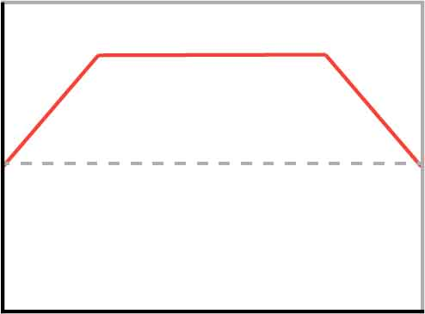

Velocity

Time

0

It starts by _____________ ________________  
Then it ______________ _________________  
Lastly, it ______________ ________________



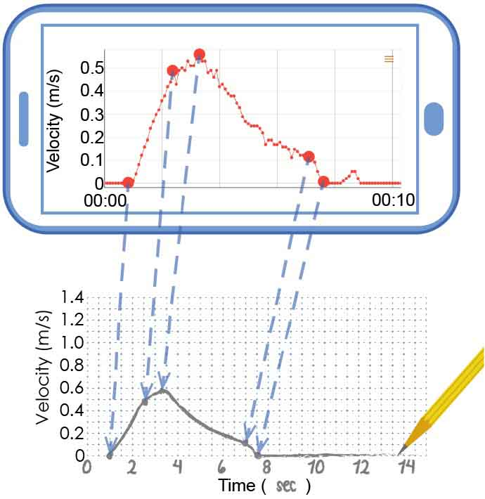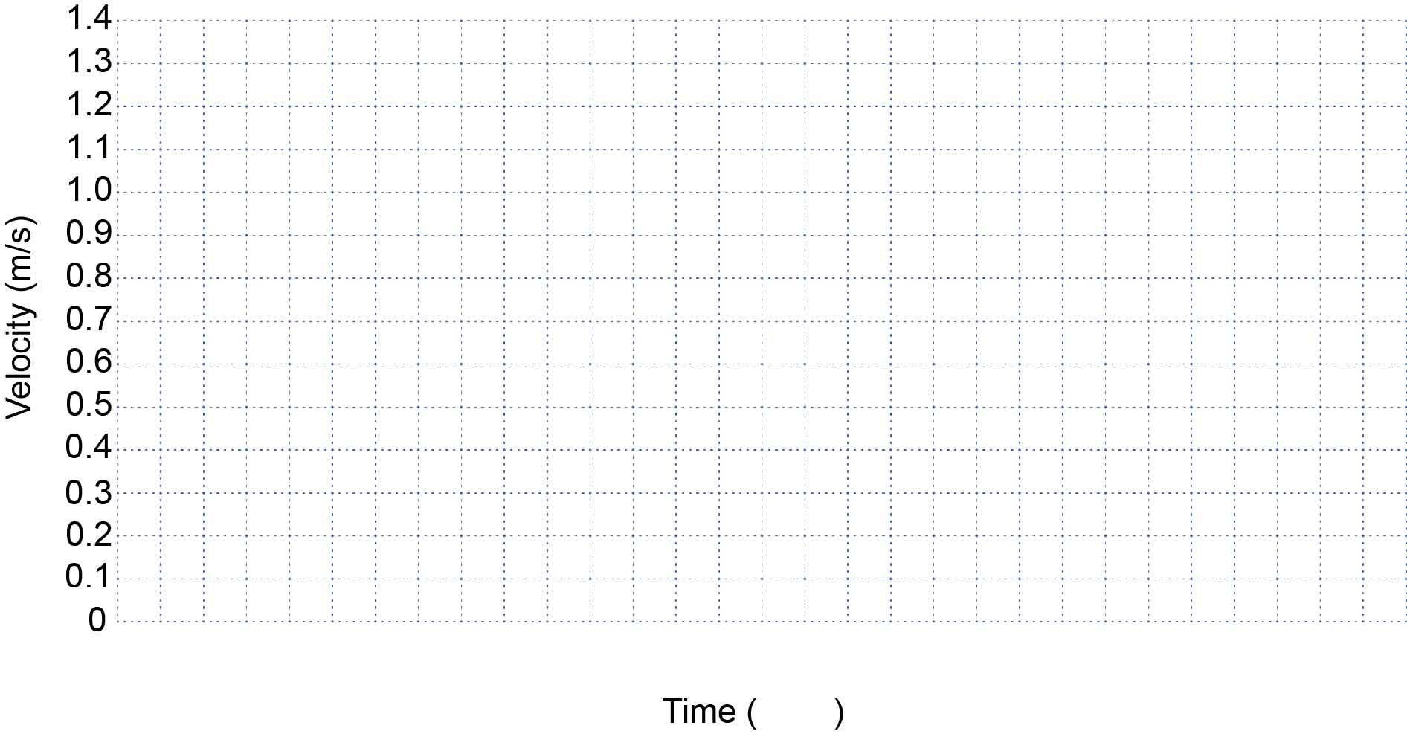

Using your smallest sail, sail your car down the track. Record the data on the PocketLab.

|  |  |  |
| --- | --- | --- |
| **Independent Variable(s)** | **Dependent Variable(s)** | **Control Variable(s)** |
|  |  |  |

What variables do you need to keep track of?

Transfer your PocketLab’s velocity graph to the axes below. The graph doesn’t need to be perfect, but you should transfer over important points and match the general shape.

**How does changing drag affect your car’s velocity? Set up an experiment to find out!**

Get data for the other sails and graph them on the same axes. Fill in the legend so you can tell one experimental condition from the other.

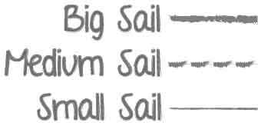

**Legend**

EXAMPLE

**Legend**





Circle all the forces acting on the sail car.

1. Drag pushing forward

2. Drag pushing backward

3. Hand holding the car

4. Gravity pulling car down

5. Ground pushing car up



If you increased the size of the car’s sail, how would this part of the graph change? Use your car’s data from p. 4 to justify your answer.  
____________________________________________________________________________________________________________________________________________________________________



Name any unbalanced forces acting on the car and explain how you know the forces are balanced/unbalanced.

____________________________________________________________________________________________________________________________________________________________________



Circle the choice that best describes the sail car’s motion.

1. Constant velocity

2. Speeding up

3. Not moving

4. Slowing down



**Answer the questions below referencing the circled part of the graph.**

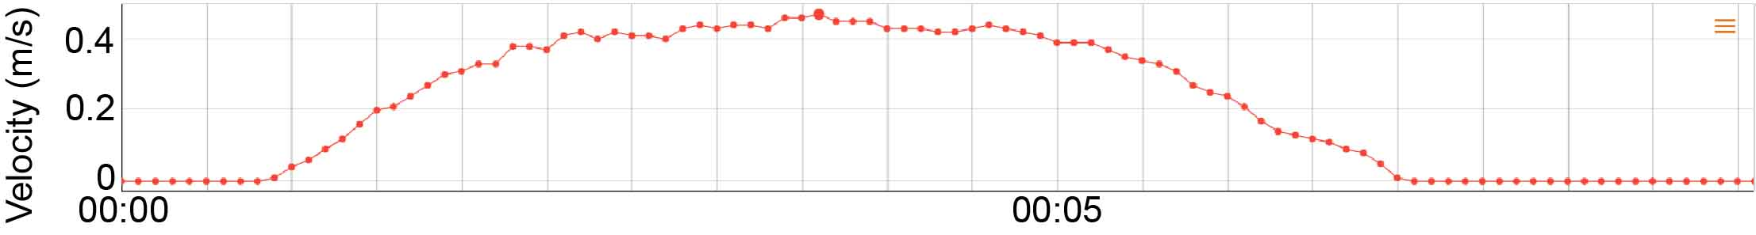

These questions focus on   
the circled part of this graph.

**What does your data tell you about drag? About forces and motion?**



If you increased the size of the car’s sail, how would this part of the graph change? Use your car’s data from p. 4 to justify your answer.  
____________________________________________________________________________________________________________________________________________________________________



Name any unbalanced forces acting on the car and explain how you know the forces are balanced/unbalanced.

____________________________________________________________________________________________________________________________________________________________________



Circle all the forces acting on the sail car.

1. Drag pushing forward

2. Drag pushing backward

3. Hand holding the car

4. Gravity pulling car down

5. Ground pushing car up



Circle the choice that best describes the sail car’s motion.

1. Constant velocity

2. Speeding up

3. Not moving

4. Slowing down



**Answer the questions below referencing the circled part of the graph.**



These questions focus on   
the circled part of this graph.



**Answer the questions below referencing the circled part of the graph.**



These questions focus on the circled part of this graph.

Name any unbalanced forces acting on the car and explain how you know the forces are balanced/unbalanced.

____________________________________________________________________________________________________________________________________________________________________



Circle all the forces acting on the sail car.

1. Drag pushing forward

2. Drag pushing backward

3. Hand holding the car

4. Gravity pulling car down

5. Ground pushing car up



Circle the choice that best describes the sail car’s motion.

1. Constant velocity

2. Speeding up

3. Not moving

4. Slowing down



If you increased the size of the car’s sail, how would this part of the graph change? Use your car’s data from p. 4 to justify your answer.  
____________________________________________________________________________________________________________________________________________________________________





**Answer the questions below referencing the circled part of the graph.**



These questions focus on the circled part of this graph.

If you increased the size of the car’s sail, how would this part of the graph change? Use your car’s data from p. 4 to justify your answer.  
____________________________________________________________________________________________________________________________________________________________________



Circle the choice that best describes the sail car’s motion.

1. Constant velocity

2. Speeding up

3. Not moving

4. Slowing down



Circle all the forces acting on the sail car.

1. Drag pushing forward

2. Drag pushing backward

3. Hand holding the car

4. Gravity pulling car down

5. Ground pushing car up



Name any unbalanced forces acting on the car and explain how you know the forces are balanced/unbalanced.

____________________________________________________________________________________________________________________________________________________________________





**What patterns did you see, and how will they help you build a better sail car?**



What is drag, and how is it related to sail size?  
____________________________________________________________________________________________________________________________________________________________________



What size sail are you going to put on your sail car? Why?  
______________________________________________________________________________________________________________________________________________________________________________________________________________________________________________________

How does drag affect the motion of your sail car?  
_____________________________________________________________________________________________________________________________________________________________________________________________________________

**SMALL SAIL**

**MEDIUM SAIL**

**LARGE SAIL**