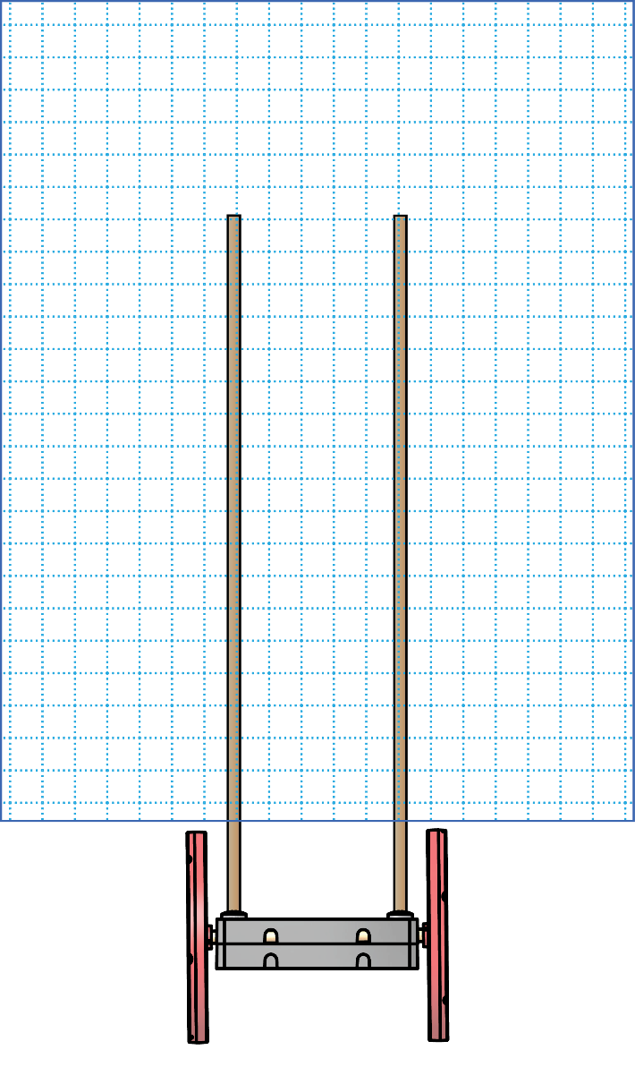

Design _____

Design _____

Design _____

**Test it.**  Circle how **far** it went.

**Test it.**  Circle how **far** it went.

**Test it.**  Circle how **far** it went.

**Draw it.**

**Make it.**

**Draw it.**

**Make it.**

**Draw it.**

**Make it.**

|  |  |  |  |  |
| --- | --- | --- | --- | --- |
| 1 | 2 | 3 | 4 | 5 |
|  |  |  |  |  |
| 6 | 7 | 8 | 9 | 10 |

|  |  |  |  |  |
| --- | --- | --- | --- | --- |
| 1 | 2 | 3 | 4 | 5 |
|  |  |  |  |  |
| 6 | 7 | 8 | 9 | 10 |

|  |  |  |  |  |
| --- | --- | --- | --- | --- |
| 1 | 2 | 3 | 4 | 5 |
|  |  |  |  |  |
| 6 | 7 | 8 | 9 | 10 |

pRe-K

eNgInEeRiNg NoTeBoOk

SaIl CaR

© TeacherGeek Inc. Permission granted for editing and printing to schools, libraries and non-profits. Materials for this activity at teachergeek.com. Adult supervision required for children under 12.

Name:____________________________________________________________