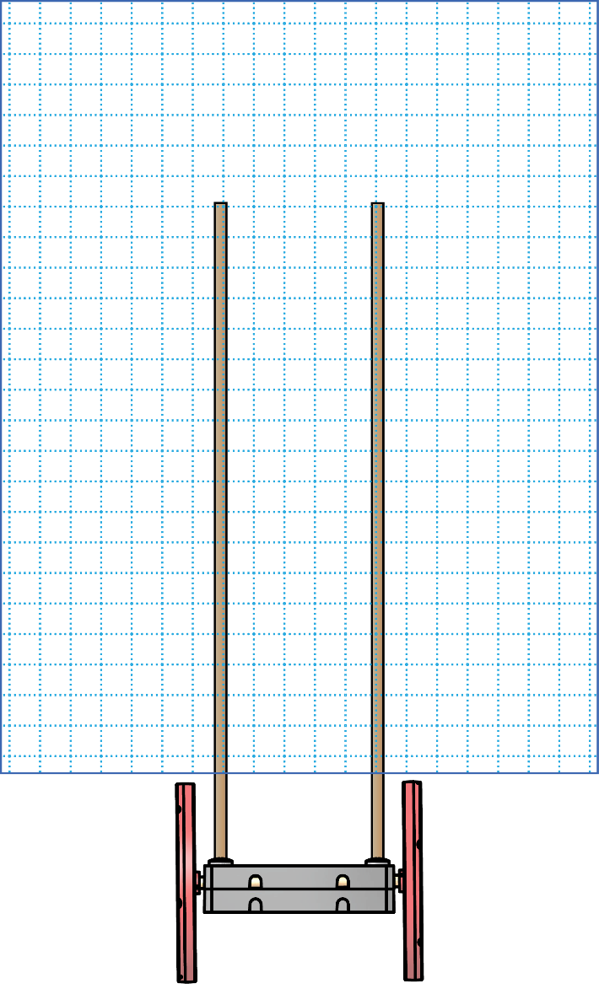

**Test it.**  Write how **far** it went.

Design _____

**Draw it.**

**Make it.**



**Test it.**  Write how **far** it went.

Design _____

**Draw it.**

**Make it.**



**Test it.**  Write how **far** it went.

Design _____

**Draw it.**

**Make it.**

© TeacherGeek Inc. Permission granted for editing and printing to schools, libraries and non-profits. Materials for this activity at teachergeek.com. Adult supervision required for children under 12.

Name:____________________________________________________________

eNgInEeRiNg NoTeBoOk

SaIl CaR

K-3