THE CHALLENGE



Check out our immersive challenge videos by scanning the QR Code or going to [**teachergeek.com/sailcar**](https://www.teachergeek.com/sailcar)

Make the fastest sail car   
that goes across the wind!



Follow the instructions below to set up your track. Then have kids design, test, and redesign sails for their cars, seeing whose sail car can go down the track in the shortest time!

TRACK SETUP

Fans will only run along the edge of your track. Place fans next to each other so they are nearly touching. The more fans you have, the longer your track will be.

Mark your start and finish lines near the middle of the first and last fans. Wind needs to hit the sail before the start line and after the finish line or else your car won’t start/finish.

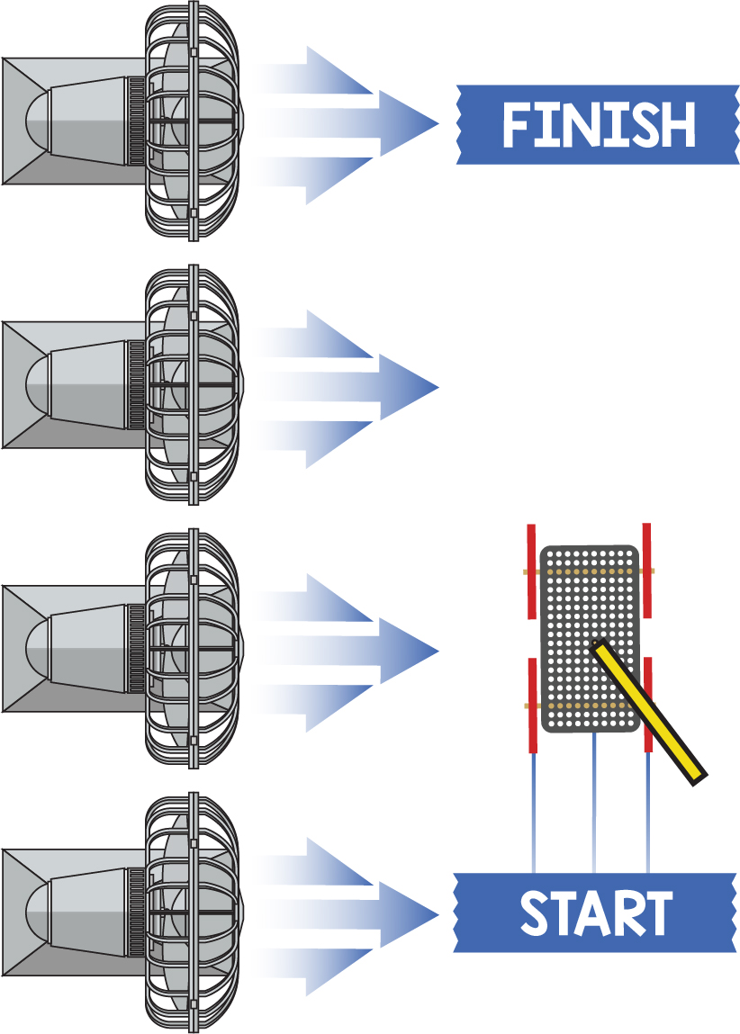

Use a stopwatch to determine whose sail car is the fastest.



Design Tip

Experimenting with the **angle of the sail is crucial** to sailing across the wind. **Start with a 45° angle** and adjust from there.