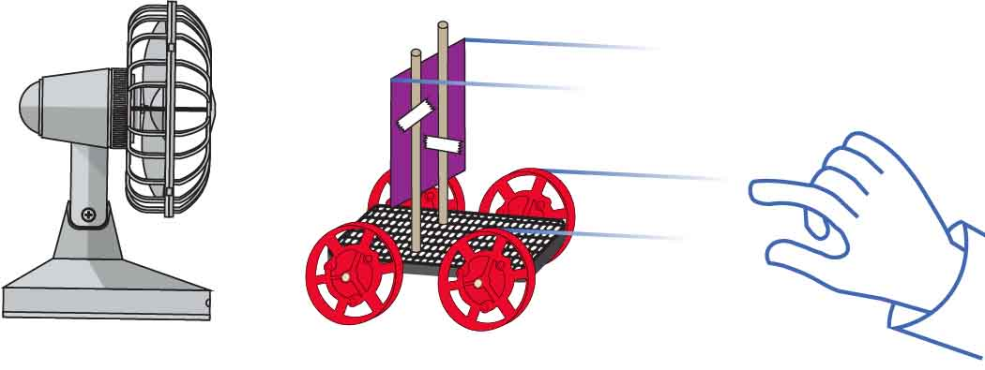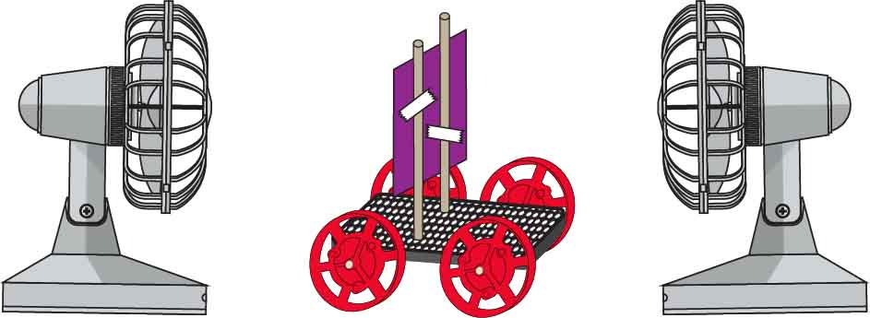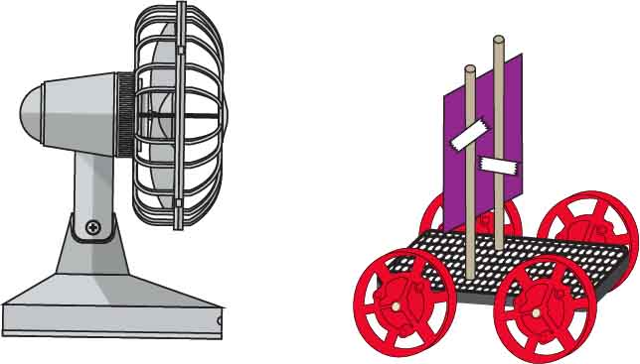

Check out the [**Lab Set-Up Video**](https://vimeo.com/406294734) by scanning the   
QR Code or going to [**teachergeek.com/sailcar**](https://www.teachergeek.com/sailcar)

Put your car in the middle of two fans blowing in opposite directions. What happens?

|  |  |
| --- | --- |
| **CAUSE** | **EFFECT** |
|  |  |

|  |  |
| --- | --- |
| **CAUSE** | **EFFECT** |
|  |  |

Roll your sail car towards the fan. What happens?

|  |  |
| --- | --- |
| **CAUSE** | **EFFECT** |
|  |  |

Test it out! Put your sail car in front of a running fan.

What happens to the sail car?

**Sails capture the force of the wind.**

Name:________________________________________

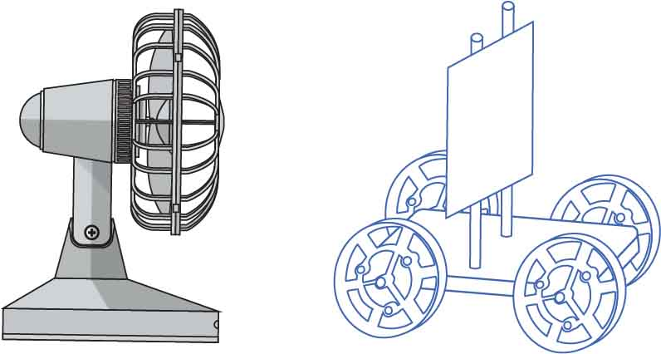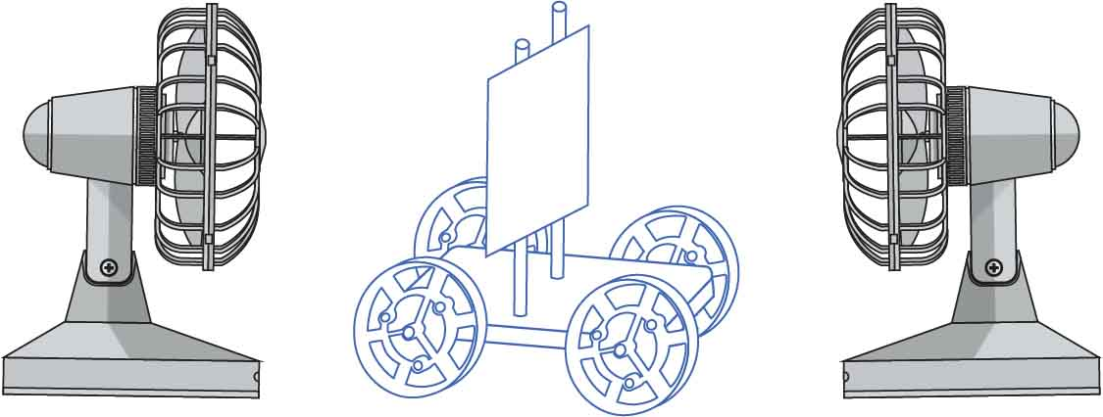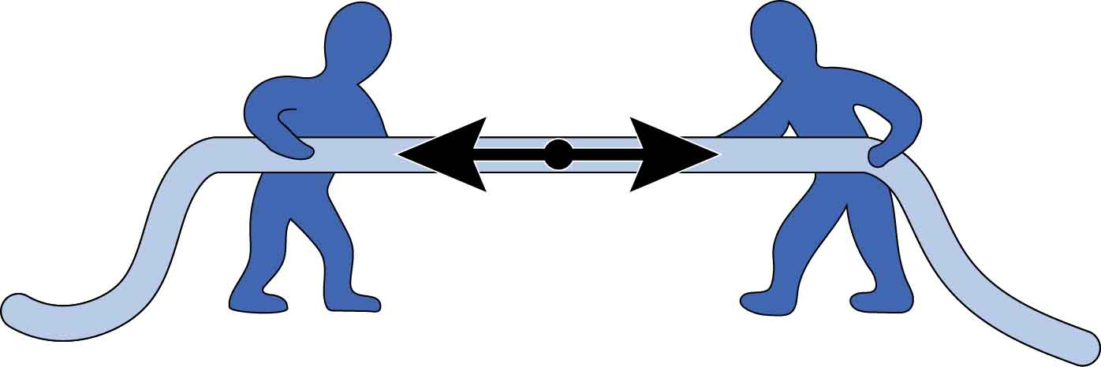

These forces are balanced because they are the push/pull against each other and undo each other.

Force diagrams are used to show what forces are pushing and pulling on objects, like your car.

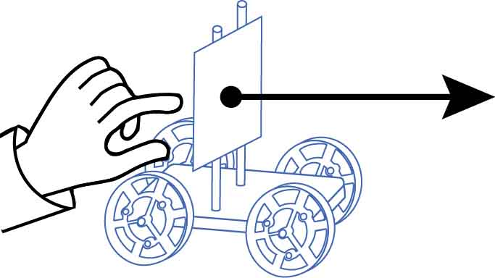

push to the right

force arrow to the right

Example:

**Are the forces balanced?**

**Are the forces balanced?**

YES NO

YES NO

Add arrows to these force diagrams to represent the forces on your car.

Diagram 2

Diagram 1

Balanced Forces



Your car is **aerodynamic** if it can catch good wind without catching bad wind.

You are going to use two fans to test your sail car’s aerodynamics.

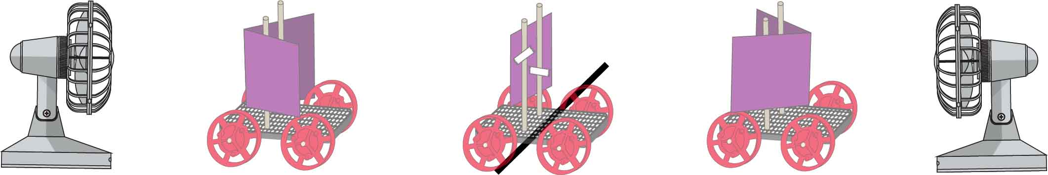

bad wind stronger

wind forces balanced

good wind stronger

**FRONT**

**BACK**

MORE AERODYNAMIC

Wind from the front slows your sail car down.



When your car is moving fast, it will feel wind from the front, just like when you put your hand out a car window.

Bad Wind

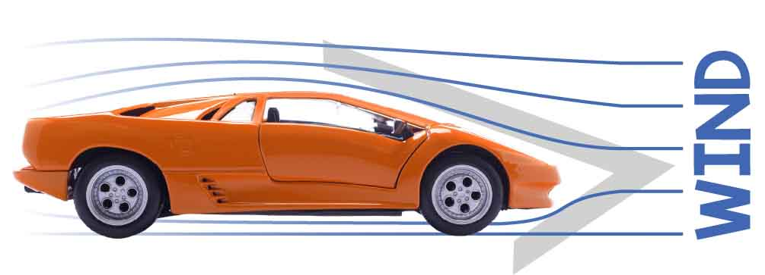

The V-shape of this Lamborghini cuts through the air like a knife, so it doesn’t catch bad wind.

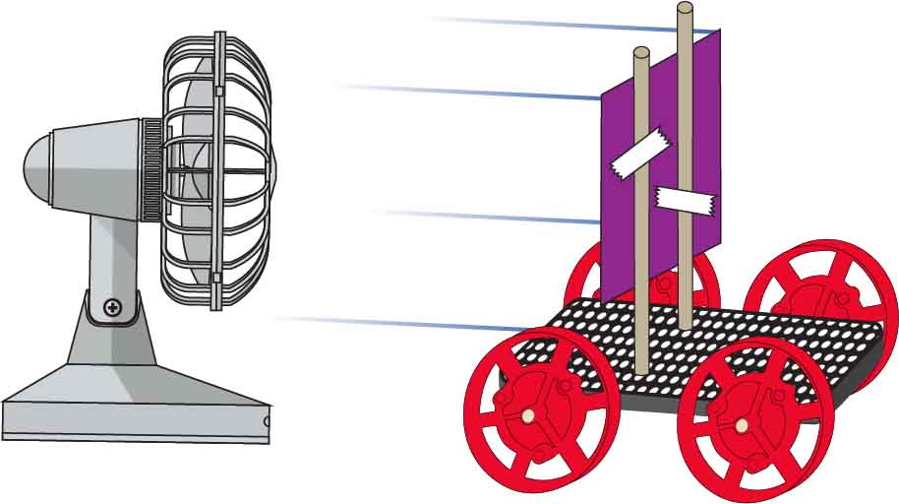

Wind from behind your sail car makes it go faster!

Good Wind

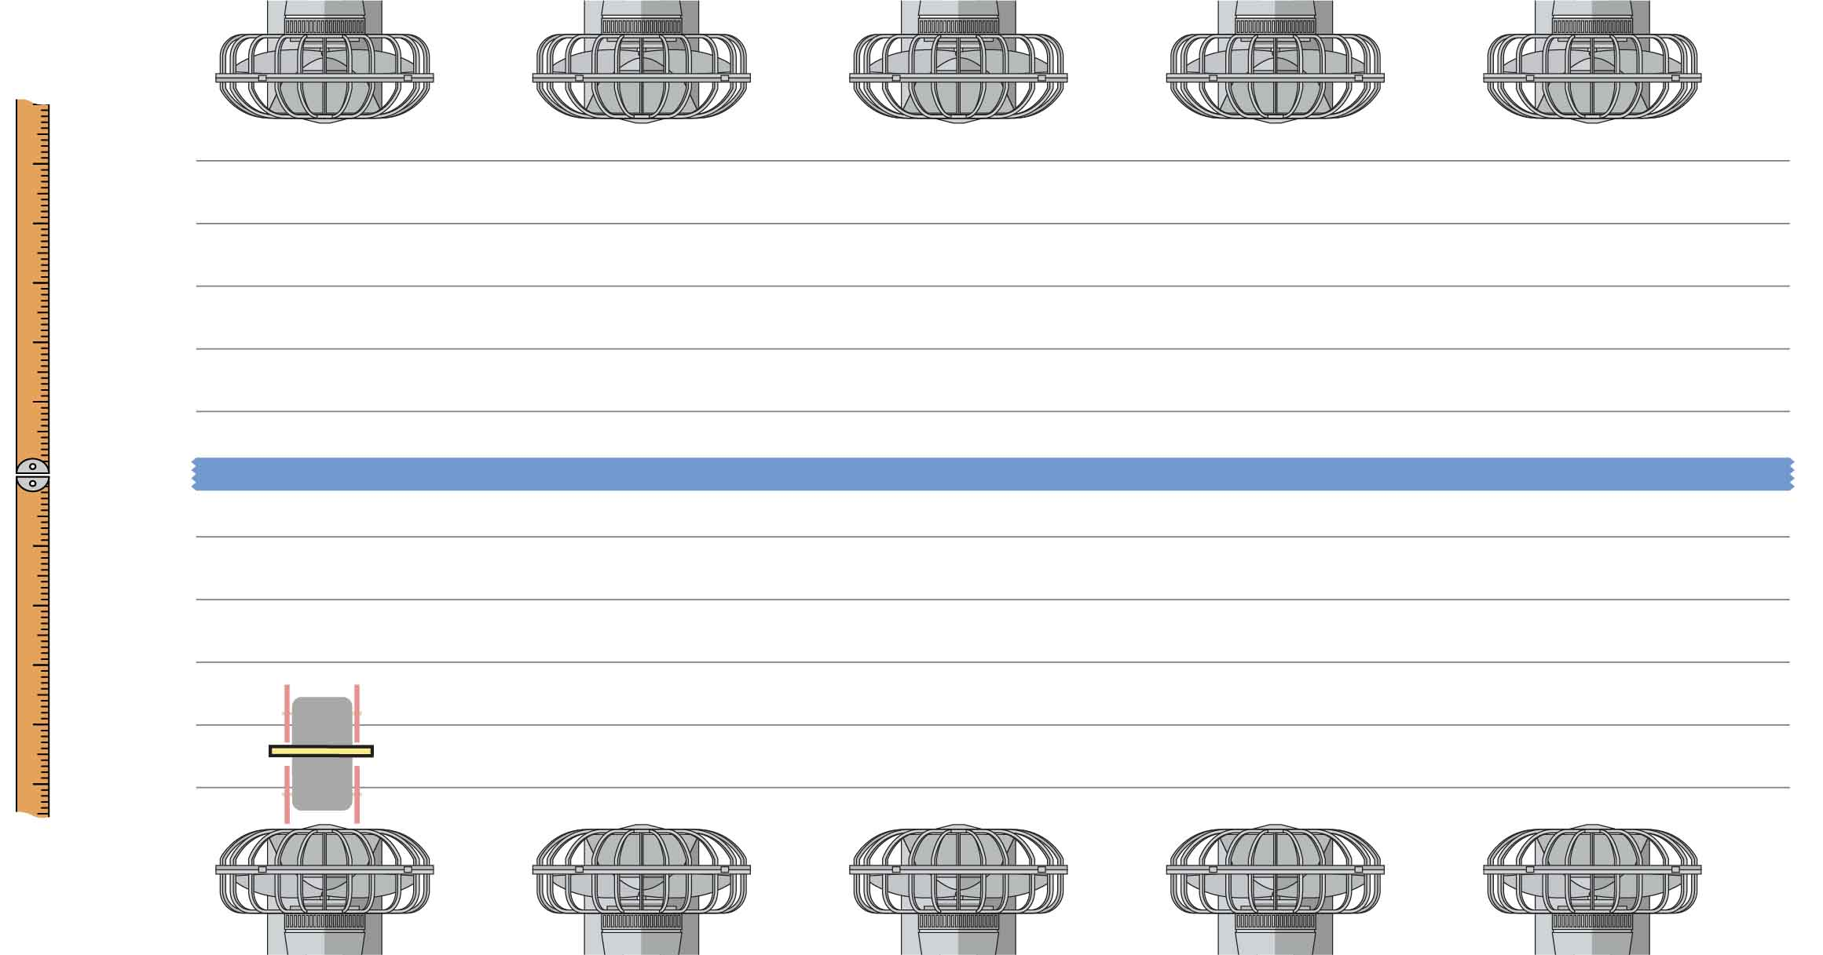

Tape

Always start with your car against the back fan.

Test the sails below, then design some of your own to test!  
For each design, graph an X where your sail car stops.



50 cm  
40 cm  
30 cm  
20 cm  
10 cm  
0 cm  
-10 cm  
-20 cm  
-30 cm  
-40 cm  
-50 cm

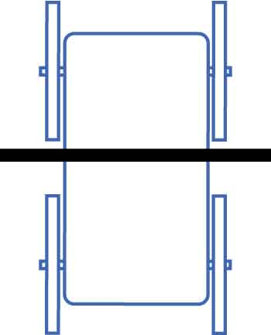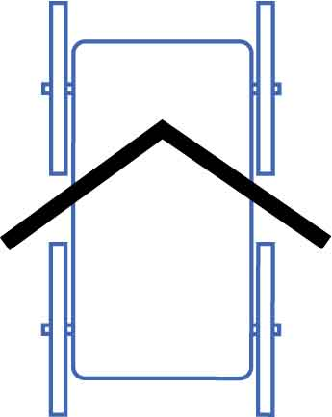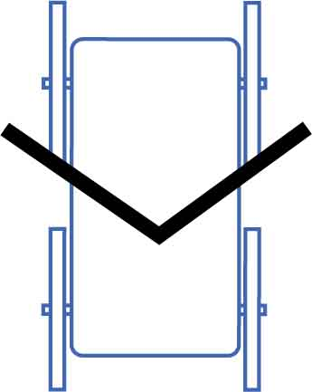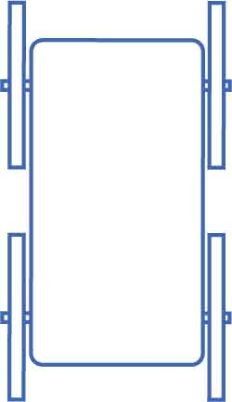

your first design

your best design

What shape sail will you put on your car? Why?

____________________________________________________________________________________________________________________________________________