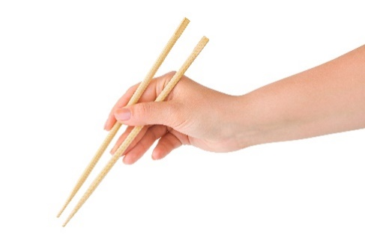

Name(s): **_____________________________________________________**



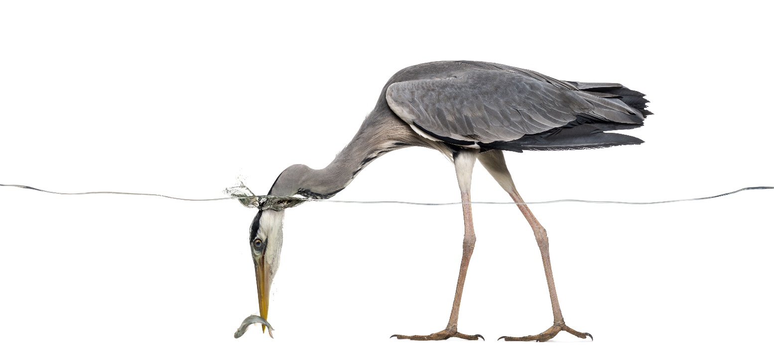  
  
Have you ever seen a bird catch a worm   
or a chipmunk stuff their cheeks?   
How do they do it? Animals have   
**evolved** some amazing grippers   
and grabbers over time.

A heron’s beak grips delicately and precisely – like chopsticks!



Heron beaks   
grip and poke

Sharp,   
flexible  
talons



**Tools & Traits**

A **tool** is an object that helps us complete a task. A hammer tap-taps nails into place, while a toothbrush freshens our mouths. Animals are born with their own tools, physical **traits** that help to hunt, fly and survive. These traits are passed on from parent to child and are unique to each **species**, or type, of critter.

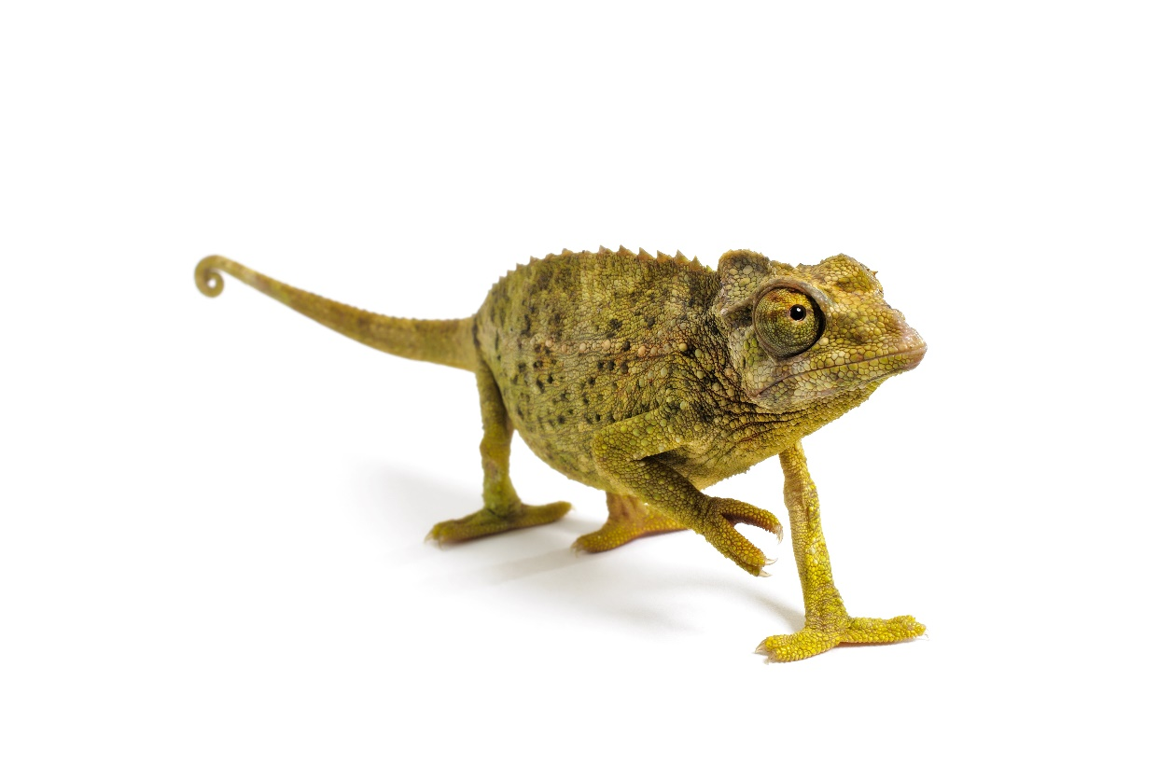****

**Match the Chameleon’s   
Unique Physical Traits:**  
  
Camoflaged Skin

Gripping Feet

Flexible Tail

**B**



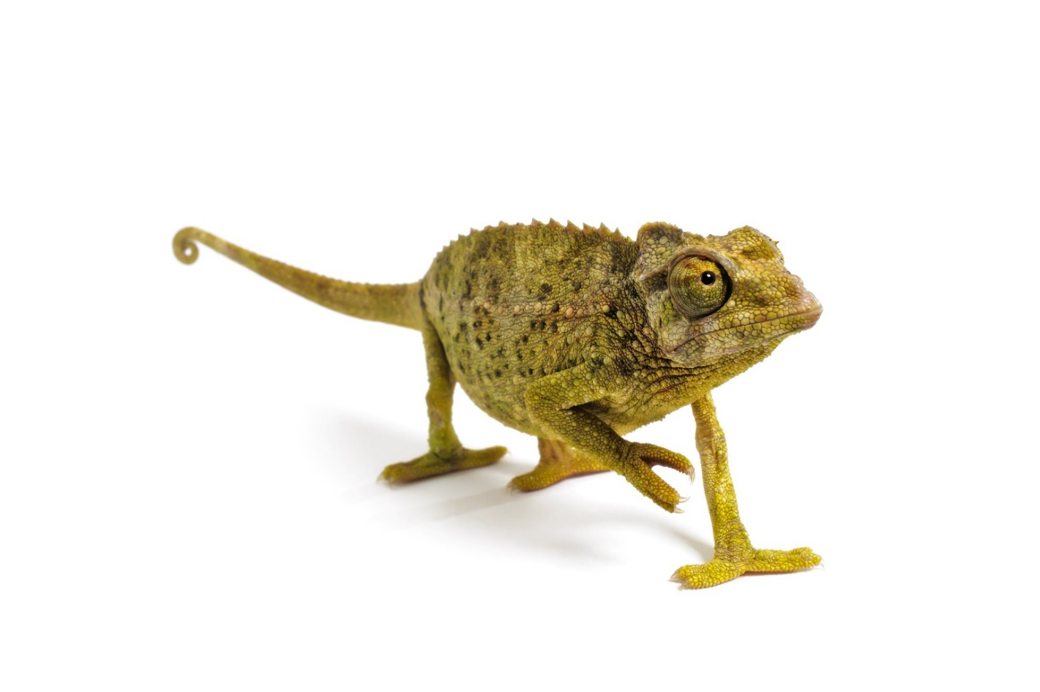

**A**



**C**

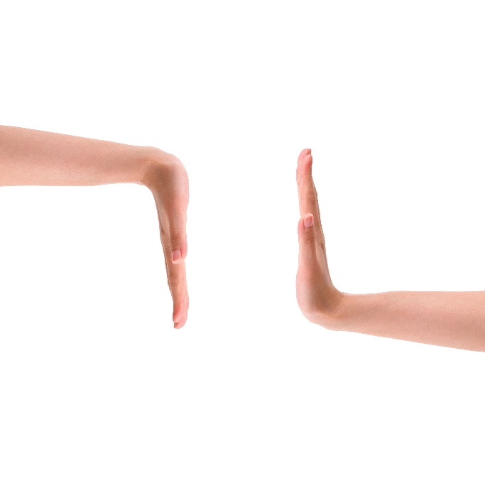

A force is a push or a pull that moves an object.

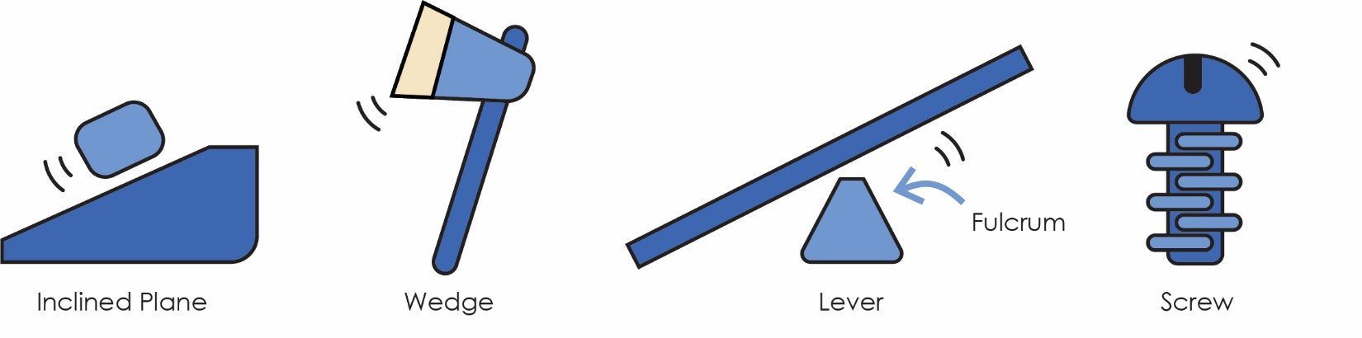**Simple Machines:** a device that provides a **force**.

**Compound Machines:** a device consisting of two or more simple machines.  
Scissors, wheelbarrows and your Reacher are types of **compound machines.**

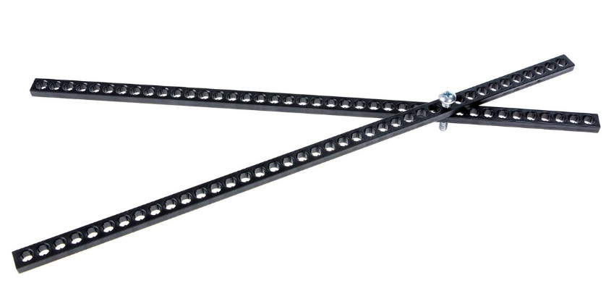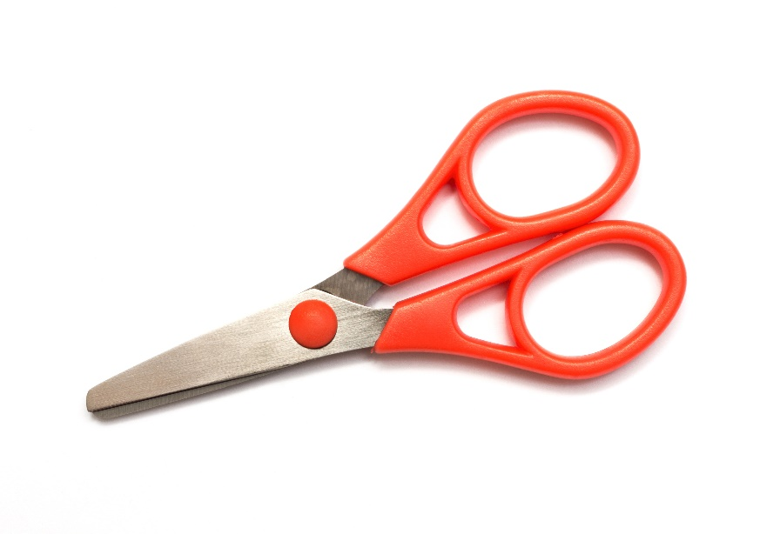

Lever

Fulcrum  
(Screw)



**B**





**A**

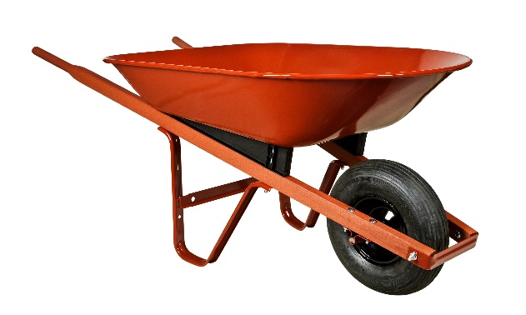

**Match the Scissors to the  
Simple Machine Labels**  
  
Lever  
  
Fulcrum



Lever

Wheel & Axle

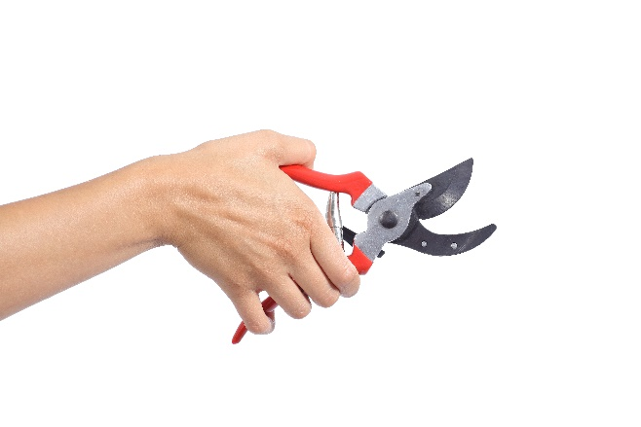

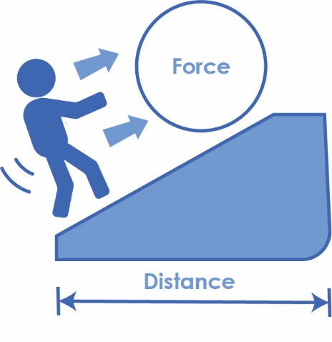What work have you done today? We don’t mean homework.  
**Work** occurs when a **force** applied to an object causes the object to move.  
  
How can you work, better?   
Using **simple machines** to trade a   
smaller amount of **force** over a greater   
**distance** creates a **mechanical advantage**,   
and makes your work more **efficient** (faster and easier)!

**Work = Force x Distance**

**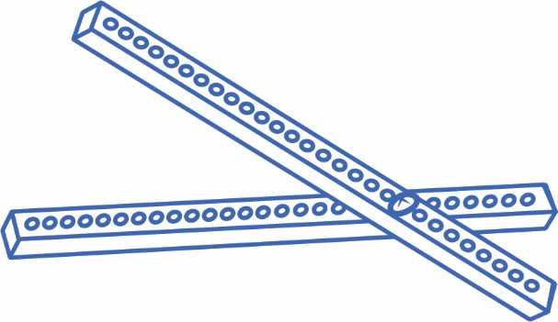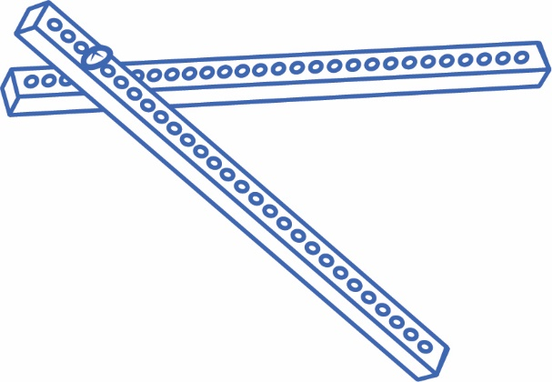  
 … Now You Try!**

Fulcrum  
(pivot point)

Change the **fulcrum** (pivot point) on   
your Reacher to make a long handle.

Change the **fulcrum** (pivot point) on   
your Reacher to make a short handle.



**B**

**A**

****Use your **Reacher** to pick up an object (e.g. marshmallow) in each position.   
*Which one made your work easier? Why?*  
   
 ___________________________________________________________________

___________________________________________________________________

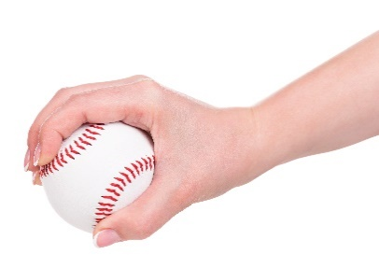

Think of **tools** and **traits** in life and nature.  
*How would you design your Reacher to:*

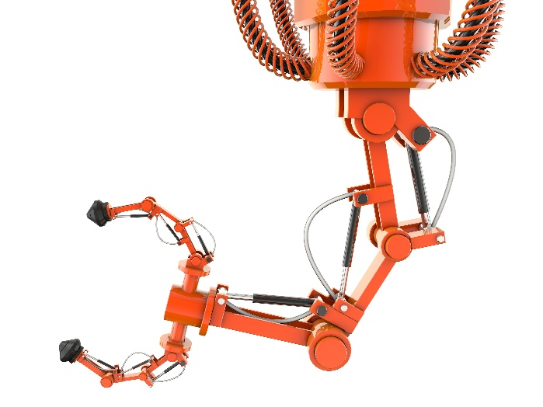



**… grab or clutch?**

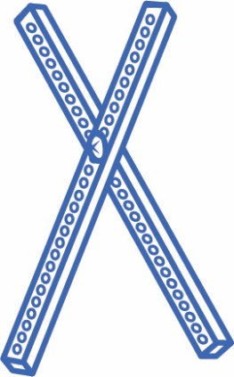

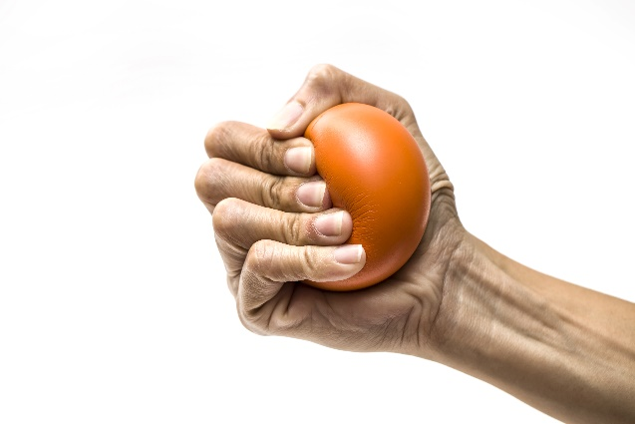

**… scrunch?**



**… grip and lift?**



