Name: ________________________________________ Set: _______ Date: _______

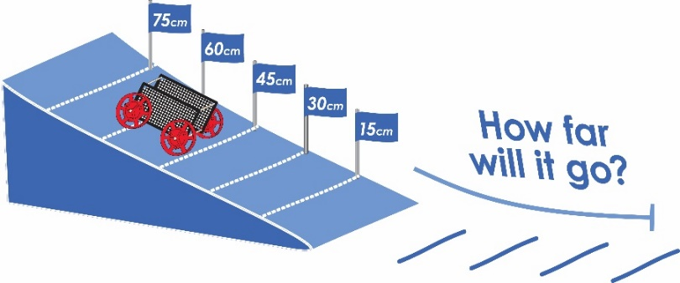

Instructions for building the ramp, and racer are available at teachergeek.com/learn

How does the height that a

car starts at on a ramp affect

the distance it rolls? Let’s find out…

What will you need to do this lab?

* 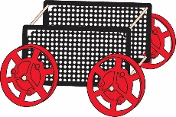Racer (Rolling Car)
* Ramp
* Tape measure.



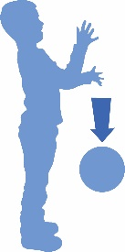

This ball has kinetic energy as it falls.

**Potential Energy** is stored energy. It’s ready to be released into kinetic energy

This ball has potential energy because of its height. If it is lifted higher, it will have more potential energy.

**Kinetic Energy** is the energy of an object’s motion. It’s doing work.



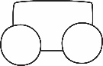

car

Draw a on the picture below, where it would have the most **kinetic** energy. Use an if you need to show that the car is moving.



car

Draw a on the picture below, where it would have the most **potential** energy.



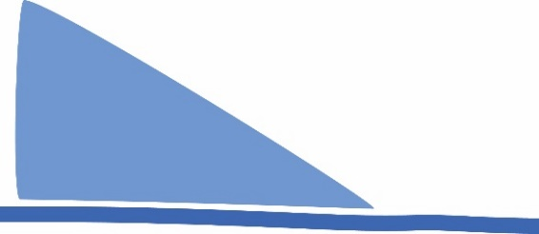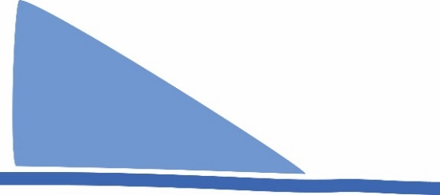

Floor

Ramp

Ramp

Floor

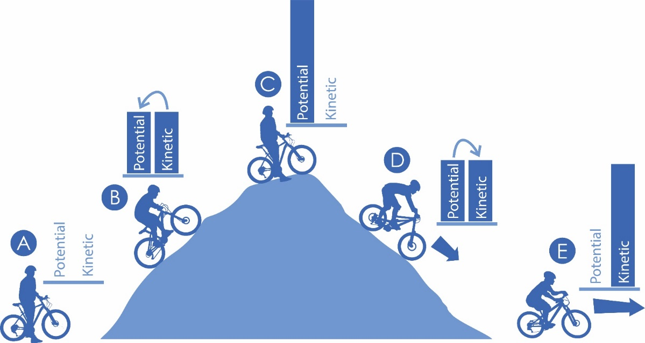



Write the letters on the lines below that correspond to the bike on the hill.

_____ *Get Ready to Roll…* The bike now has the most potential energy

_____ *Peddle Hard…* Kinetic energy is changed into potential energy

_____ *Hold On…* Potential energy has completely changed into kinetic energy

_____ *Get Ready…* There is no potential, or kinetic energy

_____ *Faster & Faster…* Potential is being converted into kinetic energy



Draw the graph to show difference in potential and kinetic energy when the arrow **has been shot.**

Draw the graph to show the difference in potential and kinetic energy when the bow is **pulled back**.

|  |  |  |
| --- | --- | --- |
| Amount |  |  |
|  |  |
|  |  |
|  |  |
| Potential | Kinetic |

|  |  |  |
| --- | --- | --- |
| Amount |  |  |
|  |  |
|  |  |
|  |  |
| Potential | Kinetic |

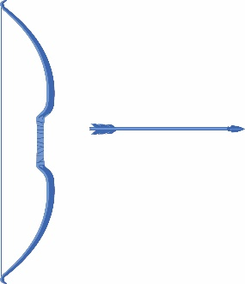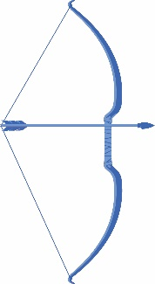

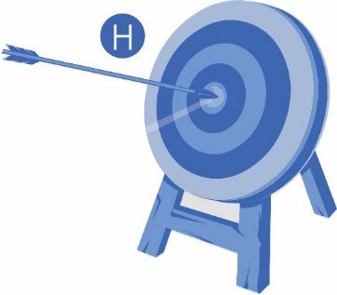

**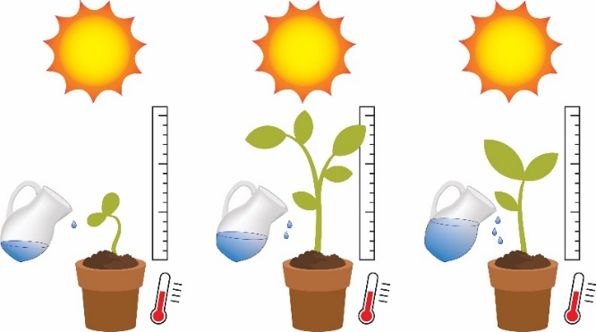****

**Variables:** The things that   
change in an experiment.

*Example Experiment*

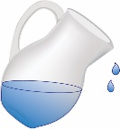

Example: Amount of water given to the plant

**Independent Variable:** The thing you change in the experiment, to test how it affects the dependent variable. *Only have one independent variable in your experiment***.**

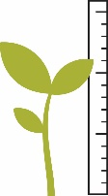

**Dependent Variable:** The variable being tested and measured. *Only have one dependent variable in your experiment.*

Example: Height of plant

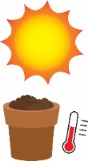

**Controlled Variables:** The things that should not change in an experiment.

Example: amount of sun, soil, temperature

Below are variables that will be part of your ramp roll experiment. Indicate what type they are by placing a letter in the box.

 I = Independent, D = Dependent, C = Control

C

 **Height** car starts on ramp  **Angle** of the ramp

 **Mass** (weight)of car  **Distance** the car travels

 **Friction** from the surface the car rolls on  Car **Design**



|  |  |  |  |  |
| --- | --- | --- | --- | --- |
|  |  |  |  |  |
|  |  |  |  |  |
|  |  |  |  |  |
|  |  |  |  |  |
|  |  |  |  |  |
| 10m  9m  8m  7m  6m  5m  4m  3m  2m  1m |  |  |  |  |
|  |  |  |  |  |
|  |  |  |  |  |
|  |  |  |  |  |
|  |  |  |  |  |
| 15 cm | 30 cm  Independent Variable | 45cm | 60cm | 75cm |

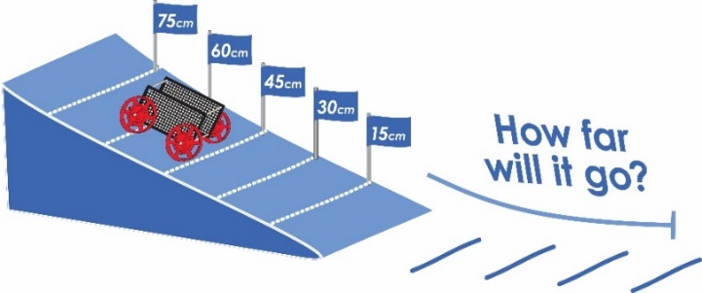

Question: How does the **height** that

a car starts at on a ramp affect the

distance it rolls?



**Label** the graph with the independent and dependent variables for the experiment.

Test your car at different heights on the ramp.

1. Start with the car wheels behind a mark
2. Let the car go, without a push
3. Measure how far it rolls
4. Record the distance traveled on the graph using a dot
5. Test your car at

each height, up

to 3 times. Put a new dot on the graph for each test. Only use data from good tests (don’t use it if car hits a wall or runs over a foot)

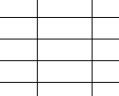

Dependent Variable



Create a line of best fit on your graph. This is a straight line that best represents your scattered dots. The line may pass

through some of the dots, none of the dots, or all of the

dots.



Was the car’s starting height and the distance it rolled, linear?   
Linear means: to take the shape of a straight line, or nearly straight line.

_____________________________________________________________________________

_____________________________________________________________________________****

How did the **height** that your car started at on the ramp affect the **distance** it rolled? Properly use the terms “**potential energy**”   
and “**kinetic energy**” in your answer.

Independent Variable

_____________________________________________________________________________

_____________________________________________________________________________

_____________________________________________________________________________

_____________________________________________________________________________

__________________________________________________________________________________________________________________________________________________________

_____________________________________________________________________________

In this experiment you changed “**height**” as the independent variable. What other variables could you change to make your car go farther?

_____________________________________________________________________________

_____________________________________________________________________________

_____________________________________________________________________________

_____________________________________________________________________________

**Bonus:** Why did your racer stop rolling? Where did the energy go? Hint… research **friction**