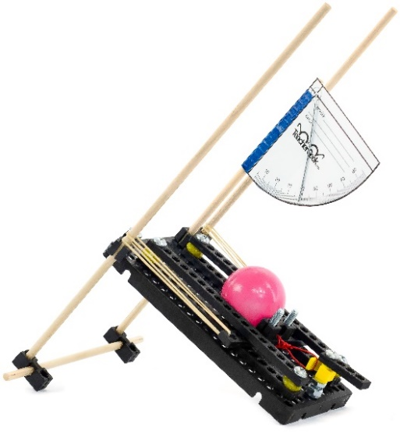

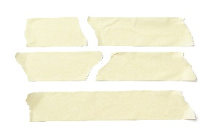

**Starting Line**Use tape or the   
crack between floor tiles.



***Keep one step ahead!***   
Redesign your launcher   
to hit a moving target –   
*best shot, wins!*



*Plop!*



**Before You Start:** Make sure   
you have built a launcher for   
use on this challenge.  
Documents & Supplies at:   
**teachergeek.com**

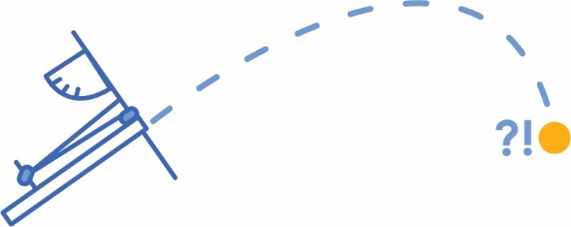

1. Aim. Take **three shots** and try to hit the **bull’s-eye**!  
2. Record your distances on an Engineering Notebook Sheet.  
3. Redesign your launcher.  
4. Repeat for the next location.

**Allowable Materials:**• TeacherGeek Components• Found & Recycling Bin • Teacher Approved• Non-Hazardous

(rules and limits for your design)

**Teacher’s Note:**Find more information on setting up   
targets and running this challenge,   
in the Launcher Classroom Overview.

**►**

**►**

**►**

**Challenge Supplies:**Launcher (from Build Guide), protractor,   
bucket or target material, ruler, tape,   
stop-watch, ping pong balls

**►**

**Difficulty:** Easy-Medium

**Ground Rules:**• Launch from behind the starting line  
• Judges check if targets are hit successfully

**►**



Fill in how much   
time you have



*The time from building   
and re-designing your   
launcher to the start   
of the competition.*

**Time Limit:** ___________



Name: ________________________________________________ Date: __________

Design #: __________

What problem do you want your design (launcher) to solve?



Build it.

Draw your new design.  
***Tip****: think of the trigger, launcher angle, amount of rubber bands, etc*.



**►**

Test it.



**Angle of Launcher***(Degrees)*

**Launch Distance in**  _________

Mark your targets’ distance on the graph with a vertical **line.**Recordthe **distance** of at least three launches for each design or **angle** you test on the graph below.



How **precise** (consistent) were your results? Does your data look   
*grouped together* in one area , or does it look *scattered* ?

0

How **accurate** (close to the ‘true’ value) were your results?   
How close is your data to the line indicating the targets’ distance?

0

**►**



Evaluate it.

How can your design be improved?   
This will become your next problem to solve.



Get another engineering notebook page.   
Solve the new problem.



Units