

Start by building the example turbine, then turn it into ***your own*** unique design.



For use with TeacherGeek [Mini Wind Turbine Activity](https://teachergeek.com/products/teachergeek-mini-turbine-1?variant=344616285) or [Maker Cart](https://teachergeek.com/products/maker-cart).  
Find documents & activity materials at [**teachergeek.com**](https://teachergeek.com/).

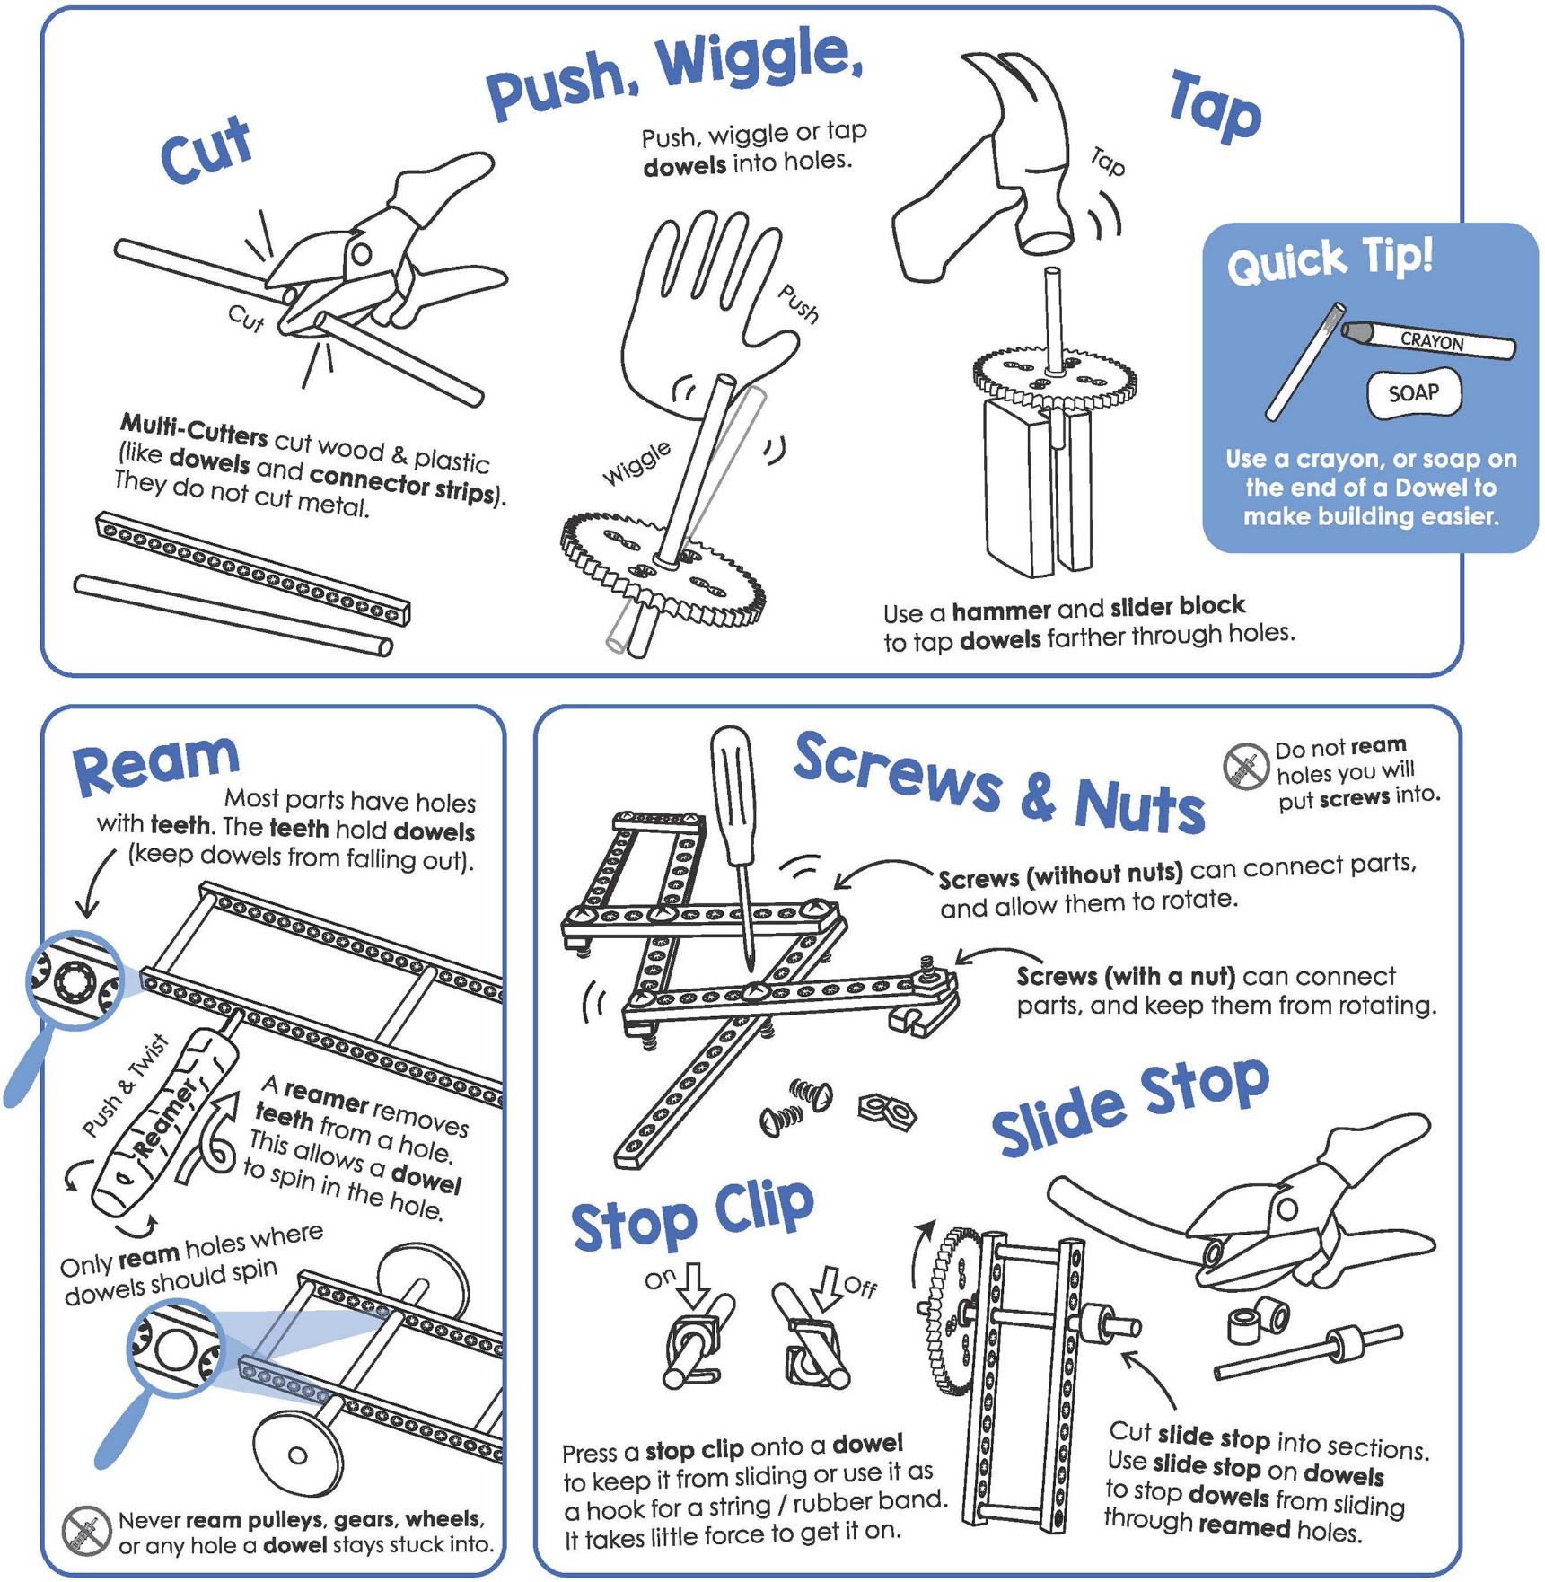



|  |  |  |  |  |  |  |  |  |
| --- | --- | --- | --- | --- | --- | --- | --- | --- |
|  |  |  |  | |  | |  |  |
| [**2 - Blocks**](https://teachergeek.com/products/teachergeek-mini-turbine-1?variant=344616285) | **2 -** [**Dowels**](https://teachergeek.com/products/teachergeek-mini-turbine-1?variant=344616285)  300mm (12″) | **1 -** [**Hole Plate**](https://teachergeek.com/products/teachergeek-mini-turbine-1?variant=344616285) | **1 -** [**Screw**](https://teachergeek.com/products/teachergeek-mini-turbine-1?variant=344616285)  #10 38mm (1″) | | **1 -** [**Mini Hub Screw**](https://teachergeek.com/products/teachergeek-mini-turbine-1?variant=344616285) | | **1 -** [**Nut**](https://teachergeek.com/products/teachergeek-mini-turbine-1?variant=344616285)#10 | **10 -** **Bamboo**  **Project Sticks** |
|  |  |  |  | | **Double Check Your Supplies!** This activity needs **red** motor mounting hubs. | |  |  |
| [**1 - Mini Hub Cover**](https://teachergeek.com/products/teachergeek-mini-turbine-1?variant=344616285) | [**1 - Mini Hub Base**](https://teachergeek.com/products/teachergeek-mini-turbine-1?variant=344616285) | **1 -** [**Small Motor**](https://teachergeek.com/products/teachergeek-mini-turbine-1?variant=344616285)1.5-3V | | [**1 - Small Motor Mount**](https://teachergeek.com/products/teachergeek-mini-turbine-1?variant=344616285) | |  |  |  |



This isn’t a kit. You’re going to really build your turbine.   
Here are the tools you’ll need to get started. Available at [**teachergeek.com**](https://teachergeek.com/)

|  |  |  |
| --- | --- | --- |
|  |  |  |
| [**Multi-Cutter**](https://teachergeek.com/products/1823-81)[*SKU 1823-81*](https://teachergeek.com/products/1823-81) | [**Screwdriver**](https://teachergeek.com/products/stubby-2-screwdriver)[*SKU 1823-90*](https://teachergeek.com/products/stubby-2-screwdriver) | [**Pliers**](https://teachergeek.com/products/slip-joint-pliers-6)[*SKU 1823-86*](https://teachergeek.com/products/slip-joint-pliers-6) |



|  |  |  |
| --- | --- | --- |
|  |  |  |
| **Tape** | **Recycling Materials** (for blades) | **Safety Goggles** |



|  |  |  |  |
| --- | --- | --- | --- |
|  | **Attach** a **block** to the **hole plate** using a **38mm screw** and **nut**.    underside  block, 38mm screw & nut |  | **Push** a **dowel** into the **block** to create the **turbine tower**.    turbine tower |
|  | **Cut** a 100mm **dowel**.    **Push** the **motor mount** onto the **dowel**. |  | **Push** or **tap** a **block** onto the **dowel** as shown.  Then **slide** the **motor** into the **mini motor mount**. |
|  | **Slide** the **block** onto the **turbine tower**. |  | Screw the **cover** to the **base** using  a **mini hub** **screw** to make the **mini hub assembly**.    cover  mini hub screw  base  **Quick Tip** *Hold the base with pliers when turning in the screw.* |
|  | **Press** the **mini hub assembly** onto the **motor** **shaft**.      mini hub  assembly | **Yes!**  Your turbine stand is done!  Time to make the blades. | |



Now it’s time to make your blades. Make the example blades shown below. Then, in the Engineering Challenges, make them into your own unique design.

|  |  |
| --- | --- |
|  | **Cut** points off **large bamboo project sticks**. |
|  | **Tape** your **recycling materials** (cardboard, card stock,  cereal boxes, etc.) to the **skewers** as shown below. |



c. Place a **stick** at the edge of   
 the **blade**, overhanging to one side.



1. **Cut** a section of **recycling material**. This will be one of your **blades**.



b. Place **tape** half over the edge   
 of the **blade**.



d. Fold the **tape** over the **stick**.  
 **Press** to secure tape.

|  |  |
| --- | --- |
|  | **Loosen** the **mini hub screw** about a **½ turn** to allow the **sticks** to **slide in**.        Then, carefully **slide** the sticks into the **mini hub’s holes**. **Angle** your blades and **re-tighten**.  First, **loosen** the mini hub screw  by **½ turns**. |

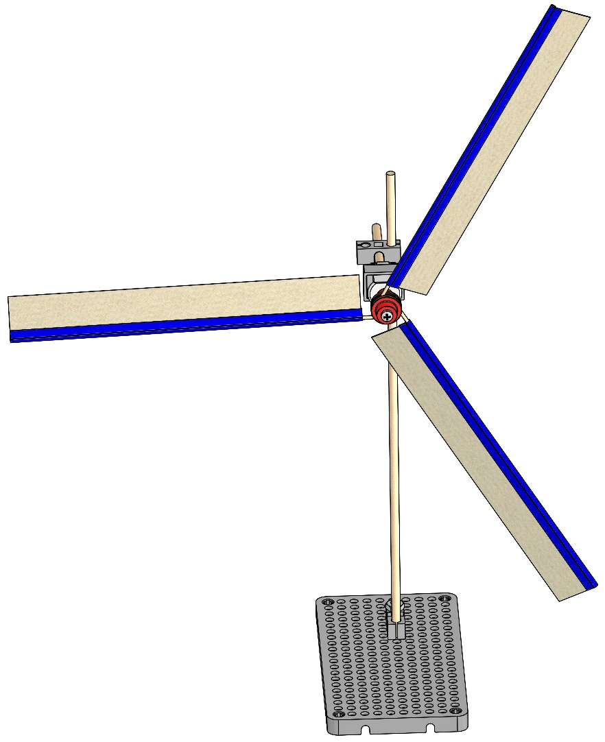

**Yes!**

Your Mini Wind Turbine is done!  
  
Experiment and play with blade placement.

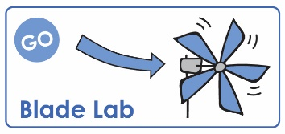

If you are going   
to do the optional   
*Blade Lab Activity*,   
now’s the time!

Documents at **teachergeek.com/learn**