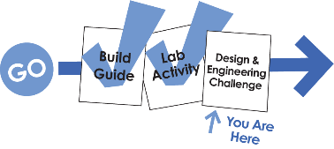Name: ______________________________________________ Set: _______________



Engineer a mini wind turbine with the greatest output.

**Criteria:**

1. Only components from the TeacherGeek Mini Turbine kit may be used, as well as approved blade materials.
   1. Blades may not be:
      1. *Premanufactured (purchased in the shape they are used)*
      2. *Dangerous*
      3. *Metal*
      4. *Sharp Edged*
2. Safety glasses must be worn when testing wind turbines.
3. Turbine must be tested 50cm (20in) from the teacher provided fan. Fan speed, angle and direction may not be modified.

**Engineering Process:**

The engineering process will be used to evolve your wind turbine through revisions (design changes). Scientific testing will provide data to engineer the ultimate turbine.

1. **Design:**
   1. ***Research:*** *Analyze your current design and test data.*

*Explore science that makes it work. Study existing*

*designs and concepts.*

* 1. ***Identify a Problem:*** *Use your Research to identify an*

*area where your turbine can be improved.*

* 1. ***Generate Possible Solutions:*** *Come up with creative*

*ideas that could solve the problem.*

* 1. ***Choose the Best Solution:*** *Select the solution you believe   
     will best solve the problem.*
  2. ***Plan:*** *Create drawings, identify materials & processes required to construct the solution.*

1. **Construct:** Create the mini turbine, or turbine revision according to your design plan.
2. **Test & Evaluate:** Evaluate the wind turbine and solution. Did your last revision work well?   
   What can be improved? No design is perfect. Your wind turbine can always be improved.
3. **Repeat (Redesign):** Engineer a solution to the problem(s) identified in the evaluation. Create a new revision.

*Don’t worry about having a design “flop”. Spectacular design revisions often follow “flopped”   
designs (you can learn a lot from a “flop”). Challenge yourself to create unique designs.*



1. Redesign your basic wind turbine using an Engineering Note page:

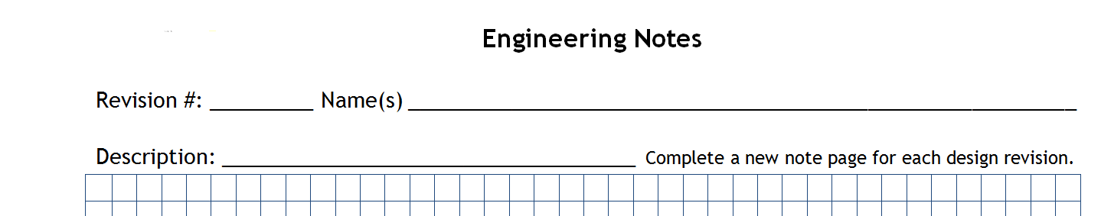

1 Wind eaters

6 Blade Design

1. 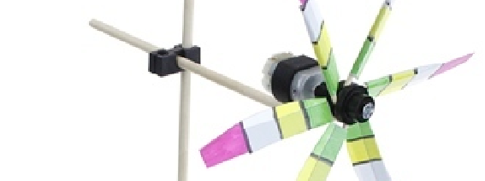Construct the new design.
2. Test the design. Record your test data in the test record, and on the engineering note page:

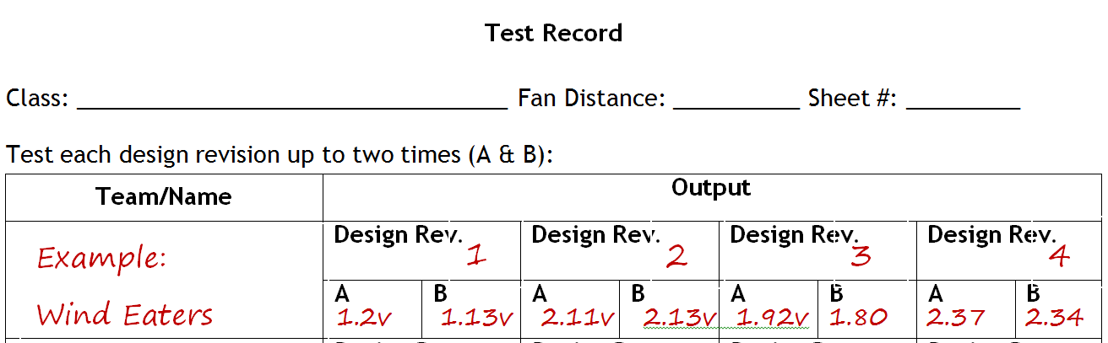

1M 1

Science 8

1. Evaluate the design based upon test performance, observations and research:

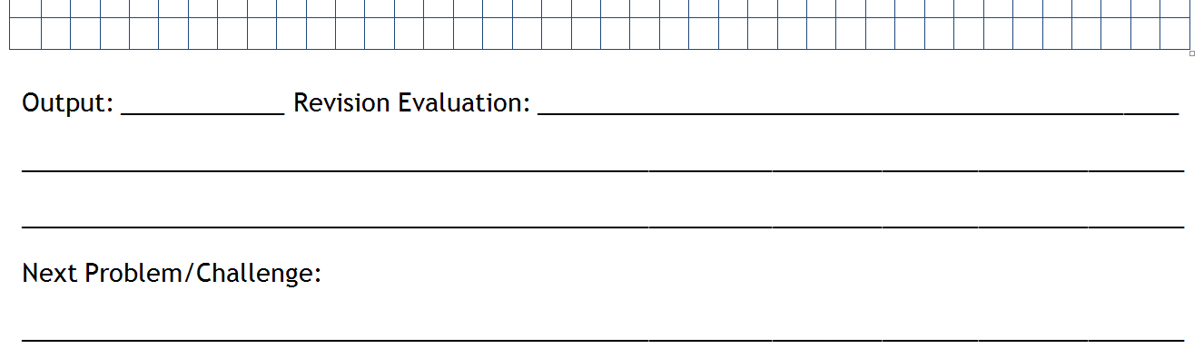

1.2v Not great. A blade broke

during testing. We need a new blade material.

Broken Blade: Redesign with a stronger material

1. Redesign (create a revision) to overcome the problem(s) identified by the evaluation.



1 Wind eaters

3 Blade Design

1. Redesign, Repeat.

Name: ___________________________________________________________   
Set: _______________ Date: _______________

**Criteria: 10pts**

How well does the turbine fit the competition criteria?

**Use of Time: 15pts**

How much productive time did you spend working on the challenge? Did you work until the time ran out?   
Did you work extra hours (for bonus points)? Regular Points= 0-15. Bonus Points= 16-18.

**Revisions: 15pts**

What was the quantity and quality of your design revisions?

**Innovation: 20pts**

How unique and creative was your design and revisions? Regular Points= 0-20. Bonus Points= 21-15.

**Performance: 15pts**

How did your turbine output compare to the output of other turbines in your class? Higher Output = More points.

**Documentation: 15pts**

Did you carefully document the engineering process using note sheets?

**Spirit: 10pts**

Did you demonstrate energy and enthusiasm for the project? Were you cooperative and helpful to your teammates and competitors?

**Student Provided Score (Self-Score):**

**Teacher Provided Score:**

**Test Record**

Class: __________________________________ Fan Distance: __________ Sheet #: _________

Test each design revision up to two times (A & B):

|  |  |  |  |  |  |  |  |  |
| --- | --- | --- | --- | --- | --- | --- | --- | --- |
| **Team/Name** | **Output** | | | | | | | |
|  | **Design Rev.** | | **Design Rev.** | | **Design Rev.** | | **Design Rev.** | |
| **A** | **B** | **A** | **B** | **A** | **B** | **A** | **B** |
|  | **Design Rev.** | | **Design Rev.** | | **Design Rev.** | | **Design Rev.** | |
| **A** | **B** | **A** | **B** | **A** | **B** | **A** | **B** |
|  | **Design Rev.** | | **Design Rev.** | | **Design Rev.** | | **Design Rev.** | |
| **A** | **B** | **A** | **B** | **A** | **B** | **A** | **B** |
|  | **Design Rev.** | | **Design Rev.** | | **Design Rev.** | | **Design Rev.** | |
| **A** | **B** | **A** | **B** | **A** | **B** | **A** | **B** |
|  | **Design Rev.** | | **Design Rev.** | | **Design Rev.** | | **Design Rev.** | |
| **A** | **B** | **A** | **B** | **A** | **B** | **A** | **B** |
|  | **Design Rev.** | | **Design Rev.** | | **Design Rev.** | | **Design Rev.** | |
| **A** | **B** | **A** | **B** | **A** | **B** | **A** | **B** |

**Engineering Notes**

Revision #: _________ Name(s) __________________________________________________________

Description: ________________________________________ *Complete a new note page for each design revision.*

|  |  |  |  |  |  |  |  |  |  |  |  |  |  |  |  |  |  |  |  |  |  |  |  |  |  |  |  |  |  |  |  |  |  |  |  |  |  |  |  |
| --- | --- | --- | --- | --- | --- | --- | --- | --- | --- | --- | --- | --- | --- | --- | --- | --- | --- | --- | --- | --- | --- | --- | --- | --- | --- | --- | --- | --- | --- | --- | --- | --- | --- | --- | --- | --- | --- | --- | --- |
|  |  |  |  |  |  |  |  |  |  |  |  |  |  |  |  |  |  |  |  |  |  |  |  |  |  |  |  |  |  |  |  |  |  |  |  |  |  |  |  |
|  |  |  |  |  |  |  |  |  |  |  |  |  |  |  |  |  |  |  |  |  |  |  |  |  |  |  |  |  |  |  |  |  |  |  |  |  |  |  |  |
|  |  |  |  |  |  |  |  |  |  |  |  |  |  |  |  |  |  |  |  |  |  |  |  |  |  |  |  |  |  |  |  |  |  |  |  |  |  |  |  |
|  |  |  |  |  |  |  |  |  |  |  |  |  |  |  |  |  |  |  |  |  |  |  |  |  |  |  |  |  |  |  |  |  |  |  |  |  |  |  |  |
|  |  |  |  |  |  |  |  |  |  |  |  |  |  |  |  |  |  |  |  |  |  |  |  |  |  |  |  |  |  |  |  |  |  |  |  |  |  |  |  |
|  |  |  |  |  |  |  |  |  |  |  |  |  |  |  |  |  |  |  |  |  |  |  |  |  |  |  |  |  |  |  |  |  |  |  |  |  |  |  |  |
|  |  |  |  |  |  |  |  |  |  |  |  |  |  |  |  |  |  |  |  |  |  |  |  |  |  |  |  |  |  |  |  |  |  |  |  |  |  |  |  |
|  |  |  |  |  |  |  |  |  |  |  |  |  |  |  |  |  |  |  |  |  |  |  |  |  |  |  |  |  |  |  |  |  |  |  |  |  |  |  |  |
|  |  |  |  |  |  |  |  |  |  |  |  |  |  |  |  |  |  |  |  |  |  |  |  |  |  |  |  |  |  |  |  |  |  |  |  |  |  |  |  |
|  |  |  |  |  |  |  |  |  |  |  |  |  |  |  |  |  |  |  |  |  |  |  |  |  |  |  |  |  |  |  |  |  |  |  |  |  |  |  |  |
|  |  |  |  |  |  |  |  |  |  |  |  |  |  |  |  |  |  |  |  |  |  |  |  |  |  |  |  |  |  |  |  |  |  |  |  |  |  |  |  |
|  |  |  |  |  |  |  |  |  |  |  |  |  |  |  |  |  |  |  |  |  |  |  |  |  |  |  |  |  |  |  |  |  |  |  |  |  |  |  |  |
|  |  |  |  |  |  |  |  |  |  |  |  |  |  |  |  |  |  |  |  |  |  |  |  |  |  |  |  |  |  |  |  |  |  |  |  |  |  |  |  |
|  |  |  |  |  |  |  |  |  |  |  |  |  |  |  |  |  |  |  |  |  |  |  |  |  |  |  |  |  |  |  |  |  |  |  |  |  |  |  |  |
|  |  |  |  |  |  |  |  |  |  |  |  |  |  |  |  |  |  |  |  |  |  |  |  |  |  |  |  |  |  |  |  |  |  |  |  |  |  |  |  |
|  |  |  |  |  |  |  |  |  |  |  |  |  |  |  |  |  |  |  |  |  |  |  |  |  |  |  |  |  |  |  |  |  |  |  |  |  |  |  |  |
|  |  |  |  |  |  |  |  |  |  |  |  |  |  |  |  |  |  |  |  |  |  |  |  |  |  |  |  |  |  |  |  |  |  |  |  |  |  |  |  |
|  |  |  |  |  |  |  |  |  |  |  |  |  |  |  |  |  |  |  |  |  |  |  |  |  |  |  |  |  |  |  |  |  |  |  |  |  |  |  |  |
|  |  |  |  |  |  |  |  |  |  |  |  |  |  |  |  |  |  |  |  |  |  |  |  |  |  |  |  |  |  |  |  |  |  |  |  |  |  |  |  |
|  |  |  |  |  |  |  |  |  |  |  |  |  |  |  |  |  |  |  |  |  |  |  |  |  |  |  |  |  |  |  |  |  |  |  |  |  |  |  |  |
|  |  |  |  |  |  |  |  |  |  |  |  |  |  |  |  |  |  |  |  |  |  |  |  |  |  |  |  |  |  |  |  |  |  |  |  |  |  |  |  |
|  |  |  |  |  |  |  |  |  |  |  |  |  |  |  |  |  |  |  |  |  |  |  |  |  |  |  |  |  |  |  |  |  |  |  |  |  |  |  |  |
|  |  |  |  |  |  |  |  |  |  |  |  |  |  |  |  |  |  |  |  |  |  |  |  |  |  |  |  |  |  |  |  |  |  |  |  |  |  |  |  |
|  |  |  |  |  |  |  |  |  |  |  |  |  |  |  |  |  |  |  |  |  |  |  |  |  |  |  |  |  |  |  |  |  |  |  |  |  |  |  |  |

Output: ______________ Revision Evaluation: ________________________________________________________

__________________________________________________________________________________________________

__________________________________________________________________________________________________

Next Problem/Challenge:

__________________________________________________________________________________________________