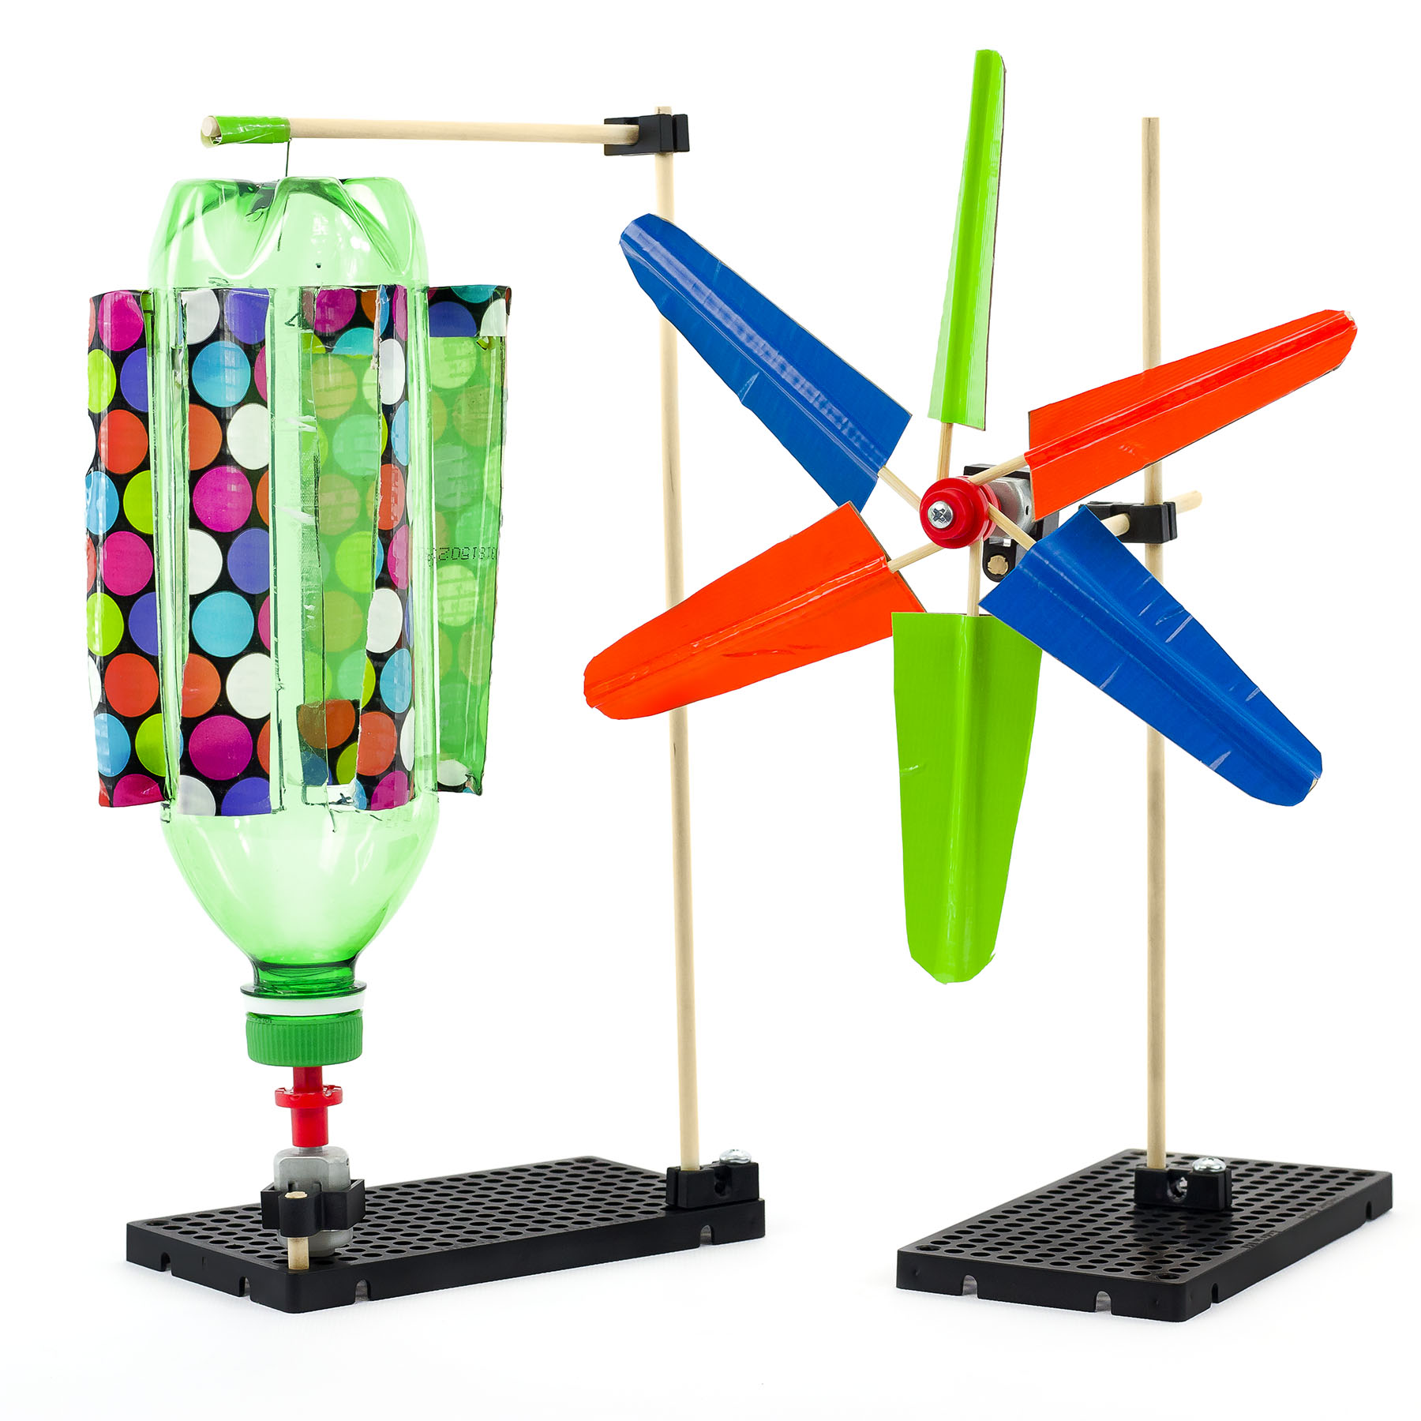

**THINKING AHEAD** *How can you create a blade design  
so that it generates more power?*

Download Documents and get your supplies at[**teachergeek.com**](https://teachergeek.com/)

*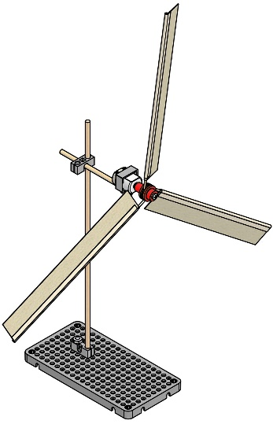***Recommended Age Level:**

Activity Age Level: 8-20

Elementary Lab Age Level: 8-12

Secondary Lab Age Level: 13-20

Recommended Group Size: 1-3 Students/Turbine

Note: This overview, and corresponding lab documents, are intended for educational use. If you are looking to build a Mini Wind Turbine outside the classroom, you may want to download the “Mind Wind Turbine Build Guide” at [**teachergeek.com/learn**](https://teachergeek.com/blogs/projects/mini-wind-turbine).



Engineer a Miniature Wind Turbine that generates electricity. Start by building the example Mini Wind Turbine in the **Build Guide**, then experiment in the **Lab** by changing blade designs. Learn how shape, pitch and number of blades affects how much electricity it can generate. Then, design and build your own unique turbine to compete in an **Engineering Challenge**.



What’s unique about this, and other TeacherGeek activities?

This is a **True STEM/Engineering** activity. It allows kids to:

* *Tinker and experiment*
* *Grow understanding through experimentation and labs*
* *Isolate variables and utilize the scientific method*
* *Apply math and science concepts*
* *Create their own unique designs to become innovators.*

Every project turns out different, and evolves with their understanding. When you create a project using TeacherGeek, the data works (it’s usable). This allows  
kids to apply the math and science, see the results,   
and experience “I-get-it” moments (understanding   
*why* they need the math/science and *what* it does).

Adapted from Bloom’s Taxonomy



**Make It Your Own:** The documents for this activity are available in   
**PDF** and **Microsoft Word** format. If you wish to edit a document,  
simply download the Microsoft Word format.



**Next Generation Science Standards:**

**Forces & Interactions**

* **K-PS2-1**: Plan & conduct an investigation to compare the effects of different strengths or different directions of pushes & pulls on the motion of an object.
* **K-PS2-2:** Analyze data to determine if a design solution works as intended to change the speed or direction of an object with a push or a pull.

**Engineering Design**

* **K-2-ETS1-1:** Ask questions, make observations, and gather information about a situation people want to change to define a simple problem that can be solved through the development of a new or improved object or tool.
* **K-2-ETS1-2:** Develop a simple sketch, drawing, or physical model to illustrate how the shape of an object helps it function as needed to solve a given problem.



When you push a friend on a swing, you are using a force. Pushing moves something in the direction of the push. The harder the push, the further the item goes. Pulling something has a similar action. The harder you pull, the faster something moves along.

* **Push:** to use force to move (someone or something) forward or away from you.
* **Pull:** to hold onto and move (someone or something) in a direction.
* **Revolution:** is the movement of one object around the center of another.
* **RPM:** revolutions per minute.
* **Torque:** a twisting force to cause rotation.
* **Wind:** a natural movement of air outside.
* **Sail:** a large cloth, that is connected to a boat (or car, in this activity), that is used to catch the wind that moves the boat (car) through the water (or over the land).



Below is the list of “ingredients” you’ll need for each Mini Wind Turbine.

|  |  |  |  |  |  |
| --- | --- | --- | --- | --- | --- |
| **x2** | **x2** | **x1** | **x1** | **x1** | **x1** |
| [**Blocks**](https://teachergeek.com/products/teachergeek-mini-turbine-1?variant=344616285) | [300mm (12″) **Dowels**](https://teachergeek.com/products/teachergeek-mini-turbine-1?variant=344616285) | [**Hole Plate**](https://teachergeek.com/products/teachergeek-mini-turbine-1?variant=344616285) | [⅝″ or 1″ #10 **Screw**](https://teachergeek.com/products/teachergeek-mini-turbine-1?variant=344616285) | [⅝″ #6 **Screw**](https://teachergeek.com/products/teachergeek-mini-turbine-1?variant=344616285) | [#10 **Nut**](https://teachergeek.com/products/teachergeek-mini-turbine-1?variant=344616285)  **Double Check Your Supplies!** This activity needs **red** motor mounting hubs. |
| **x1** | **x1** | **x10** | **x1** | **x1** |  |
| [**Motor Mounting Hub Cover**](https://teachergeek.com/products/teachergeek-mini-turbine-1?variant=344616285) | [**Motor Mounting Hub Base**](https://teachergeek.com/products/teachergeek-mini-turbine-1?variant=344616285) | [150mm (10″) **Skewers**](https://teachergeek.com/products/teachergeek-mini-turbine-1?variant=344616285) | [1.5V **Motor**](https://teachergeek.com/products/teachergeek-mini-turbine-1?variant=344616285) | [**Mini Motor Mount**](https://teachergeek.com/products/teachergeek-mini-turbine-1?variant=344616285) |  |



*Perfect for sharing in groups of 3 and 4!*

Time to break out those tools and start building! Available at [**teachergeek.com**](https://teachergeek.com/)

|  |  |  |  |
| --- | --- | --- | --- |
|  |  |  |  |
| [**Multi-Cutter**](https://teachergeek.com/products/1823-81) | [**Screwdriver**](https://teachergeek.com/products/stubby-2-screwdriver) | [**Pliers**](https://teachergeek.com/products/slip-joint-pliers-6) |  |



Go on your own scavenger hunt to find these items. Try creating with all kinds of things!

|  |  |  |  |
| --- | --- | --- | --- |
|  |  |  |  |
| **Tape** | **Recycling Materials** (for blades) | **Safety Goggles** |  |

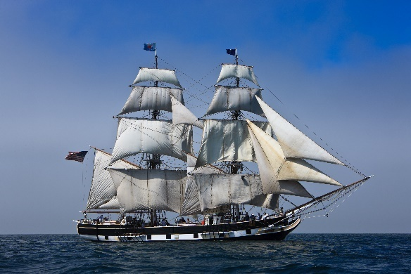

When you think of sailing, you probably think of a boat that is propelled by the wind, like the one over here.

Did you know that sailing isn’t just for the water? Cars can be powered by the wind. As shown below, people have been “sailing on land” for centuries.

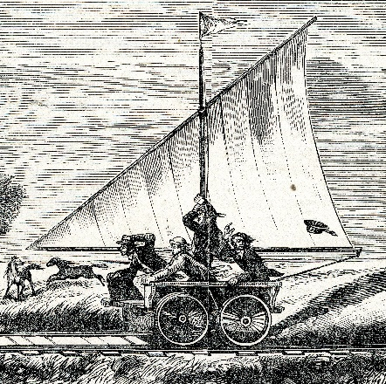

Sail driven vehicle on Kansas Pacific Railway (ca. 1890)

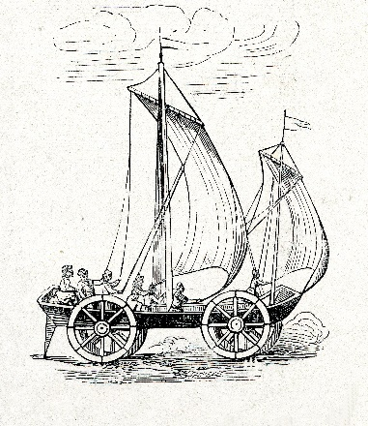

Sail driven Dutch Cart   
17 century

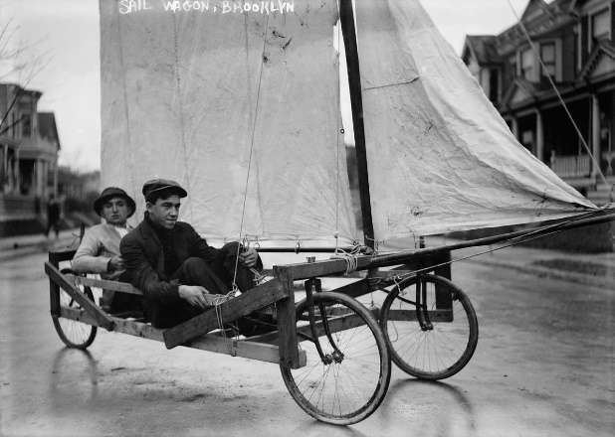

Brooklyn Sail Car

**Land Sail Car**: A vehicle with wheels that uses a sail and is powered by the wind.   
Sail Cars, also known as land yachts, were once a mode of transportation.   
Now, they are mainly used for recreation and fun.

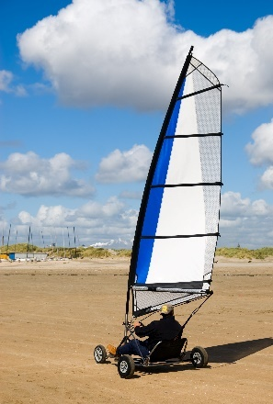Here’s what today’s Sail Cars look like. The “Greenbird” is a Sail Car that   
can go 126 miles per hour. That’s faster than most gas powered cars!

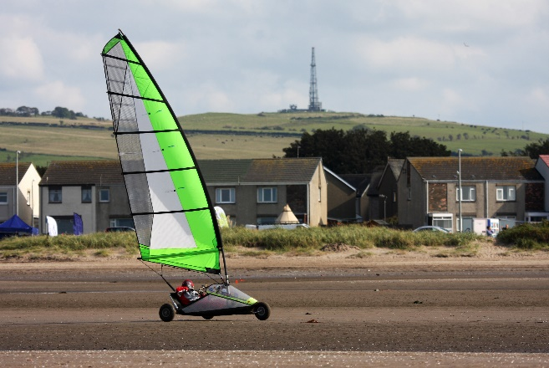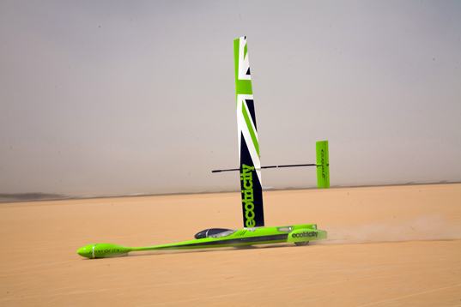

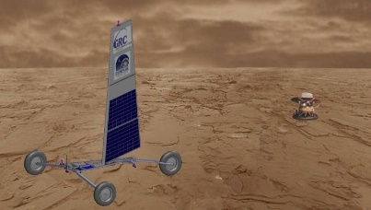

NASA is thinking about using a Sail Car   
to travel on the surface of the planet Venus.

*Zephyr Land Sailing Rover  
Image from NASA John Glenn Research Center*



There are “a ton” of resources to help you complete this activity. Pick and choose the ones that will work for you. They are available as links below, or at teachergeek.com/learn.

**Mini Wind Turbine Documents**

* **Classroom Overview** - This is it (you’re reading it).
* **Mini Wind Turbine Build Guide and Labs**
  + [Mini Wind Turbine Build Guide](http://teachergeek.org/mini_wind_turbine_buildguide.pdf) - Required
    - Students will make an example Mini Wind Turbine to use in the Lab.
  + [Lab “Pitch & Torque”](http://teachergeek.org/mini_turbine_labs.pdf) - Optional
    - Students investigate blade pitch and moving their Mini Wind Turbine   
      away from the wind source (fan); graphing voltage output and   
      learning how rpm and torque relates to energy conversion.
* [Mini Wind Turbine Engineering Challenge](http://teachergeek.org/mini_turbine_design_challenge.pdf)
  + **Power Challenge**
    - Design the Mini Wind Turbine with the greatest output

**Mini Wind Turbine Videos**

* [Land Sailing at 126 mph, Greenbird](https://youtu.be/TRFRQXPtXTs)—Youtube Video
* [Land Sailing in Nevada](https://youtu.be/9XzHIMMVJZs)—Youtube Video

[](https://teachergeek.com/blogs/projects/sail-car-activity)

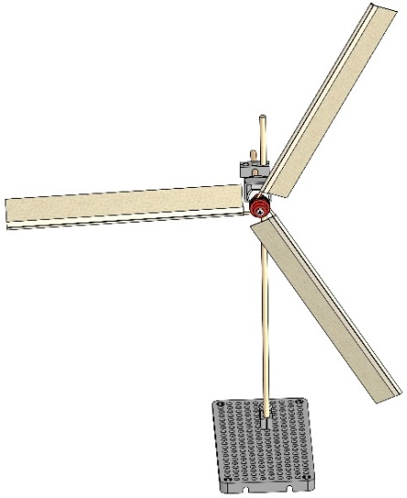There are optional Labs for Mini Wind Turbines. You get to choose which Labs (if any) you would like to do. After you’ve finished, you can download the [Mini Wind Turbine Engineering Challenge](http://teachergeek.org/mini_turbine_design_challenge.pdf) and [Engineering Notebook](http://teachergeek.org/engineering_notebook.pdf) sheets to take your designs to the next level. Documents are available as links below or at [**teachergeek.com/learn**](https://teachergeek.com/blogs/projects/mini-wind-turbine).

**Build Guide - Required**

During this step you will create the example Mini Wind Turbine for the Labs and Engineering Challenges.

The Turbine can be kept together (for another class/student), or taken apart at the end of the activity.

**[Download the Mini Wind Turbine Build Guide](http://teachergeek.org/mini_wind_turbine_buildguide.pdf)

**Secondary ‘Pitch & Torque’ Lab**

This lab allows students to experiment with blade pitch and moving their Mini Wind Turbine away from the wind source (fan); graphing voltage output and learning how rpm and torque relates to energy conversion.

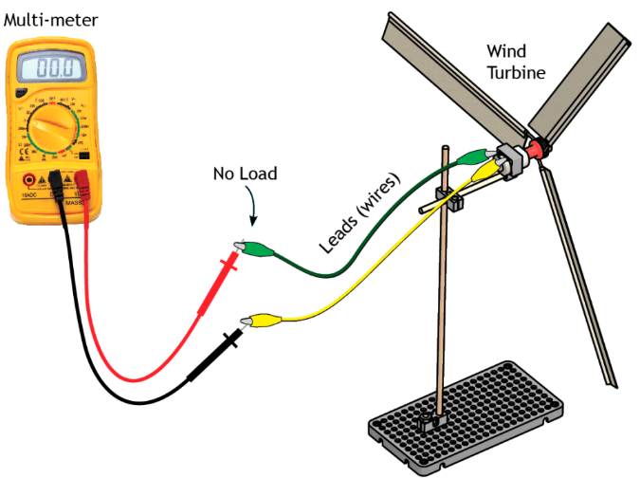**Instructions:**

* + Discuss the following concepts with your students. Ask them to provide examples for each.
    - Force
    - Push
    - Pull
    - Torque
    - Hypothesis
  + Hand out the Lab sheets. Explain the lab procedure and get to work.

If students finish early, you may want them   
to start onto the Engineering Challenge.

[Download the Mini Wind Turbine Lab](http://teachergeek.org/mini_turbine_labs.pdf)

**Engineering Challenge - Optional**

It’s an Engineering Challenge; immersing students in the Engineering Design process. Learn more about the Engineering Design Process on the next page.

[*Download the Engineering Notebook Sheets*](http://teachergeek.org/engineering_notebook.pdf)

**Power Challenge - Optional**

The challenge is simple: design and build Mini Wind Turbine blades to produce the greatest output power. Compete against classmates and record the results.

*[Download the Mini Wind Turbine Engineering Challenge](http://teachergeek.org/mini_turbine_design_challenge.pdf)*



Do you have a challenge to solve? Is there something   
you want to invent, fix or improve? You do? Excellent!   
The Engineering Design Process is exactly what you need.

Inventing, fixing, improving… these are really ways to create a solution to a problem. A problem can be as complicated as creating a way to live on Mars, or as simple as stopping a door from squeaking. You are reading this because you have a problem to solve: to create the Mini Wind Turbine with the greatest output. The Design Process will help you solve it. Here’s how it works…



**What is the problem (what needs to be solved/made better)?**

The Design Process helps you solve a problem. This is why you need to start the Design Process by identifying a problem. In this activity, your first problem it to create a Mini Wind Turbine that will produce the greatest output.

After constructing your first Mini Wind Turbine and completing one time around the Design Process, your problem may change. Your next problem might be to make the Mini Wind Turbine spin faster or keep from tipping over.

There is no perfect design, so there is no end to the Design Process. You can always identify a new problem (a way to make your Mini Wind Turbine better) and go around the Design Process again.

**Research: How have others solved, or attempted to solve this problem?**

If you are going to solve the problem, you better know what you are doing. After identifying the problem, take a look at how others have solved, or tried to solve it. Look around your class, search the library and internet or ask other people.

**What are the constraints (things your design cannot, or must, do or be)?**

It would be great if you could solve this problem any way you want, with anything you want. The truth is, you can’t. You have these things called “constraints” which limit what your design can do, can’t do, must be, or can’t be (How confusing is that?). Constraints could be resources like time or materials. They could also be rules, such as how big the Mini Wind Turbine can be, or what materials the blades are made of. You must identify constraints.



**Brainstorm, sketch and describe possible solutions (different ideas that might solve the problem).**

This is a fun part. You can brainstorm, or use another process, to come up with as many possible solutions to your problem as possible. Consider your problem, constraints and research while generating possible solutions. Do not judge, or pick, your best solution at this point. Just write as many down as you can. Note: whacky/unique ideas sometimes lead to wonderful new design solutions. Be super creative, and original.

**Choose the best solution. Circle it. Why do you think it is best?**

Ok - now it’s time to judge. Pick what you think will be the best solution to your problem. Make sure it fits the constraints. It’s ok to feel sorry for all of the possible solutions that didn’t get picked. They were good ideas too…



**Draw the solution you choose. Include the details you will need to create it.**

Neatly sketch the design you choose (the one you are going to build).   
The sketch should include details and descriptions about how it will work, or be built.



**Build the solution you planned.**

Is this the step you have been waiting for? You finally get to build the solution to your problem (the new design). Have fun! Take the time to make it properly.

**Test it.**

Test your solution (new design). How does it work? Does it create a lot of power?   
Make small adjustments to optimize it (to try and make this design solution work best).

**Make observations. Record results.**

Pay close attention while testing your solution. Write down what happened (it tipped over, the blades didn’t spin, one of the turbine blades broke). You will use this information to make your Mini Wind Turbine even better.



**Did you solve the problem?**

Take a look at the test results. Reflect on your observations. Did your solution solve the problem as you had planned?

**Yes? Great! Identify a new problem (a way to make your design even better).**

There is no perfect design (yep... your design can still be improved). Identify another problem that will make your Mini Wind Turbine an even better power source. Grab another Engineering Notebook Sheet and try to solve it.

**No? That’s OK. What did you learn that can help solve it in a new/different way?**

You learn more from failures than you do from successes. The best solutions come from/after failures (ideas that didn’t work). Most inventions do not work the first time around the Design Process. Learn from what didn’t work. Grab another Engineering Notebook Sheet and try to solve the problem a different way.



Fill in a TeacherGeek Engineering Notebook Sheet (front and back) every time you go around the Design Process. Keep your Notebook Sheets. Assemble them into an Engineering Notebook at the end of the project.

[*Download the Engineering Notebook Sheets*](http://teachergeek.org/engineering_notebook.pdf)

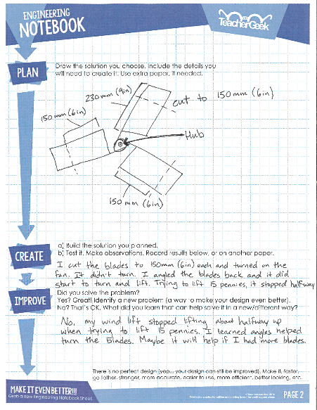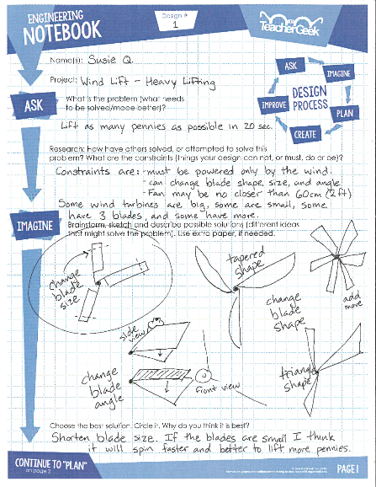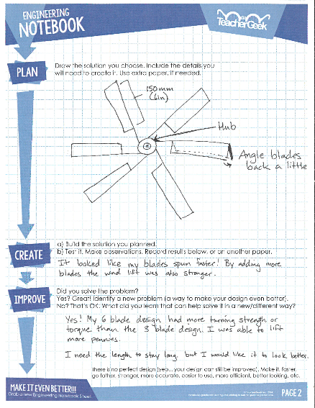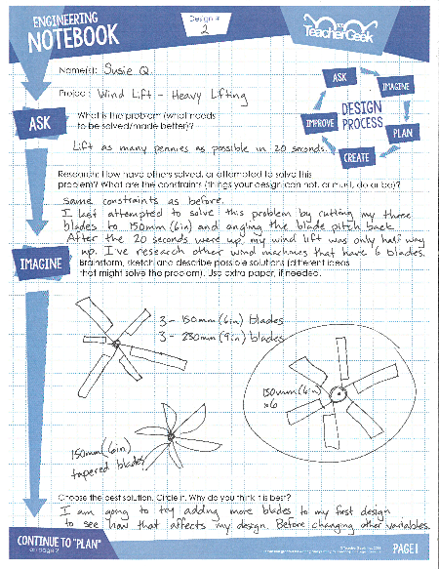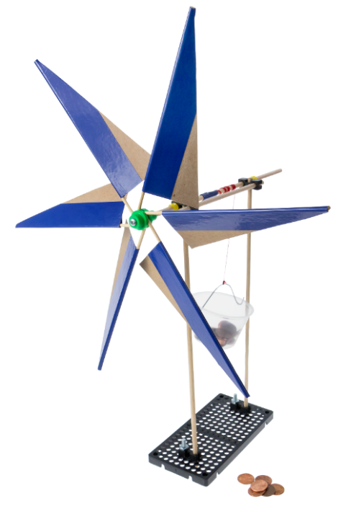

***Question*** *Do you need to fill out a new Engineering Notebook Sheet for small changes or tweaks to an existing design?*

*Nope… just record what you did on the current Notebook Sheet.*