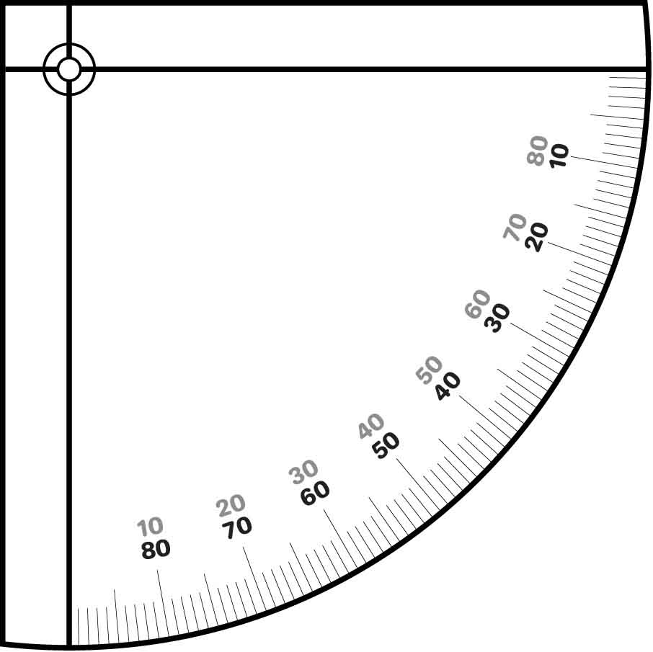

**Cut out the rulers and protractors to add more precision to your design!**

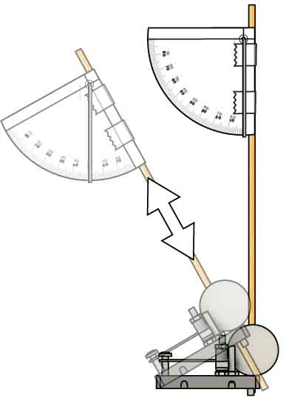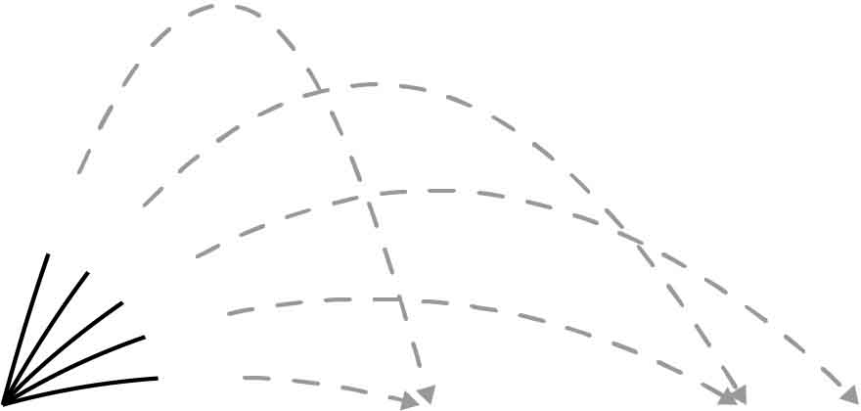

15°

30°

45°

60°

75°

Add a paperclip or wire to the protractor to make an inclinometer (which measures launch angle).   
See Page 4 of the [**Go Guide**](https://teachergeek.org/launcher2.0_go_guide.docx), available at [**teachergeek.com/launcher2.0**](https://teachergeek.com/launcher2.0)

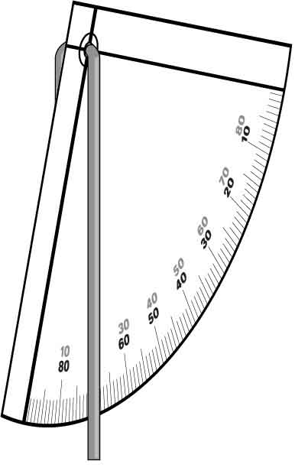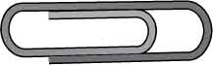



Use the protractor or ruler to measure wind-up distance.

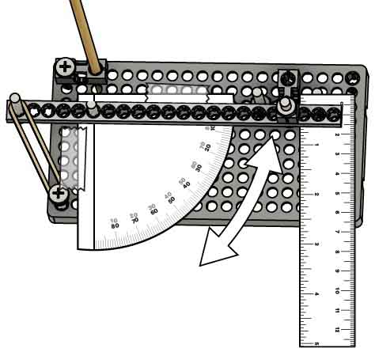

POWER

