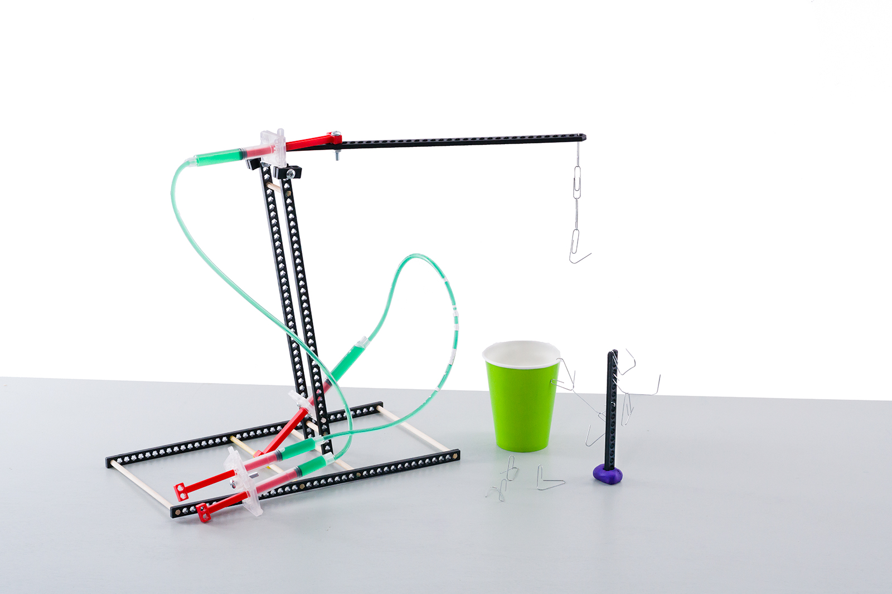

**Challenge Supplies**Judo-Bot, 25-50 paper clips,   
cup or container for sorting, ruler

**The Challenge:** Redesign your Judo-Bot   
to pick up and sort as many paper clips   
as possible in two minutes’ time.



**Time Limit:** Two-minutes

**Difficulty:** Easy-Medium







Attach bent paper clips   
to your lever arm to act   
as end effectors to grab and sort the other clips.

**Pick up paper clips 30 cm (1ft) from surface.**



**Paperclip  
Tree**

**Tip:** Use a **“tree”** structure to hold paper clips –   
a connector strip and clay allows the clips to be grabbed at different heights.

**Use any cup or container**

This is an *example* Judo-Bot.   
You can make it *so* much better. Redesign it to pick up and sort   
as many paper clips as possible.

**Clay**

**Constraints:** (rules and limits for your design)

* Only **hydraulic power** may be used to move and control the Judo-Bot.
  + Hydraulic lines may not be pushed or pulled to move the bot – just **pistons**.
* The **base** may not be anchored (taped, screwed, bolted) to the challenge surface.
* The **end effector** should include a paper clip in some way.
* Additional materials should be brought in for Judo-Bot designs, if they are:
  + TeacherGeek Components
  + Found & Recycling Bin Materials
  + Teacher Approved
  + Non-Hazardous (no sharp edges, harmful chemicals, etc.)
* You will have _____________________ to complete the challenge.

Fill in how much   
time you have



*The time from building and   
re-designing your Judo-Bot   
to the start of the competition.*

**Amount of Paper Clips Picked Up and Sorted, in Two Minutes**

|  |  |  |  |  |  |  |
| --- | --- | --- | --- | --- | --- | --- |
| **Group Name** | **Design #1** | **Design #2** | **Design #3** | **Design #4** | **Design #5** | **Design #6** |
|  |  |  |  |  |  |  |
|  |  |  |  |  |  |  |
|  |  |  |  |  |  |  |
|  |  |  |  |  |  |  |
|  |  |  |  |  |  |  |
|  |  |  |  |  |  |  |
|  |  |  |  |  |  |  |
|  |  |  |  |  |  |  |
|  |  |  |  |  |  |  |