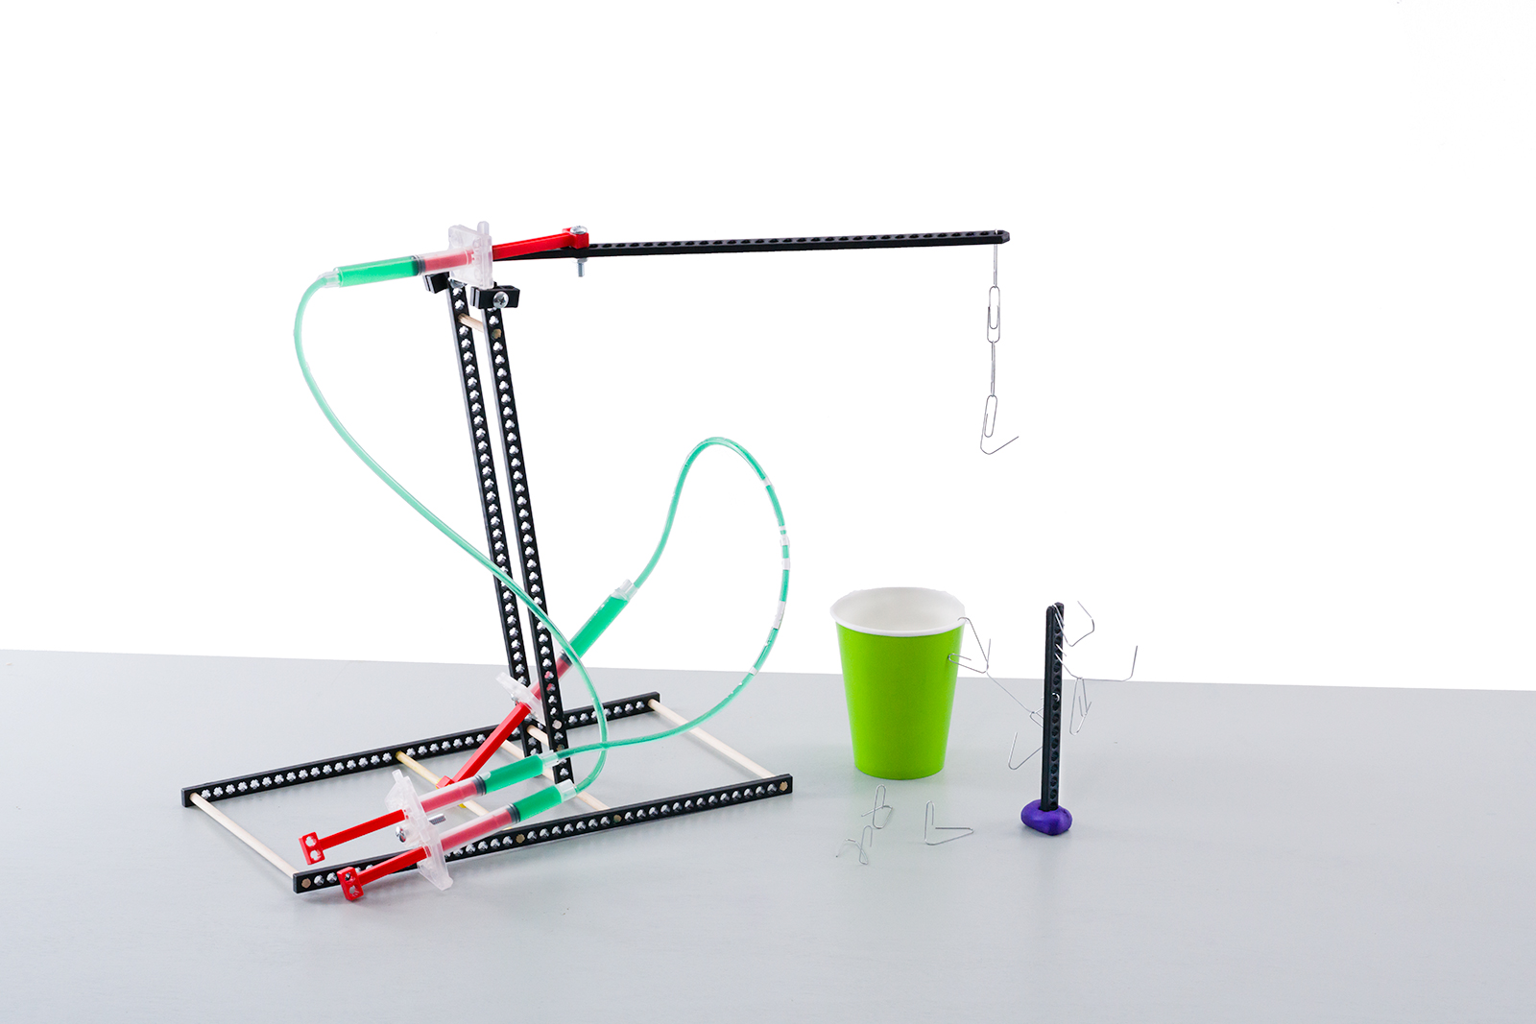



**THINKING AHEAD** *How does shifting the   
lever arm’s fulcrum  
change how your   
Judo-Bot moves?*

Download Documents and get   
your supplies at **teachergeek.com**

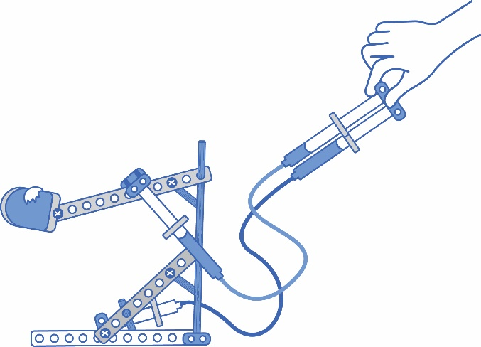 **Recommended Age level:**

Activity Age Level: 5-10

Lab Age Level: 5-10 (grades 3-12)

Recommended Group Size: 2-4



Engineer a Judo-Bot that can easily topple an opponent.  
Start by building the example Judo-Bot in the “Build Guide”.   
Learn about hydraulic systems and fluid power by completing the optional Lab Activities.   
Then, design and build your own Judo-Bot to compete and battle in Engineering Challenges.



What’s unique about this, and other TeacherGeek activities?

This is a **True STEM/Engineering** activity. It allows kids to:

* *Tinker and experiment*
* *Grow understanding through experimentation and labs*
* *Isolate variables and utilize the scientific method*
* *Apply math and science concepts*
* *Create their own unique designs to become innovators.*

Every project turns out different, and evolves with their understanding. When you create a project using TeacherGeek, the data works (it’s usable). This allows  
kids to apply the math and science, see the results,   
and experience “I-get-it” moments (understanding   
*why* they need the math/science and *what* it does).

Adapted from Bloom’s Taxonomy



**Make It Your Own:** The documents for this activity are available   
in **PDF** and **Microsoft Word** format. If you wish to edit a document,   
simply download the Microsoft Word format.



**Next Generation Science Standards:**

**Motion and Stability: Forces and Interactions**

**3-PS2-1:** Plan and conduct an investigation to provide evidence of the effects of balanced and unbalanced forces on the motion of an object.

**3-PS2-2:** Make observations and/or measurements of an object's motion to provide evidence that a pattern can be used to predict future motion.

**MS-PS2-1:** Apply Newton's Third Law to design a solution to a problem involving the motion of two colliding objects.

**MS-PS2-2:** Plan an investigation to provide evidence that the change in an object's motion depends on the sum of the forces on the object and the mass of the object.

**MS-PS3-4:** Plan an investigation to determine the relationships among the energy transferred, the type of matter, the mass, and the change in the average kinetic energy of the particles as measured by the temperature of the sample.

**MS-PS3-5:** Construct, use, and present arguments to support the claim that when the motion energy of an object changes, energy is transferred to or from the object**.**

**MS-PS1-6:** Undertake a design project to construct, test, and modify a device that either releases or absorbs thermal energy by chemical processes.

**Engineering Design**

**MS-ETS1-1:** Define the criteria and constraints of a design problem with sufficient precision to ensure   
a successful solution, considering relevant scientific principles and potential impacts on people   
and the natural environment that may limit possible solutions.

**MS-ETS1-2:** Evaluate competing design solutions using a systematic process to determine how well they meet the criteria and constraints of the problem.

**MS-ETS1-3:** Analyze data from tests to determine similarities and differences among several design solutions to identify the best characteristics of each that can be combined into a new solution to better meet the criteria for success.

**MS-ETS1-4:** Develop a model to generate data for iterative testing and modification of a proposed object, tool, or process such that an optimal design can be achieved.

**Energy**

**HS-PS3-1:** Create a computational model to calculate the change in the energy of one component in a system when the change in energy of the other component(s) and energy flows in and out of the system are known.

**HS-PS3-2:** Develop and use models to illustrate that energy at the macroscopic scale can be accounted for as either motions of particles or energy stored in fields.

**HS-PS3-3:** Design, build, and refine a device that works within given constraints to convert one form of energy into another form of energy.

**Science Standards of Learning for Virginia Public Schools:**

**Scientific Investigation, Reasoning, and Logic**

**4.1:** The student will plan and conduct investigations in whichdistinctions   
 are made among observations, conclusions, inferences, and predictions:

**□** Hypotheses are formulated based on cause-and-effect relationships

□ Variables that must be held constant in an experimental situation are defined

**□** Appropriate instruments to measure linear distance, volume, mass, temperature

□ Appropriate metric measures are used to collect, record, and report data

□ Data are displayed using bar and basic line graphs

□ Numerical data that are contradictory or unusual in experimental results are recognized

□ Predictions are made based on data from picture graphs, bar graphs, and line graphs.

**Force, Motion, and Energy**

**4.2**: Will investigate and understand characteristics and interaction of moving objects.

□ Motion is described by an object’s direction and speed  
 □ Forces cause changes in motion

□ Friction is a force that opposes motion

□ Moving objects have kinetic energy



**Hydraulic Systems** transmit and transfer power through fluid (gas or water).

* **Pneumatic Systems:** systems that use a gas to transmit and store power.
* **Hydraulic Systems:** systems that use a fluid (liquid) to transmit power.
* **Cylinders:**transform pressure and fluid flow into mechanical force.
* **Force:** a push or pull upon an object.
* **Pressure:** a force applied over an area.
* **Friction:** resistance of motion between two objects. Turns kinetic energy into heat.
* **Fluid:** a substance, gas or liquid, capable of flowing.
* **Viscosity:** a measure of a fluid’s resistance to flowing, or its thickness.
* **Pascal’s Law:** a confined fluid transmits an external pressure uniformly in all directions.
* **Non-Newtonian Fluids:** fluids without a constant viscosity.
* **Mechanical Advantage:** trading force for distance.
* **End Effector:** a device at the end of a robotic “arm” to interact with the environment.



Below is the list of “*ingredients*” you’ll need for one Judo-Bot.

|  |  |  |  |  |
| --- | --- | --- | --- | --- |
|  |  |  |  |  |
| **6 - Connector Strips** | **6 - Dowels** 300mm (12 ″) | **1 - Slide Stop**  76mm (3 ″) | **8 - Blocks** | **4 - 4.5mL Cylinders**  May need to be cut off a roll |
|  |  |  |  |  |
| **4 - Cylinder Screws** | **6 - 25mm Screws** #10 25mm (1″) | **6 - Nuts**  #10 | **4 - Zip Ties** | **Vinyl Tubing**  (2 ft section) |



*[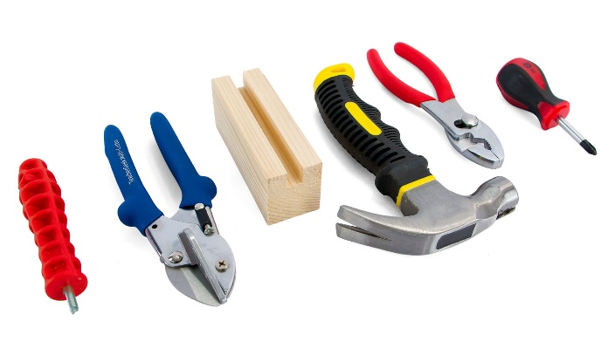](https://teachergeek.com/products/easy-engineering-tool-set?variant=344866731)*This isn’t a kit. You’re going to really build   
(cut, ream, screw) your Judo-Bot.   
Here are tools you’ll need to get started.   
They can be shared by up to 4 groups at a time.

* **TeacherGeek Reamer**
* **TeacherGeek** [**Multi-Cutter**](https://teachergeek.com/products/1823-81)
* **Tapping Block** - Optional
* **Small** [**Hammer**](https://teachergeek.com/products/stubby-claw-hammer)
* **Pliers** - Optional



**Tip:** Save all your materials (even what you cut off). Keep them in a bag. They can be used later.

* **Philips** [**Screwdriver**](https://teachergeek.com/products/stubby-2-screwdriver)

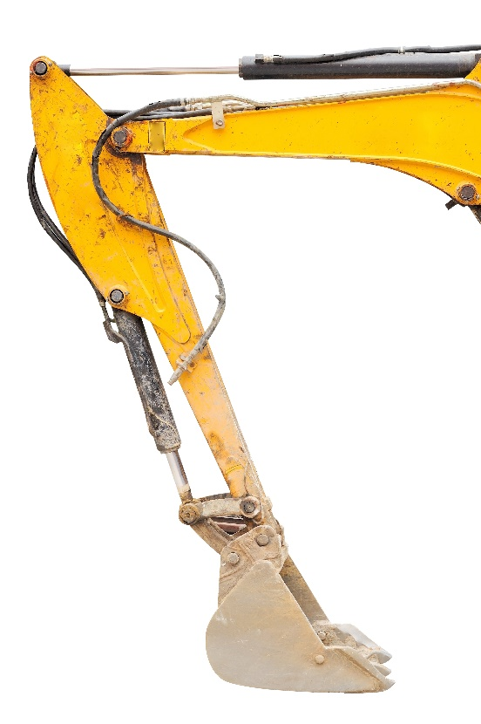



Just as blood pumps and circulates throughout our bodies,   
machines can be powered by fluids. **Hydraulic Systems** transfer   
**force** via **pressure** through **cylinders**, resulting in the **energy** that   
powers motors, pistons, joints and arms. If you ever see tubing on   
the side of industrial equipment, **Hydraulic Systems** are at work.

****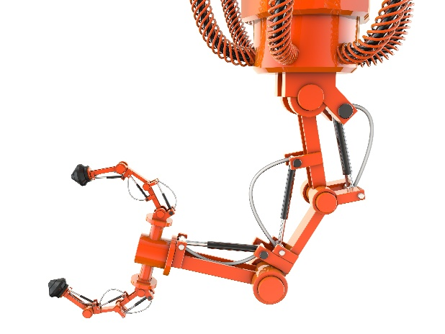

**Hydraulic Systems** power more than   
construction and agriculture, however.   
They are often the foundation of **robotics.**   
Robots are more than the realm of Science Fiction;   
these task-based machines coincided with the dawn   
of automation, christened by **Karel Čapek** in the 1920 play **R.U.R.**



Modern **Robots** are frequently designed for **“dull, dirty or dangerous**” work – things humans cannot, or will not, do. Mining rare materials deep underground, diffusing bombs, working a factory assembly   
line or roving the surface of Mars, robots need to be **engineered**   
to best fit their environment and complete their task.



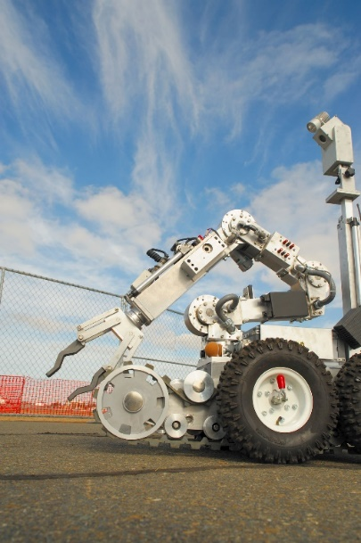

**Judo** is a Japanese martial art and Olympic competition. Opponents are subdued through a throw, pin or **take down**. Martial arts are for more than just human athletes however –   
robots have sports too! **Robot Competitions** such as   
**Battle Bots**, **Robot Wars** and student robotics clubs   
pit creations against each other. Sometimes, the   
bots have to complete a task like robot soccer   
or “**end effector** to end effector” combat.

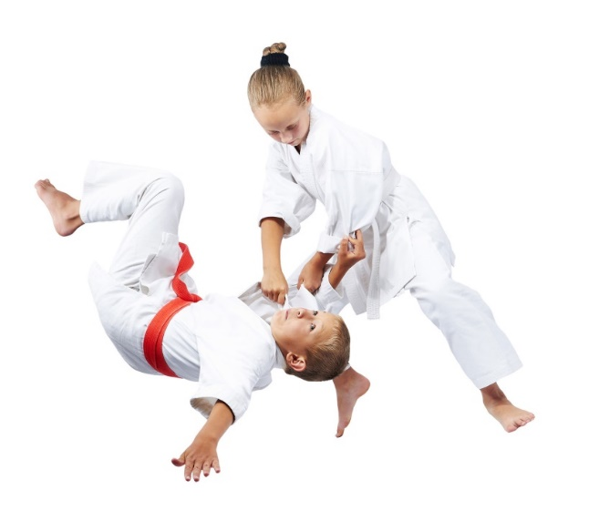

*How would you design your Judo-Bot’s base or end effector  
to best knock down an opponent, or push it out of bounds?*



There are “a ton” of resources to help you complete this activity. Pick and choose the ones that will work for you. They are available as links below, or at **teachergeek.com/learn**.

**Judo-Bot Documents**

* Classroom Overview - This is it (you’re reading it).
* Judo-Bot Build Guide – Required
  + [Build Guide](http://teachergeek.org/Judo%20Bot%20Build%20Guide.pdf)
* Labs
  + [Fluid Power Lab](http://teachergeek.org/gears-basic-ratio-lab.pdf) - Optional
    - Learn about hydraulic and pneumatic systems in this guided activity.
* [Judo-Bot Engineering Challenges](http://teachergeek.org/Judo-Bot-r-r-rumble-challenge.pdf) - Optional

**Judo-Bot Videos**

* [NASA Student Robot Competitions](https://www.youtube.com/watch?v=Mth3WlPxawQ)- Youtube Video

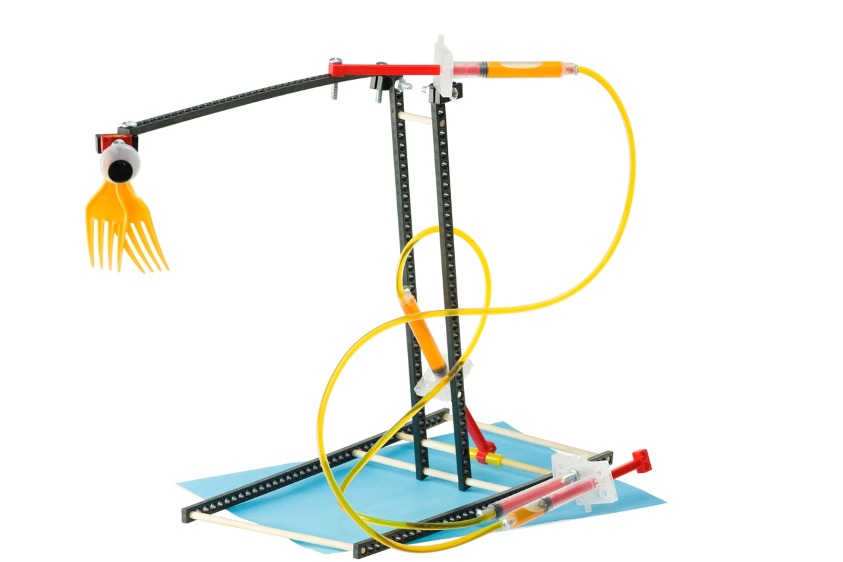

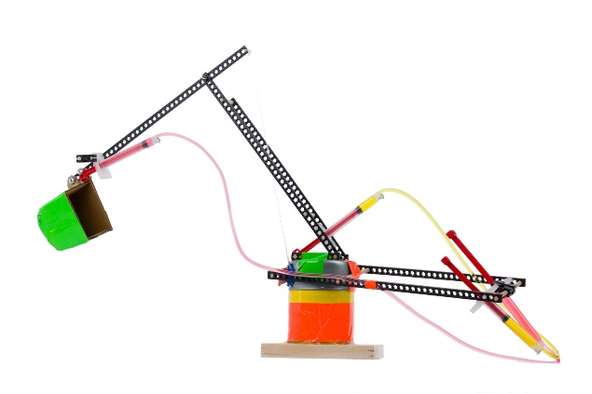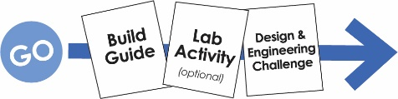



There are many optional Labs for your **Judo-Bot**.

Links in the Build Guide indicate when during the building process

these Labs and Challenges can be completed, if you want to.

After you’ve finished, you can download the Engineering Challenges

and [Engineering Notebook](http://teachergeek.org/engineering_notebook.pdf) sheets to take your designs to the next level.

Documents are available as links below or at teachergeek.com/learn.



**Build Guide — Required**

During this step you will create an example Judo-Bot.   
The Bot can be kept together and used in the labs and challenges or   
taken apart at the end of the activity to be used during other class sessions.

[Download the Judo-Bot Build Guide](http://teachergeek.org/Judo%20Bot%20Build%20Guide.pdf)



**Lab Activities — Optional**

**Fluid Power Lab**

This Lab allows students to explore Hydraulic and Pneumatic Systems and how they function in powering machinery through worksheets, experiments and application.

**Instructions:**

* + Discuss the following concepts with your students.   
    Ask them to provide describe, define, and/or give examples for each:
    - Hydraulic
    - Pneumatic
    - Pascal’s Law
    - Pressure
    - Kinetic & Potential Energy
    - Mechanical Advantage
    - Friction
    - Viscosity
    - Work
  + Distribute Lab sheets. Explain the lab procedure and let them get to work.

[Download the Fluid Power Lab](http://teachergeek.org/gears-basic-ratio-lab.pdf)



**Engineering Challenges**

The following challenges are optional. It’s an Engineering Challenge –

immersing students in the Engineering Design process. Learn more

about the Engineering Design Process on the next page.

[*Download the Engineering Notebook Sheets*](http://teachergeek.org/engineering_notebook.pdf)

[Download the R-R-Ready to Rumble!](http://teachergeek.org/Judo-Bot-r-r-rumble-challenge.pdf)

Are you ready to r-r-rumble? Design and redesign Judo-Bots for battle, competing head-to-head in tournaments for the coveted TeacherGeek Intercontinental Championship Title Belt. Using bases, end effectors and mechanical advantage, students will engineer bots ready for the spirit of combat.[Download the Heavy Lifting Challenge](http://teachergeek.org/judo-bot-Heavy-Weight-challenge.pdf)Students will engineer their Judo-Bot to try and lift the most weight (in clay and grams) possible. Watch the lever arms bend and sway as weight is added incrementally, and mechanical advantage is used to gain an advantage on classmates.[Download the Paper Clip Challenge](http://teachergeek.org/judo-bot-paper-clip-challenge.pdf)Students will design Judo-Bots (and end effectors) to pick-up and sort the most paper clips possible in a time limit. Speed, precision and delicious heartache are all at play in this high octane competition – who knew office supplies could be so thrilling?

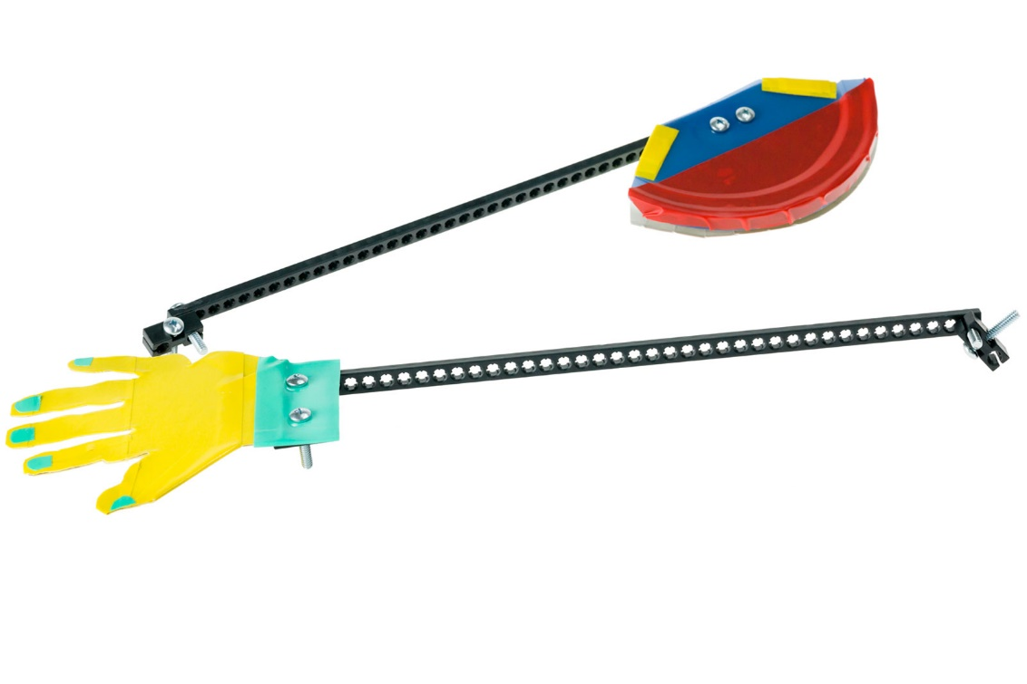



Do you have a challenge to solve? Is there something you want to invent, fix or improve? You do? Excellent…   
the **Engineering Design Process** is exactly what you need.

Inventing, fixing, improving… these are really ways to create a solution to a problem. A problem can be as complicated as creating a way to live on Mars, or as simple as stopping a door from squeaking. You are reading this because you have   
a problem to solve: design a Judo-Bot to topple opponents.  
The Design Process will help you solve it. Here’s how it works:



**What is the problem (what needs to be solved/made better)?**

The Design Process helps you solve a problem. Therefore you need to start the   
Design Process by identifying a problem. In this activity, your problem is to create   
a Judo-Bot that can move its arm and end effector to battle opponents in competition.

After constructing your first Judo-Bot and going through the initial Design Process,   
your problem may change. Your next problem might be to make the Judo-Bot’s  
lever arm move nimbly up and down, back and forth or side-to-side.

There is no perfect design, so there is no end to the Design Process. You can always identify a new problem (make your Judo Bot better) and go through the Design Process again.

**Research: How have others solved, or attempted to solve this problem?**

If you are going to solve the problem, you better know what you are doing.   
After identifying the problem, look at how others have solved, or tried to solve it.  
Look around your class, search the library and internet, or ask other people.

**What are the constraints (things your design cannot, or must, do or be)?**

It would be great if you could solve this problem any way you want, with anything you want. The truth is… you can’t! You have these things called “constraints” which limit what your design can do, can’t do, must be, or can’t be (How confusing is that?). Constraints could be resources like time or materials. They could also be rules – like what materials can be used for end effectors. You need to identify the constraints to your problem before you can solve it.

 **Brainstorm, sketch and describe possible solutions (different ideas might solve the problem).**

This is a fun part. You can brainstorm, or use another process, to come up with as many possible solutions to your problem as possible. Consider your problem, constraints and research while generating possible solutions. Do not judge, or pick, your best solution   
at this point. Just write as many down as you can. Note: whacky/unique ideas   
sometimes lead to wonderful new design solutions. Value creativity and originality!

**Choose the best solution. Circle it. Why do you think it is best?**

Ok - now it’s time to judge. Pick what you think will be the best solution to your problem. Make sure it fits the constraints. It’s ok to feel sorry for all the possible solutions that didn’t   
get picked. They were good ideas too…



**Draw the solution you choose. Include the details you will need to create it.**

Neatly sketch the design you choose (the one you are going to build).   
The sketch should include details and descriptions about how it will work, or be built.



**Build the solution you planned.**

Is this the step you have been waiting for? You finally get to build the solution to   
your problem (the new design). Have fun! Take the time to make it properly.

**Test it.**

Test your solution (new design). How does it work? Does the Judo-Bot   
tip over every time the lever arm moves? Are the end effectors too light, or heavy?  
Make small adjustments to optimize it (to try and make this design solution work best).

**Make observations. Record results.**

Pay close attention while testing your solution. Write down what happened   
Did your Judo-Bot’s arm move quickly? Slowly? Did the base stay balanced or   
topple too easily? Could your cylinder be positioned closer on the lever arm?  
You will use this information to make your Judo-Bot even better.  
  
  


**Did you solve the problem?**

Look at the test results. Reflect on your observations.   
Did your solution solve the problem as you had planned?

**Yes? Great! Identify a new problem (a way to make your design even better).**

There is no perfect design (yep... your design can still be improved).   
Identify another problem that will make your Judo-Bot even better.   
Grab another Engineering Notebook Sheet and try to solve it.

**No? That’s OK. What did you learn that can help solve it in a new/different way?**

You learn more from failures than you do from successes. The best solutions come   
from/after failures (ideas that didn’t work). Most inventions do not work the first   
time around the Design Process. Learn from what didn’t work. Grab another   
Engineering Notebook Sheet and try to solve the problem a different way.



Fill in a TeacherGeek Engineering Notebook Sheet (front and back)  
every time you go around the Design Process. Keep your Notebook Sheets.   
Assemble them into an Engineering Notebook at the end of the project.

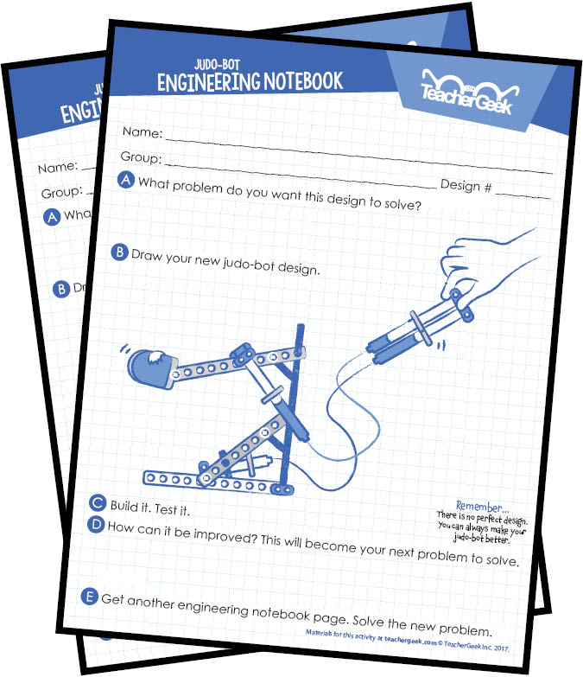[*Download the Engineering Notebook Sheets*](http://teachergeek.org/engineering_notebook.pdf)

***Question*** *Do you need to fill out a new Engineering Notebook Sheet for small changes or tweaks to an existing design?*

*Nope… just record what you did on the current Notebook Sheet.*

**