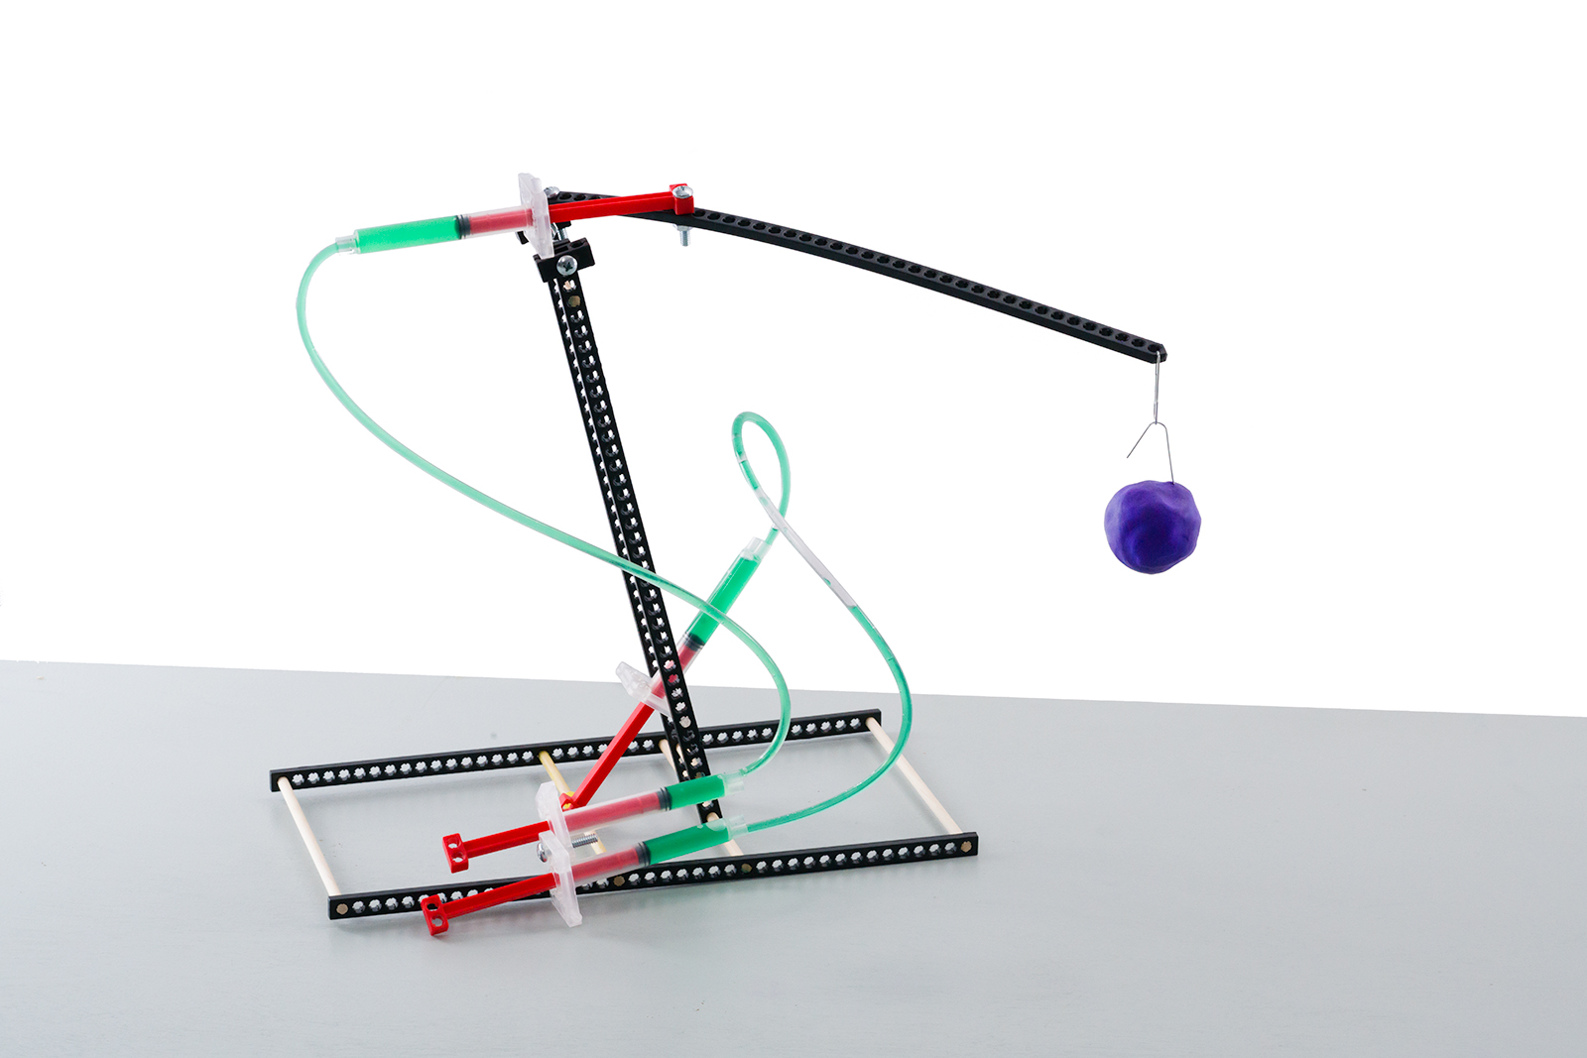

**Challenge Supplies**Judo-Bot, paper clips,  
100-500 grams of clay, ruler

**The Challenge:** Redesign your Judo-Bot to   
lift the most weight, as high as possible, without the frame tipping over.



**Time Limit:** Two-minutes

**Difficulty:** Hard







**Lift weight 30 cm (1ft) from surface.**

The clay must be placed   
30 cm from the base to start.

**Base**

Bend two **paper clips** to lift & hold the clay.  
One for the **lever arm**, the other as a handle for the **clay** (weight).

**Optional:** Make the challenge more difficult   
by requiring the bot’s base stay in one place.

This is an *example* Judo-Bot design. You can make it *so much* better. Redesign it so the **lever arm** can   
lift as much weight as possible.

**Clay**

**Constraints:** (rules and limits for your design)

* Only **hydraulic power** may be used to move and control the Judo-Bot.
  + Hydraulic lines may not be pushed or pulled to move the bot – just **pistons**.
* The **base** may not be anchored (taped, screwed, bolted) to the challenge surface.
* The End Effector must be one paper clip, bent however you choose.
* Additional materials should be brought in for Judo-Bot designs, if they are:
  + TeacherGeek Components
  + Found & Recycling Bin Materials
  + Teacher Approved
  + Non-Hazardous (no sharp edges, harmful chemicals, etc.)
* You will have _____________________ to complete the design challenge.

Fill in how much   
time you have



*The time from building and   
re-designing your Judo-Bot   
to the start of the competition.*

|  |  |  |
| --- | --- | --- |
|  | **Weight Lifted   (Grams)** | **Height Lifted  (Cm)** |
| **Design #1** |  |  |
| **Design #2** |  |  |
| **Design #3** |  |  |
| **Design #4** |  |  |
| **Design #5** |  |  |
| **Design #6** |  |  |
| **Design #7** |  |  |



**Independent Variable:**Height Lifted by Lever Arm

**Dependent Variable:**Weight of Clay in Grams

