

**THINKING AHEAD** *How can you best  
deliver nutrients to  
a plant without soil?*

Download Documents   
and get your supplies at **teachergeek.com**

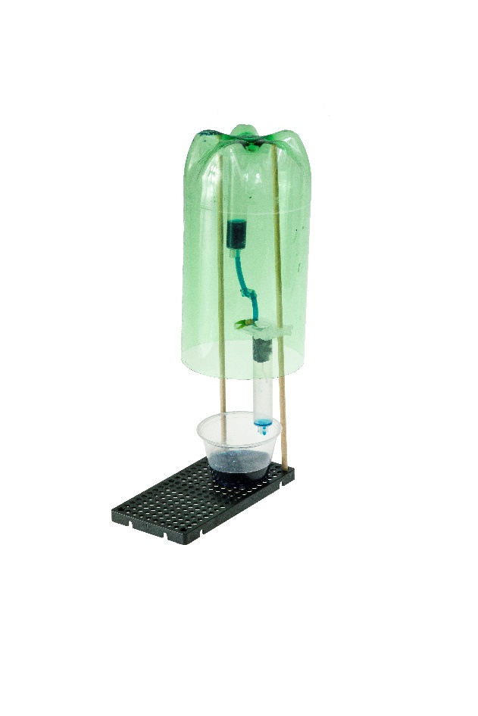**Recommended Age level:**

Activity Age Level: 12 -18

Lab Age Level: (grades 7-12)

Recommended Group Size: 2-4



Engineer a Hydroponic System that can grow durable plants without soil.  
Start by building an example Micro Hydroponic System in the “Build Guide”.   
Learn about forces and concepts like torque by completing the optional Ratio Lab.   
Then, design and build your own Tinker Set to compete in Engineering Challenges.



What’s unique about this, and other TeacherGeek activities?

This is a **True STEM/Engineering** activity. It allows kids to:

* *Tinker and experiment*
* *Grow understanding through experimentation and labs*
* *Isolate variables and utilize the scientific method*
* *Apply math and science concepts*
* *Create their own unique designs to become innovators.*

Every project turns out different, and evolves with their understanding. When you create a project using TeacherGeek, the data works (it’s usable). This allows  
kids to apply the math and science, see the results,   
and experience “I-get-it” moments (understanding   
*why* they need the math/science and *what* it does).

Adapted from Bloom’s Taxonomy



**Make It Your Own:** The documents for this activity are available in   
**PDF** and **Microsoft Word** format. If you wish to edit a document,   
simply download the Microsoft Word format.



**Next Generation Science Standards:**

**From Molecules to Organisms: Structures and Processes**

**MS-LS1-5 :** Construct a scientific explanation based on evidence for how environmental and genetic factors influence the growth of organisms.

**MS-LS1-6:** Construct a scientific explanation based on evidence for the role of photosynthesis in the cycling of matter and flow of energy into and out of organisms.

**MS-LS1-7:** Develop a model to describe how food is rearranged through chemical reactions forming new molecules that support growth and/or release energy as this matter moves through an organism.

**Ecosystems: Interactions, Energy, and Dynamics**

**MS-LS2-1:** Analyze and interpret data to provide evidence for the effects of resource availability on organisms and populations of organisms in an ecosystem.

**MS-LS2-3:** Develop a model to describe the cycling of matter and flow of energy among living and nonliving parts of an ecosystem.

**MS-LS2-5:** Evaluate competing design solutions for maintaining biodiversity and ecosystem services.

**Earth and Human Activity**

**MS-ESS3-2:** Analyze and interpret data on natural hazards to forecast future catastrophic events and inform the development of technologies to mitigate their effects.

**MS-ESS3-3:** Apply scientific principles to design a method for monitoring and minimizing a human impact on the environment

**Engineering Design**

**MS-ETS1-1:** Define the criteria and constraints of a design problem with sufficient precision to ensure a successful solution, taking into account relevant scientific principles and potential impacts on people and the natural environment that may limit possible solutions.

**MS-ETS1-2:** Evaluate competing design solutions using a systematic process to determine how well they meet the criteria and constraints of the problem.

**MS-ETS1-3:** Analyze data from tests to determine similarities and differences among several design solutions to identify the best characteristics of each that can be combined into a new solution to better meet the criteria for success.

**MS-ETS1-4:** Develop a model to generate data for iterative testing and modification of a proposed object, tool, or process such that an optimal design can be achieved.

**Ecosystems: Interactions, Energy, and Dynamics**

**HS-LS2-7:** Design, evaluate, and refine a solution for reducing the impacts of human activities on the environment and biodiversity.

**Virginia Department of Education Standards of Learning**  
  
**Life Systems, Ecosystems, Earth & Space Systems**

**LS.5**: The student will investigate and understand the basic physical and chemical processes

of photosynthesis and its importance to plant and animal life. Key concepts include

a) energy transfer between sunlight and chlorophyll;

b) transformation of water and carbon dioxide into sugar and oxygen; and

c) photosynthesis as the foundation of virtually all food webs

**LS.10**: The student will investigate and understand that ecosystems, communities,

populations, and organisms are dynamic, change over time, and respond to daily,

seasonal, and long-term changes in their environment. Key concepts include

a) phototropism, hibernation, and dormancy;

b) factors that increase or decrease population size; and

c) eutrophication, climate changes, and catastrophic disturbances.

**LS.11:** The student will investigate and understand the relationships between   
 ecosystem dynamics and human activity. Key concepts include

a) food production and harvest

e) environmental issues

**6.6:** The student will investigate and understand the properties of air and the structure and

dynamics of Earth’s atmosphere. Key concepts include

b) pressure, temperature, and humidity;

d) natural and human-caused changes to the atmosphere and the importance of

protecting and maintaining air quality



Insert information about **Hydroponic Systems**

* **Photosynthesis:** plant process converting sunlight into chemical energy
* **Phototropism:** the specific movement of a plant part toward a light source.
* **Evaporation:** a substance changing from a liquid state to a gaseous state
* **Hydroponic System:** The practice of farming without soil, mainly through water
* **Aeroponic System:** The practice of farming without soil, through mist and air
* **Fluid:** a substance with flow, either a liquid or gas
* **pH (Potential of Hydrogen):** scale to determine the acidity or basicity of afluid
* **Acid:** a fluid with a pH >7
* **Base:** a fluid with a pH <7
* **Neutral:** a fluid with a pH of 7
* **Macro-nutrients:** nitrogen, phosphorus, potassium
* **Micro-nutrients:** boron, calcium , copper, iron, magnesium, sulfur, zinc
* **Greenhouse:** an enclosed glass building that allows in sunlight and traps heat
* **Greenhouse Effect:** the earth’s atmosphere trapping heat through greenhouse gases
* **Climate:** general weather conditions in a region observed over a long period of time
* **Independent Variable:** the thing you change in an experiment
* **Dependent Variable:** the thing that changes as a result of the IV
* **Control Variable:** the things that do not change in an experiment

Components available in the TeacherGeek [Maker Cart](https://teachergeek.com/products/maker-cart), or at [**teachergeek.com**](https://teachergeek.com/)

|  |  |  |  |  |  |
| --- | --- | --- | --- | --- | --- |
|  |  |  | |  | |
| **4 - Barrels**  [14.5](https://teachergeek.com/products/wiggle-bots?variant=13701612932)ml | [**Vinyl**](https://teachergeek.com/products/wiggle-bots?variant=13701612932) **Tubing**  ⅛″D x 38cm (15″)L | **1 - Hole Plate** | | **Portion Cup** | |
|  |  |  |  |  |  |
| **6 - Dowels**  300mm (12″) | **4 - Connector Strips** | **1 - Slide Stop 4 - Blocks** | | **Check Valve** | **T-Connector** |



Tools can be shared between classes and groups.



**Tip:** Save all your materials (even what you cut off). Keep them in a bag. They can be used later.

|  |  |  |
| --- | --- | --- |
|  |  |  |
| **Multi-Cutter** | [**Hammer**](https://teachergeek.com/products/stubby-claw-hammer) | **Reamer** |



Here are some non-TeacherGeek materials that you will need.

|  |  |  |
| --- | --- | --- |
|  |  |  |
| **Recycling Materials**  Plastic, cardboard,  food packaging. | **Growing Media**  Piece of cloth, rockwool, cotton ball, etc.  Needs to hold seedling in barrel,  but still allow roots to grow. | **Seeds** mung beans, tomatoes, lettuce, spinach, basil |



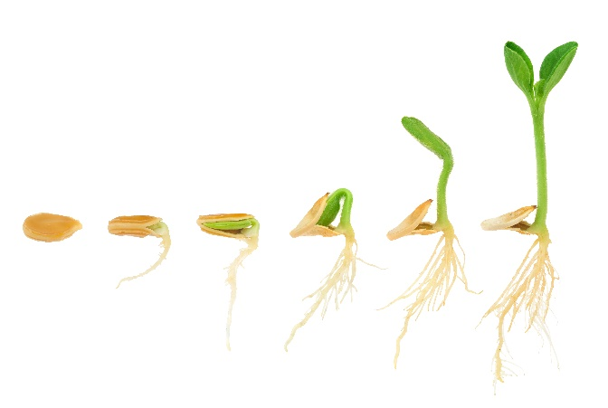



**Hydroponic Systems** may sound complex, but   
they have been the foundation of agricultural   
engineering since the **Hanging Gardens of Babylon.**

The father of Hydroponics is **Dr. William Frederick Gericke**,   
a Berkeley professor who combined the Latin for “water”   
(**Hydro**) and “power” (**Ponic**s) to describe his revolutionary,   
**soil-free** cultivation of tomato plants in 1929.

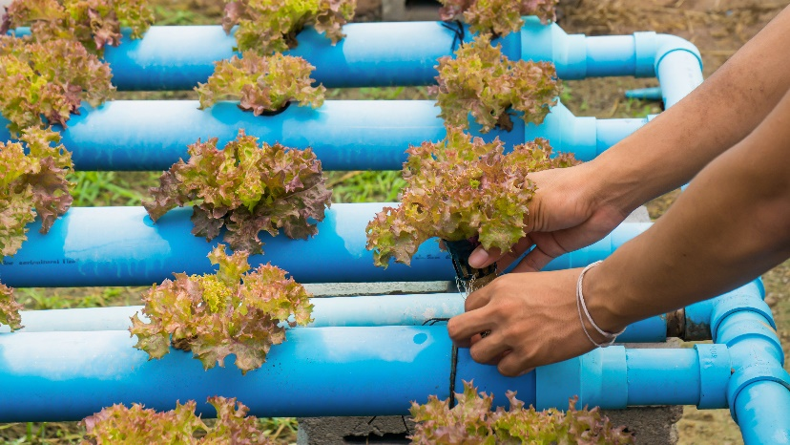 **Hydroponic Systems** have many benefits.   
They support land and **water conservation**,   
utilizing less square space and water than traditional agriculture for greater output.   
Farmers control **nutrient** intake to grow  
bigger, healthier plants more consistently.

These systems are adaptable for non-traditional growing environments, including **urban centers**, **arid climates** and the **International Space Station.**

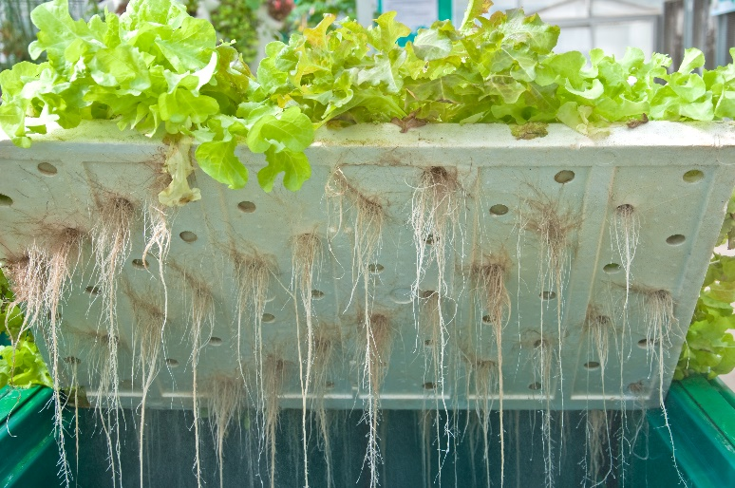

The most common Hydroponic crops include leafy greens such as **lettuce**, spinach and   
herbs. **Tomatoes** and **strawberries** are   
popular choices as well, their soil-free   
planting allowing for cultivation year-round.   
Ideal plants for a hydroponic system grow quickly and require very little **surface area**.

*What sort of plant would work best in   
your micro Hydroponic System?*



There are “a ton” of resources to help you complete this activity. Pick and choose the ones that will work for you. They are available as links below, or at **teachergeek.com/learn**.

**Micro Hydroponic Systems Documents**

* Classroom Overview - This is it (you’re reading it).
* [Micro Hydroponic Build Guide](http://teachergeek.org/Hydro-BUILD-GUIDE-IN-CLASSROOM.pdf) - Required
* [Hydroponic Systems Worksheet](http://teachergeek.org/Hydro-WORKSHEET.pdf) – Optional
* Labs
  + **Micro Hydroponic Systems Build Guide**
    - During this step you will create your own *Example Hydroponic System*.
  + **Hydroponic Systems Labs** - Optional
    - [pH Lab](http://teachergeek.org/Hydro-PH-LAB.pdf)
    - 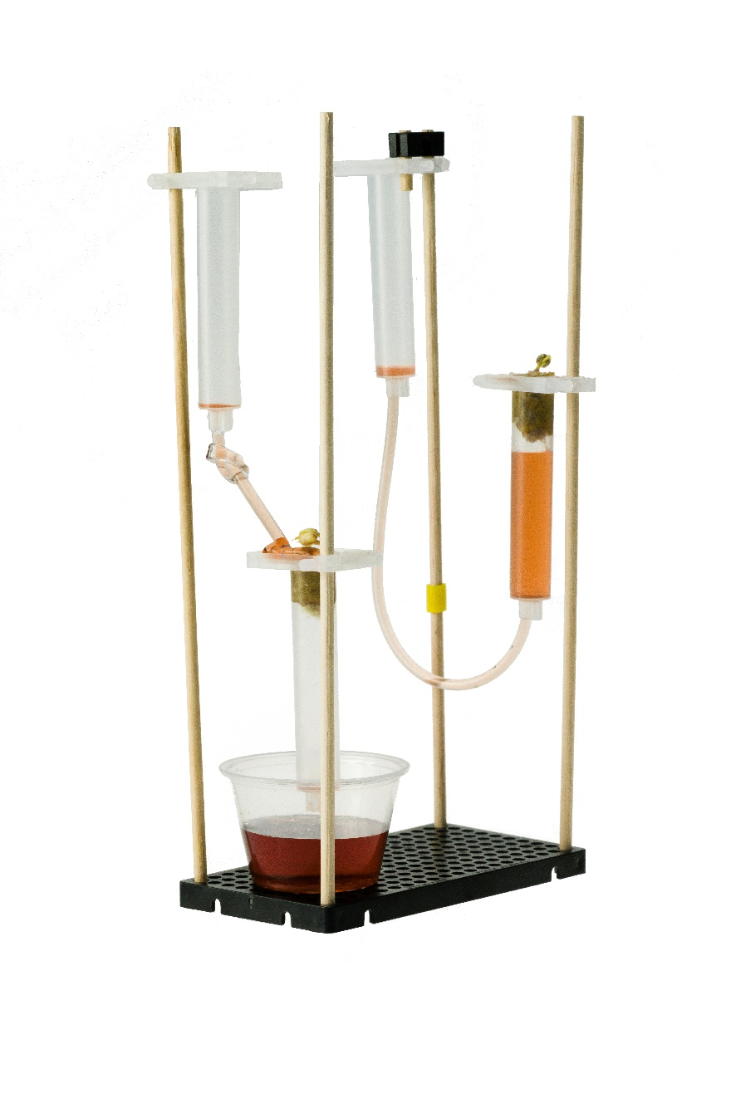[Nutrient Solution Lab](http://teachergeek.org/Hydro-NUTRIENT-LAB.pdf)
* [Micro Hydroponic Systems Challenges](http://teachergeek.org/Hydro-DESIGN-ENGINEERING-CHALLENGES.pdf) - Optional

**Micro Hydroponic System Videos**

* [NASA: Growing Plants in Space](https://www.youtube.com/watch?v=b-9bJTxwc3U) - YouTube Video
* [What are Hydroponics](https://www.youtube.com/watch?v=tzBK4QZSQaY&feature=youtu.be) - YouTube Video
* [Hydroponics at Disney’s Epcot](https://www.youtube.com/watch?v=BcdUYia7llk&feature=youtu.be) - Youtube Video

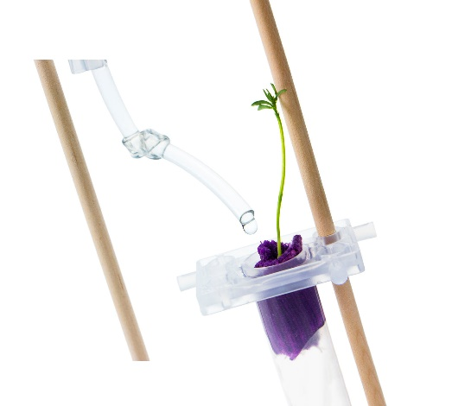[](https://teachergeek.com/blogs/projects/sail-car-activity)

There are many optional Labs for your **Micro Hydroponic System**.

Links in the Build Guide indicate when during the building process

these Labs and Challenges can be completed, if you want to.

After you’ve finished, you can download the Engineering Challenges

and [Engineering Notebook](http://teachergeek.org/micro_hydro_engineering_notebook.pdf) sheets to take your designs to the next level.

Documents are available as links below or at teachergeek.com/learn.



**Build Guide — Required**

During this step you will create an example Micro Hydroponic System.   
The System can be kept together and used in the labs and challenges or   
taken apart at the end of the activity to be used during other class sessions.

[Download the Micro Hydroponic Build Guide](http://teachergeek.org/Hydro-BUILD-GUIDE-IN-CLASSROOM.pdf)



**Hydroponic Systems Worksheet — Optional**

Learn about the history and different applications of hydroponic systems,   
from automated methods to the challenges of gardening in space, as well as photosynthesis. Excellent for in the classroom use with guided questions throughout.

[Download the Hydroponic Systems Worksheet](http://teachergeek.org/Hydro-WORKSHEET.pdf)



**Lab Activities — Optional**

**pH Measurement Lab** Learn the properties of acids and bases (alkali) through household fluids,

soda pop and the experimental process. Then, apply these pH measurement

concepts to the nutrient solution and water in their micro Hydroponic Systems.

**Instructions:**

* + Discuss the following concepts with your students.   
    Ask them to provide describe, define, and/or give examples for each:
    - pH
    - Acid
    - Base
    - Fluid
  + Distribute Lab sheets. Explain the lab procedure and let them get to work.

[Download the pH Measurement Lab](http://teachergeek.org/Hydro-PH-LAB.pdf)

**Nutrient Solution Lab** This Lab allows students to explore the power of Hydroponic Systems. They will explore   
 the different types of systems, the process of photosynthesis and space agriculture.

**Instructions:**

* + Discuss the following concepts with your students.   
    Ask them to provide describe, define, and/or give examples for each:
    - Photosynthesis
    - Hydroponic Farming
    - Aeroponic Farming
    - Micro-Nutrients
    - Macro-Nutrients
  + Distribute Lab sheets. Explain the lab procedure and let them get to work.

[Download the Nutrient Solution Lab](http://teachergeek.org/Hydro-NUTRIENT-LAB.pdf)



**Engineering Challenges**

*The following challenges are optional.*   
It’s an Engineering Challenge, immersing students in the Engineering Design process. Learn more about the Engineering Design Process on the next page. **To Such Great Heights Challenge**Students will design and adjust their micro Hydroponic Systems to grow   
the tallest, healthiest plants. They will utilize the experimental method,   
independent, dependent and control variables as well as graphing skills. **Pump it Up Challenge**Explore how hydroponic systems use the power of air pumps and oxygen for   
water aeration. Students will design and construct their own pumps using   
check valves, t-connectors, tubing and engineering ingenuity.

[Download the Hydroponic Design & Engineering Challenges](http://teachergeek.org/Hydro-DESIGN-ENGINEERING-CHALLENGES.pdf)

[Download the Hydroponic Systems Engineering Notebook Sheets](http://teachergeek.org/micro_hydro_engineering_notebook.pdf)



Do you have a challenge to solve? Is there something you want to invent, fix or improve? You do? Excellent…   
the **Engineering Design Process** is exactly what you need.

Inventing, fixing, improving… these are really ways to create a solution to a problem. A problem can be as complicated as creating a way to live on Mars, or as simple as stopping a door from squeaking. You are reading this because you have a problem to solve: use your Micro Hydroponic System to   
grow plants without soil. The Design Process will help you solve it. Here’s how it works:



**What is the problem (what needs to be solved/made better)?**

The Design Process helps you solve a problem. Therefore you need to start the   
Design Process by identifying a problem. In this activity, your problem is to create   
a Hydroponic System that can drip or give your plant nutrient solution over time.

After constructing your first Hydroponic System and going through the initial   
Design Process, your problem may change. Your next problem might be to   
develop a pump to oxygenate the water or construct a micro greenhouse.

There is no perfect design, so there is no end to the Design Process.   
You can always identify a new problem (a way to make your Micro   
Hydroponic System better) and go through the Design Process again.

**Research: How have others solved, or attempted to solve this problem?**

If you are going to solve the problem, you better know what you are doing.   
After identifying the problem, look at how others have solved, or tried to solve it.  
Look around your class, search the library and internet, or ask other people.

**What are the constraints (things your design cannot, or must, do or be)?**

It would be great if you could solve this problem any way you want, with anything you want. The truth is… you can’t! You have these things called “constraints” which limit what your design can do, can’t do, must be, or can’t be (How confusing is that?). Constraints could be resources like time or materials. They could also be rules, such as the size or material of the tubing. You need to identify the constraints to your problem before you can solve it.

**Brainstorm, sketch and describe possible solutions (different ideas that might solve the problem).**  
This is a fun part. You can brainstorm, or use another process, to come up with as many possible solutions to your problem as possible. Consider your problem, constraints and research while generating possible solutions. Do not judge, or pick, your best solution at this point. Just write as many down as you can. Note: wacky/unique ideas sometimes lead to wonderful new design solutions. Be super creative, and original.

**Choose the best solution. Circle it. Why do you think it is best?**

Ok - now it’s time to judge. Pick what you think will be the best solution to your problem. Make sure it fits the constraints. It’s ok to feel sorry for all the possible solutions that didn’t   
get picked. They were good ideas too…



**Draw the solution you choose. Include the details you will need to create it.**

Neatly sketch the design you choose (the one you are going to build).   
The sketch should include details and descriptions about how it will work, or be built.



**Build the solution you planned.**

Is this the step you have been waiting for? You finally get to build the solution to   
your problem (the new design). Have fun! Take the time to make it properly.

**Test it.**

Test your solution (new design). How does it work? Does the tubing allow the water to flow? Should the positioning of the barrels be changed? Make small adjustments to optimize it (to try and make this design solution work best).

**Make observations. Record results.**

Pay close attention while testing your solution. Write down what happened (the tubing closed, the nutrient solution changed pH). You will use this information to make your   
Micro Hydroponic System even better.



**Did you solve the problem?**

Look at the test results. Reflect on your observations.   
Did your solution solve the problem as you had planned?

**Yes? Great! Identify a new problem (a way to make your design even better).**

There is no perfect design (yep... your design can still be improved).   
Identify another problem that will make your Hydroponic System even better.   
Grab another Engineering Notebook Sheet and try to solve it.

**No? That’s OK. What did you learn that can help solve it in a new/different way?**

You learn more from failures than you do from successes. The best solutions come from/after failures (ideas that didn’t work). Most inventions do not work the first time around the Design Process. Learn from what didn’t work. Grab another Engineering Notebook Sheet and try to solve the problem a different way.



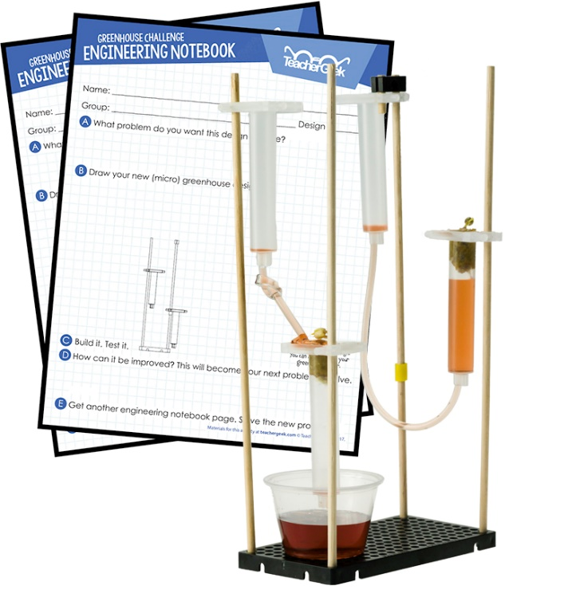

Fill in a TeacherGeek **Engineering Notebook Sheet** (front and back) every time you go around the Design Process. Keep your Notebook Sheets.   
Assemble them into an Engineering Notebook   
at the end of the project.  
  
***Question*** *Do you need to fill out a new   
Engineering Notebook Sheet for small   
changes or tweaks to an existing design?   
  
Nope… just record what you did   
on the current Notebook Sheet.*[Download the Engineering Notebook Sheets](http://teachergeek.org/micro_hydro_engineering_notebook.pdf)