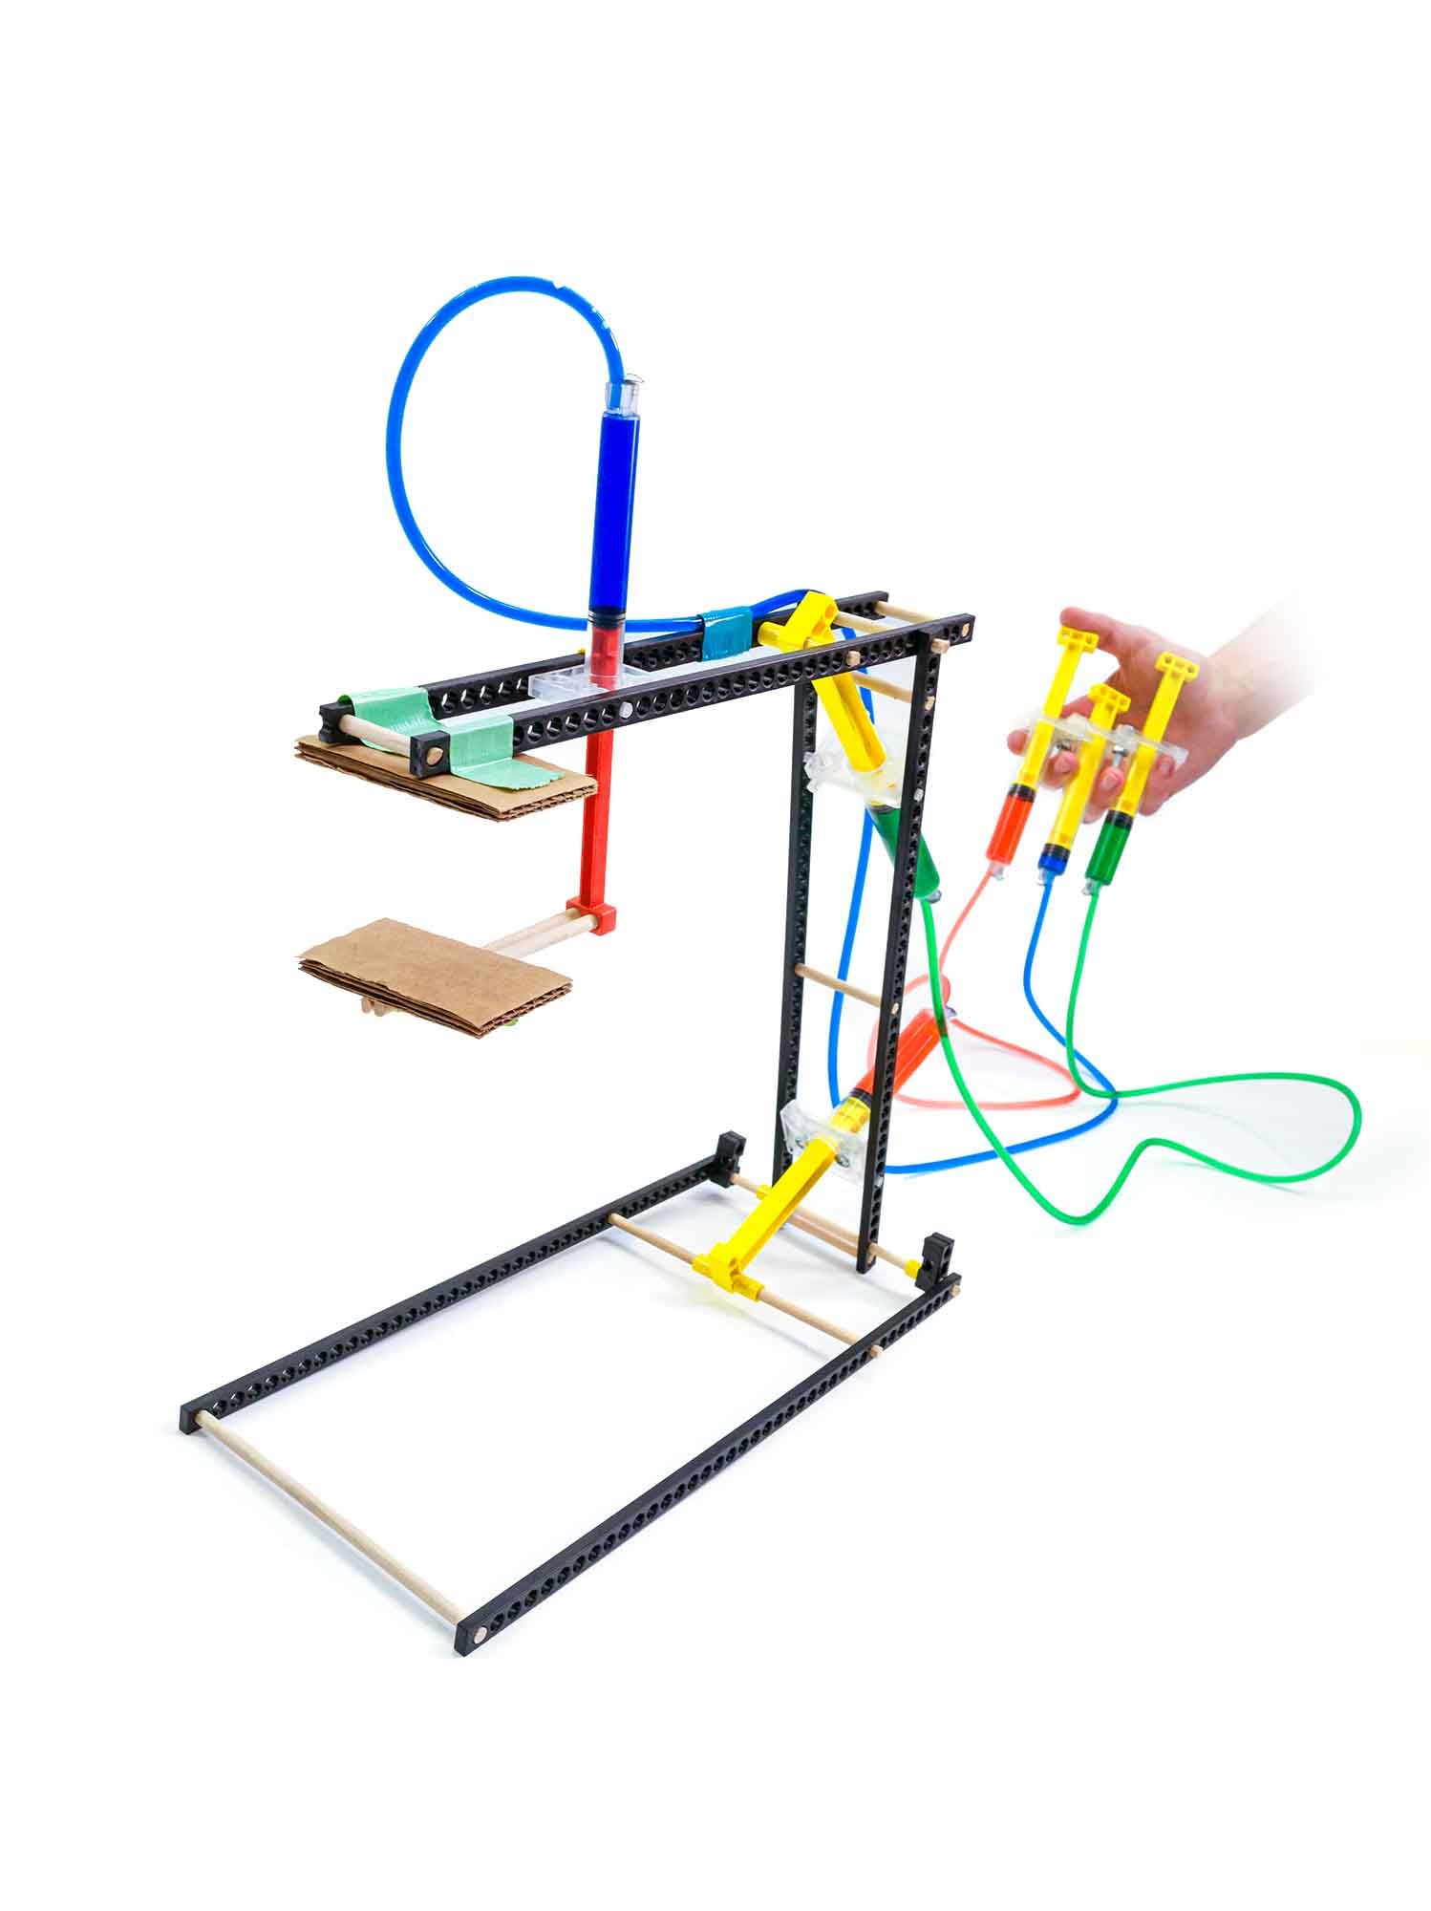  
Hydraulics are *AMAZING*!  
Use the power of water to control a machine.

This guide will help you create   
your own Hydraulic Arm.

**Swing**!

GRAB!

­­­

**Swing**!



Download Documents  
at **teachergeek.com**

**THINKING AHEAD** *What kinds of objects can you move with different gripper designs?*



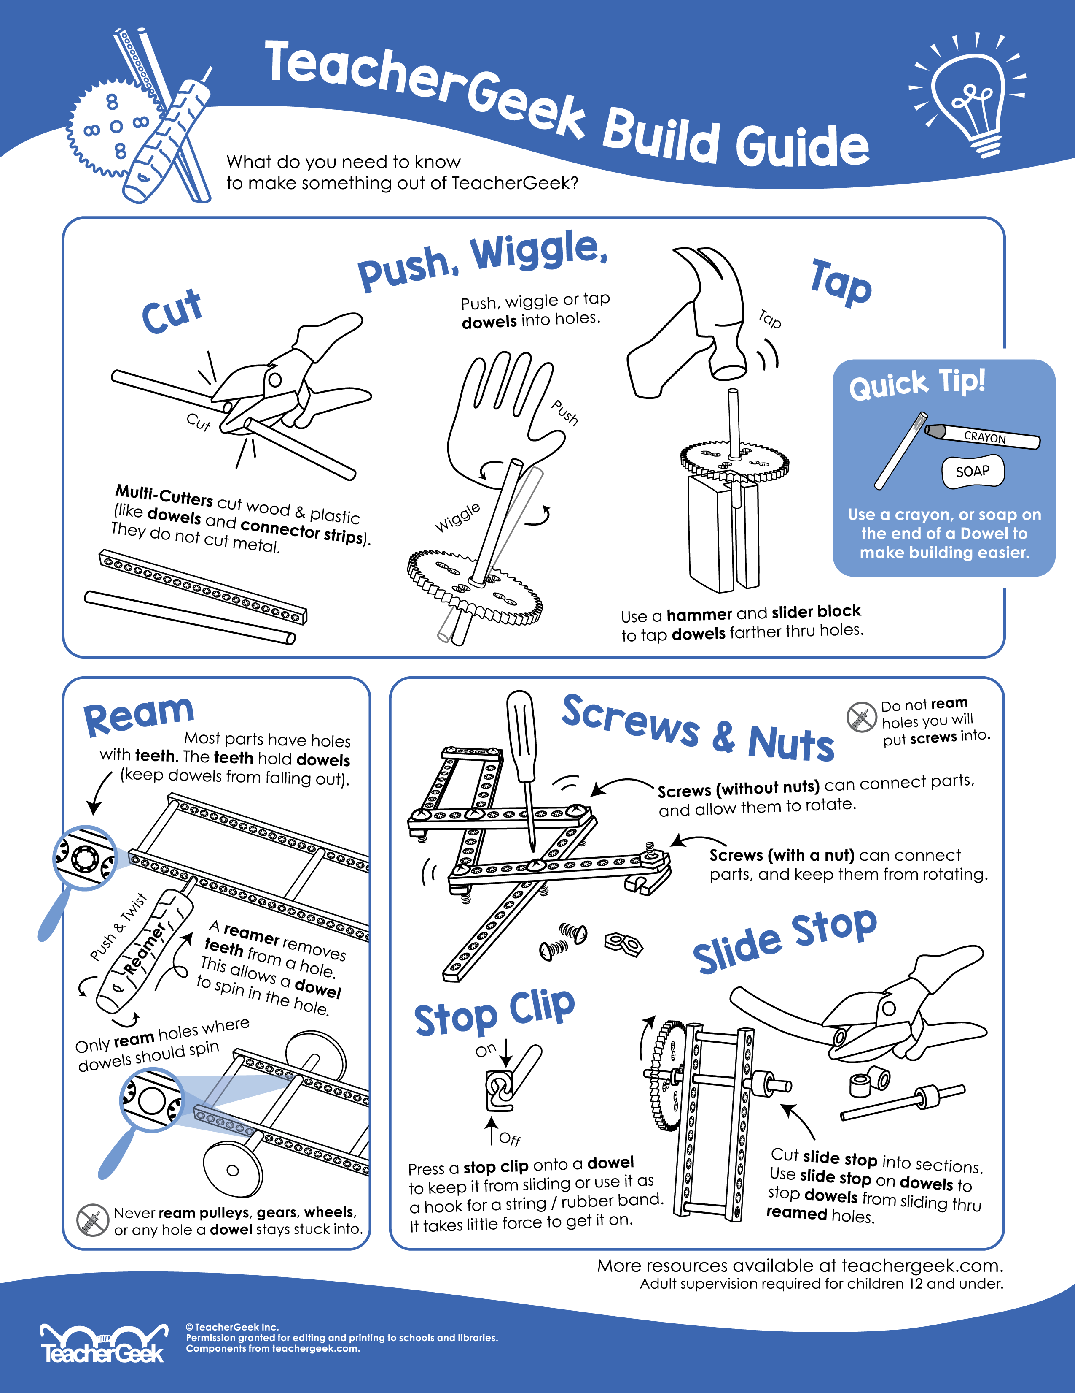



Below is the list of “ingredients” you’ll need for each Hydraulic Arm Build.   
Available as a 10 pack, which includes extra parts for your own innovative creations!

|  |  |  |  |  |  |
| --- | --- | --- | --- | --- | --- |
| **x6** | **x5** | **x6** | **x1** |   **x1** | **x1** |
| **Connector Strips** | 300mm (12″) **Dowels** | **Blocks** | **Cable Tie** | **Tubing**: 40cm (15”) – x2 90 cm (36”) – x1 | 100mm (3″) **Slide Stop** |
| **x5** |  | **x6** |  |  | **X1**  **x18**  **x5** |
| #10 1″ **Screw** | ¼” Cylinder **Screw** | #10 **Nut** | 14mL **Cylinder** | 4.5mL **Cylinder** |  |



*Perfect for sharing in groups of 3 and 4!*

Time to break out those tools and start building! Remember to be kind and share with others.

|  |  |  |  |
| --- | --- | --- | --- |
|  |  |  |  |
| **Multi-Cutter** | **Reamer** | **Screwdriver** | **Pliers** |



Go on your own scavenger hunt to find these items. Try building with all kinds of materials!

|  |  |  |  |
| --- | --- | --- | --- |
|  |  |  |  |
| **Safety Goggles** | **Tape** | **Crayon** (rub on dowels to make sliding them easier into holes of components) | **Recycling Materials**  *What else could you  use for a gripper?* |

**­­**

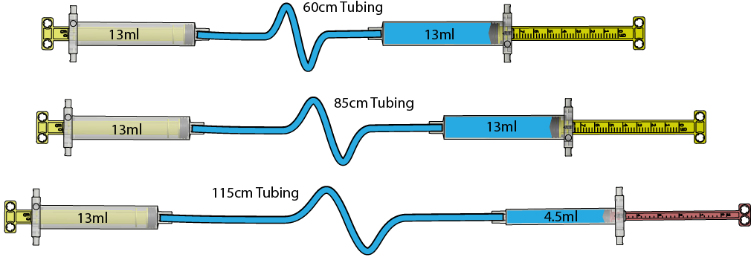

**40cm (15”) Tubing**

**40cm (15”) Tubing**

**90cm (36”) Tubing**

**14mL**

**14mL**

**4.5mL**

**14mL**

**14mL**

**14mL**



**Hydraulic Systems** are the foundation of how this build design functions. Follow the steps below to **connect** and **fill** cylinders to create your own hydraulic system.

**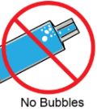***Please note: in order to work properly, there can be no air bubbles in the   
cylinders or tubes.*

|  |  |  |  |
| --- | --- | --- | --- |
|  | **Cut tubing** into the following **lengths**:  Two 40cm (15″)  If you’re using an **activity pack**, the tubing has been **cut for you**.      One 90cm (36″) |  | **Fill** the five 14mL **cylinders** and one 4.5mL **cylinder** with water by **pushing** the **piston** all the way in and **submerging** the **tip** under water;  **pull back** to fill completely with water. ***Remember:*** *no air bubbles*    **Quick Tip**  *Use food coloring  to make seeing*  *the water easier.* |
|  | **Attach** the **cut** **tubing** pieces from  **Step 1** to four of the filled **cylinders**  from **Step 2.**    *Connection Close-Up* |  | Over a **cup**, push the **cylinder** **piston** to completely fill the **tubing** with water.  *Remember: no air bubbles* |
|  | **Attach** the water filled **tubing** to the remaining water filled **cylinders** from Step 2. |  | **Insert** a 1/4″ cylinder **screw** into the **hole** next to the **cylinder’s** **tip** to prevent the **tubing** from disconnecting. |
|  | From the end of a **dowel**, **measure**  and **cut** three 55mm (2 ⅛″) sections -  *save the extra, you will use this later.* |  | Push, wiggle or tap the 55mm (2 ⅛″) **dowels** into the **holes** of a **connector strip** as shown below. |
|  | Push, wiggle or tap a second **connector strip** onto the 55mm (2 ⅛″) **dowels**. |  | **Ream** the two **holes** marked with a . |
|  | **Cut** a new **dowel** to get two **150mm** (6″) **dowels** and **slide one** through the **reamed holes** from **Step 10**. Hold in place with two **cut** 6mm (¼″) sections of **slide stop.** |  | Push, wiggle or tap two **blocks** onto each **end** of the 150mm (6″) **dowel** and leaving 5mm (¼″) of space on the ends. |
|  | With the **blocks** pointing down, **attach** the **ends** of two **connector strips** to each side of the 150mm (6″) **dowel**.    **Full (uncut) Strip** | **Full (uncut) Strip** | Push, wiggle or tap the leftover 150mm (6″) **dowel** from Step 11 in between the ends of the **connector strips** from Step 13 to complete the base. |
| **Good job!**  You just completed the **base** and first **boom** of your hydraulic arm.  You should be able to pivot the boom at the fulcrum. | | | |
| **14mL**  **14mL**  **40cm (15”) Tubing** | With the **40cm** (15″) **hydraulic systems** from **Steps 1-6**, **ream** the **hole** marked with a  on one of the **cylinder’s** pistons. |  | **Cut** a 150mm (6″) **dowel** and **insert** through the **reamed hole** from **Step 15**. |
|  | **Cut** two **6mm** (¼″) sections of **slide stop**      **Slide** onto both **ends** of the **150mm** (6”) **dowel** all the way to the **center, touching** the **piston’s handle.** |  | Insert the 150mm (6″) **dowel** in  between the base **connector strips**  and **insert** the **pegs** of the **cylinder** in between the boom **connector strips**.  (*You can change this position later*). |
| **Quick Experiment!**  Does changing the placement  of the piston move the lever with  the same distance or force? | | | |
|  | Create a **second boom** by cutting two 45mm (1¾″) **dowels** and inserting them between two **connector strips**. |  | **Ream** the four **holes** marked with a . |
|  | **Cut** a 65mm (2½″) **dowel** and **slide** through the **reamed holes** to **connect** the **first** and **second** boom. | **14mL**  **14mL**  **90cm (36”) Tubing** | With the **90cm** (36″) **hydraulic systems** from Steps 1-6, **ream** the **hole** marked with a  on one of the **cylinder’s** piston. |
|  | **Cut** a 45mm (1¾″) **dowel** and **insert** into the **reamed hole** from Step 22. Hold in place with two **cut** 6mm (¼″) sections of **slide stop**. |  | Place the **cylinder** assembly from  Step 23 in between the first and  second boom **connector strips**  (*you can change this position later*). |
| **Quick Experiment!**  Change where the cylinders **attach** to your arm  to allow it to move as **far in** and **out** as possible. | | | |
|  | Start to create the **gripper** by **cutting** two 90mm (3½″) **dowels** and push, wiggle, or tap into the **center holes** of two **blocks**. |  | **Cut** two 110mm (4⅜″) **dowels** and push, wiggle, or tap into the **outside holes** of one of the **blocks** from Step 25. |
|  | **Ream** the **holes** marked with the  symbol on the leftover **block/dowel** from Step 25. |  | **Slide** the **reamed** **block** from Step 27 onto the 110mm (4⅜″) **dowels** from  Step 26.    *Slide* |
|  | Use the remaining **hydraulic system** from Steps 1-6 (the 13mL **cylinder** connected to the 4.5mL **cylinder**)  and **insert** the two **dowels** into the  holes of the **4.5mL** **cylinder**.  **4.5mL Cylinder** |  | Use a **cable tie** to attach the  **cylinder’s** piston to the **dowel**  with the **sliding block**. |
|  | **Place** two **blocks** on the ends of the 60mm (2 ⅜″) **dowels** to complete the **gripper**. |  | **Cut** the **last two holes** off one of the  **connector strips** of the **second boom**. |
|  | Use a **screw** and **nut** to attach the gripper to the **second boom**. |  | **Cut** the **pegs** off the loose **cylinders** and use #10 1″ **screws** and #10 **nuts** to **attach** the **cylinders** together to form a control panel. |
|  | **Tape** the **tubing** to the **arm**, but be careful not to crimp or smash the **tubing**. | | |

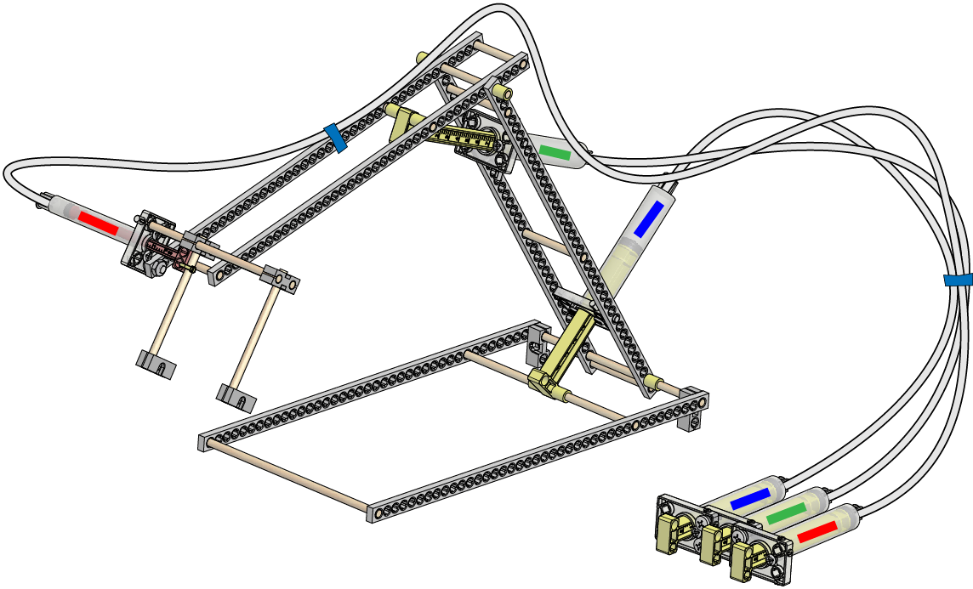

**Quick Tip***Use different colored markers,  
tape, or colored water in the cylinder tubing to identify which control panel cylinders   
connect to which arm parts.*

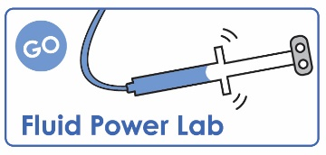

Documents at **teachergeek.com/learn**

If you are going   
to do the optional   
*Fluid Power Lab*,   
now’s the time!