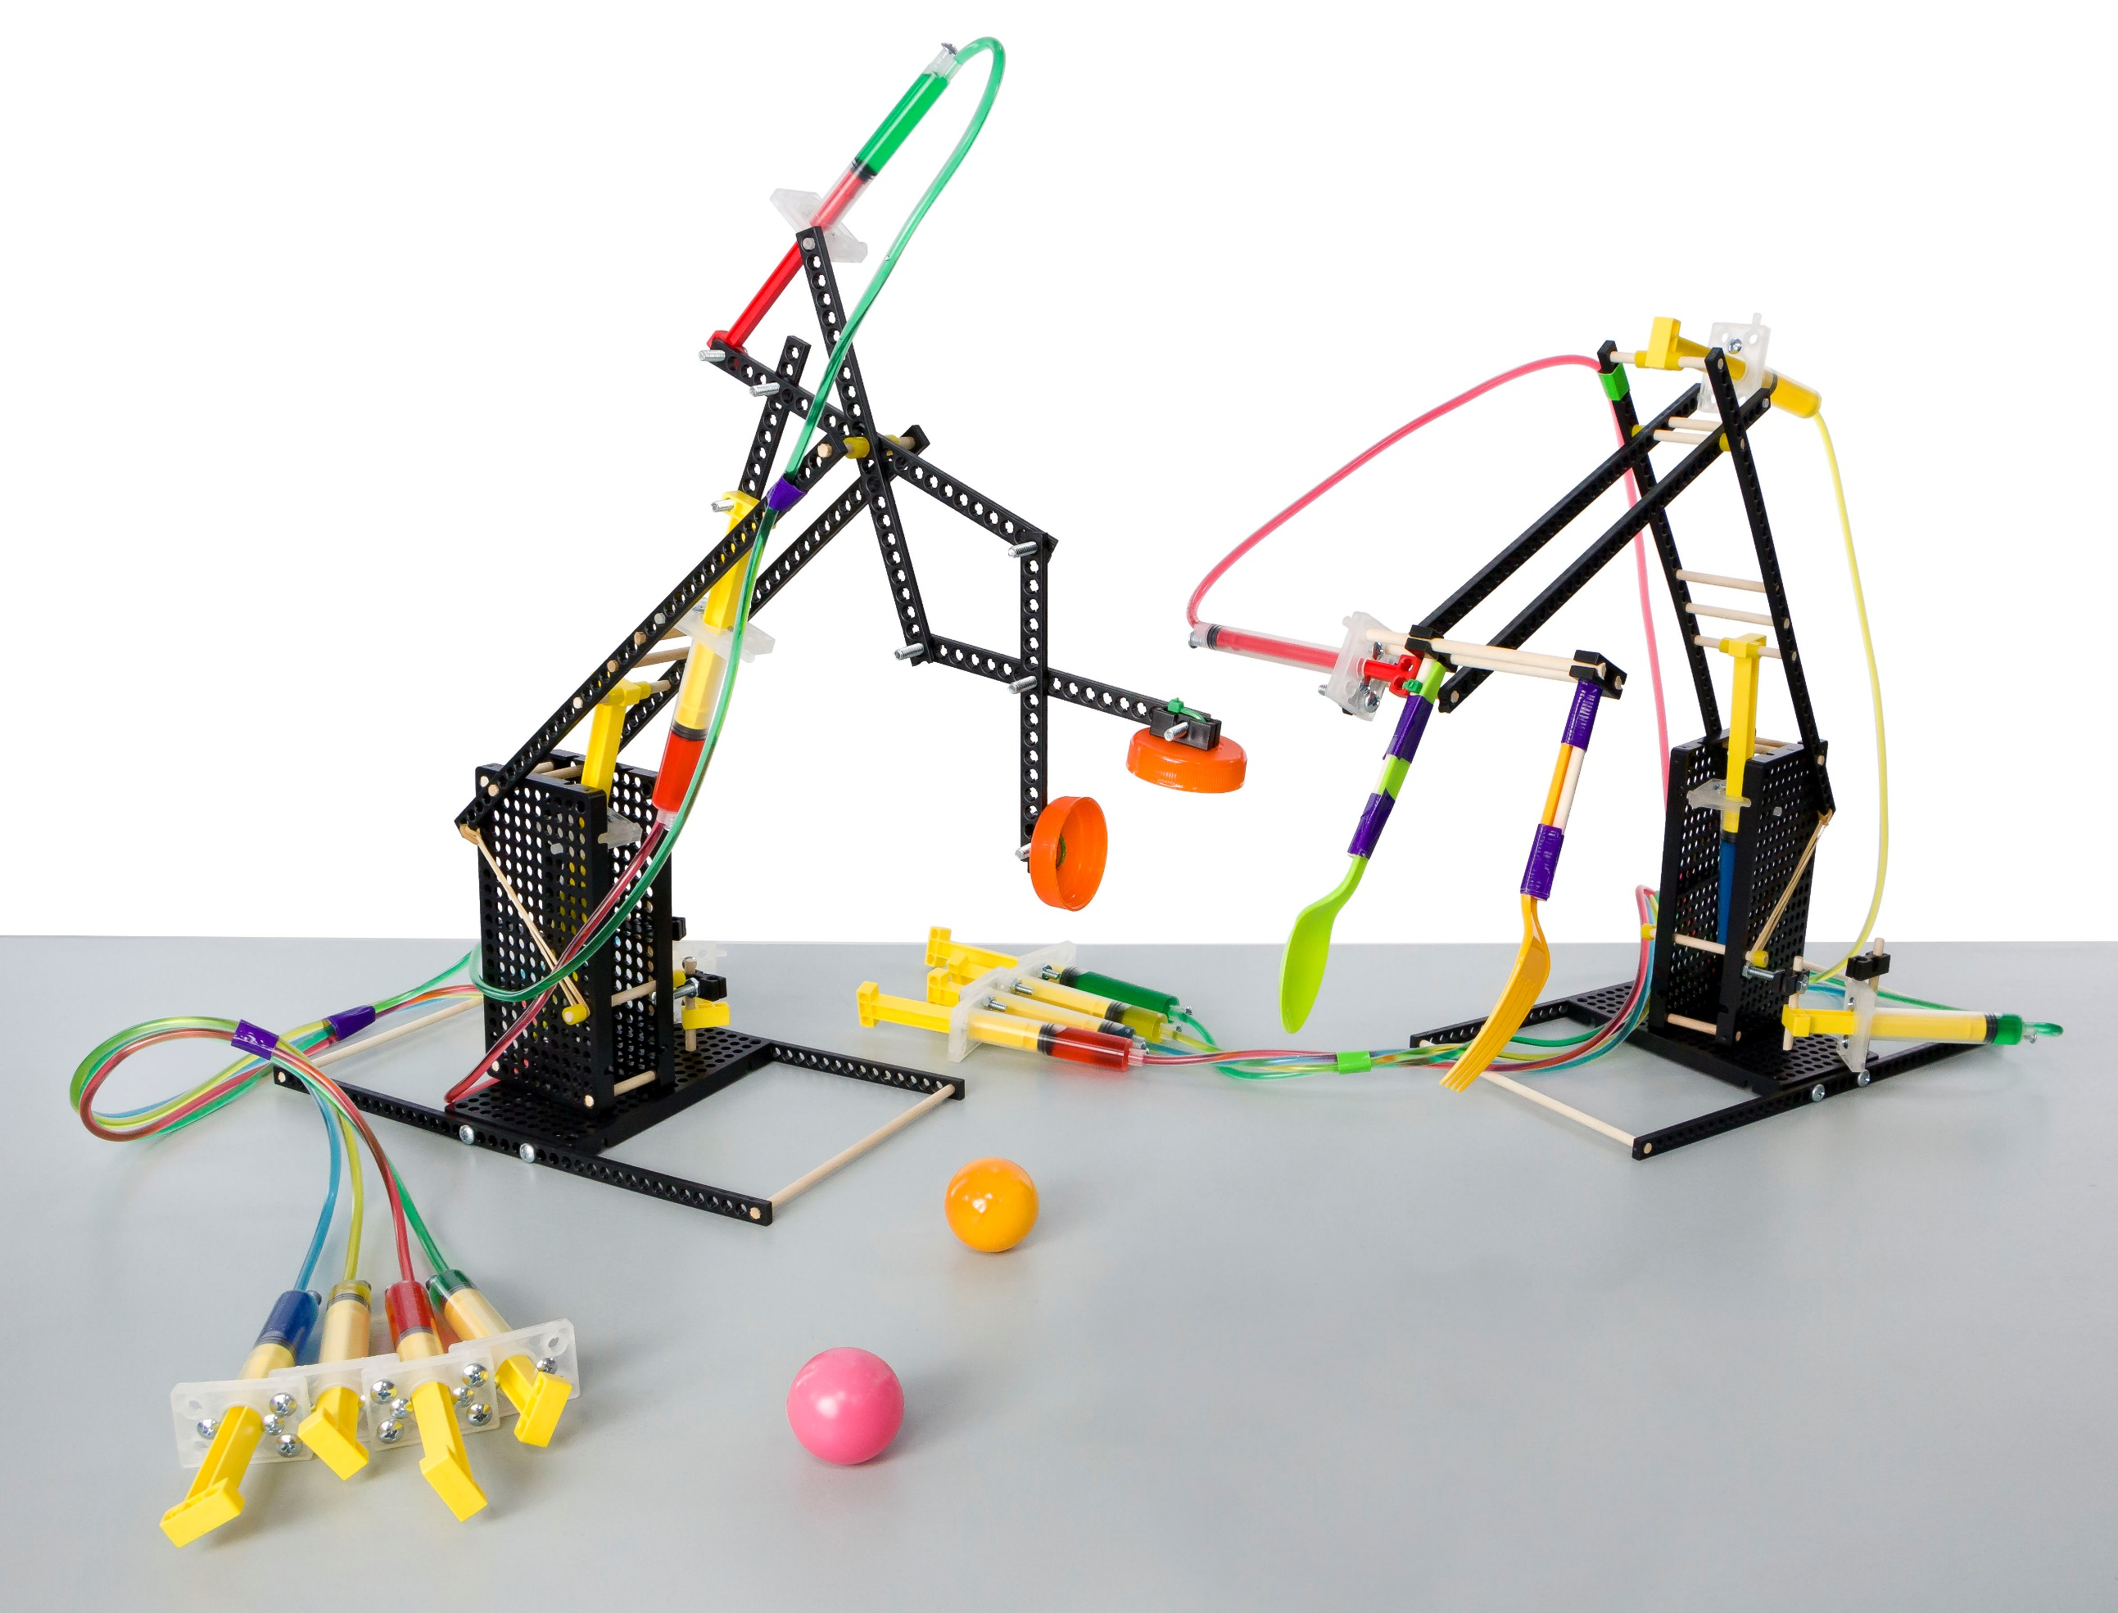

Download Documents and get your supplies at **teachergeek.com**



**THINKING AHEAD** *What other machines   
do Hydraulic Systems  
power everyday?*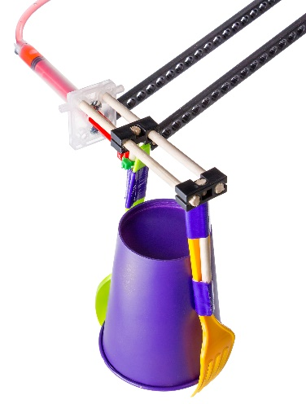**Recommended Age level:**

Activity Age Level: 12 -18

Lab Age Level: Grades 7-12

Recommended Group Size: 3-4 per arm



Engineer a **Hydraulic Arm** to grip and move objects through fluid power. Start by building the example **Hydraulic Arm** in the **Build Guide**.   
Learn about hydraulic systems and fluid power by completing the optional **Labs**.   
Then, design and build your own **End Effectors** to compete in **Engineering Challenges**.



What’s unique about this, and other TeacherGeek activities?

This is a **True STEM/Engineering** activity. It allows kids to:

* *Tinker and experiment*
* *Grow understanding through experimentation and labs*
* *Isolate variables and utilize the scientific method*
* *Apply math and science concepts*
* *Create their own unique designs to become innovators.*

Every project turns out different, and evolves with their understanding. When you create a project using TeacherGeek, the data works (it’s usable). This allows  
kids to apply the math and science, see the results,   
and experience “I-get-it” moments (understanding   
*why* they need the math/science and *what* it does).

Adapted from Bloom’s Taxonomy



**Make It Your Own:** The documents for this activity are available in   
**PDF** and **Microsoft Word format**. If you wish to edit a document,   
simply download the Microsoft Word format.



**Next Generation Science Standards:**

**Motion and Stability: Forces and Interactions**

**MS-PS3-4:** Plan an investigation to determine the relationships among the energy transferred, the type of matter, the mass, and the change in the average kinetic energy of the particles as measured by the temperature of the sample.

**MS-PS3-5:** Construct, use, and present arguments to support the claim that when the motion energy of an object changes, energy is transferred to or from the object**.**

**Engineering Design**

**MS-ETS1-1:** Define the criteria and constraints of a design problem with sufficient precision to ensure a successful solution, taking into account relevant scientific principles and potential impacts on people and the natural environment that may limit possible solutions.

**MS-ETS1-2:** Evaluate competing design solutions using a systematic process to determine how well they meet the criteria and constraints of the problem.

**MS-ETS1-3:** Analyze data from tests to determine similarities and differences among several design solutions to identify the best characteristics of each that can be combined into a new solution to better meet the criteria for success.

**MS-ETS1-4:** Develop a model to generate data for iterative testing and modification of a proposed object, tool, or process such that an optimal design can be achieved.  
 **Energy**

**HS-PS3-1:** Create a computational model to calculate the change in the energy of one component in a system when the change in energy of the other component(s) and energy flows in and out of the system are known.

**HS-PS3-2:** Develop and use models to illustrate that energy at the macroscopic scale can be accounted for as either motions of particles or energy stored in fields.

**HS-PS3-3:** Design, build, and refine a device that works within given constraints to convert one form of energy into another form of energy.



* **Pneumatic Systems:** systems that use a gas to transmit and store power
* **Hydraulic Systems:** systems that use a liquid to transmit power.
* **Cylinders:**transform pressure and fluid flow into mechanical force.
* **Force:** a push or pull upon an object.
* **Pressure:** a force applied over an area.
* **Friction:** resistance of motion between two objects. Turns kinetic energy into heat.
* **Viscosity:** a measure of a fluid’s resistance to flowing, or its thickness.
* **Pascal’s Law:** a confined fluid transmits an external pressure uniformly in all directions.
* **Non-Newtonian Fluids:** fluids without a constant viscosity.
* **Mechanical Advantage:** trading force for distance.
* **End Effector:** a device at the end of a robotic “arm” to interact with the environment.

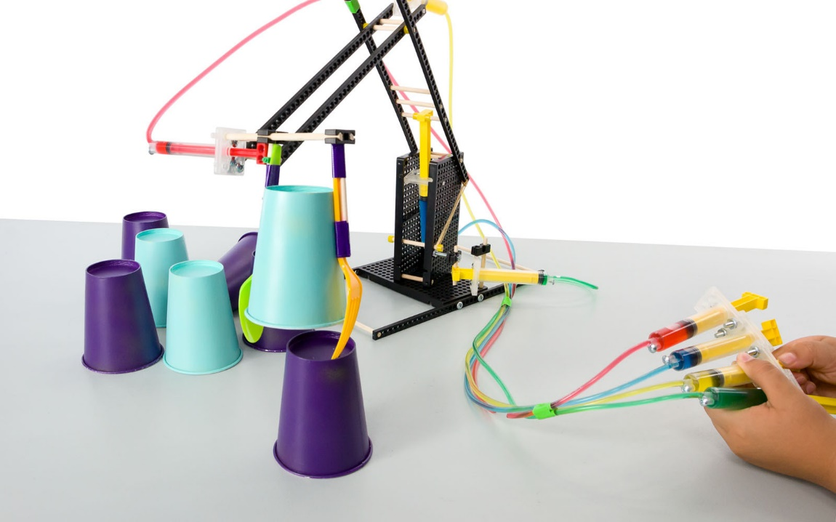

  
Below is the list of “ingredients” you’ll need for each **Hydraulic Arm** Build.

|  |  |  |  |  |
| --- | --- | --- | --- | --- |
| **x5** | **x5** | **x3** | **x1** | **x7** |
| **Connector Strips** | 300mm (12″) **Dowels** | **Hole Plate** | **Tubing** cut to a 285mm (10ft) piece | **Perpendicular Blocks** |
|  |  |  |  | **x1**  **x1**  **x12**  **x24**  **x14** |
| #10 1.5″ **Screw** | #10 1″ **Screw** | #6 ½″ **Screw** | #10 **Nut** | #10 **Locking Nut** |
| **x1** | | **x1** | **x7** | **x1** |
| 100mm (3″) **Slide Stop** | | **Cable Tie** | 13mL **Cylinder** | 4mL **Cylinder** |



*Perfect for sharing in groups of 3 and 4!*

Time to break out those tools and start building! Remember to be kind and share with others.

|  |  |  |  |
| --- | --- | --- | --- |
|  |  |  |  |
| **Multi-Cutter** | **Reamer** | **Screwdriver** | **Pliers** |



Go on your own scavenger hunt to find these items. Try building with all kinds of materials!

|  |  |  |  |
| --- | --- | --- | --- |
|  |  |  |  |
| **Safety Goggles** | **Crayon** (rub on dowels to make sliding them easier into holes of components) | **Tape** | **Recycling Materials**  *What else could you  use for a gripper?* |

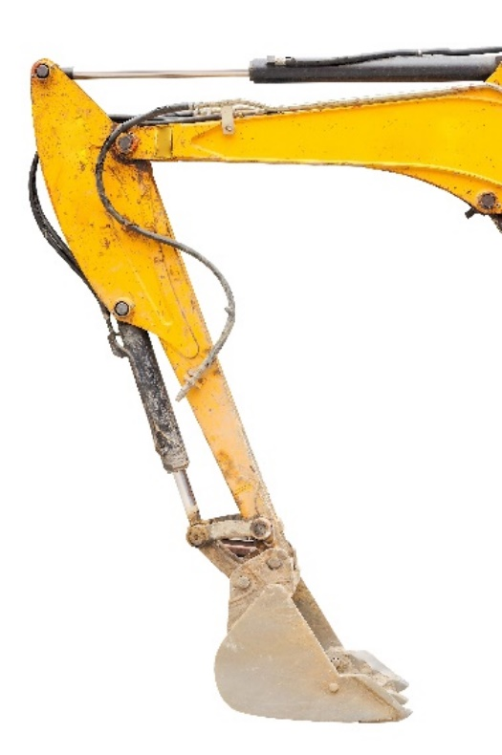



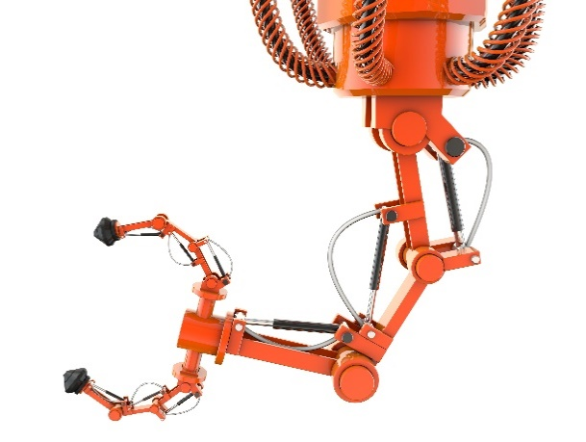Did you know, just as blood pumps and circulates throughout our   
bodies, machines can be powered by fluids too? **Hydraulic Systems**transfer **force** via **pressure** through **cylinders**, resulting in the **energy**   
that powers motors, pistons, joints and arms. If you ever see tubing   
on the side of industrial equipment, it’s a **Hydraulic System** at work.



**Hydraulic Systems** power more than construction   
 and agriculture, however. They are often the   
 foundation of **robotics**. Robots are more than   
 the realm of Science Fiction; these task-based   
 machines coincided with the dawn of **automation**,  
 officially named by **Karel Čapek** in the 1920 play **R.U.R**.

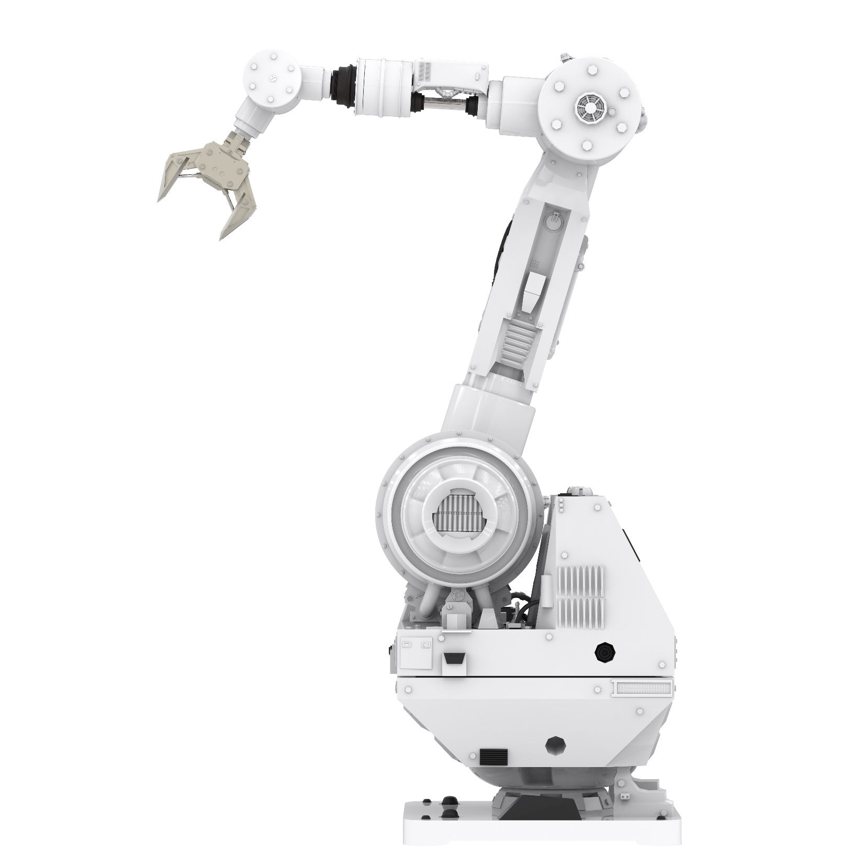  
Modern **Robots** are frequently designed for **“dull, dirty or dangerous**” work –   
things humans cannot, or will not, do. Mining rare materials deep underground,  
diffusing bombs, working a factory assembly line or roving the surface of Mars,   
robots need to be **engineered** to best fit their environment and complete their task.



The design of an **End Effector** (device at the end of a robot’s ‘arm’ for interaction)  
is essential for gripping, grabbing, poking, digging or otherwise manipulating the   
environment. You will have the opportunity to design several **End Effectors** for   
your **Hydraulic Arm**, using materials you find or craft. Think of your hand.   
 *How does it move? When does it need a tool to complete a task?*



There are “a ton” of resources to help you complete this activity. Pick and choose what will work for you. They are available as links below, or at **teachergeek.com/learn**.

**Hydraulic Arm Documents**

* Classroom Overview - This is it (you’re reading it).
* Hydraulic Arm Build Guide and Labs
  + [(Elementary) Basic Hydraulic Arm Build Guide](http://teachergeek.org/hydraulic_basic_build_guide.pdf) – Required
    - During this step you will make the *Example Hydraulic Arm*.
  + [(Secondary) Advanced Hydraulic Arm Build Guide](http://teachergeek.org/hydraulic_arm_adv_build_guide.pdf)- Required
    - During this step you will make the *Example Hydraulic Arm*.
  + [Fluid Power Lab](http://teachergeek.org/fluid_power.pdf) - Optional
    - Students investigate hydraulic systems, Pascal’s Law and pressure.
* [Hydraulic Arm Design & Engineering Challenges](http://teachergeek.org/end_effector_challenge.pdf) - Optional
  + **The Big Dig Challenge**
    - Design End Effectors that are accurate and quick at digging.
  + **Tower Stack Challenge**
    - Design End Effectors to stack the highest tower.
  + **Aim for Eggcellence Challenge**
    - Design End Effectors to pick up and move an egg without breaking.

**Hydraulic Arm Videos**

* [Advanced Hydraulic Arm Build](https://youtu.be/4Ej21493K5E) - Youtube Video

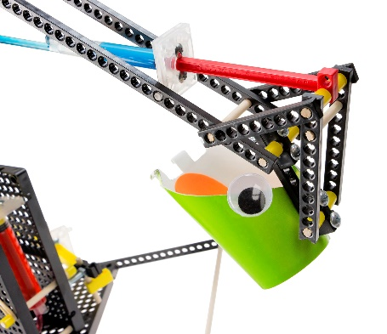[](https://teachergeek.com/blogs/projects/sail-car-activity)

There are many optional Labs for your Hydraulic Arm.   
Links in the Build Guide indicate when during the building process

these Labs and Challenges can be completed, if you want to.  
After you’ve finished, you can download the [Engineering Challenges](http://teachergeek.org/end_effector_challenge.pdf)   
and [Engineering Notebook](http://teachergeek.org/engineering_notebook.pdf) sheets to take your designs to the next level.   
Documents are available as links below or at [**teachergeek.com/learn**](https://teachergeek.com/blogs/projects/wiggle-bots).

**Build Guide — Required**

During this step you will create the components of your example Hydraulic Arm.   
Links throughout the Build Guide indicate optional Labs and Challenges to test   
your creation at various points of the Design Process.

[Download the Hydraulic Arm Build Guide](http://teachergeek.org/hydraulic_arm_adv_build_guide.pdf)

**[](http://teachergeek.org/wind_lift_LS_build_lab_3-12.pdf)**

**Lab Activities — Optional**

**Fluid Power Lab**

This Lab allows students to explore Hydraulic and Pneumatic Systems and how they function in powering machinery through worksheets, experiments and application.

**Instructions:**

* + Discuss the following concepts with your students.   
    Ask them to provide describe, define, and/or give examples for each:
    - Hydraulic
    - Pneumatic
    - Pascal’s Law
    - Pressure
    - Kinetic & Potential Energy
    - Mechanical Advantage
    - Friction
    - Viscosity
    - Work
  + Distribute Lab sheets. Explain the lab procedure and let them get to work.

[Download the Fluid Power Lab](http://teachergeek.org/fluid_power.pdf)

**Engineering Challenges**

*The following challenges are optional.*   
Engineering Challenges work by immersing students in the Engineering Design process. Learn more about the Engineering Design Process on the next page.

[*Download the Engineering Notebook Sheets*](http://teachergeek.org/engineering_notebook.pdf)

**The Big Dig Challenge**

Engineer an End Effector that digs quickly, accurately and effectively. Students can dig and sort objects in competition, judge the accuracy of their End Effectors in selecting objects or even play a game of hydraulic powered “Tic, Tac, Tow”.

**Tower Stack Challenge**

*How high can you go?* Design an end effector to best stack objects into the   
highest tower possible, using only your Hydraulic Arm to grip, move and stack.

**Aim for Eggcellence Challenge**This hardboiled challenge requires an end effector design that can safely   
pick-up and move an egg. Be careful – break it, and you lose!

[Download the Hydraulic Arm Design & Engineering Challenges](http://teachergeek.org/end_effector_challenge.pdf)



Do you have a challenge to solve? Is there something you want to invent, fix or improve? You do? Excellent…   
the **Engineering Design Process** is exactly what you need.

Inventing, fixing, improving… these are really ways to create a solution to a problem. A problem can be as complicated as creating a way to live on Mars, or as simple as stopping a door from squeaking. You are reading this because you have a problem to solve: to create the best End Effector for your Hydraulic Arm.  
 The Design Process will help you solve it. Here’s how it works:



**What is the problem (what needs to be solved/made better)?**

The Design Process helps you solve a problem. Therefore you need to start the   
Design Process by identifying a problem. In this activity, your problem is to   
create a Hydraulic Arm that can pick up an object without breaking it.

After constructing your first Hydraulic Arm and going through the initial   
Design Process, your problem may change. Your next problem might be to make the   
End Effector accurately grip and sort objects, or defeat an opponent at tic-tac-toe.

There is no perfect design, so there is no end to the Design Process.   
You can always identify a new problem (a way to make your   
Hydraulic Arm better) and go through the Design Process again.

**Research: How have others solved, or attempted to solve this problem?**

If you are going to solve the problem, you better know what you are doing.   
After identifying the problem, look at how others have solved, or tried to solve it.  
Look around your class, search the library and internet, or ask other people.

**What are the constraints (things your design cannot, or must, do or be)?**

It would be great if you could solve this problem any way you want, with anything you want. The truth is… you can’t! You have these things called “constraints” which limit what your design can do, can’t do, must be, or can’t be (How confusing is that?). Constraints could be resources like time or materials. They could also be rules, such as the size or material of the blades. You need to identify the constraints to your problem before you can solve it.



**Brainstorm, sketch and describe possible solutions (different ideas that might solve the problem).**

This is a fun part. You can brainstorm, or use another process, to come up with as many possible solutions to your problem as possible. Consider your problem, constraints and research while generating possible solutions. Do not judge, or pick, your best solution   
at this point. Just write as many down as you can.Be super creative, and original!

**Choose the best solution. Circle it. Why do you think it is best?**

Ok - now it’s time to judge. Pick what you think will be the best solution to your problem. Make sure it fits the constraints. It’s ok to feel sorry for all the possible solutions that didn’t get picked. They were good ideas too…



**Draw the solution you choose. Include the details you will need to create it.**

Neatly sketch the design you choose (the one you are going to build).   
The sketch should include details and descriptions about how it will work, or be built.



**Build the solution you planned.**

Is this the step you have been waiting for? You finally get to build the solution to your problem (the new design). Have fun! Take the time to make it properly.

**Test it.**

Test your solution (new design). How does it work? Does it go fast down the track?   
Make small adjustments to optimize it (to try and make this design solution work best).

**Make observations. Record results.**

Pay close attention while testing your solution. Write down what happened   
(the end effector was too top heavy, sorting was easier with bigger objects than small).   
You will use this information to make your Hydraulic Arm even better.



**Did you solve the problem?**

Look at the test results. Reflect on your observations.   
Did your solution solve the problem as you had planned?

**Yes? Great! Identify a new problem (a way to make your design even better).**

There is no perfect design (yep... your design can still be improved).   
Identify another problem that will make your Hydraulic Arm even better.   
Grab another Engineering Notebook Sheet and try to solve it.

**No? That’s OK. What did you learn that can help solve it in a new/different way?**

You learn more from failures than you do from successes. The best solutions come from/after failures (ideas that didn’t work). Most inventions do not work the first time around the Design Process. Learn from what didn’t work. Grab another Engineering Notebook Sheet and try to solve the problem a different way.



Fill in a TeacherGeek Engineering Notebook Sheet (front and back)  
every time you go around the Design Process. Keep your Notebook Sheets.   
Assemble them into an Engineering Notebook at the end of the project.

[*Download the Engineering Notebook Sheets*](http://teachergeek.org/engineering_notebook.pdf)

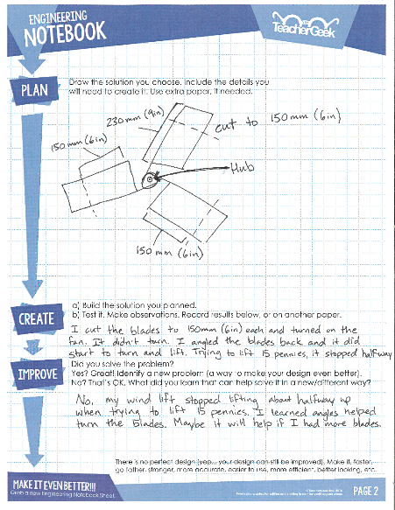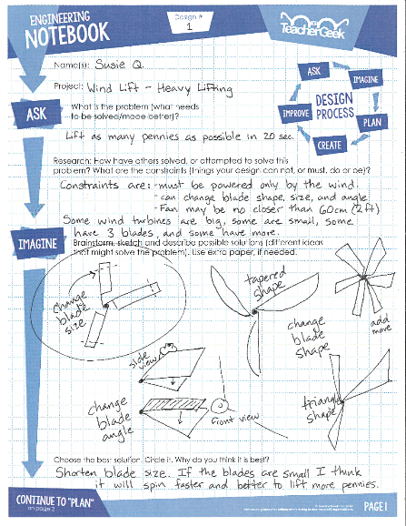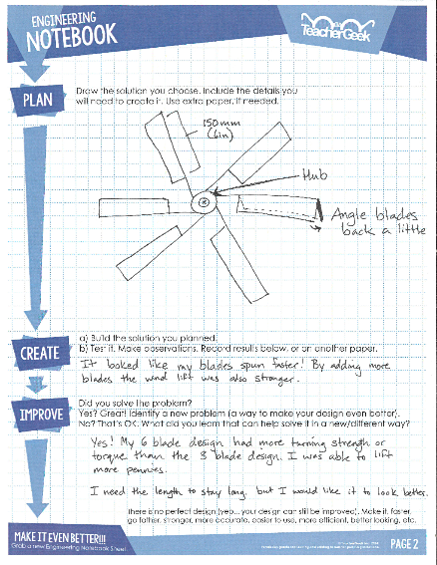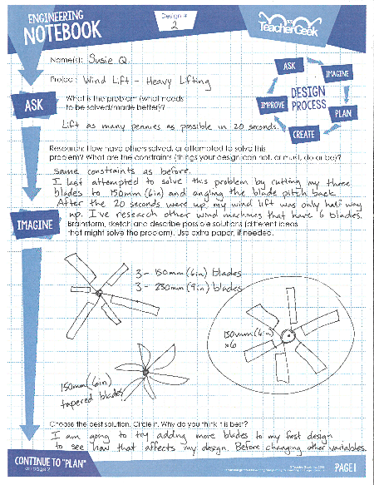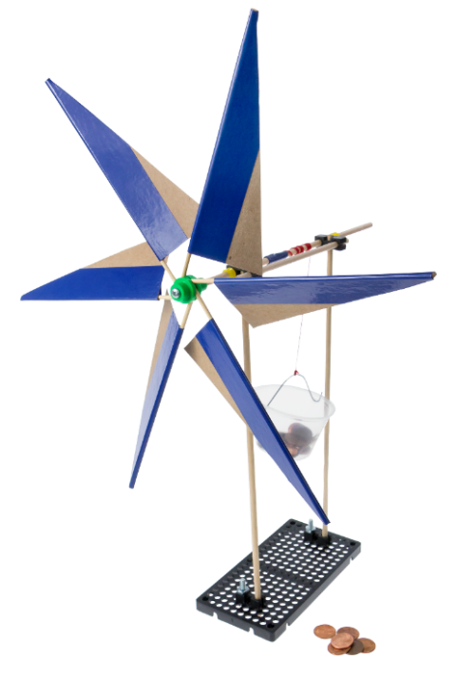

***Question*** *Do you need to fill out a new Engineering Notebook Sheet for small changes or tweaks to an existing design?*

*Nope… just record what you did on the current Notebook Sheet.*