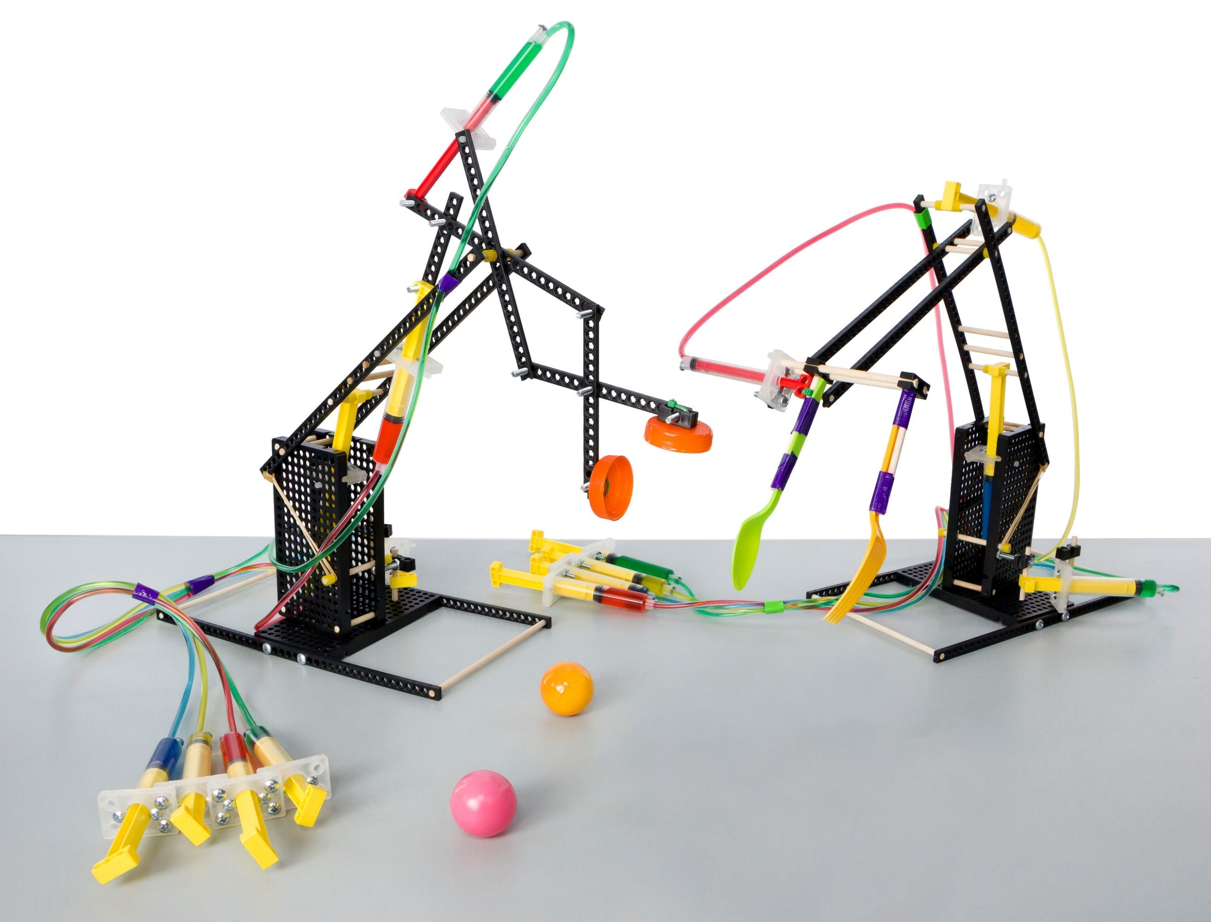  
Hydraulics are *AMAZING*!  
Use the power of water to control a machine.

This guide will help you create   
your own Advanced Hydraulic Arm.

Perfect for Grades: 7+  
Difficulty: Advanced

­­­



Download Documents  
at **teachergeek.com**

  
**THINKING AHEAD** *What kinds of objects can you  
move with different gripper designs?*

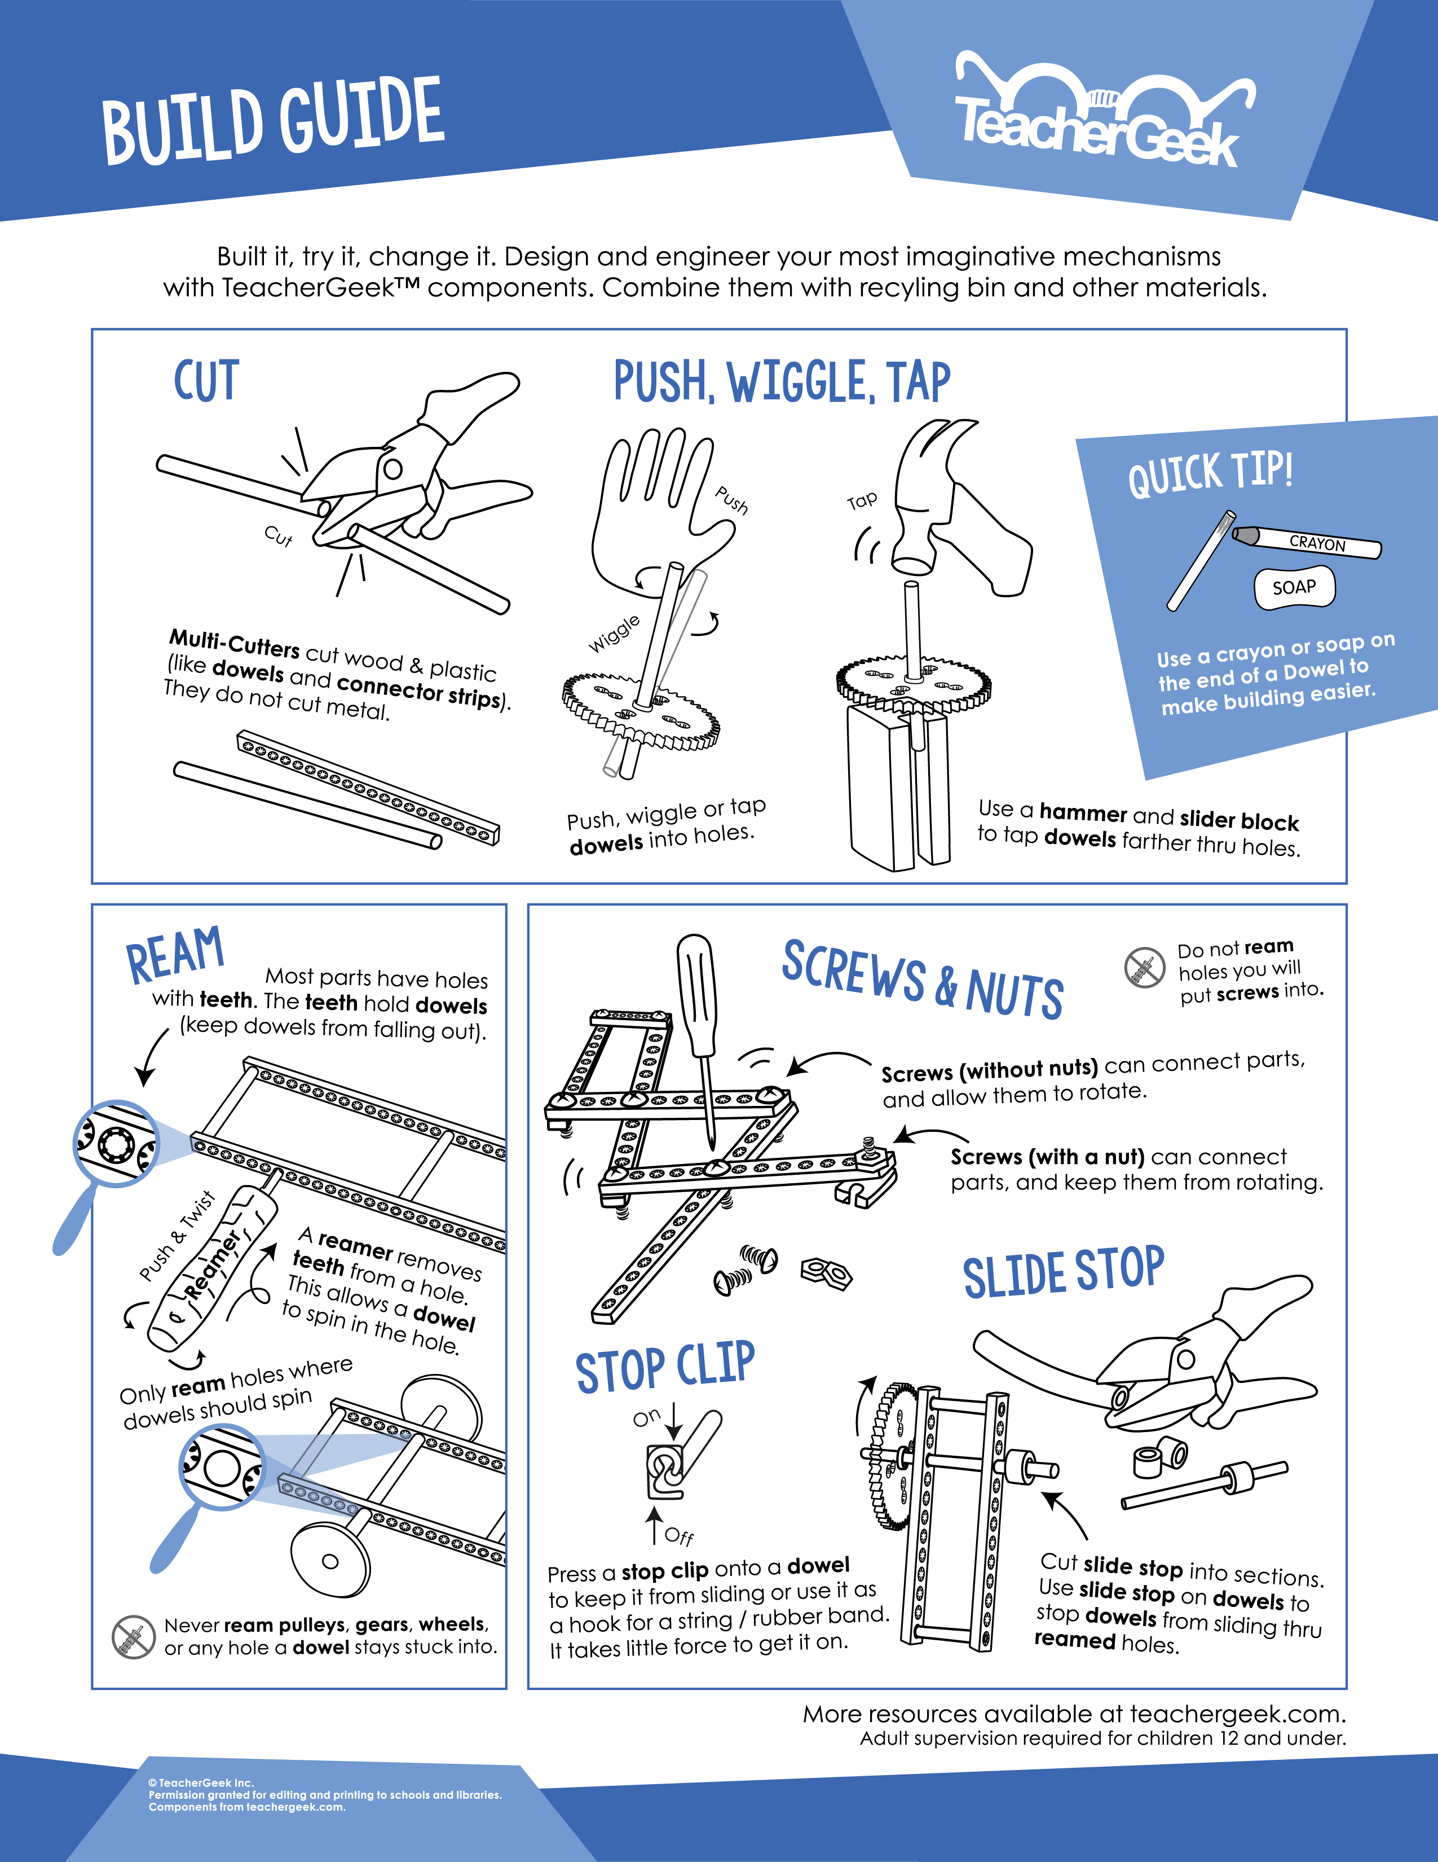



Below is the list of “ingredients” you’ll need for each Hydraulic Arm Build.  
Available as single: *SKU 1823-08* or 10 pack: *SKU 1823-09*. Both include extra parts for your own innovative creations!

|  |  |  |  |  |
| --- | --- | --- | --- | --- |
| **x5** | **x5** | **x3** | **x4** | **x7** |
| **Connector Strips** | 300mm (12″) **Dowels** | **Hole Plate** | **Tubing:**  90cm (36”) - x1 60cm (24”) - x1 40cm (15”) - x2 | **Perpendicular Blocks** |
|  |  |  |  | **x1**  **x1**  **x12**  **x24**  **x14** |
| #10 1.5″ **Screw** | #10 1″ **Screw** | #6 ½″ **Screw** | #10 **Nut** | #10 **Locking Nut** |
| **x1** | **x1** | **x7** | **x1** | **x10** |
| 100mm (3″) **Slide Stop** | **Cable Tie** | 14mL **Cylinder** | 4.5mL **Cylinder** | Small **Rubber Bands** |



*Perfect for sharing in groups of 3 and 4!*

Time to break out those tools and start building! Remember to be kind and share with others.

|  |  |  |  |
| --- | --- | --- | --- |
|  |  |  |  |
| **Multi-Cutter** | **Reamer** | **Screwdriver** | **Pliers** |



Go on your own scavenger hunt to find these items. Try building with all kinds of materials!

|  |  |  |  |
| --- | --- | --- | --- |
|  |  |  |  |
| **Safety Goggles** | **Crayon** (rub on dowels to make sliding them easier into holes of components) | **Tape** | **Recycling Materials**  *What else could you  use for a gripper?* |

**­­**

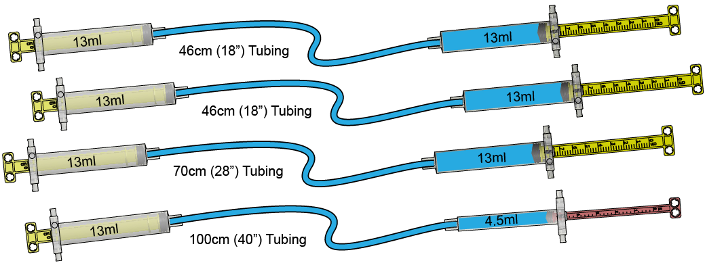

**14ml**

**14ml**

**14ml**

**4.5ml**

**14ml**

**14ml**

**14ml**

**14ml**

**40cm (15”) Tubing**

**40cm (15”) Tubing**

**60cm (24”) Tubing**

**90cm (36”) Tubing**



**Hydraulic systems** are the foundation of how this build design functions. Follow the steps below to **connect** and **fill** cylinders to create your own hydraulic system.

**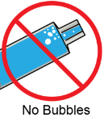***Please note: in order to work properly, there can be no air bubbles in the cylinders or tubes.*

|  |  |  |  |
| --- | --- | --- | --- |
|  | **Cut** **tubing** into the following lengths:  If you’re using an **activity pack**, the tubing has been **cut for you**.  40cm (15″)      60cm (24″)      90cm (36″) |  | **Fill** the seven 14mL **cylinders** and one 4.5mL **cylinder** with water by **pushing** the **piston** all the way in and **submerging** the **tip** under water; pull back to fill completely with water. *Remember: no air bubbles*    **Quick Tip**  *Use food coloring to make seeing the water easier.* |
|  | **Attach** the cut **tubing** pieces from **Step 1**  to four of the **filled** **cylinders** from **Step 2**.      *Connection Close-Up* |  | Over a **cup**, push the **cylinder** **piston** to completely fill the **tubing** with water. *Remember: no air bubbles* |
|  | **Attach** the water filled **tubing** to the remaining water filled **cylinders** from **Step 2**. |  | **Insert** a #6 ½″ **screw** into the hole aside  the **cylinder’s** **tip** to prevent the **tubing**  from disconnecting. |
|  | From the **end** of a **dowel**, measure and **cut** three 50mm (2″) sections - *save the extra, you will use this later.* |  | **Insert** the cut **dowels** from **Step 7** into the **outside corners** of a **hole plate** as shown below. |
|  | **Slide** a **block** halfway onto the  **corner dowel** piece. |  | **Push** another **hole plate** onto the **dowels** from **Step 3**, sandwiching them in place. This piece will be the waist for your arm. |
|  | **Cut** two 60mm (2 ⅜″) **dowels** and insert into two **connector strips** as shown below to create the **main boom**. |  | **Cut** a 65mm (2 ⅝″) **dowel** and **slide**  into the **hole plates** as shown. |
|  | Secure the **main boom** to the arm waist  by tapping or pushing the **connector strips** around the **dowel** from **Step 12**. This creates the **boom fulcrum** or *pivot point*. | **40cm Tubing** | With one of the 40cm (15″) **hydraulic systems** from **Steps 1-6**, insert one of the **cylinder** ends inside the two **hole plates**.    **40cm Hydraulic System** |
|  | **Ream** the **hole** shown on the **cylinder’s** piston, cut a 60mm (2 ⅜″) **dowel** and **slide** through the hole. |  | **Spread** the main boom apart slightly  and **insert** the **dowel** from **Step 15** into  the **connector strips**. |
|  | This is the **shoulder** for your **arm**. The **boom** should **move** as the **cylinders** are **pushed** and **pulled**. | | |
|  | **Cut** a **connector strip** in half 15 cm (16”) to get two equal pieces. Since **connector strips** do not have a center hole, **cut** as shown below. |  | Use four #10 1″ **screws** and #10 **nuts** to attach the **connector strips** from **Step 18** to a **hole plate**. |
|  | **Cut** a 170mm (6 ⅝″) **dowel** and **slide** into the last holes of the **connector strips**.  This forms the **base** of your arm. |  | Feed a #10 1″ **screw** up from the bottom and through one of the **back-center holes** of the base’s **hole plate**. |
|  | **Attach** the arm’s waist to the base by feeding the **screw** from **Step 21** through the **center hole** of the **block** from **Step 9** and **fasten** the #10 **locking nut** to the **screw** to hold the waist to the base. The **screw** and **nut** should be loose enough to allow the waist to easily turn on the base. | | |
|  | **Create** the forearm by **cutting** two  40mm (1 ⅝″) **dowels** and inserting them  in between two **connector strips**. |  | **Ream** the two **holes** marked with a . |
|  | **Cut** a 60mm (2 ⅜″) **dowel** and **slide** it into the **reamed holes**.      *Slide* |  | **Cut** **slide stop** into two 5mm (⅜″) sections and **slide** it onto the outside of the 60mm **dowel**. This becomes the forearm. |
|  | Insert the forearm **dowel** inside the **connector strips** of the main arm to  create the elbow.  **60cm Tubing** |  | Use the of the 60cm (24″) **hydraulic systems** from **Steps 1-6**, and **ream** the hole on the **piston** marked with a . |
|  | **Cut** a 60mm (2 ⅜″) **dowel** and **slide** it into the **reamed hole** of the piston from **Step 28** and secure with two sections of **slide stops**. |  | **Insert** the **dowel** end of the **piston** to the top of the main arm and the pegs of the **cylinder** to the top of the forearm. |
|  | **Cut** a 75mm (3″) **dowel** and push, wiggle, or tap into the **corner** of the **base’s hole**.  **Top** with a **block**. | **40cm Tubing** | Use the remaining 40cm (15″) **hydraulic systems** from **Steps 1-6**, and **ream** the **hole** on the **piston** marked with a . |
|  | **Insert** the **pegs** of the **cylinder** in between the base’s **hole plate** and the **perpendicular block** from **Step 31**. |  | Place a #10 1.5″ **screw** through the  **hole plate** of the waist and **secure**  with a #10 **nut**. |
|  | **Cut** a 60mm (2 ⅜″) **dowel** and **tap** into the **outer hole** of a **perpendicular block**. |  | Insert the **dowel** from **Step 35** into the **reamed hole** of the **cylinder’s** piston and attach  the **block** (through the **center hole**) to the **screw** by using two #10 **nuts** on each side of the **block**. |
|  | **Cut** the **pegs** off the three **cylinders**  that are attached to your arm and use  #10 1″ **screws** and #10 **nuts** to attach the **cylinders** together to form a control panel. | **14ml**  **90cm (36”) Tubing** | Let’s create an **end effector**: a device  or tool that is connected to the end of  a robot arm (as a hand) and remains controlled by a hydraulic system.  Use the remaining **hydraulic system** from Steps 1-6 (the 14mL **cylinder** connected  to the 4.5mL **cylinder**) and cut off the pegs of the 14mL **cylinder** and **screw** it to the control panel as well.    **Design & Create Your Own End Effector**  Think of what tasks your robot could perform, such as gripping, suction, scooping, dispensing, or welding.  Download at **teachergeek.com/learn**  Now is the time to *Design & Create* your own end effector. Use guide as example. |
|  | **End Effector Options:**  Create this example gripper (end effector).  Create your own end effector.  Create the example gripper and then change it into your own end effector.  Remember: your end effector should be designed to complete a specific task. |  | Start to create the **gripper** by **cutting** two 90mm (3½″) **dowels** and push, wiggle,  or tap into the **center holes** of two **blocks**. |
|  | **Cut** two 110mm (4⅜″) **dowels** and push, wiggle, or tap into the **outside holes** of one of the **blocks** from **Step 38**. |  | **Ream** the **holes** marked with the  symbol on the remaining **open** **block** from **Step 38**. |
|  | **Slide** the **reamed** **block** from **Step 40** onto the 110mm (4⅜″) **dowels** from **Step 39**. |  | **Insert** the two **dowels** into the **holes** of the 4.5mL **cylinder**. |
|  | Use a **cable tie** to attach the **cylinder’s** **piston** to the **dowel** with the **sliding** **block**. |  | Place two **blocks** on the **ends** of the 60mm (2 ⅜″) **dowels** to complete the gripper. |
|  | **Cut** the last two **holes** off the **connector strips** of the forearm. |  | Use a **screw** and **nut** to **attach** the gripper to the forearm. |
|  | **Congratulations!**  Now try your design in the **Lab** or  **Design & Engineering Challenge**.  **Quick Tip** *Use different markers, tape,  or colored water in the cylinder tubing  to identify which control panel cylinders  connect to which arm parts.* | | |

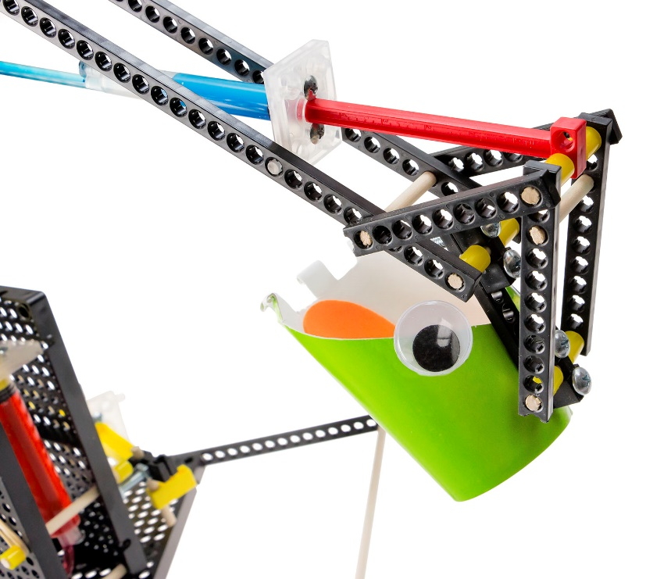

Create your own **end effector** to complete  
all kinds of tasks. Try building an end effector  
that will perform gripping, suction, scooping,   
dispensing, or welding actions.

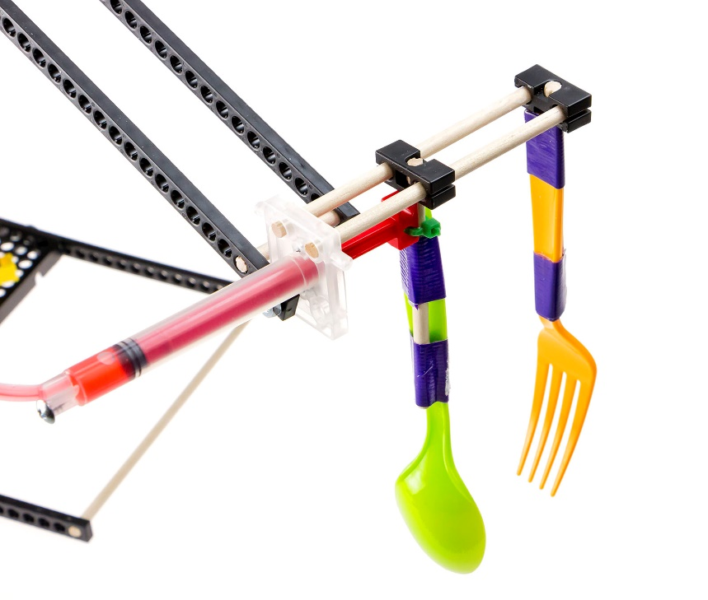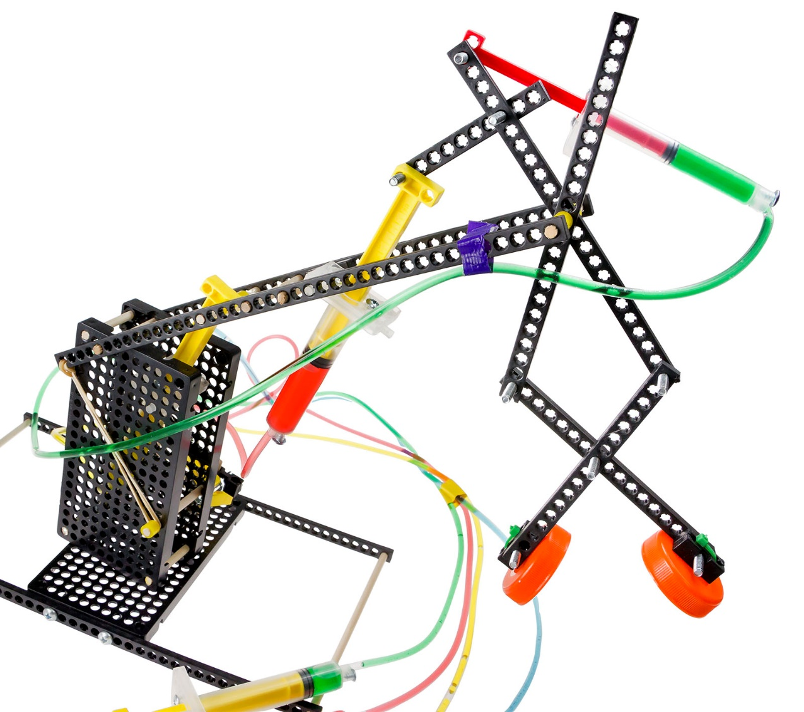Use TeacherGeek components and   
recycling materials to achieve your goal.