Name:_____________________________________

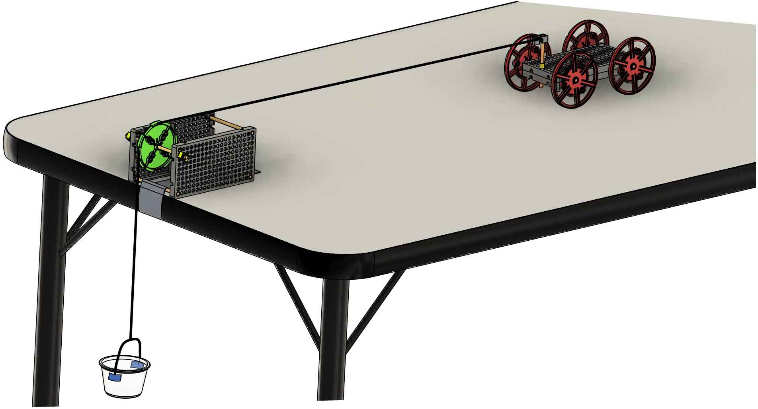

**How can we model forces and motion? What equations describe them? Find out with a Half Atwood’s Machine!**



For instructions on assembling your Car or Half Atwood’s Machine, go to [**teachergeek.com/learn**](http://teachergeek.com/learn)

TeacherGeek Parts

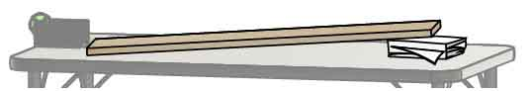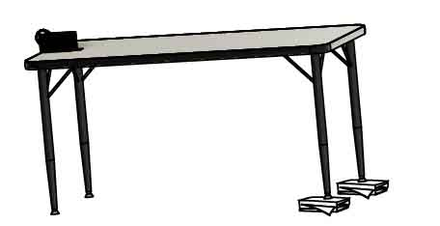

**Table or Board**

to create a slightly declined ramp.

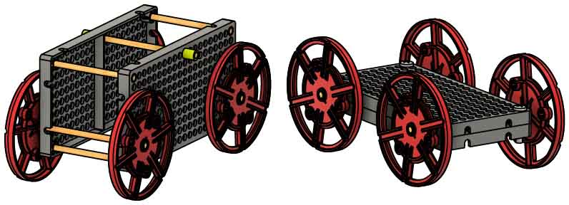

**“Built” TeacherGeek Car**

from Sail Car, Electric Race Car, or Rubber Band Racer.

**OR**

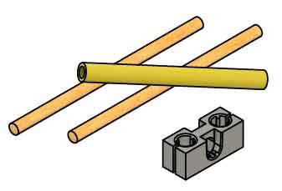

**Spare Parts**

to make minor modifications to your car.

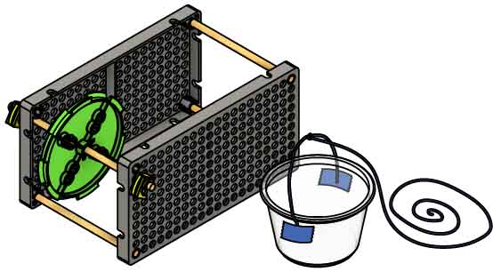

**Half Atwood’s Machine**

TeacherGeek machine   
 pictured; any will work.

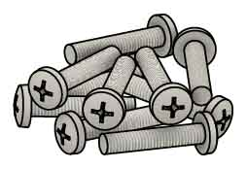

**10x Screws**

or 3-5 gram weights.

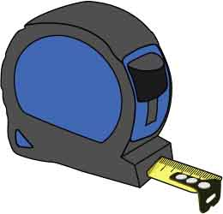

**Measuring Tape**

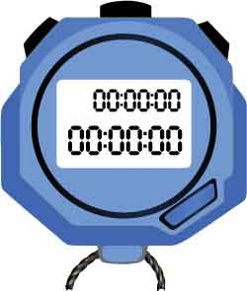

**Stopwatch**

**&**

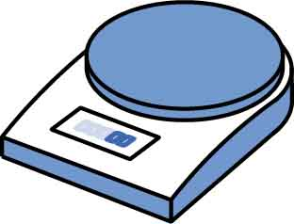

**Scale**

grams/ounces

**OR**

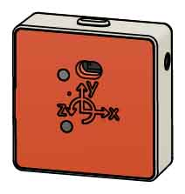

**Motion Sensor**

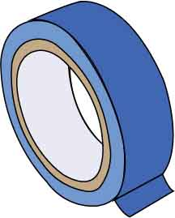

**Tape**

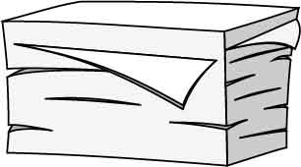

**Index Cards**

to prop your table.

Other Supplies

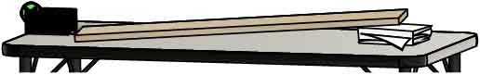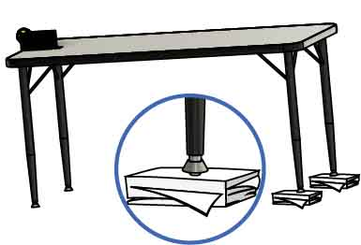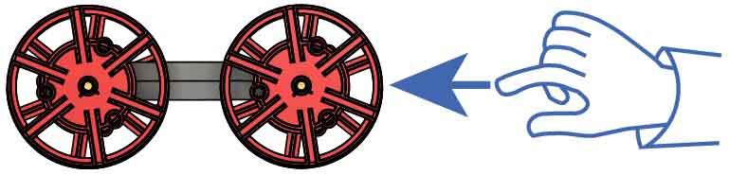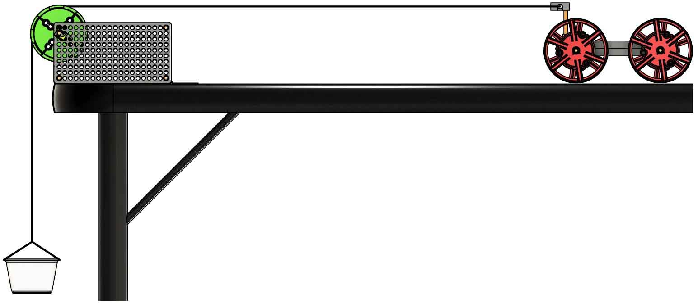

Use a ream of paper or index cards to **incline one side of your track**. Incline as much as possible without your car moving.

**Tip**

**Softly push your car** again. You want it to move across the track at **constant velocity**.

You should see **friction** **slowing** **your** **car**. To continue our investigation, we need to **eliminate** **the** ***effects*** **of** **friction**. We cannot get rid of friction, so we will gravity to balance it out.

Adding or subtracting mass from the hanger changes the   
force on the car.

Hanging weights over the pulley applies a constant horizontal force to the car.

For the best results, use a sensor to graph velocity and make sure velocity is constant.

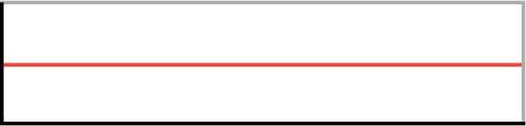

Velocity

Time

**Don’t hook up the car yet! First, you need to calibrate the Atwood’s Machine.**

If your pulley isn’t already attached, you will attach it on the next page.

The slower your car moves, the easier it is to see if velocity is constant.

Make a prediction: If you **softly** **push** the **car**, will it move at **constant** **velocity?** Or will it **slow down?** Test it.

**Adjust the track up or down** until your car moves with constant velocity.

**Atwood’s Machines let us study the motion of a car under a constant force.**

Changing the mass of the car allows you to adjust mass without changing the force.





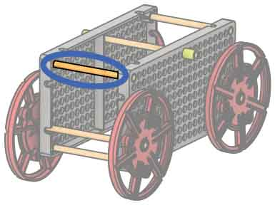

Otherwise, tie string to this dowel.

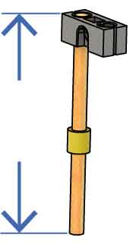

**8 cm**  
(3 in)

If using a Sail Car, modify as shown.

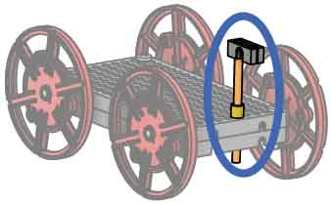

**Test it out!**   
The empty weight hanger should pull the car down   
the track.

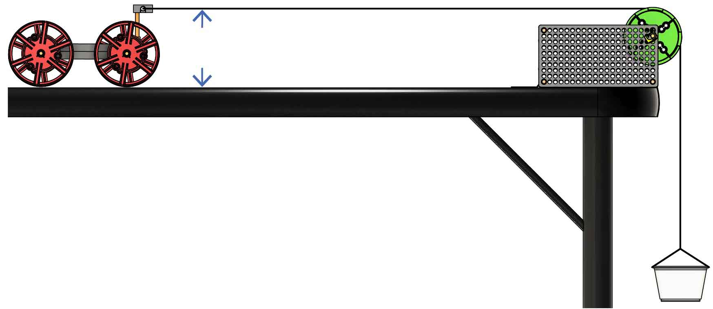

**≈ 10 cm**  
(≈ 4 in)

String parallel to track

**Hang** the **weight**   
**hanger** **over** the **pulley**. Adjust so the **string** is **parallel** to the **track**.



**Tie** the **string** **to** **your** **car** **10 cm** (4 in) **above** the **track**.



**If your pulley does not spin freely, try these fixes:**

Spin your pulley to **make sure it spins freely**. A solid ‘flick’ should make it spin for 8 to 10 seconds.

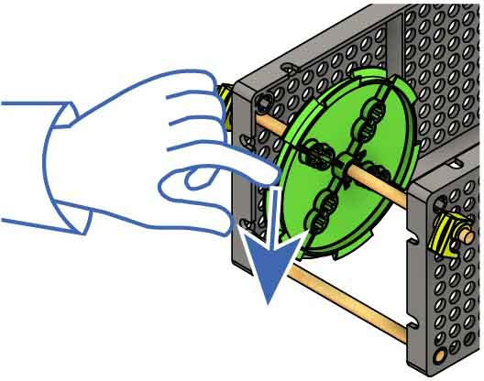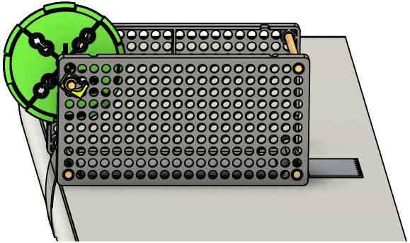

**Tape** the **pulley** **frame** **to** the **table**, with the edge of   
the pulley extending   
beyond the table.



Make sure your **hole plates are parallel** and your **dowel is straight**.

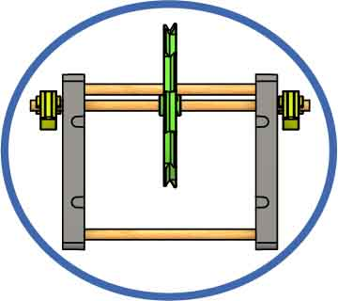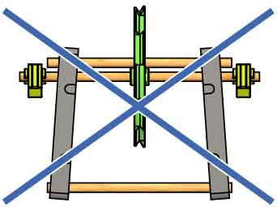

**Pull** the **stop clips** **away** from the hole plates.

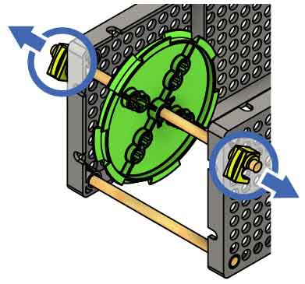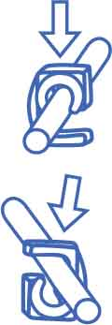

On

Off

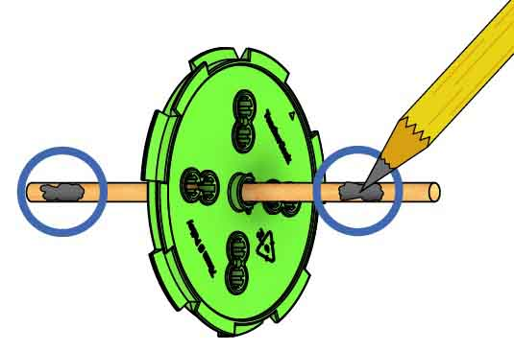

**Use** a **pencil** **to** **lubricate** the **dowel** **where** **it** **spins** in the hole plate.

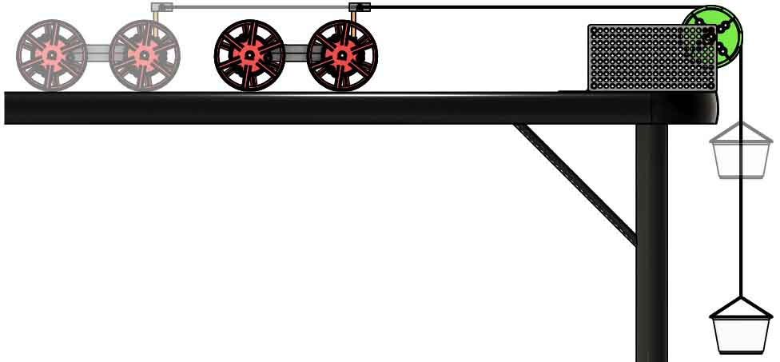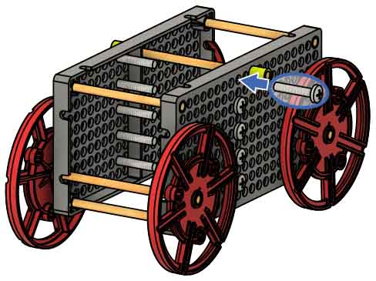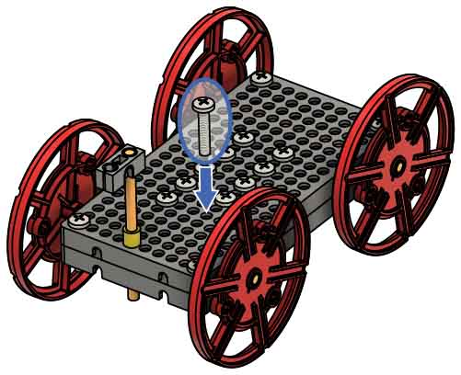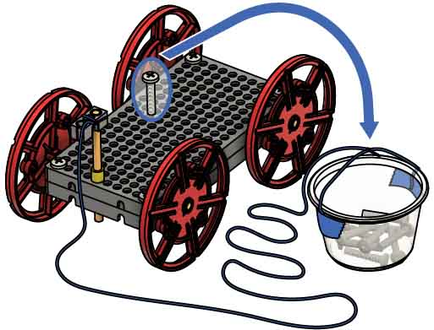

Sail Car

Electric Race Car or Rubber Band Racer

Use the Atwood’s machine to **accelerate the car** down the track.

Now **move all 10 of the screws from the car to the weight hanger** and send it down the track again.

You don’t need to measure time or velocity – that comes later.

**List all the objects that were accelerated** when you sent the car down the track.

________________________________________________________________________________________________________________________________________

**Slide** **10 screws into** the **hole plate** of your car. These will let you adjust the car’s mass.

**What variables(s) *did* *change*** when you moved the screws?

________________________________________________________________________________________________________________________________________________________________

When you moved the screws from the car to the hanger, **did you change the mass being accelerated?**

________________________________________________________________________________________________________________________________________

Was your **prediction correct?** Explain.

________________________________________________________________________________________________________________________________________

Predict **what will happen if you move screws** from the car **to** **the** **weight** **hanger**.

____________________________________________________________________________________________________________________________________

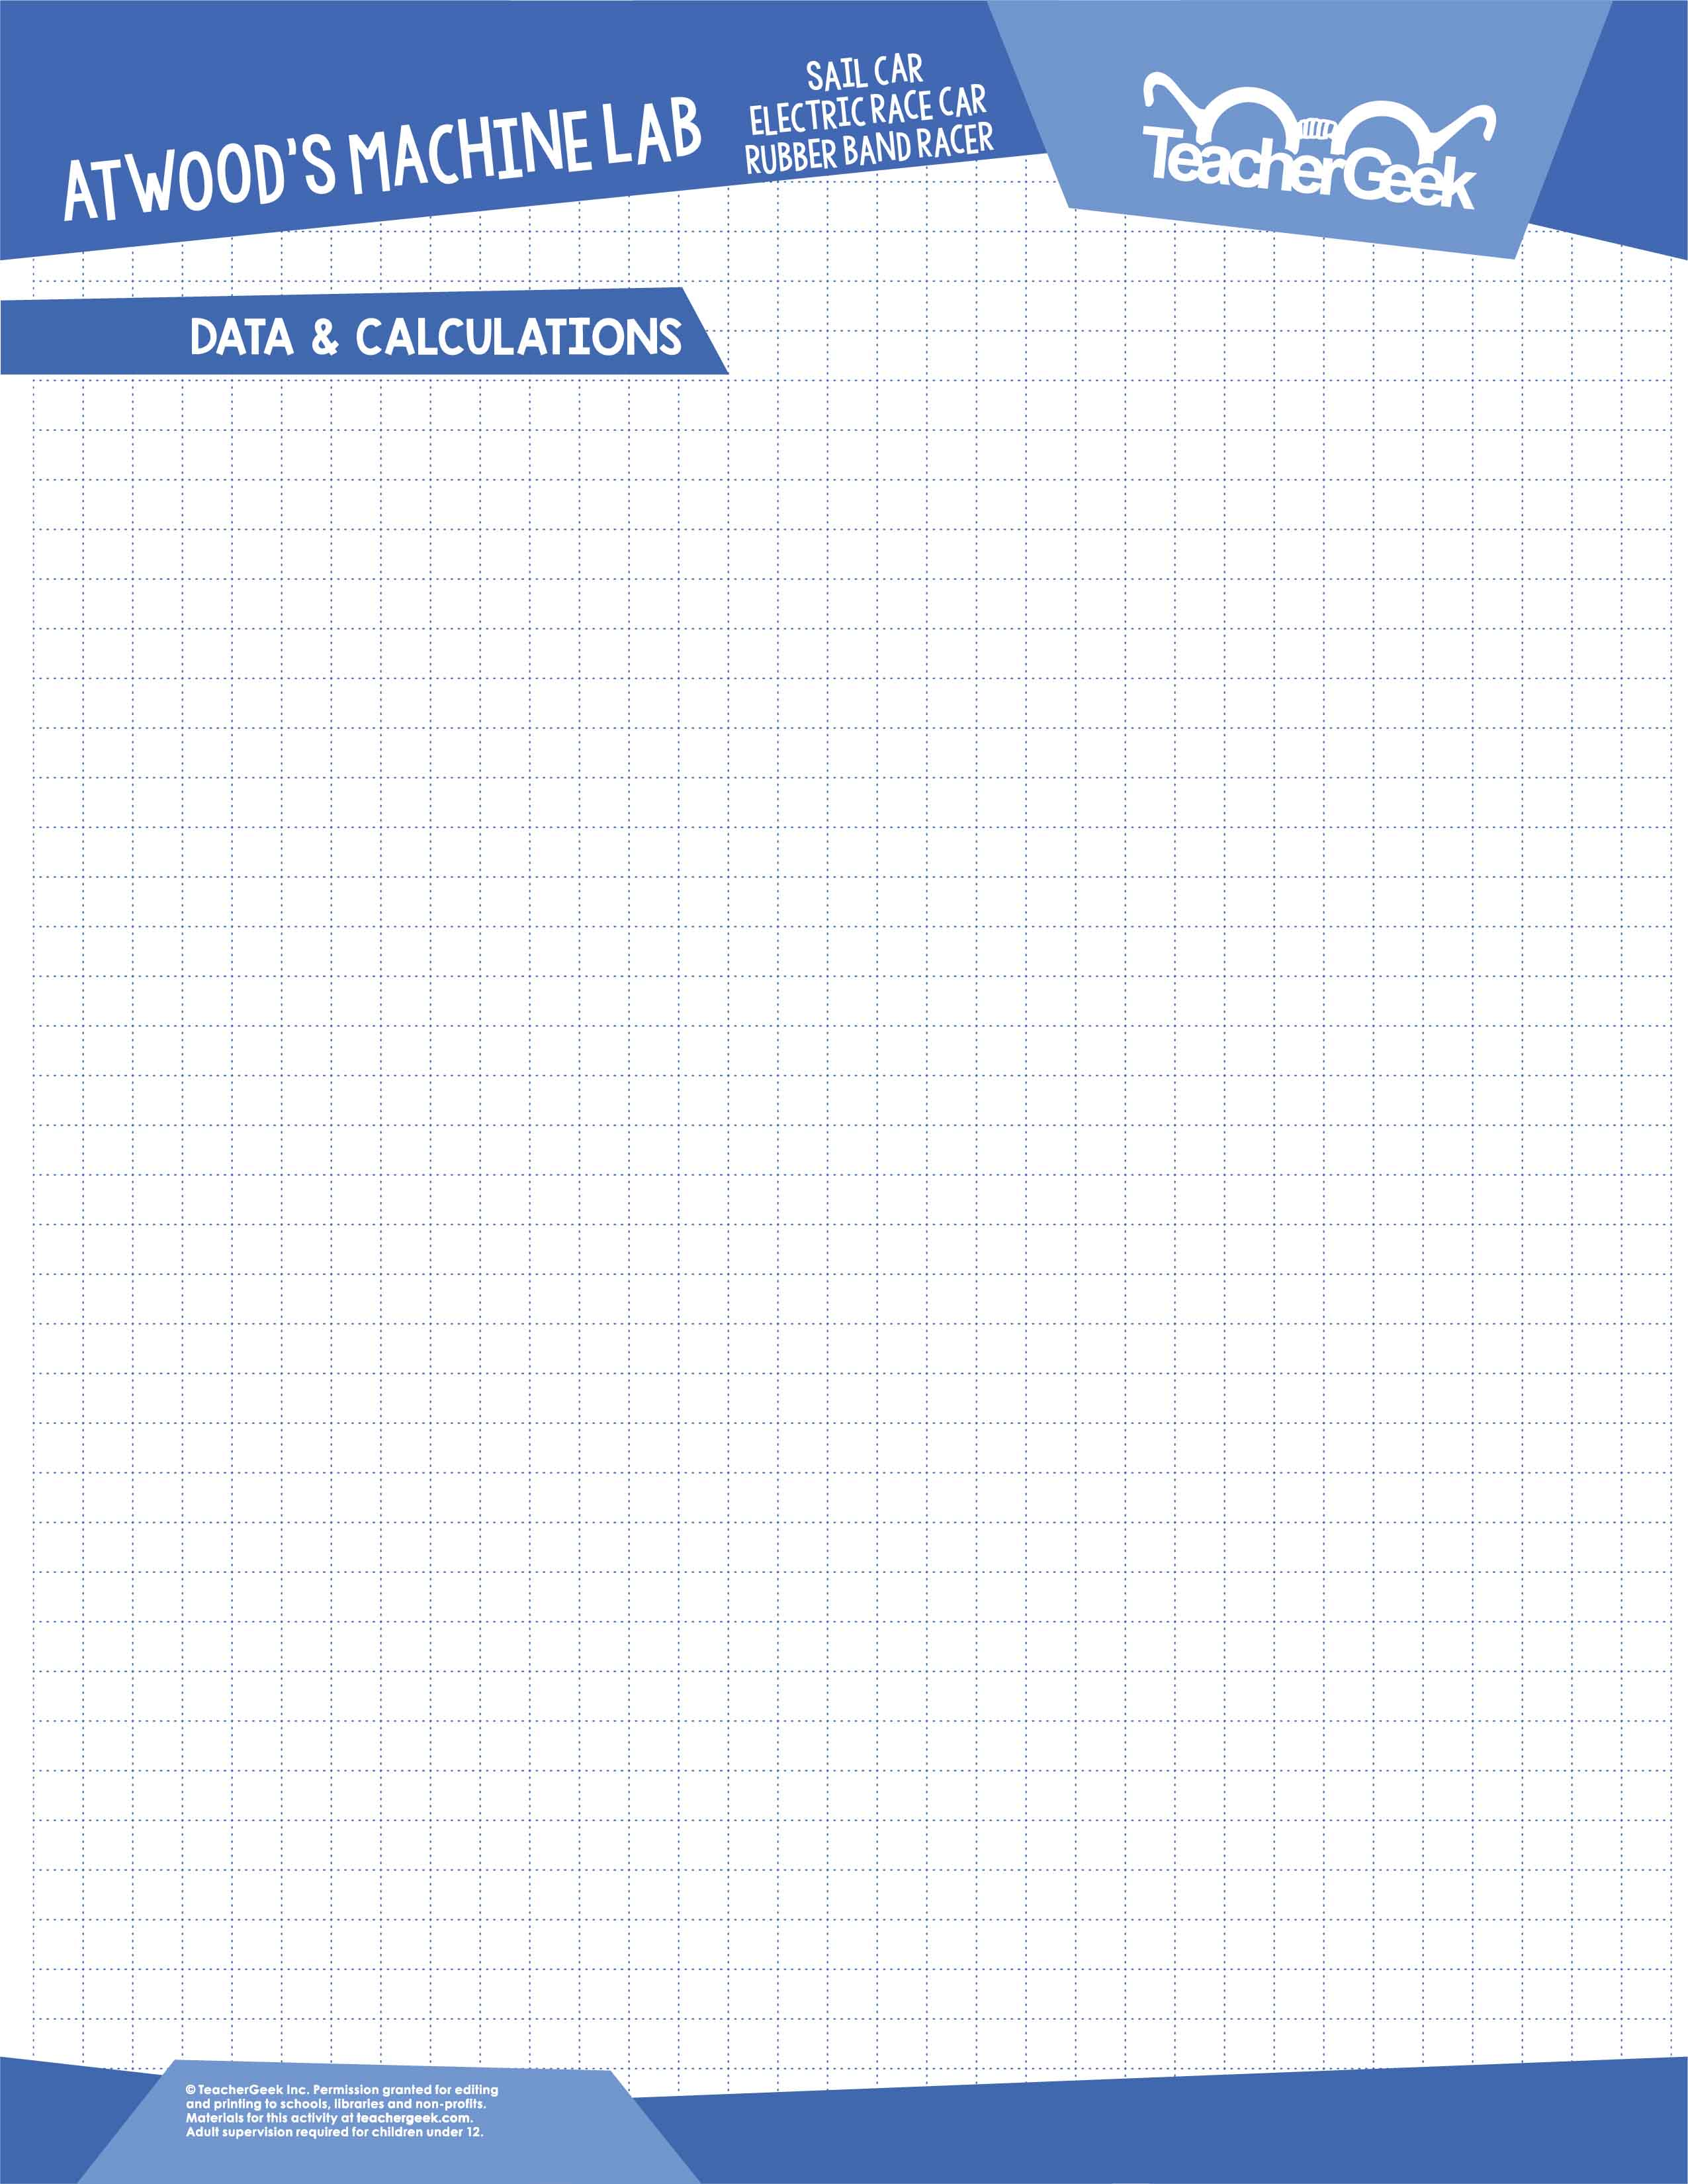

**Get instructor approval** before moving on to your experiment.

**How will you measure** (or calculate) **these variables?**

|  |  |  |
| --- | --- | --- |
| **Independent Variable(s)** | **Dependent Variable(s)** | **Control Variable(s)** |
|  |  |  |

**What variables** do you need to **keep track of?**

Use Sensors

OR

Calculate Using $d=v_{i}t+\frac{1}{2}at^{2}$

|  |  |  |
| --- | --- | --- |
| **Mass** | **Acceleration** (circle one) | **Force** |
|  |  |  |

**Instructor Approval**: _______________________________________

**Describe your procedure**:

______________________________________________________________________________________________________________________________________________________________________________________________________________________________________________________________________________________________________________________________________________________________________________________________________________________________________________________________________________________________________________________________________________________________________________________________________________________________________________________________________________________________________________________________________________________________________________________________________________________________________________________________________________________________________________________________________________

**Acceleration vs Mass** OR **Acceleration vs Force**

**What relationship will you investigate?** Circle one.



**Complete your experiment**, recording data, calculations, tables, graphs, etc. in this section. Be sure to **show all work for your calculations**. If you run out of room, continue on a separate paper.

**Page 6**





Newton’s 2nd “Law” states that $ΣF=ma$ (when mass is constant). Using this “Law,” **calculate the theoretical acceleration** for your car for each of your trials. **Show all work.**



Compare the theoretical acceleration (from Step 24) to your measured acceleration (from Step 23) by **computing the percent error. Show all work.**

$$\left(\% Error\right)=\frac{\left(Measured Value\right)-\left(Theoretical Value\right)}{(Theoretical Value)}$$





**Describe all the forces** that acted on your car.

__________________________________________________________________________________________________________________________________________________________________________________________________________________

What variables did you measure and **what was their mathematical relationship?**   
(Proportional, inversely proportional, quadratic, inverse square?) How can you tell?

________________________________________________________________________________________________________________________________________________________________________________________________________________________________________________________________________________________

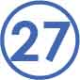



**How will** your experiences from **this lab** **help you create a better design** for your   
engineering challenge?

________________________________________________________________________________________________________________________________________________________________________________________________________________________________________________________________________________________

What were some possible **sources of error?**

________________________________________________________________________________________________________________________________________________________________________________________________________________________________________________________________________________________

**Does your data support Newton’s 2nd “Law”** ($ΣF=ma$)**?** Reference your percent errors in   
your explanation.

________________________________________________________________________________________________________________________________________________________________________________________________________________________________________________________________________________________