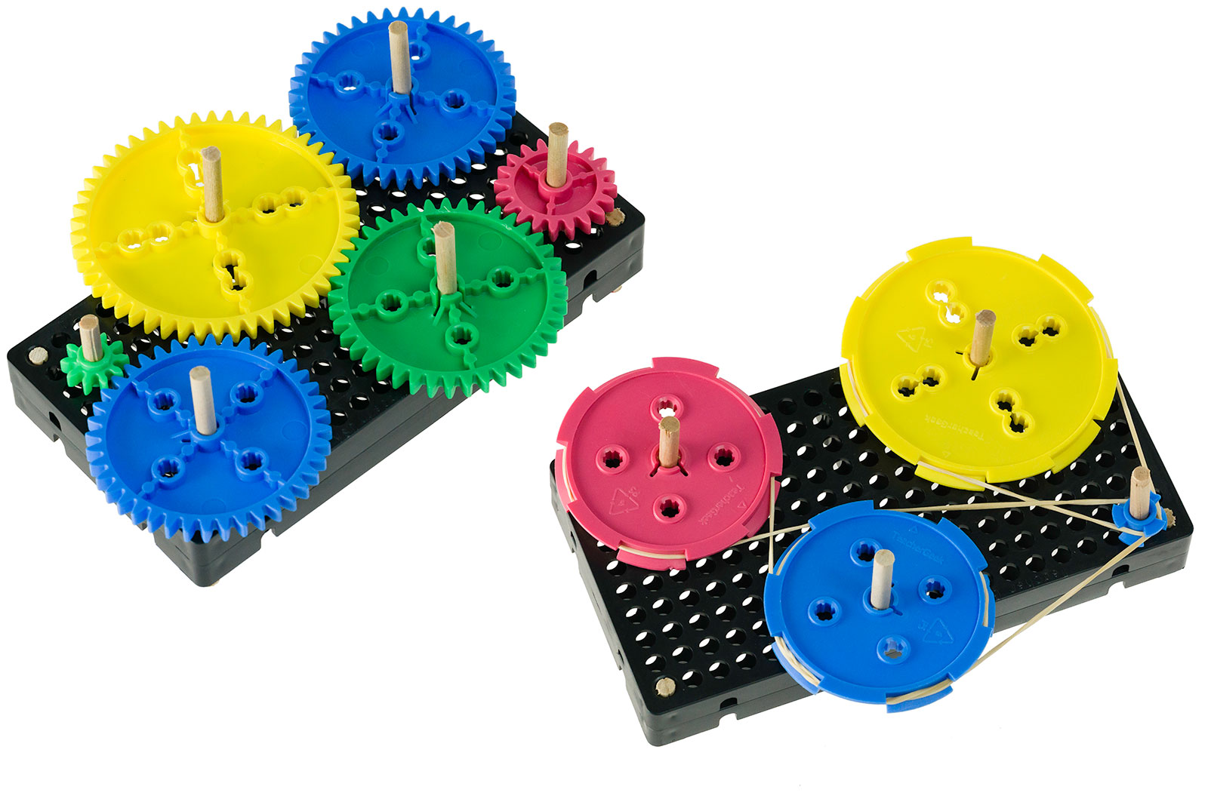

**►**

If Doing This Activity With Young Children:  
*Have an adult assemble it first (using this build guide), and then give to children to tinker and engineer with.*

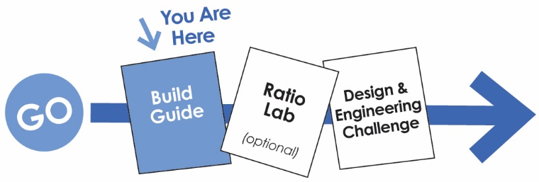

**WARNING!**Small Parts, Choking Hazard,   
For ages 4 and Up.   
Use only with Adult Supervision.

*Download Documents at teachergeek.org/learn*



You’ll need these components to create one Gears & Pulleys Tinker Set.

|  |  |  |
| --- | --- | --- |
|  | Colors will vary. |  |
| **8 – Pulleys** Two of the following pulleys:  9mm, 25.5mm, 55.5mm, 70mm | **8 – Gears**  Two each of the following gears:  10, 20, 40, 50 Tooth | **4 –** [**Blocks**](https://teachergeek.com/products/teachergeek-wind-lift?variant=344617145) |
| **x10** |  |  |
| **2 – Hole Plates** | **4 – Dowels**  5mmx300mm (12in) | **10 – Rubber Bands**  Small (#16) |



This isn’t a kit. With TeacherGeek, you get to really build (*cut, ream, screw*).  
Here are tools you’ll need to get started. They can be shared, between kids/groups, if needed.

* *[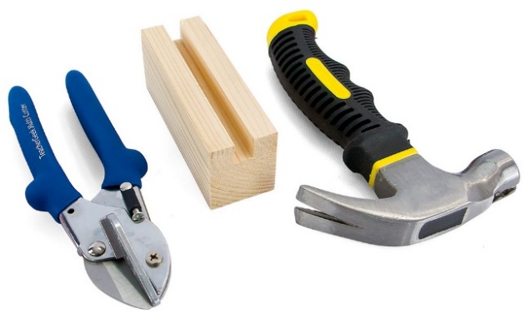](https://teachergeek.com/products/easy-engineering-tool-set?variant=344866731)***TeacherGeek** [**Multi-Cutter**](https://teachergeek.com/products/1823-81)
* **Tapping Block**
* **Small** [**Hammer**](https://teachergeek.com/products/stubby-claw-hammer)



**Tip:** Save all your materials (even what you cut off). Keep them in a bag. They can be used later.

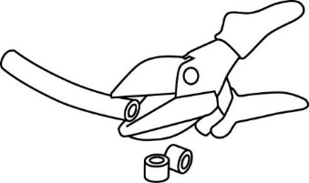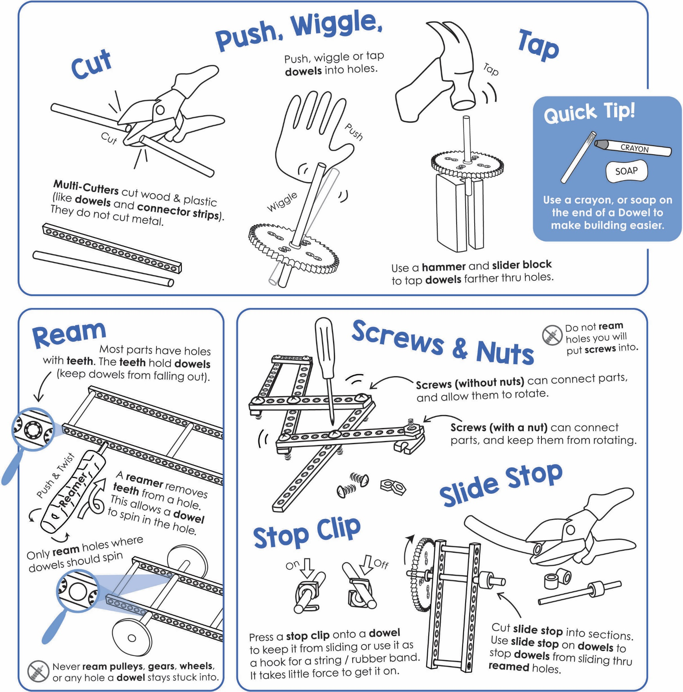

Get individual tools, or the complete  
**TeacherGeek / Maker Tool Set**   
[Single SKU 1823-24](https://teachergeek.com/products/easy-engineering-tool-set?variant=344866731)  
Class Set [SKU 1823-85](https://teachergeek.com/products/easy-engineering-tool-set?variant=344866731)

Tools for ages 13 and above, or with adult super vision





**Tap** or push the **dowels** into two, stacked, upside-down **hole plates**.

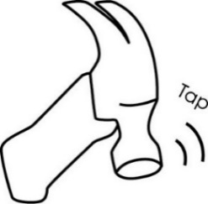**Cut** four **3cm** (1in) **dowels**.

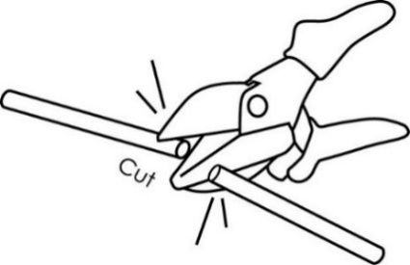

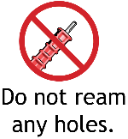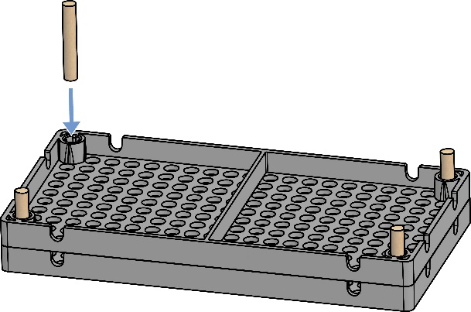

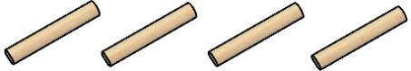

3cm (1in)

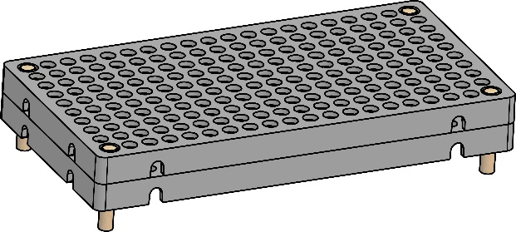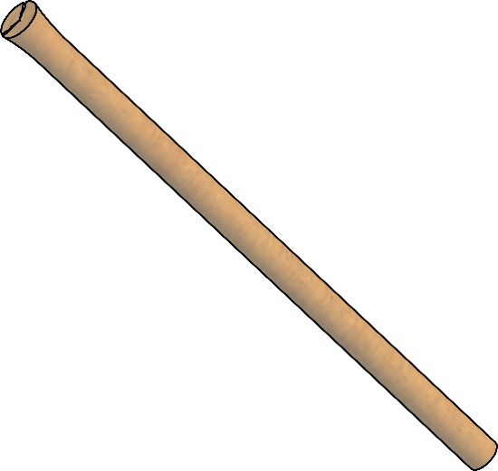

**Congratulations!**

Your **base** is done.

Damaged Dowel End

Dowel End fixed with a pencil sharpener

**Tip:** Use a pencil sharpener to clean up damaged dowel ends. Don’t sharpen it to a point; only take a little off.

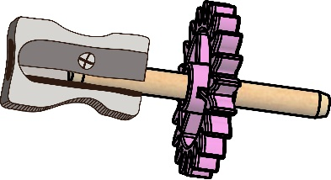

**►**

Now, it’s time to construct your gears and pulleys   
for your tinker set.

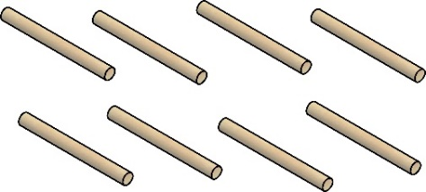****

5cm (2in)

**Cut** 16 **5cm** (2in) **dowels**.   
These will become **shafts** for gears.



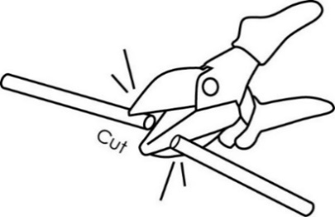

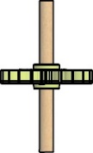****

*Finished Gears*

**Tap** a **shaft** into each gear’s **center hole**, so the gear is in the center of the shaft.



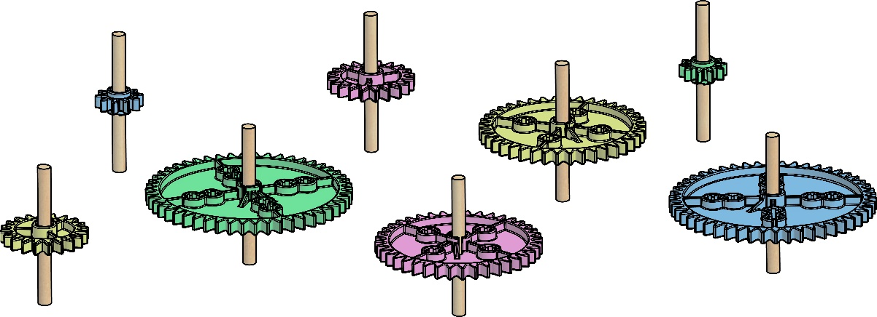

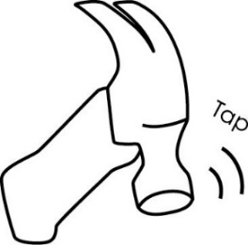

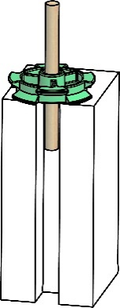



**Tap** a **shaft** into each pulley center hole,   
so the pulley is in the center of the shaft.

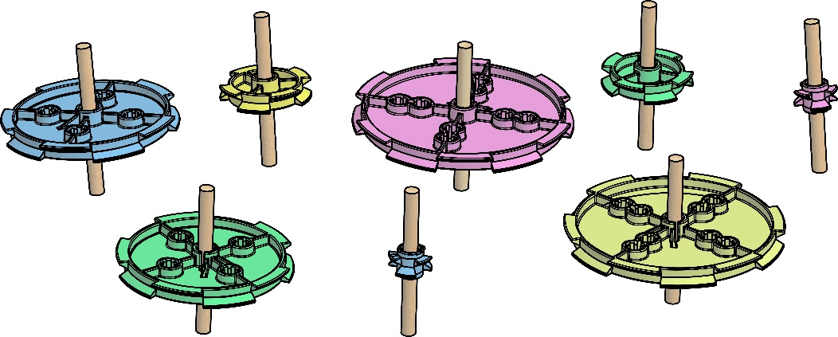

**►**

**Tip:** Tap the dowel through the gear   
or pulley, and down   
into the groove   
on a tapping block.

*Finished Pulleys*



A gear is a wheel with teeth. The teeth **mesh** (connect) with other gears.

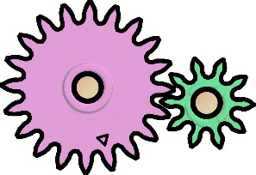

Tooth

Meshed Teeth





Place **gears** into the base. Position them so that the teeth **mesh**. If gears are too close, or too far away, the teeth will not mesh correctly.



Keep experimenting… Rearrange how the   
gears mesh.

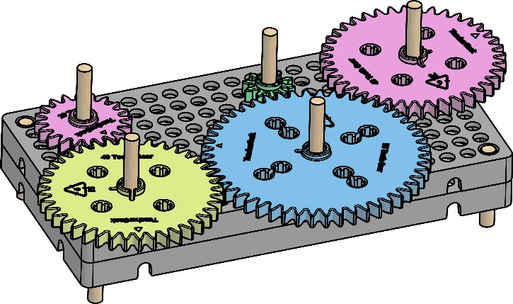

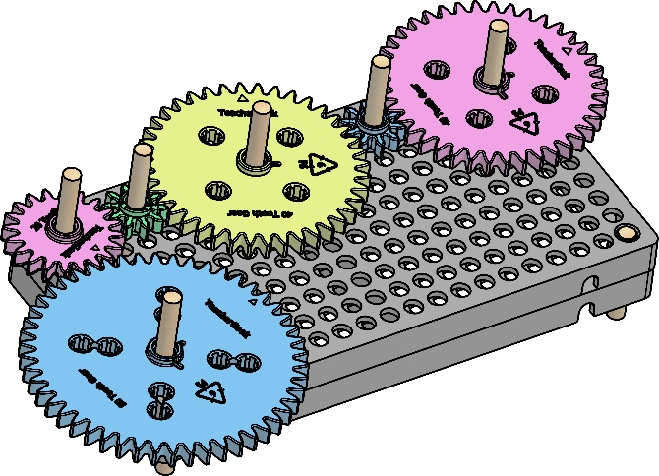





Place **pulleys** into the base. They should not touch   
each other. Use **rubber bands** (belts) to connect them.

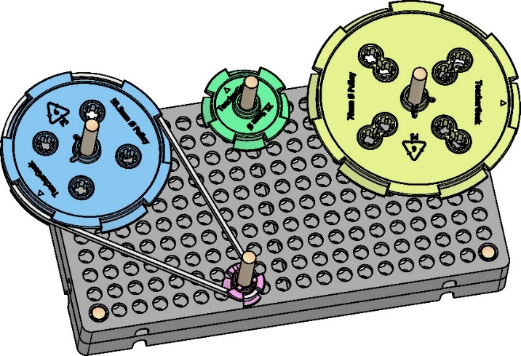

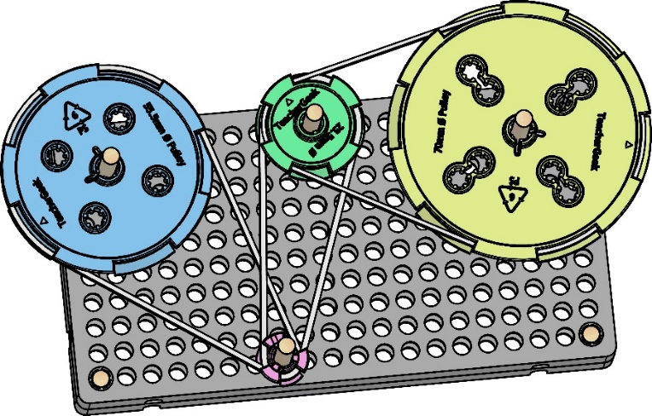





Want more room to play with gears and pulleys?

**Bases** can be **combined** using **blocks**.

block

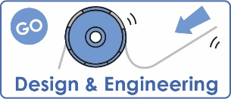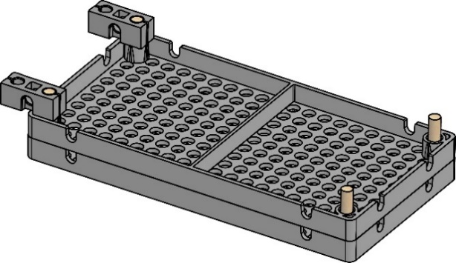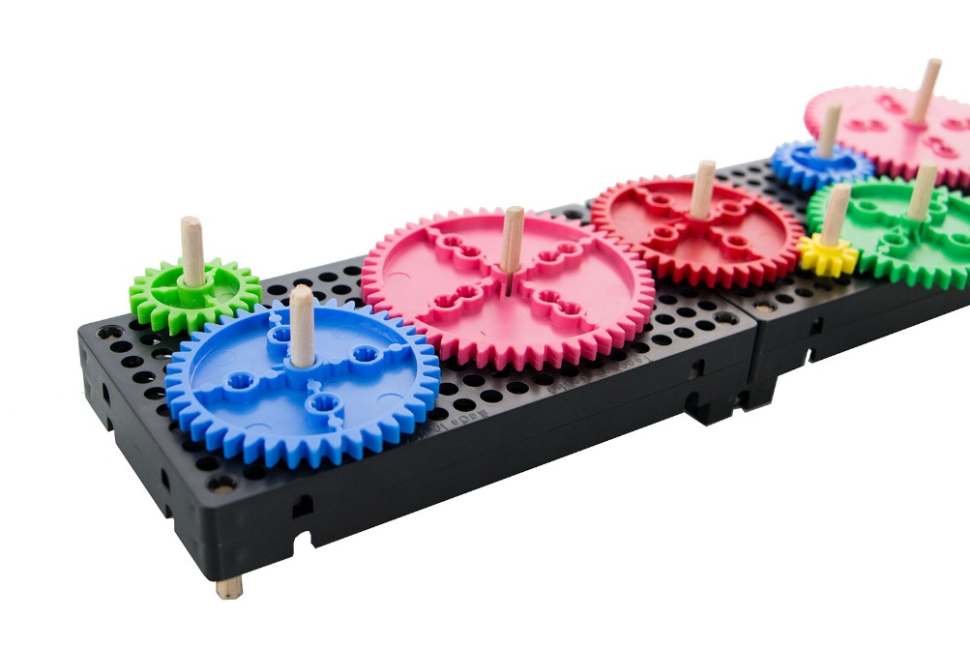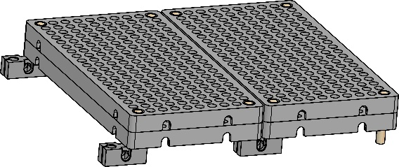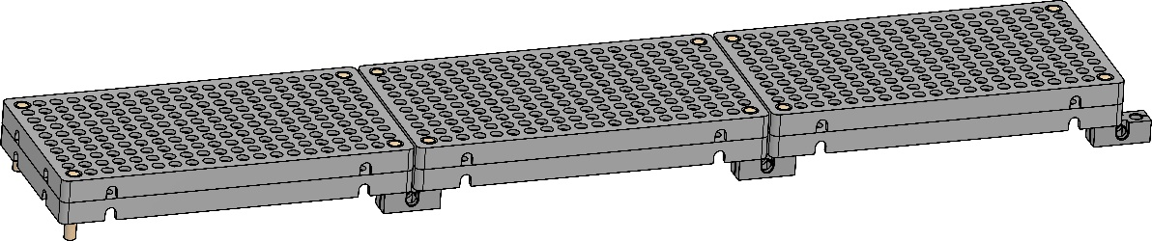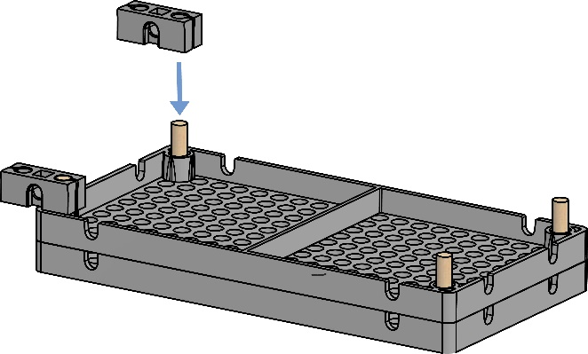

Documents at **teachergeek.com/learn**

If you are going to do the optional Challenges, now’s the time.



If you are going to do the optional Ratio Lab, now’s the time.

Bases can be combined long, or wide.