

*Design and build a kinetic sculpture  
with your gears and pulleys tinker set.*

**Kinetic Energy** is energy in motion. With your gears and pulleys, you can harness this energy to power animated sculptures and art that *interacts*.   
*Art doesn’t have to stay flat – Alexander Calder’s* ***mobiles*** *rotated and spun.*



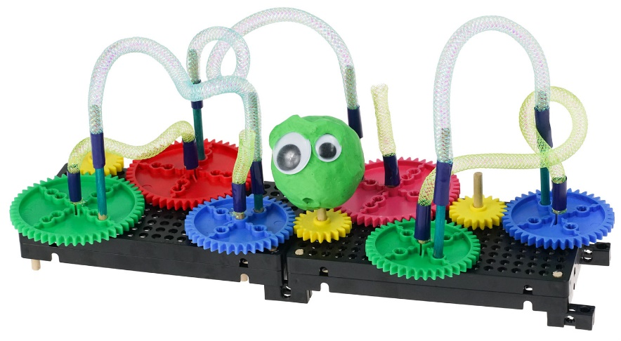



Connect dowels  
with yarn, tape   
or tubing.





**Challenge Supplies**Gears and Pulleys Tinker Set with base, dowels, sculpture materials (paper, clay, pipe cleaners, string, recycled materials), glue, tape

Make sure you have built a **Tinker Set** for use on this challenge.

Cut out the example gears and pulleys below to plan your design.   
 Use an **engineering notebook** page to sketch out ideas.

Tap a **dowel** into each gear or pulley’s **center hole** *– use different   
 heights depending on what you want higher in your sculpture.*

Attach drawings, fabric or clay figures to the dowels.   
 Note the direction of **rotation** – *how can you make art,* ***interact****?*

**►**

**►**

**►**

**►**

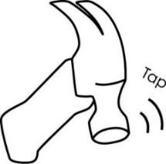

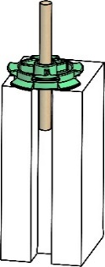

**Tapping   
Block**



**The Engineering Design Process:**

You will be using the **Engineering Design Process**. What does that mean?   
Your design is never finished (it can always be improved). There is no   
such thing as a perfect design. Fill out a new *Engineering Notebook*   
page each time you design/redesign your **Gears & Pulleys Tinker Set**.

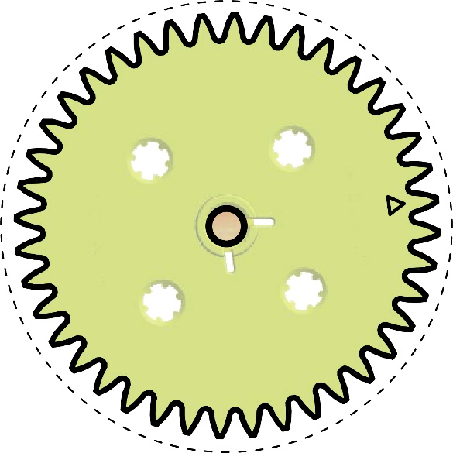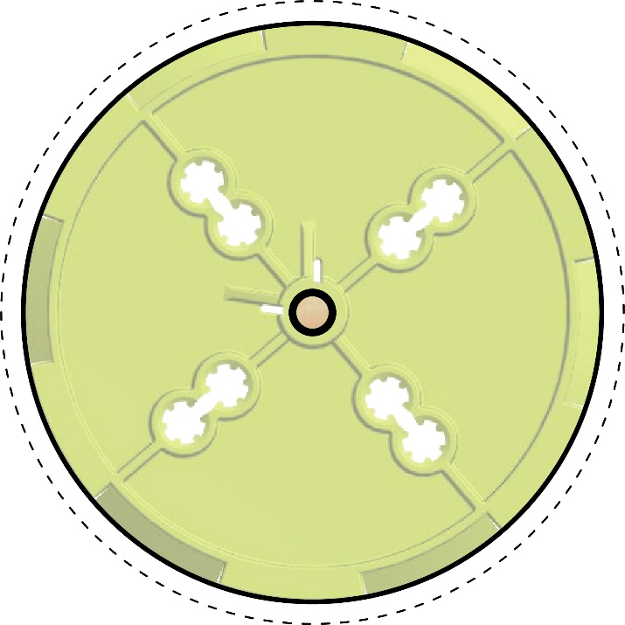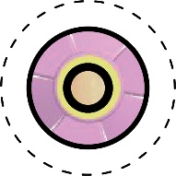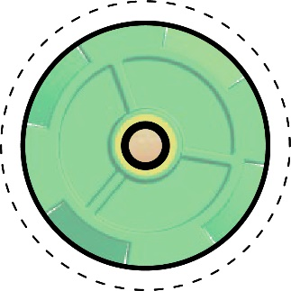

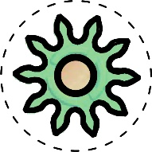

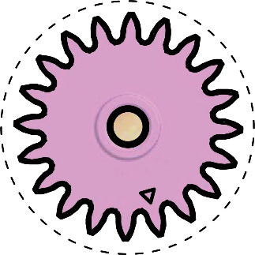

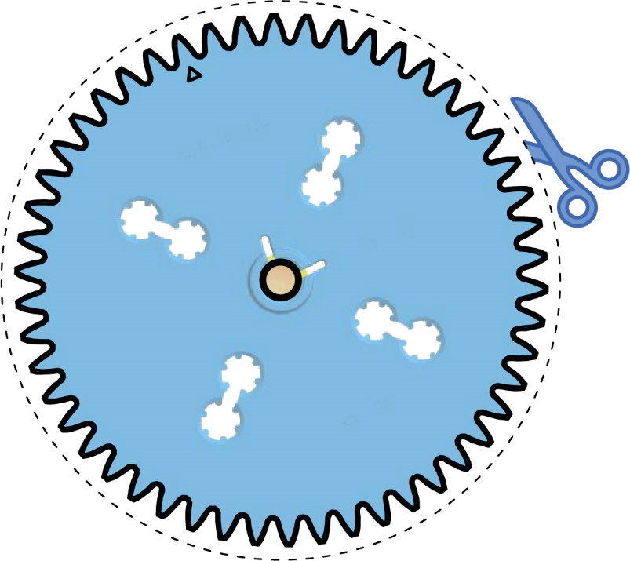

**►**

Cut the gears and pulleys   
on the dotted line. Don’t worry about the gear teeth. Use the paper cut-outs to experiment with designs and ideas for   
your tinker sets and sculptures.

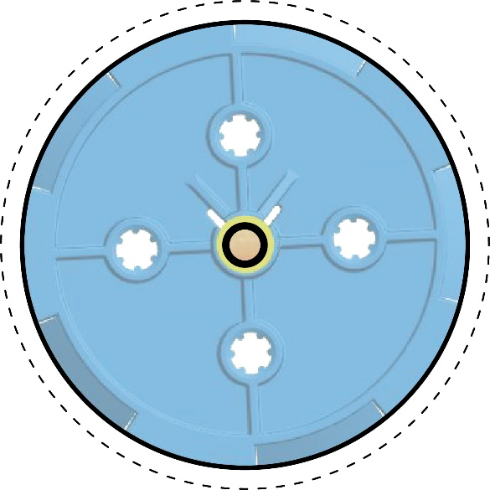



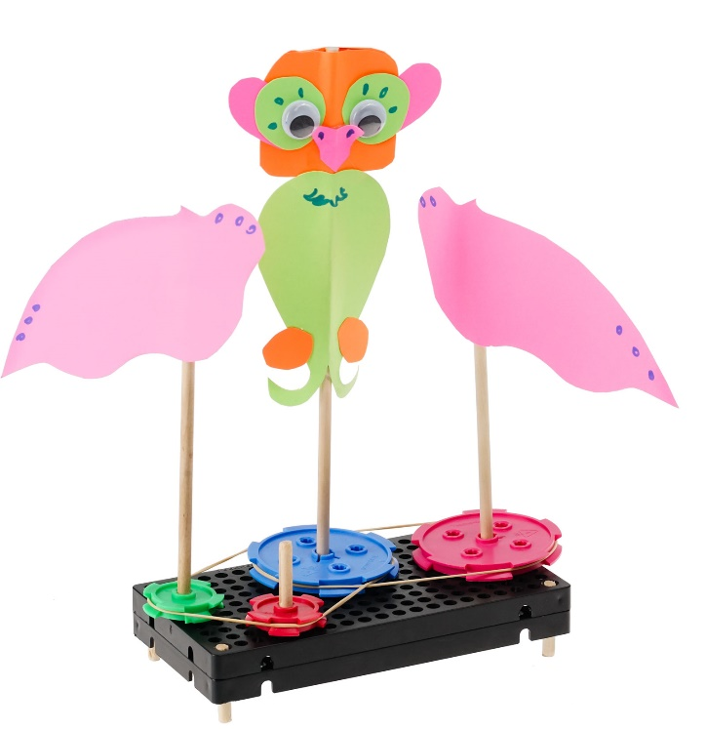

These wings flap back and forth.



**Kinetic Sculptures** can do more than just spin –   
use your gears and pulleys’ direction of   
rotation to make art that *interacts*.



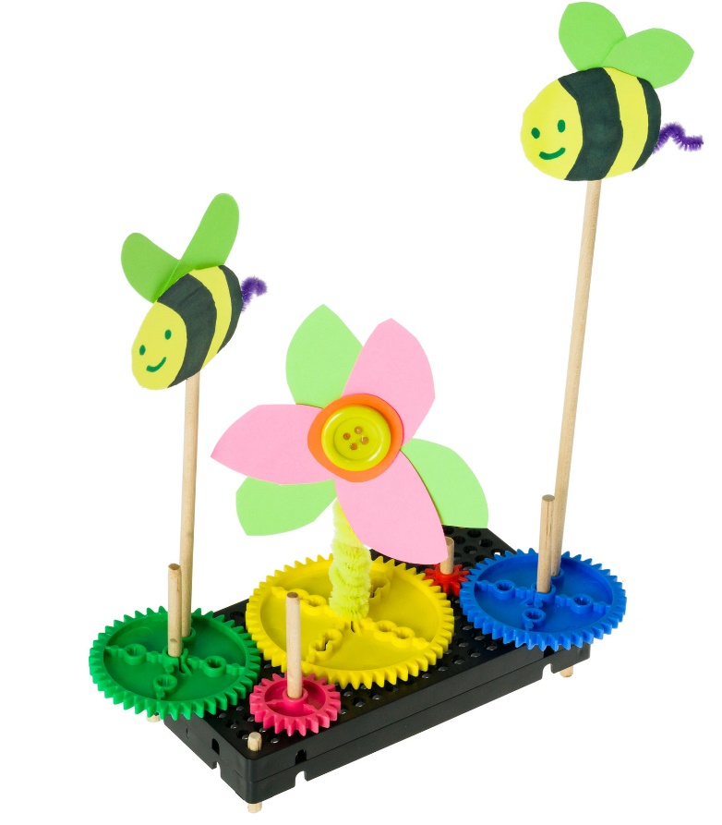

These bees circle  
the flower and each other.







Use recycling bin innovation to hide   
or add mechanisms.





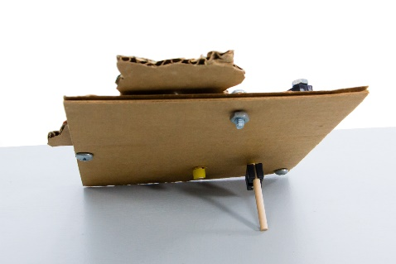



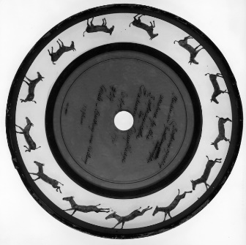

The **Zoopraxiscope** (inventedby Eadweard Muybridge) was the first movie projector. Drawings on the circle   
blur and “move” when **rotated** by a center dowel.  
*How could you animate your kinetic sculptures?  
With boxers in a ring, or twirling ballet dancers?*





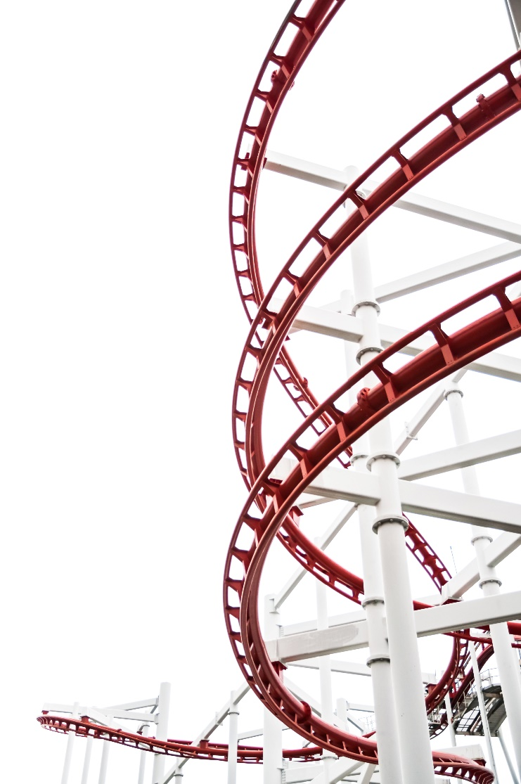

*Design a gears and pulleys inspired attraction   
for the hip, new theme park* ***Darren Lake****.*

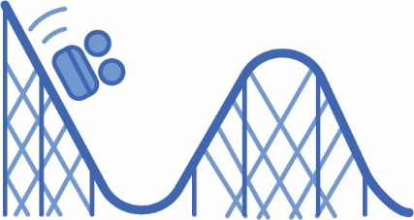



Make sure you have built a **Tinker Set** for use on this challenge.

Cut out the example gears and pulleys below to plan your design.   
 Use an **engineering notebook** page to sketch out ideas.

Your attraction must utilize gears and pulleys in its operation.   
 Demonstrate with your TeacherGeek tinker set how you can  
 change speed and direction, or transmit force.

Do not mesh gears with pulleys on the same base –   
 if combined in your attraction’s design, keep each separate.

You will have ___________________ to complete the challenge.

**►**

**►**

**►**

**►**

Fill in how much time you have

**►**

**Challenge Supplies**Gears and Pulleys Tinker Set with base, dowels,   
cut out sheet, Engineering Notebook Pages, pencil, pen



**The Engineering Design Process:**

You will be using the **Engineering Design Process**. What does that mean?   
Your design is never finished (it can always be improved). There is no   
such thing as a perfect design. Fill out a new *Engineering Notebook*   
page each time you design/redesign your **Gears & Pulleys Tinker Set**.



*These ideas are just to get you started – what else can you   
design for an amusement park using gear and pulley sets?*

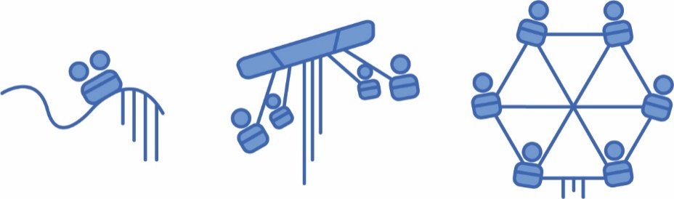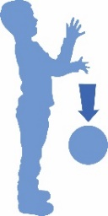

**Kinetic Energy** is   
energy in motion.

**Potential Energy** is   
stored energy, ready   
to be put in motion.

**►**

**Rock Your Roller Coaster***Control the thrills**on your personal roller coaster design.*Roller coaster cars have no power source of their own.   
They reach thrilling speeds using **gravity**, **kinetic energy,**    
**gears** and **pulleys** to lift, transmit force and increase speed.

How could you get coaster cars to the top of the **incline** (lift hill)?



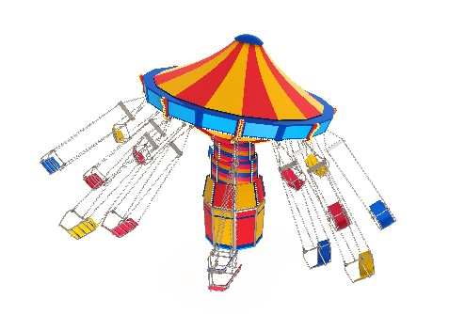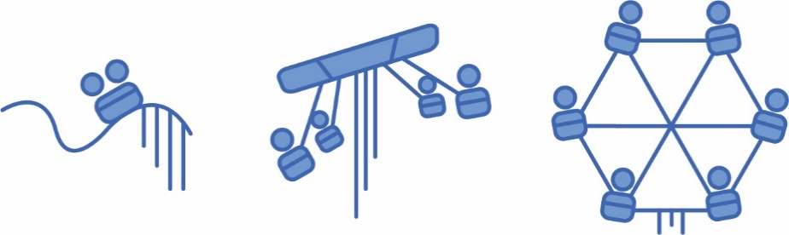

**►**

**Swingin’ Party Down the Line***Whee! Try not to get sick on this whirling rotary ride.*Chair swing rides tilt and whirl, flying guests in circles.   
The transfer of force through **pulley systems** use   
**simple** and **cross belt positions** to pull and drag.

How could you use pulleys to lift and lower **loads** (chairs)?

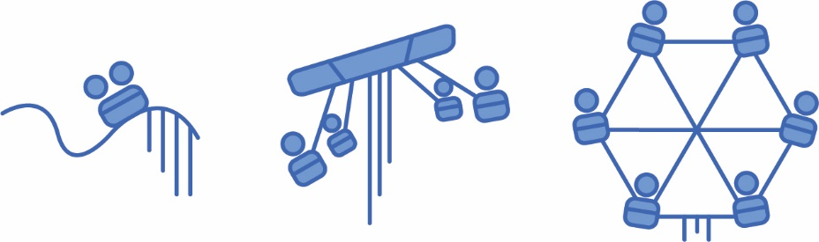

**Around and Around We Go!***Is there anything more relaxing than a spin on a Ferris Wheel?*   
Passengers complete one full wheel **revolution** each trip,   
much like a giant gear. Smaller **input gears** transmit   
power over distance, allowing the wheel to turn.

How would you change the wheel’s **direction**?

**►**

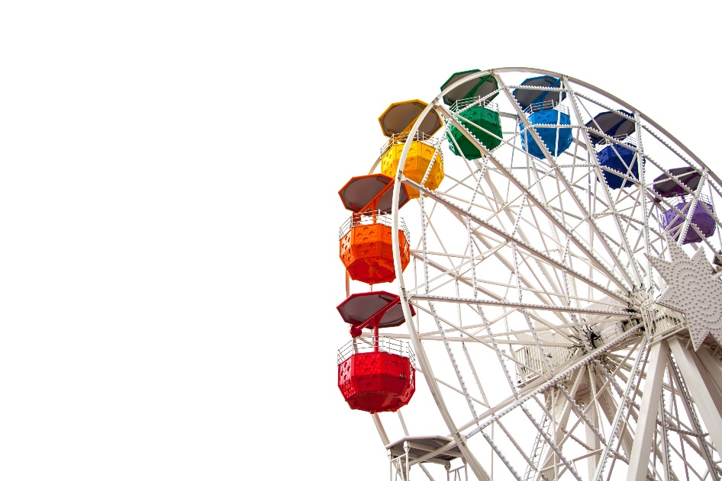



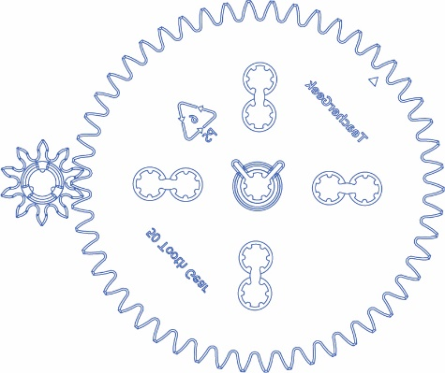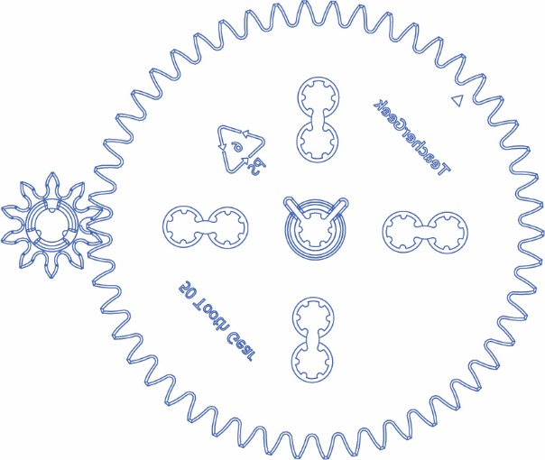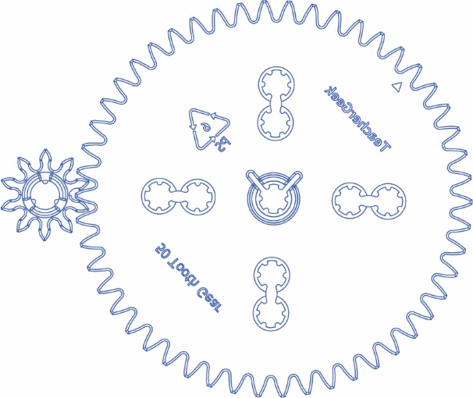

**►**

**Need More Room?**   
Print Extra Engineering Notebook Sheets:   
teachergeek.org/engineering_notebook.pdf

*Sketch, Write and Design your park attraction ideas below.*

