

**►**

If Doing This Activity With Young Children:  
*Have an adult assemble it first (using this build guide), and then give to children to tinker and engineer with.*

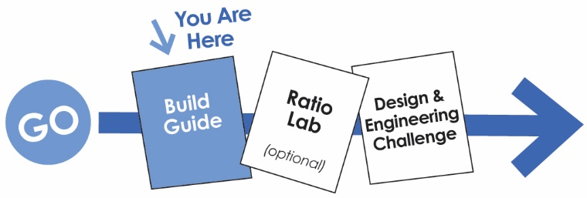

**WARNING!**Small Parts, Choking Hazard,   
For ages 4 and Up.   
Use only with Adult Supervision.

*Download Documents at teachergeek.org/learn*



You’ll need these components to create one Gears & Pulleys Tinker Set.

|  |  |  |
| --- | --- | --- |
| *Colors will vary.* |  |  |
| **8 – Pulleys** Two of the following pulleys:  9mm, 25.5mm, 55.5mm, 70mm | **8 – Gears**  Two of the following gears:  10, 20, 40, 50 Tooth | **2 –** [**Blocks**](https://teachergeek.com/products/teachergeek-wind-lift?variant=344617145) **1– Slide Stop** |
| **x10** |  |  |
| **2 – Hole Plates** | **4 – Dowels**  5mmx300mm (12in) | **6 – Rubber Bands**  Small (#16) |



This isn’t a kit. With TeacherGeek, you get to really build (*cut, ream, screw*).  
Here are tools you’ll need to get started. They can be shared, between kids/groups, if needed.

* *[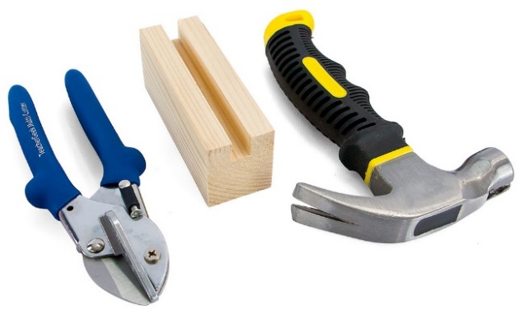](https://teachergeek.com/products/easy-engineering-tool-set?variant=344866731)***TeacherGeek** [**Multi-Cutter**](https://teachergeek.com/products/1823-81)
* **Tapping Block**
* **Small** [**Hammer**](https://teachergeek.com/products/stubby-claw-hammer)



**Tip:** Save all your materials (even what you cut off). Keep them in a bag. They can be used later.

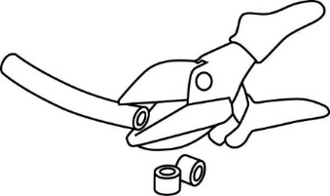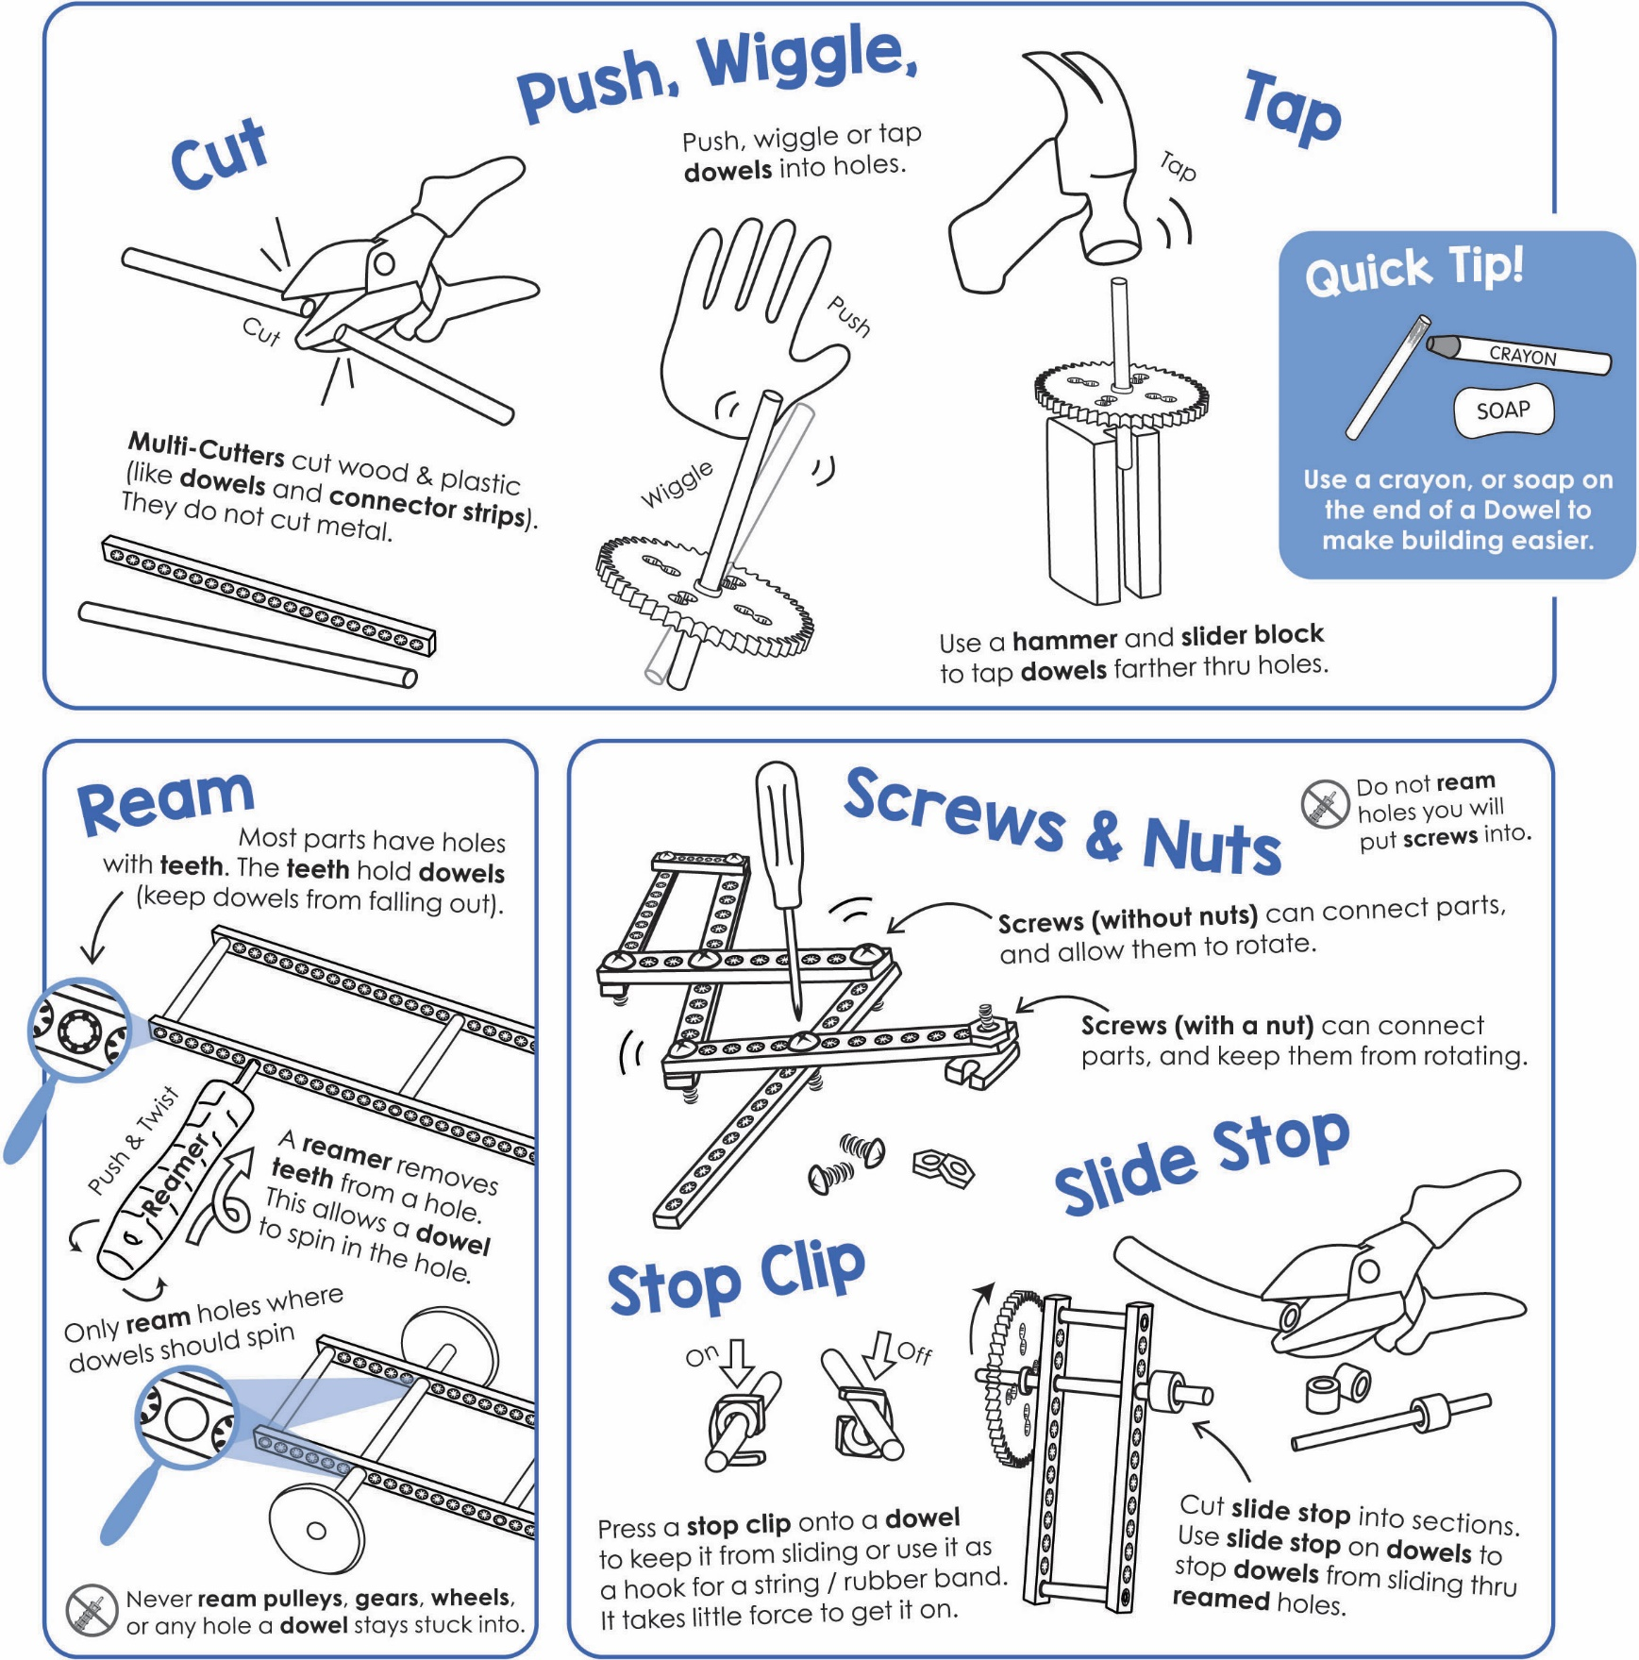

Get individual tools, or the complete  
**TeacherGeek / Maker Tool Set:**   
[Single SKU 1823-24](https://teachergeek.com/products/easy-engineering-tool-set?variant=344866731)  
Class Set [SKU 1823-85](https://teachergeek.com/products/easy-engineering-tool-set?variant=344866731)

Tools for ages 13 and above,   
or with adult supervision





**Tap** or push the **dowels** into two, stacked, upside-down **hole plates**.

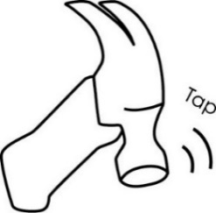**Cut** four **3cm** (1in) **dowels**.

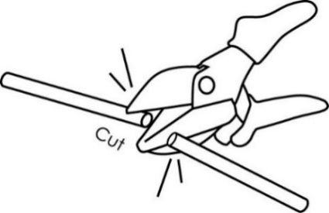

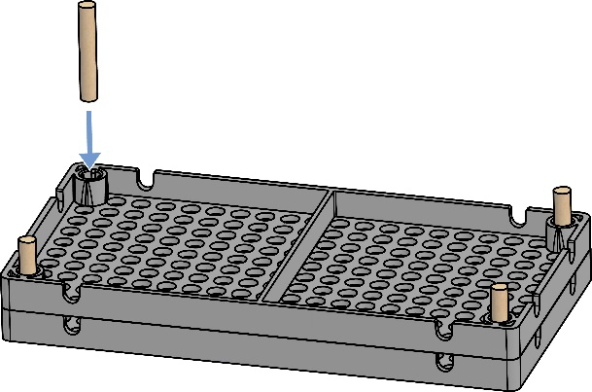

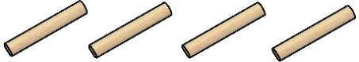

3cm (1in)

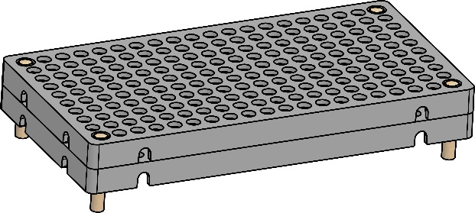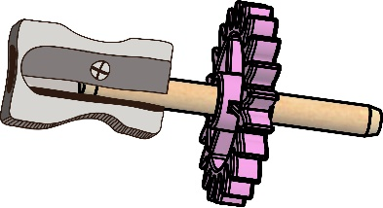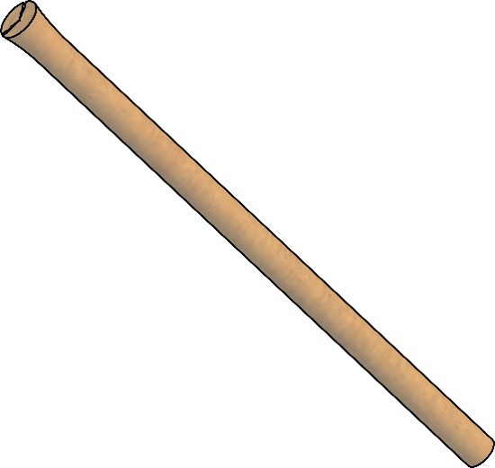

**►**

Now, it’s time to construct your gears and pulleys   
for your tinker set.

**Congratulations!**

Your **base** is done.

Dowel End fixed with a pencil sharpener

**Tip:** Use a pencil sharpener to clean up damaged dowel ends. Don’t sharpen it to a point; only take a little off.

Damaged Dowel End





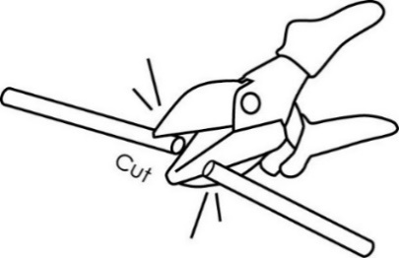

**Cut** two **5cm** (2in) **dowels**.   
These will become **shafts** for gears.

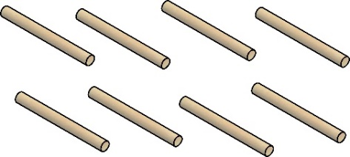

5cm (2in)

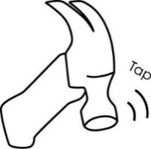

**Tip:** Tap the dowel   
through the center   
hole of a gear or pully, and down   
into the groove   
on a wooden   
**tapping block**.

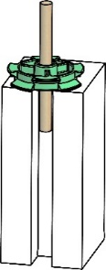



**Tap** a **shaft** into each gear center **hole**, so the gear is in the **center** of the shaft.

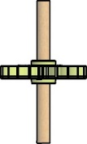

Gear on  
Center Shaft

*Each gear 0.5 cm tall*

**Stack** two **gears** on the dowel   
to create a **compound gear**.  
Slide one 0.5 cm piece of **slide stop** on single gear dowels – this will help   
each level, **mesh**.

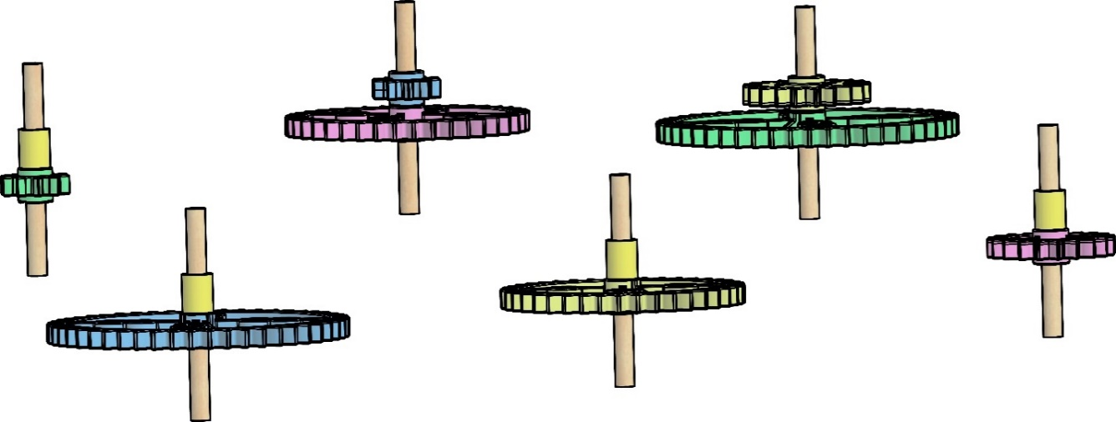

40-Tooth Gear

40-Tooth Gear

10-Tooth Gear

20-Tooth Gear

50-Tooth Gear

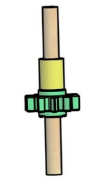



Slide Stop

20-Tooth Gear

50-Tooth Gear



*Finished Compound Gears*

10 Tooth Gear

****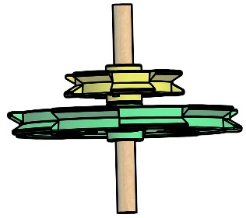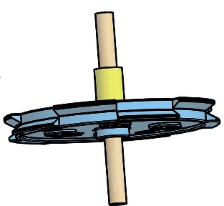

**Stack** two **pulleys** on   
the dowel to create   
a **compound pulley**.  
Slide one 0.5 cm piece  
of **slide stop** on single   
pulley dowels – this will   
help each level line up.

25.5mm  
Pulley

55.5mm  
Pulley

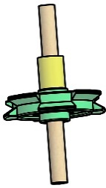

25.5mm  
Pulley

55.5mm  
Pulley

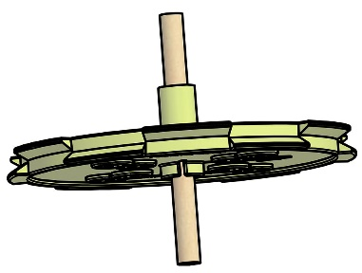

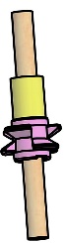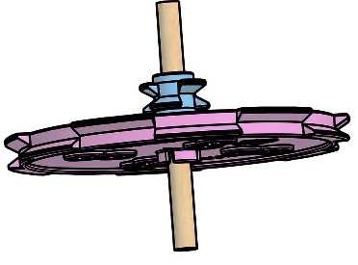

9mm  
Pulley

9mm  
Pulley

70mm  
Pulley

70mm  
Pulley



*Finished Compound Pulleys*





Tooth

Meshed Teeth



Place **gears** into the **base**. Position them so that the teeth **mesh**. If gears are too close, or too far away, the teeth will not mesh correctly.

A gear is a wheel with teeth. The teeth **mesh** (connect) with other gears.

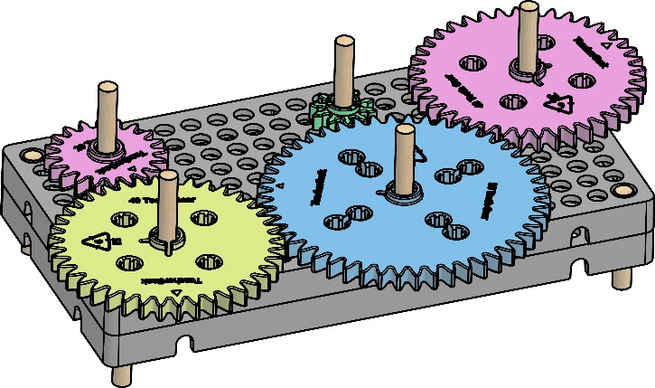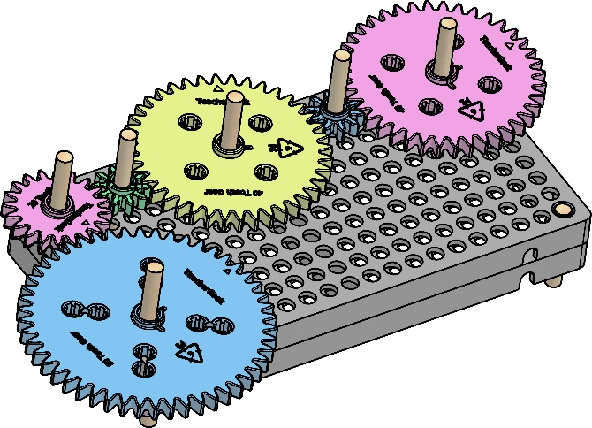

Keep experimenting… Rearrange how   
the gears mesh.



Place **pulleys** into the **base**. They should not touch each other. Use **rubber bands** (belts) to connect them.



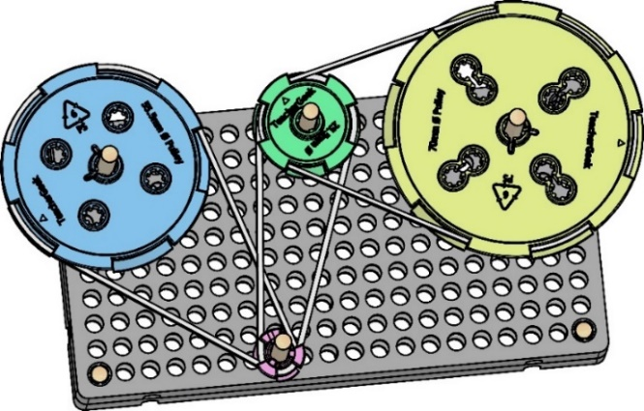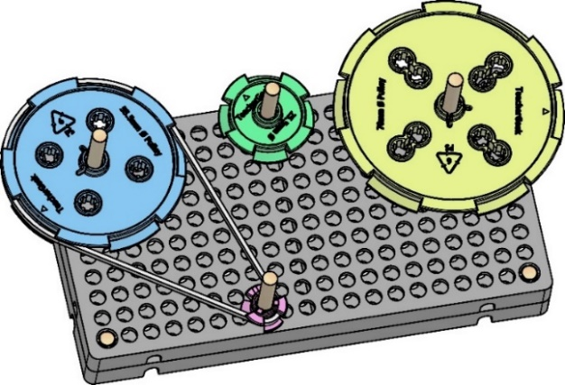







Want more room to play with gears and pulleys?  
Based can be combined using **blocks**.

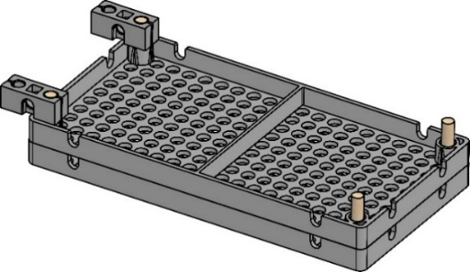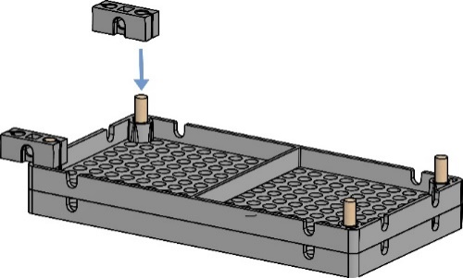

block



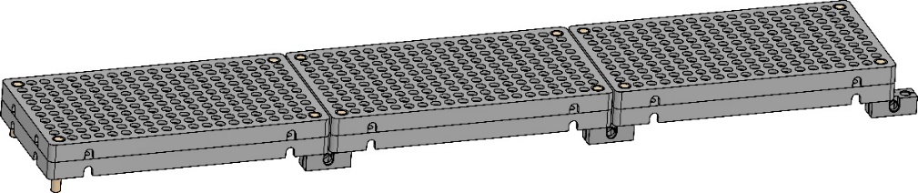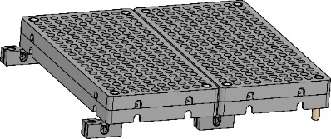

Bases can   
be combined   
long, or wide.







If you are going to do the optional Ratio Lab, now’s the time.

If you are going to do the optional Challenges, now’s the time.

Documents at **teachergeek.com/learn**