Name: ______________________________________________________ Set: _____ Date: _______

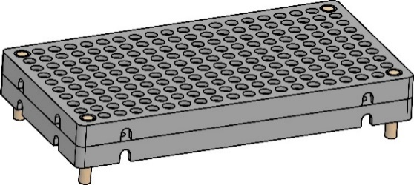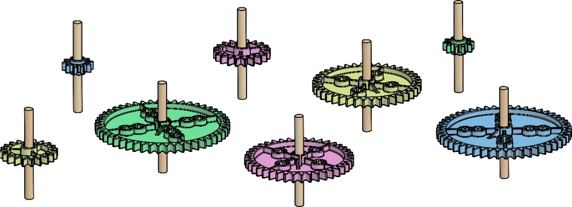

Make sure you have a “built” Gears and Pulleys Tinker Set before starting this lab. The build guide can be found teachergeek.com/learn

**Two** – 40 Tooth

**Two** – 10 Tooth

Base

**Two** – 20 Tooth

**Two** – 50 Tooth

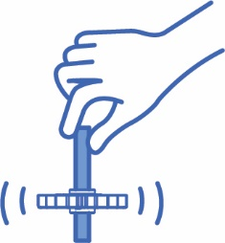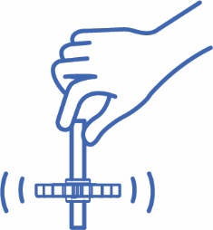

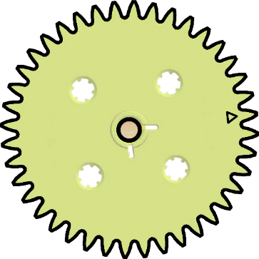



**Tooth**

**Meshed Teeth**



A **gear** is a wheel with **teeth**.   
The teeth **mesh** (connect) with other gears, to make them turn together.

**Output Gear:**   
The gear that gets powered (turned   
by the other gear).

**Input Gear**:   
The gear that   
is powered   
(turned by you).



Place gears into the **base**, so they mesh. Give a spin   
and see what happens. Try different combinations!

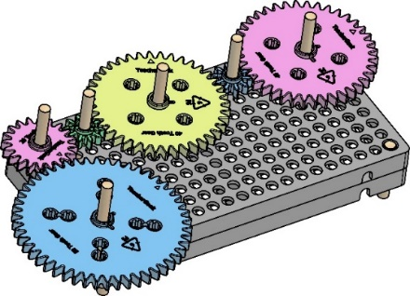

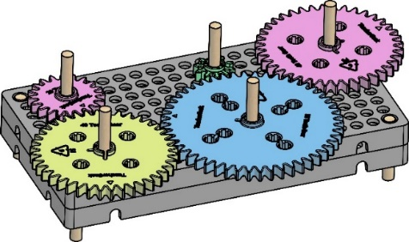

**►**

**Be Careful:**   
If your gears are too close, or too far apart, they won’t mesh.



**Page 1**

**►**

**Revolution:**   
one full rotation

**A Clock’s Rotation:**  
The minute hand on   
a clock makes one revolution every minute.

**Counter Clockwise (CCW)**

**►**

**►**

**Clockwise (CW)**





**Mesh** (connect) two 40-Tooth gears together on the base plate.   
 Using the dowel, spin **Gear A** clockwise (direction of the arrow) one   
**revolution**. Draw an arrow around **Gear** **B** to show the direction of **rotation** (turn).



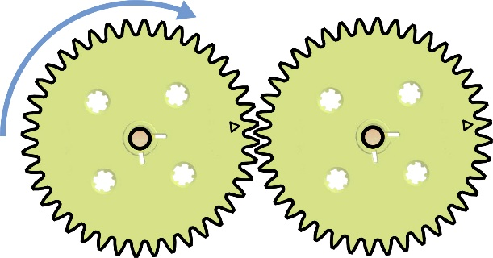

**A**

**B**

**Input  
Revolutions**

Complete for meshed gears **A** & **B**

|  |  |  |  |  |
| --- | --- | --- | --- | --- |
| **Gear** | **# of Teeth** | **Rotation Direction** | **# of**  **Revolutions** | **Revolutions’**  **Ratio** |
| **A Input** | 40 | **CW** | 1 |  |
| **B Output** | 40 |  |  |

**Output  
Revolutions**

**►**

A **ratio** is a comparison of two values (numbers).   
Which values are you comparing? ____________  
 ______________________________________________  
 ______________________________________________

Which **direction** did the output gear rotate?

Clockwise Counter Clockwise

40-Tooth

**►**





Swap your output for a 20-Tooth gear and spin **Gear C** clockwise one revolution.

Complete for meshed gears **C** & **D**

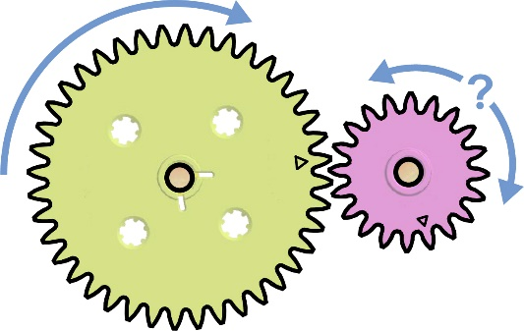

**C**

**D**

|  |  |  |  |  |
| --- | --- | --- | --- | --- |
| **Gear** | **# of Teeth** | **Rotation Direction** | **# of**  **Revolutions** | **Revolutions’**  **Ratio** |
| **C Input** | 40 | **CW** | 1 |  |
| **D Output** | 20 |  |  |

20-Tooth

How did changing the **output gear** size affect   
the revolutions’ ratio? _________________________  
 ______________________________________________

**►**

**2**



Now, spin **Gear C** counter clockwise one full revolution.   
 Draw an around **Gear D** to show the direction of rotation.

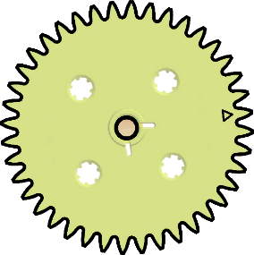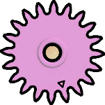

**C**

**D**



Complete for meshed gears **C** & **D**

|  |  |  |  |  |
| --- | --- | --- | --- | --- |
| **Gear** | **# of Teeth** | **Rotation Direction** | **# of**  **Revolutions** | **Revolutions’**  **Ratio** |
| **C Input** | 40 | **CCW** | 1 |  |
| **D Output** | 20 |  |  |

Did changing the **direction of rotation** affect   
the revolutions’ ratio? _________________________  
 ______________________________________________

**►**





Find the **common factor**that’sdivisiblebetween the **input** and **output** numbers.

**►**

Many ratios can   
be written with smaller numbers – this is called **reducing**, or simplifying.

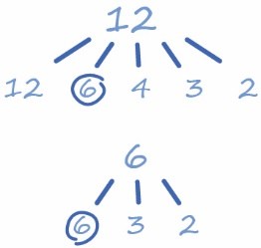****

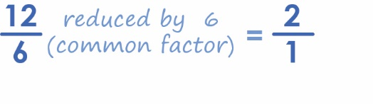



Reduce both values. Divide each by the same   
**common factor** (number).

**►**

**Reduced  
Ratio**

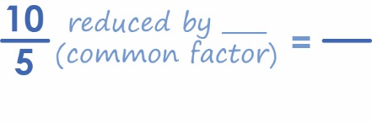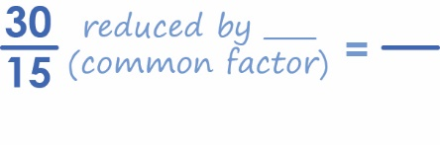

Reduce these  
 ratios on your own:

|  |  |  |  |  |  |
| --- | --- | --- | --- | --- | --- |
| **Gear** | **# of Teeth** | **Rotation Direction** | **# of**  **Revolutions** | **Revolutions’**  **Ratio** | **Reduced Ratio** |
| **C Input** | 40 | **CW** | 6 |  |  |
| **D Output** | 20 |  |  |





**C**

**D**

Complete for meshed gears **C** & **D**

**Reduce   
to a Fraction**

**3**



Switch your 20-Tooth and 40-Tooth gears. Using a dowel,   
 spin **Gear E** (now the **input**) clockwise.

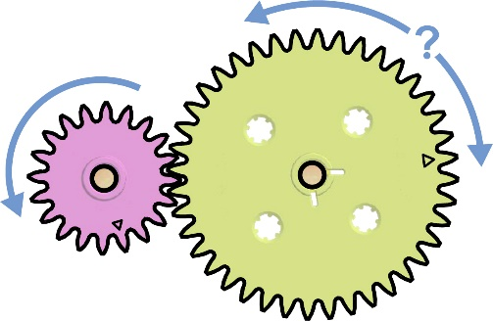

**E**

**F**

Complete for meshed gears **E** & **F**

|  |  |  |  |  |  |
| --- | --- | --- | --- | --- | --- |
| **Gear** | **# of Teeth** | **Rotation Direction** | **# of**  **Revolutions** | **Revolutions’**  **Ratio** | **Reduced Ratio** |
| **E**  **Input** | 20 | **CW** | 6 |  |  |
| **F Output** | 40  **Inverse from before** |  |  |



How did switching input and output gear size affect the revolutions’ ratio? _______________________________  
_____________________________________________________

**►**





**Teeth** allow gears to mesh and indicate gear **size**. Look at the **tooth ratio** of your   
 meshed gears. *How does it compare to the revolutions’ ratio?* _________________

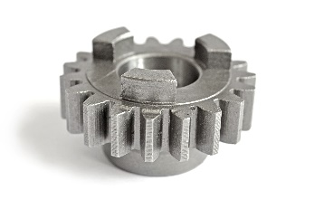

**Reduce the tooth ratio values:**  
40**/**40 tooth reduces to: ____ **/** ____

40**/**20 tooth reduces to: ____ **/** ____

20**/**40 tooth reduces to: ____ **/** ____

**Predict for other gear combinations:**  
10**/**50 tooth reduces to: ____ **/** ____

50**/**20 tooth reduces to: ____ **/** ____

10**/**40 tooth reduces to: ____ **/** ____

**►**

**►**



Comparing the number of **teeth** in one gear to another is called **gear ratio.**  
 Spin the 10-Tooth and 50-Tooth gear combination on the base.   
 **Reduce** and then compare the results to your above predictions.

|  |  |  |  |  |  |
| --- | --- | --- | --- | --- | --- |
| **Gear** | **# of Teeth** | **Rotation Direction** | **# of**  **Revolutions** | **Revolutions’**  **Ratio** | **Reduced Ratio** |
| **A Input** | 10 | **CW** | 12 |  |  |
| **B Output** | 50 |  |  |

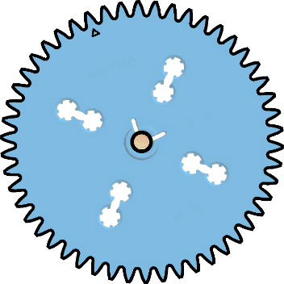



**A**

**B**

Was the reduced ratio the same as the tooth ratio?  
 __________________________________________________

**►**

**4**



Now, spin the 50-Tooth and 20-Tooth gear combination on the base.   
 **Reduce** and then compare the results to your above predictions.



|  |  |  |  |  |  |
| --- | --- | --- | --- | --- | --- |
| **Gear** | **# of Teeth** | **Rotation Direction** | **# of**  **Revolutions** | **Revolutions’**  **Ratio** | **Reduced Ratio** |
| **C Input** | 50 | **CCW** | 12 |  |  |
| **D Output** | 20 |  |  |





**C**

**D**

Was the reduced ratio the same as the tooth ratio?  
 __________________________________________________

**►**



Now, spin the 10-Tooth and 40-Tooth gear combination on the base.   
 **Reduce** and then compare the results to your above predictions.



|  |  |  |  |  |  |
| --- | --- | --- | --- | --- | --- |
| **Gear** | **# of Teeth** | **Rotation Direction** | **# of**  **Revolutions** | **Revolutions’**  **Ratio** | **Reduced Ratio** |
| **E Input** | 10 | **CW** | 12 |  |  |
| **F Output** | 40 |  |  |



**F**

**E**

**►**

Was the reduced ratio the same as the tooth ratio?  
 __________________________________________________



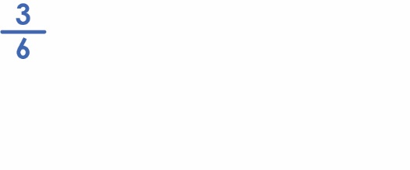

**Denominator  
(Bottom)**

**Numerator  
(Top)**

A **proportion** is an equation   
showing that two ratios are **equal**.

**►**

**Choice #1:**  
Convert ratios into **decimal**s by dividing   
the **numerator** by the **denominator**.

**□**

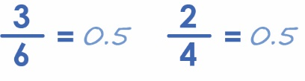



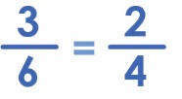

**Choice #2:**  
Determine a **cross product** by multiplying   
the **numerator** of one fraction by the **denominator** of another fraction.

**□**

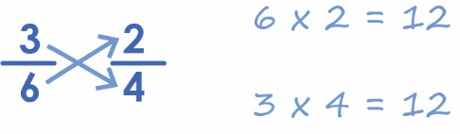

**Proportion**

**5**



Spin the gear combinations to determine their ratio. Write it as a **fraction**.   
 *The input’s revolutions are the* ***numerator****, while the output’s the* ***denominator****.*



|  |  |  |  |  |  |  |
| --- | --- | --- | --- | --- | --- | --- |
| **Gears I** | **# of Teeth** | **Rotation Direction** | **# of**  **Revolutions** | **Revolutions’**  **Ratio** | **Reduced Ratio** | **Fraction** |
| **A Input** | 10 | **CW** | 6 |  |  |  |
| **B Output** | 20 |  |  |



**A**

**B**

**Use for   
Proportion**

|  |  |  |  |  |  |  |
| --- | --- | --- | --- | --- | --- | --- |
| **Gears II** | **# of Teeth** | **Rotation Direction** | **# of**  **Revolutions** | **Revolutions’**  **Ratio** | **Reduced Ratio** | **Fraction** |
| **C Input** | 20 | **CW** | 6 |  |  |  |
| **D Output** | 40 |  |  |



**C**

**D**

**Gears I Fraction**



**=**

**Gears II Fraction**



Were the ratios of meshed   
gears I & II equal **proportions**?   
____________________________  
____________________________

**►**



Balance the **proportions** below by converting  
 to decimals or multiplying the cross products.

3

6

43

**=**

86

2

50

**=**

32

40

**=**

5

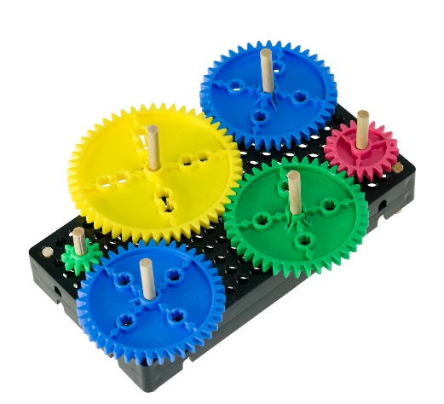

2

4

6

**=**

**=**

6

15

25

**6**



**Meshing** (combining) gears   
together creates a **gear train**.



Mesh two 40-Tooth gears on either side of a 50-Tooth   
 on the base plate. Spin **Gear A** clockwise one   
 full **revolution**. Draw an around **Gear B**   
 and **Gear C** to show their directions of **rotation**.



|  |  |  |  |
| --- | --- | --- | --- |
| **Gear** | **# of Teeth** | **Rotation Direction** | **# of**  **Revolutions** |
| **A Input** | 40 | **CW** | 1 |
| **B Output** | 50 |  |  |
| **C Output** | 40 |  |  |

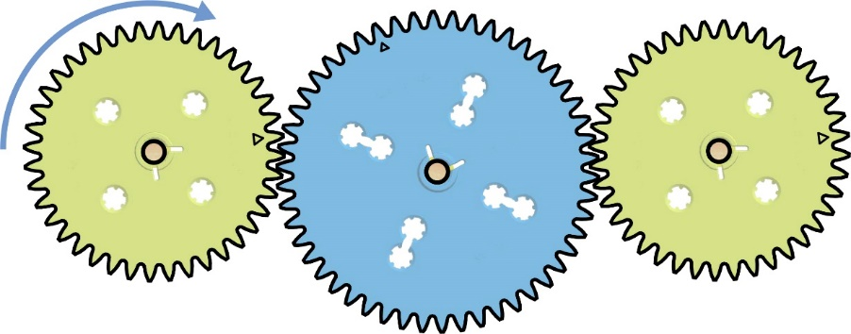

**A**

**C**

**B**

The revolutions’ ratio for **Gear A** and **Gear B** ? ________ **:** ________

**►**

**►**

**►**

The revolutions’ ratio for **Gear B** and **Gear C** ? ________ **:** ________

Multiply the two ratios together.  
 ( _____ : _____ ) x ( _____ : _____ ) = **_____** : **_____** (**reduce** if you can).



A gear inserted *between* two or more gears is known as the **idler-wheel**.   
 It works to keep the direction of rotation of the input and output gears   
 the same, without affecting **gear ratio**.



**►**

Which gear in the train to the right acts as the idler-wheel?   
 Why? _________________________________________________  
 _______________________________________________________  
 _______________________________________________________



**C**

**B**

**A**

**7**

**7**

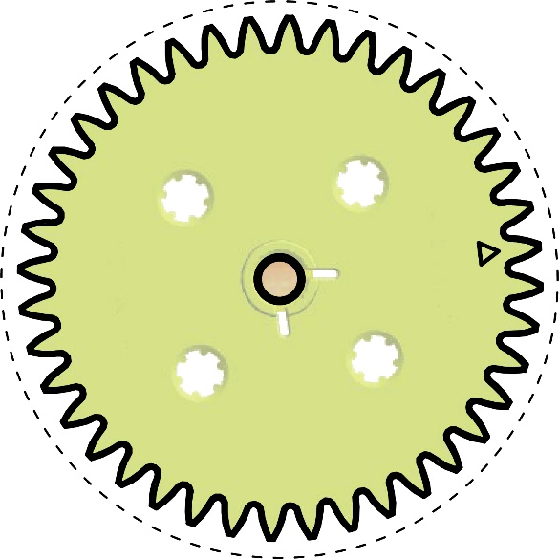



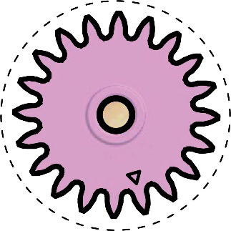

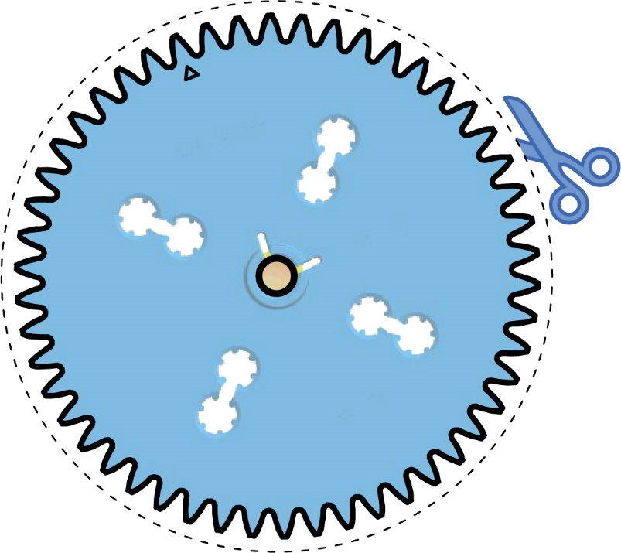

Cut out the gears and pulleys on the dotted line. Don’t worry about the teeth – *just cut on the circle.* Use them to help design gear trains and pulley sets.

**►**

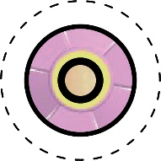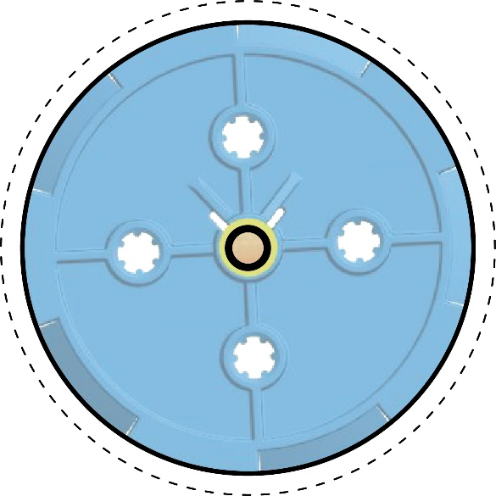

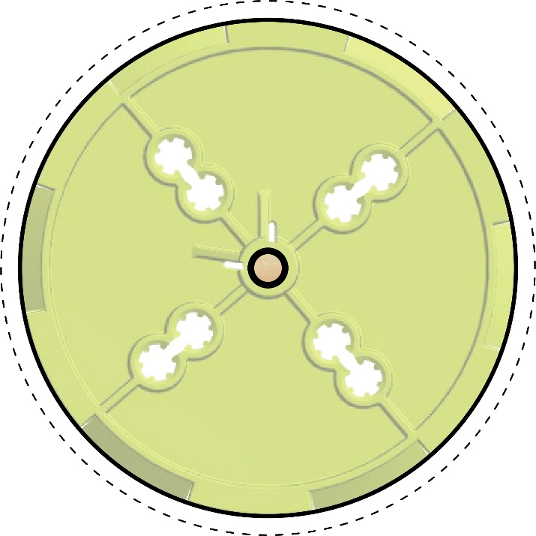

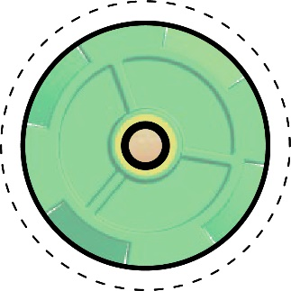

**8**

**8**