Name: _______________________________________________ Set: __________ Date: __________



**Force**: A push or pull on an object. A force can cause an object to accelerate, slow down, remain in place, or change shape.

**Friction**: A force that resists (holds back) the movement of a sliding   
or rolling object

**Gravity:** Aforce attracting objects toward the center of the earth.

Set your racer frame down on a table or desk. Complete the following questions.

1. A ______________________ is needed to move the frame.
2. List two different types of force you could use to move your frame.

**Hint:** How could you use your mouth to apply a force?

* 1. ______________________________________________
  2. ______________________________________________

1. Apply a force to your racer frame (push it). Why does the frame stop moving after you stop applying a force? Tip: Read the top of this page.

______________________________________________________________________________________________

______________________________________________________________________________________________



1. Rub your hands together fast. The motion is converted through friction into what type of energy? Hint: You should feel it.

_______________________________________________________________



Use the letters from the diagram

to fill in the blank lines.

1. Force of Gravity _____
2. Foce of Friction _____
3. Forward Motion _____
4. If _____ is greater than _____ , the sled will move.
5. If _____ is greater than
6. _____ , the sled will not move.
7. Sometimes you want friction. Other times you don’t. Tell us if the following

items are design to increase, or decrease friction.

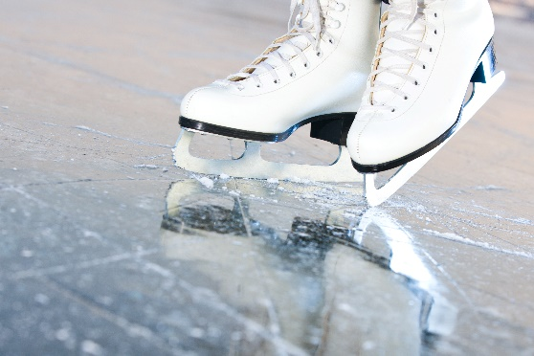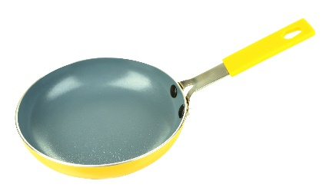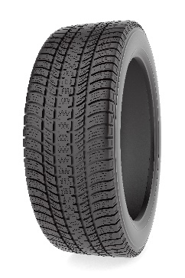

Ice Skates are designed to

____________ friction.

A tire is designed to

____________ friction.

A frying pan surface is designed to

____________ friction.