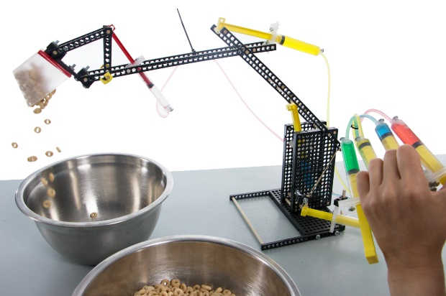Engineer your **End Effector** to dig   
quickly, accurately and effectively.

**Before You Start…** Make sure you have built   
a **Hydraulic Arm** for use on this challenge.

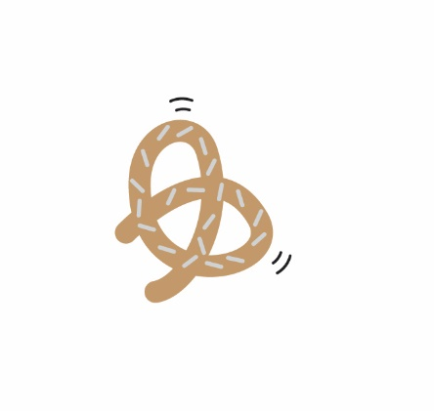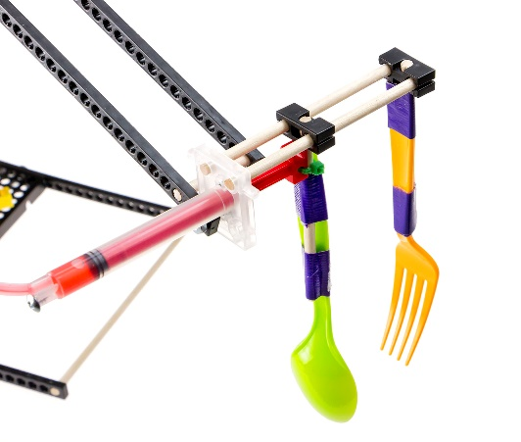

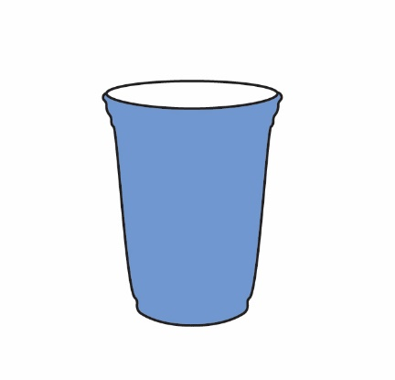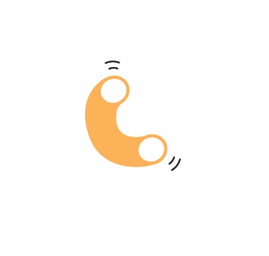



**Constraints:** (rules and limits for your design)

* Only use your **Hydraulic Arm** to dig or grab objects.
* Objects may be picked up only from the same surface the **Hydraulic Arm** is on.
* You may change the **End Effector** shape and material, and the arm itself.
* The **Hydraulic Arm** base and hydraulic system **must not** be altered.  
  (they must be as shown in the **Hydraulic Arm** Example *Build Guide*).
* You may bring in materials for your **End Effector** and **Tower**, if the materials are:
  + Teacher Approved
  + Non-Hazardous (no sharp edges, harmful chemicals, etc.)
* You will have __________________ to complete the challenge.

Fill in how much   
time you have

**Challenge Supplies:**

**Hydraulic Arm**, material for **End Effector** (cardboard, recycled packaging),   
dry objects to dig in or for (cereal, gravel, jelly beans, pasta) tape, ruler,   
scissors, Philips screw driver, *Engineering Notebook* pages.



**The Engineering Design Process:**

You will be using the **Engineering Design Process**. What does that mean?   
Your design is never finished (it can always be improved). There is no   
such thing as a perfect design. Fill out a new *Engineering Notebook*   
page each time you design/redesign your **End Effector**.

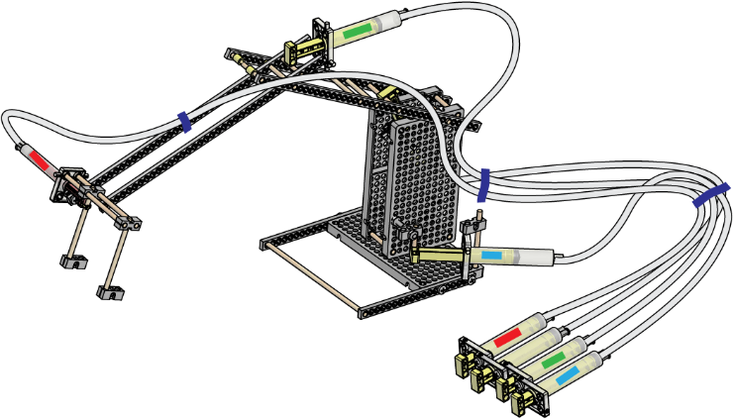

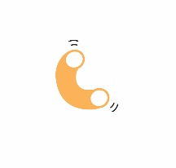

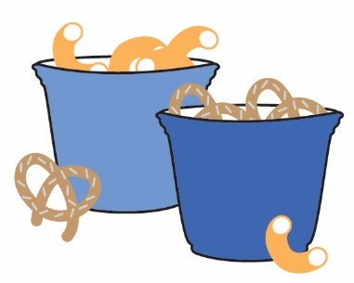**The Big Dig**  
See who can **dig** a hole to the **bottom**, the **fastest**.   
Work in teams and use a stop watch. **Speed** can be   
determined by **size** of hole or who touches bottom, first.   
  
  
**Filled to the Brim**  
**Dig** through a **material** (such as pasta or rice)   
for “**buried treasure**” (paper clips). Use your **End Effector**   
design to grasp and drop objects into **separate bowls**.   
First team to fill it to the brim, wins! Record your results.

  
**Out of Sorts**  
**Sort** two mixed-up objects (e.g. pretzels and popcorn) into   
**separate bowls** using your chosen **End Effector**. The team with   
the most **accurate** sorting and **speed**, wins! Record your results.

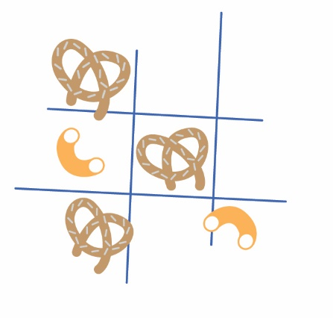 **Tic-Tac-Tow**  
Use **tape** or **yarn** to make the **3 x 3 grid**.   
Using only your **Hydraulic Arm** and chosen **End Effector**   
design, place an object (such as pretzels) and make your   
move. You are **disqualified** if you touch your opponent’s   
pieces or take longer than 10 seconds to complete a turn.  
  
  
**Fun Tip:**

How can you design your **End Effector** to be more **accurate**   
(better for selecting one object over another)? Can you use  
**sticky** or **magnetic** materials to win the challenges? Can some  
designs hold more **weight**, while others have a better **grip**?

Class: ______________________________________________________   
Set: _____________ Challenge: ______________________

Record the results of your challenges. Print more sheets if necessary.

|  |  |  |  |  |  |  |  |  |  |  |
| --- | --- | --- | --- | --- | --- | --- | --- | --- | --- | --- |
| Group Name | Design  #1 | Design  #2 | Design  #3 | Design  #4 | Design  #5 | Design  #6 | Design  #7 | Design  #8 | Design  #9 | Design #10 |
|  |  |  |  |  |  |  |  |  |  |  |
|  |  |  |  |  |  |  |  |  |  |  |
|  |  |  |  |  |  |  |  |  |  |  |
|  |  |  |  |  |  |  |  |  |  |  |
|  |  |  |  |  |  |  |  |  |  |  |
|  |  |  |  |  |  |  |  |  |  |  |
|  |  |  |  |  |  |  |  |  |  |  |
|  |  |  |  |  |  |  |  |  |  |  |
|  |  |  |  |  |  |  |  |  |  |  |

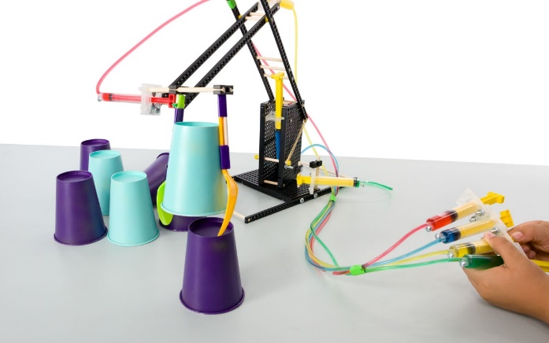Design & Build an **End Effector**   
to best stack a tower of objects.

**Before You Start…** Make sure you have built   
a **Hydraulic Arm** for use on this challenge.

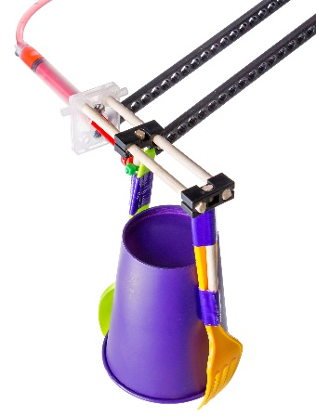

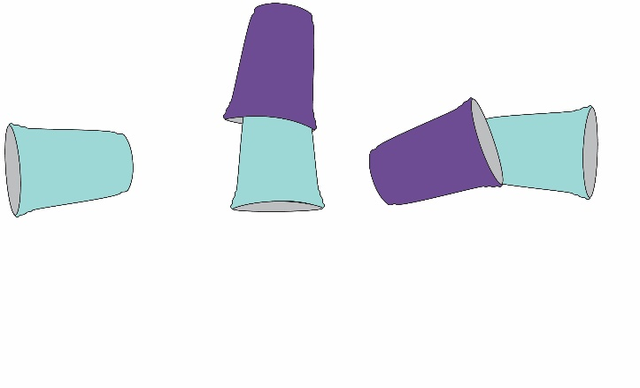

**Constraints:** (rules and limits for your design)

* Objects must be stacked (and remain stacked) using only your **Hydraulic Arm**.
* Objects may be picked up only from the same surface the **Hydraulic Arm** is on.
* You may change the **End Effector** shape and material, and the arm itself.
* The **Hydraulic Arm** base and hydraulic system **must not** be altered.  
  (they must be as shown in the **Hydraulic Arm** Example *Build Guide*).
* You may bring in materials for your **End Effector** and **Tower**, if the materials are:
  + Teacher Approved
  + Non-Hazardous (no sharp edges, harmful chemicals, etc.)
* You will have __________________ to complete the challenge.

Fill in how much   
time you have

**Challenge Supplies:**

**Hydraulic Arm**, material for **End Effector** (cardboard, recycled packaging),   
objects to stack (plastic cups, milk cartons, candy) tape, ruler, scissors,   
Philips screw driver, *Engineering Notebook* pages.



**The Engineering Design Process:**

You will be using the **Engineering Design Process**. What does that mean?   
Your design is never finished (it can always be improved). There is no   
such thing as a perfect design. Fill out a new *Engineering Notebook*   
page each time you design/redesign your **End Effector**.

Class: __________________________________________________________  
Set: _____________

Record the height of each design’s tower stack.

|  |  |  |  |  |  |  |  |  |  |
| --- | --- | --- | --- | --- | --- | --- | --- | --- | --- |
| Group Name | Object(s) | Design #1 | Design #2 | Design #3 | Design #4 | Design #5 | Design #6 | Design #7 | Design #8 |
|  |  |  |  |  |  |  |  |  |  |
|  |  |  |  |  |  |  |  |  |  |
|  |  |  |  |  |  |  |  |  |  |
|  |  |  |  |  |  |  |  |  |  |
|  |  |  |  |  |  |  |  |  |  |
|  |  |  |  |  |  |  |  |  |  |
|  |  |  |  |  |  |  |  |  |  |
|  |  |  |  |  |  |  |  |  |  |
|  |  |  |  |  |  |  |  |  |  |

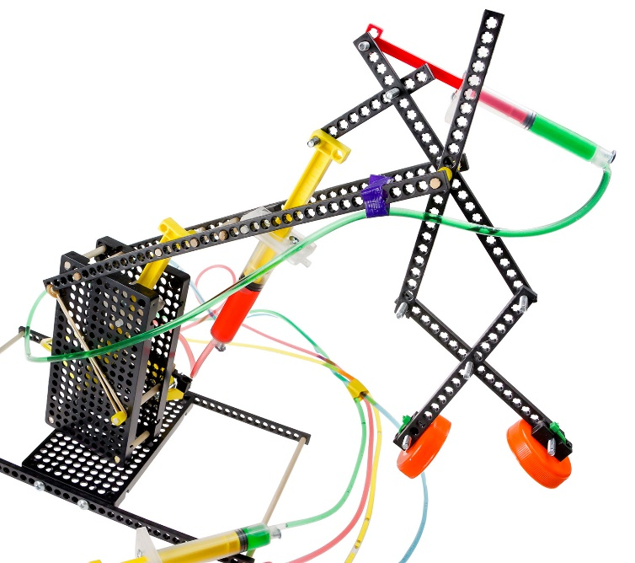Engineer your **End Effector** to pick up   
and move an egg without breaking it.

**Before You Start…** Make sure you have built   
a **Hydraulic Arm** for use on this challenge.

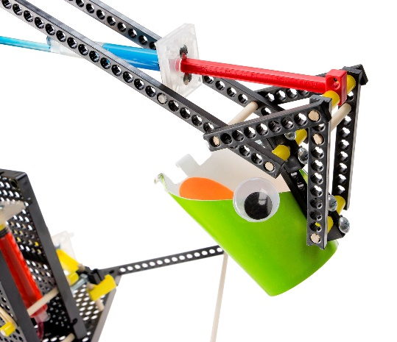

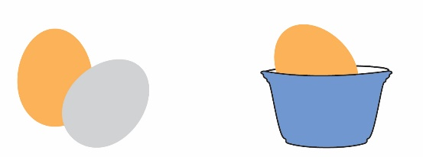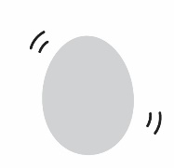

**Constraints:** (rules and limits for your design)

* Only use your **Hydraulic Arm** to pick up and move the egg.
* Eggs must be picked up from the same surface the **Hydraulic Arm** is on.
* You may change the **End Effector** shape and material, and the arm itself.
* The **Hydraulic Arm** base and hydraulic system **must not** be altered.  
  (they must be as shown in the **Hydraulic Arm** Example *Build Guide*).
* You may bring in materials for your **End Effector** and **Tower**, if the materials are:
  + Teacher Approved
  + Non-Hazardous (no sharp edges, harmful chemicals, etc.)
* You will have __________________ to complete the challenge.

Fill in how much   
time you have

**Challenge Supplies:**

**Hydraulic Arm**, material for **End Effector** (cardboard, recycled packaging),   
egg, tape, ruler, scissors, Philips screw driver, *Engineering Notebook* pages.



**The Engineering Design Process:**

You will be using the **Engineering Design Process**. What does that mean?   
Your design is never finished (it can always be improved). There is no   
such thing as a perfect design. Fill out a new *Engineering Notebook*   
page each time you design/redesign your **End Effector**.

Class: __________________________________________________________  
Set: _____________

Record the distance of each design’s egg lift.

|  |  |  |  |  |  |  |  |  |  |  |
| --- | --- | --- | --- | --- | --- | --- | --- | --- | --- | --- |
| Group Name | Design  #1 | Design  #2 | Design  #3 | Design  #4 | Design  #5 | Design  #6 | Design  #7 | Design  #8 | Design  #9 | Design #10 |
|  |  |  |  |  |  |  |  |  |  |  |
|  |  |  |  |  |  |  |  |  |  |  |
|  |  |  |  |  |  |  |  |  |  |  |
|  |  |  |  |  |  |  |  |  |  |  |
|  |  |  |  |  |  |  |  |  |  |  |
|  |  |  |  |  |  |  |  |  |  |  |
|  |  |  |  |  |  |  |  |  |  |  |
|  |  |  |  |  |  |  |  |  |  |  |
|  |  |  |  |  |  |  |  |  |  |  |