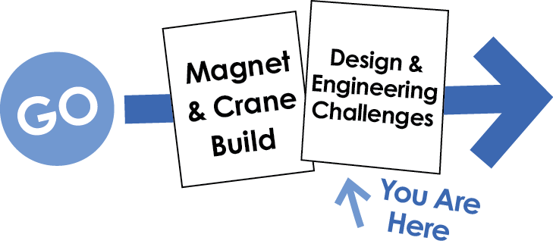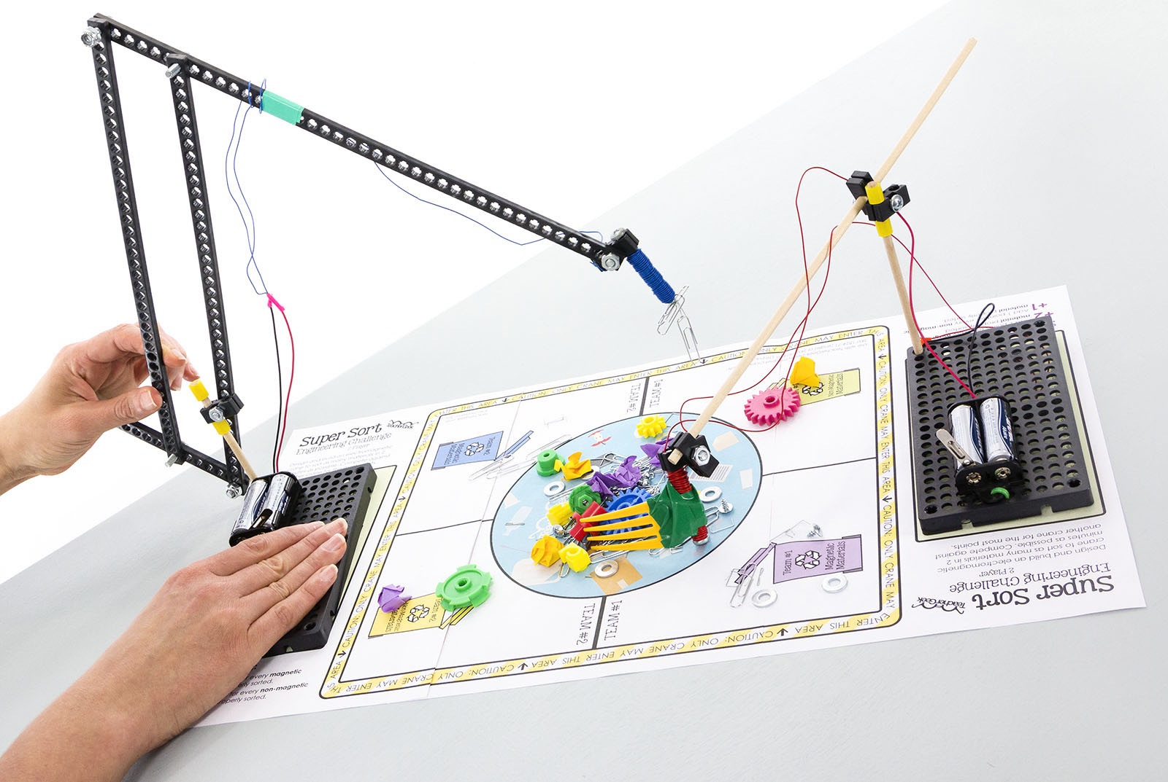

**Difficulty:** Medium

Redesign your crane to reach all of the sorting areas. The example crane will not work.

Add parts to your crane to help you move non-magnetic. materials.

Move materials from the pile in the center, to the correct sorting areas.

**The Challenge:** Design an Electromagnet Crane to sort as many materials in 2 minutes as possible.

Other documents and activity components at [teachergeek.com](https://teachergeek.com/) © TeacherGeek Inc. 2016

Single Player Arena

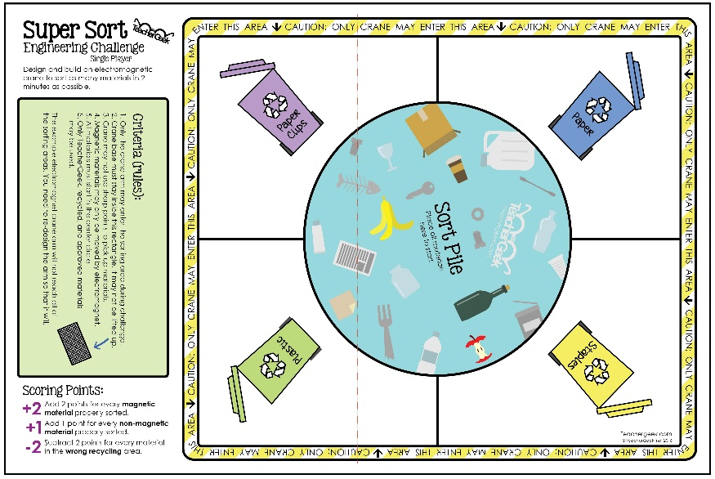

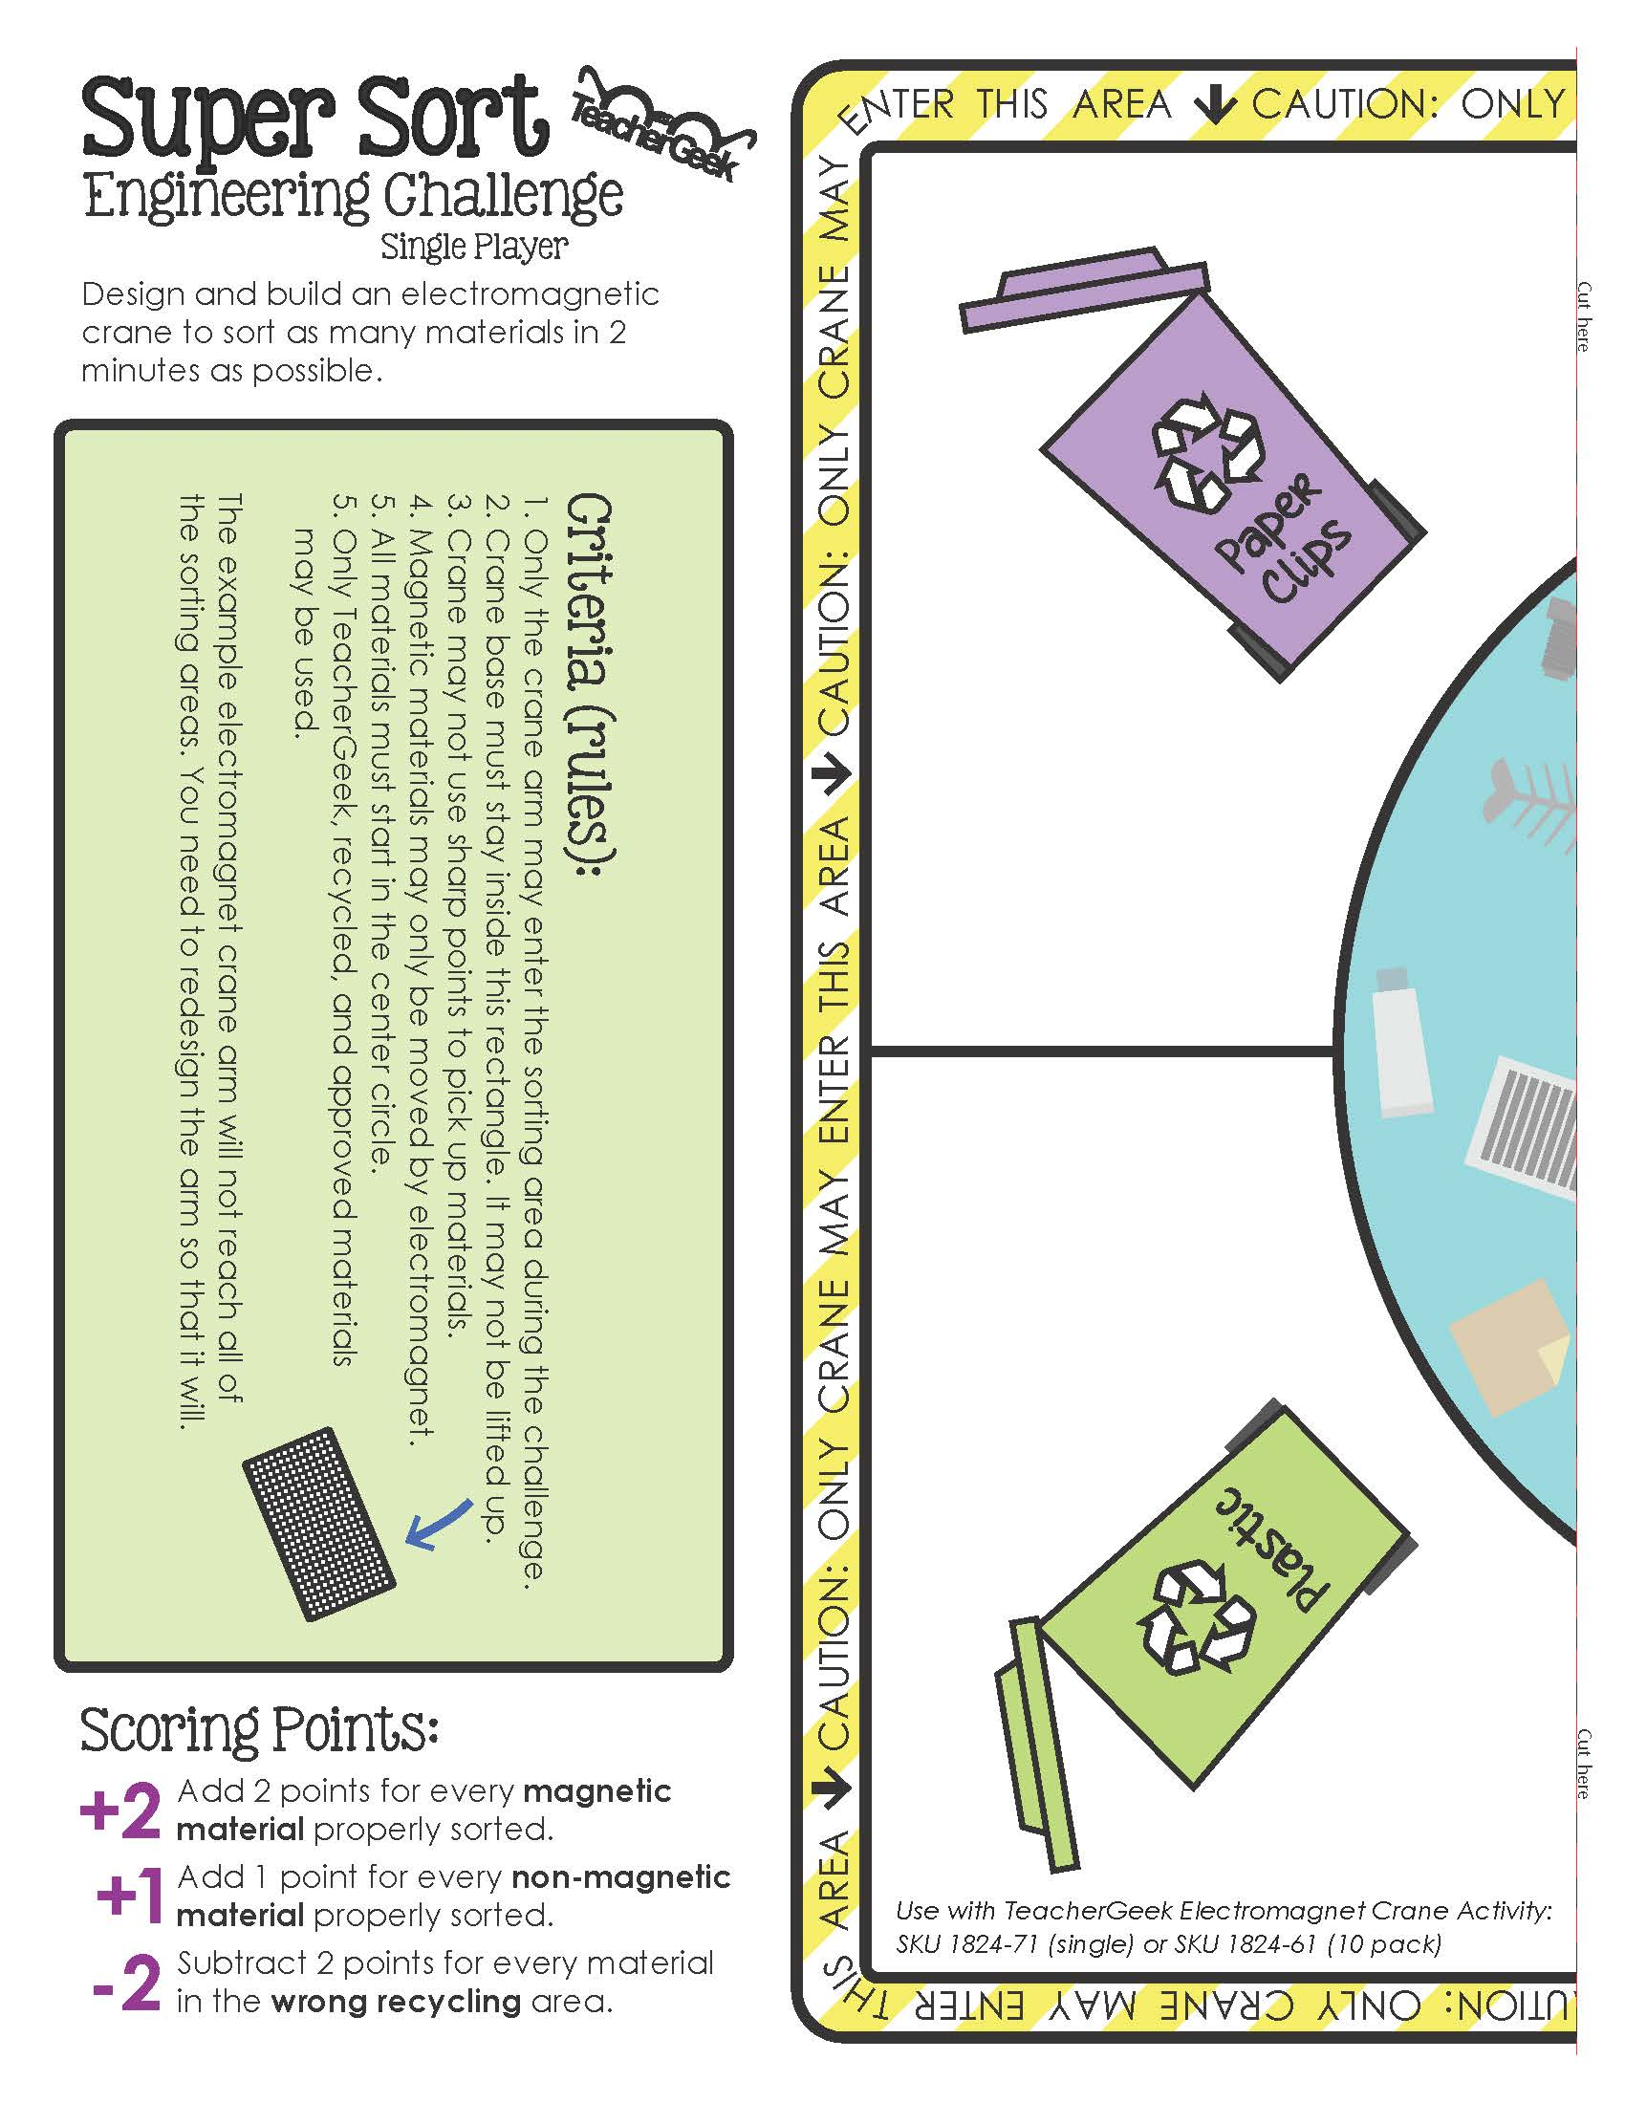

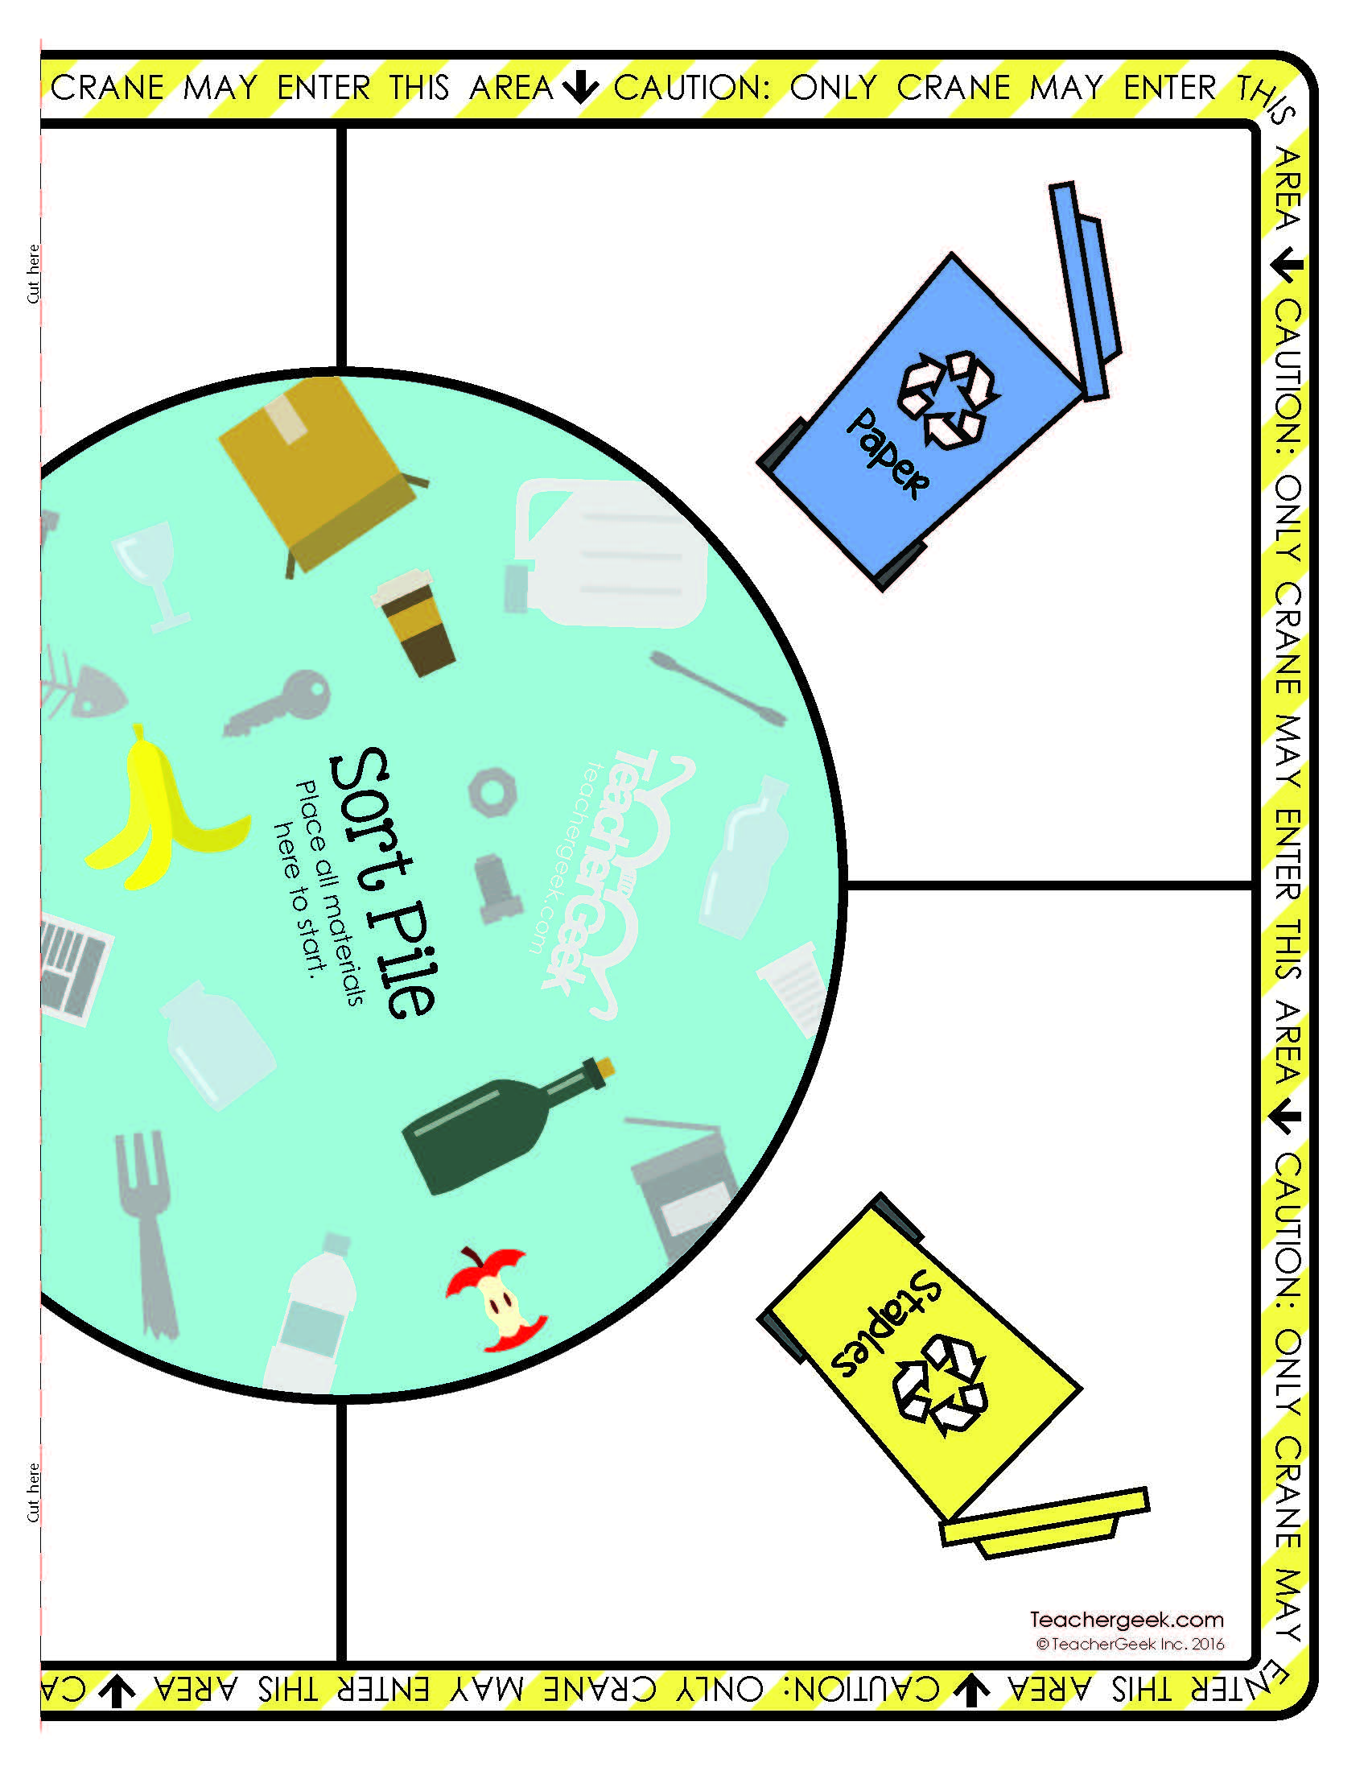

Two Player Arena

