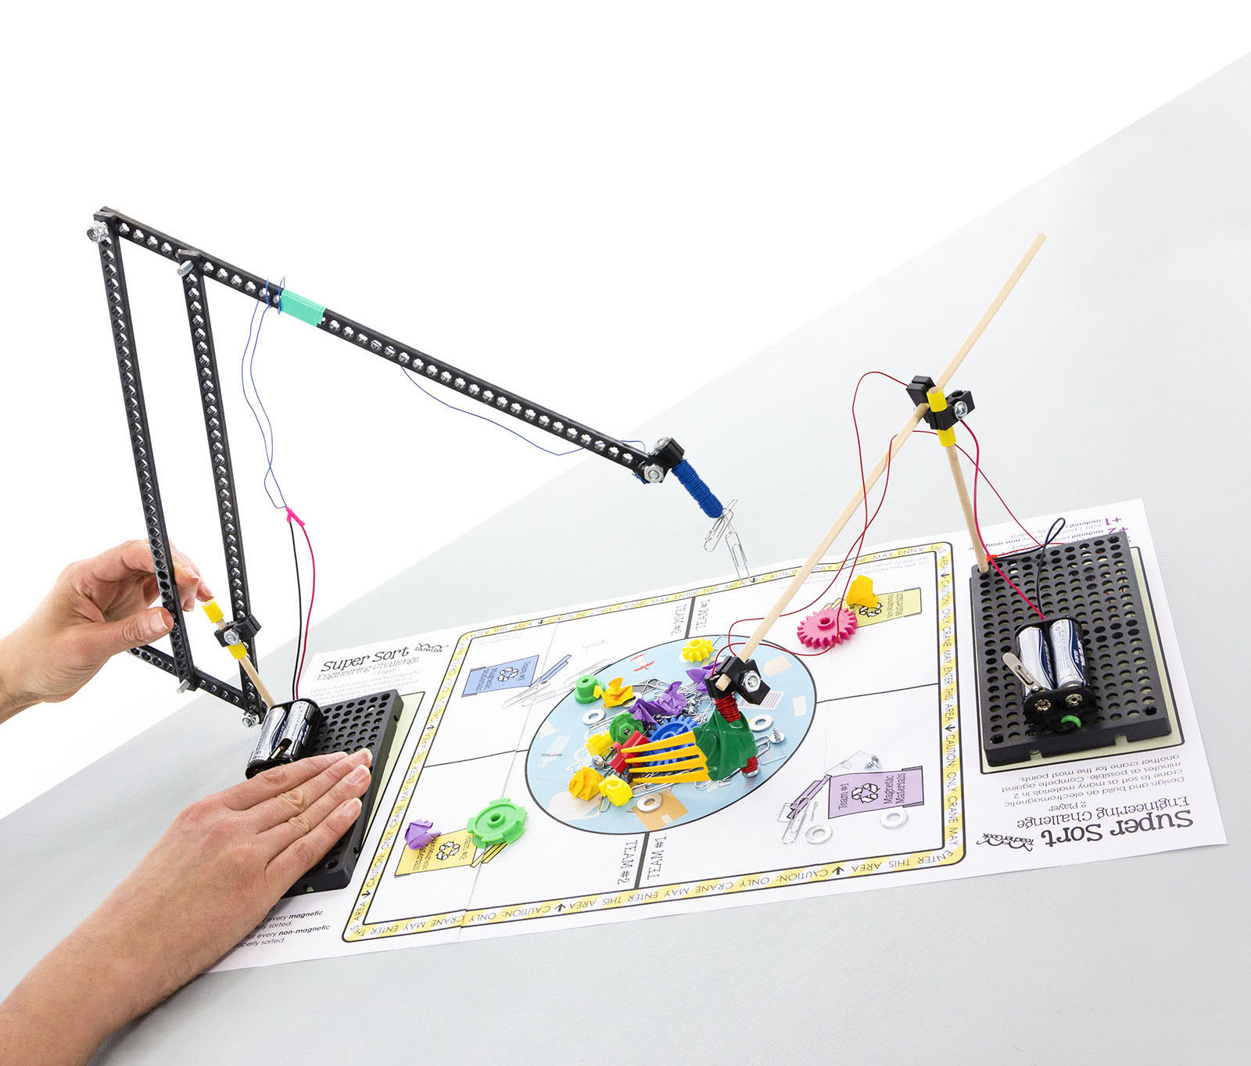

Download Documents and get your supplies at[**teachergeek.com**](teachergeek.com). Use this activity with a TeacherGeek [Maker Cart](https://teachergeek.com/products/maker-cart), or [Electromagnet Crane Activity](https://teachergeek.com/products/electromagnet-crane-activity).

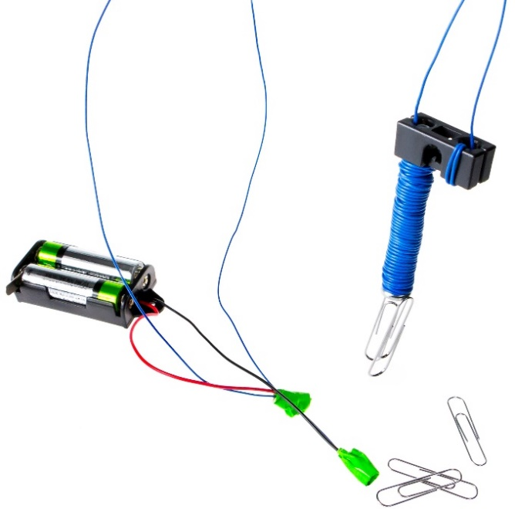 **Recommended Age Level:**

Activity Age Level: 7+

Recommended Group Size: 1-3 Students/Crane

**There are two ways to complete   
this Electromagnet Crane activity…**

**Just for Fun (without the lab)**

[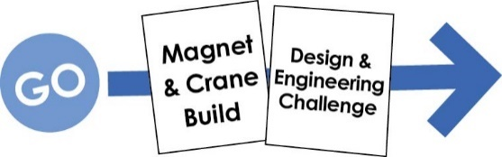](https://teachergeek.com/blogs/projects/electromagnet-crane-activity)

**For School (with a lab)**

[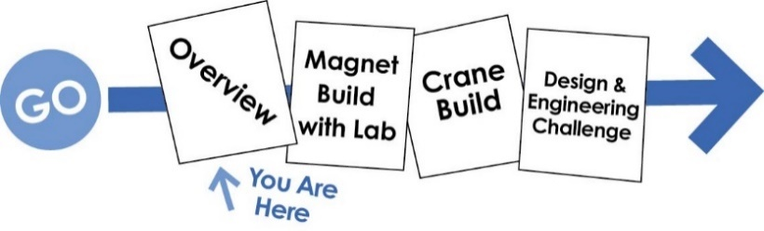](https://teachergeek.com/blogs/projects/electromagnet-crane-activity)

This overview document is for teacher use.

The other documents (build guides and challenges)

are for student use.

Download other documents at [**teachergeek.com/learn**](https://teachergeek.com/blogs/projects).



Your mission: Design and build a crane that can best sort magnetic materials for recycling. Start by making and experimenting with an electromagnet, then create a crane to move it. Test the crane using the scientific method. Evolve the crane through the engineering design process. How many magnetic items can you sort in two minutes? Compete against other cranes, or challenge yourself.

What’s unique about this, and other TeacherGeek activities?

This is a True STEM/Engineering activity; It allows kids to… tinker and experiment, grow understanding through experimentation and labs, isolate variables and use the scientific method, apply math and science concepts, create their own unique designs, and become innovators. Every project turns out different, and evolves with their understanding.

When you create a project using TeacherGeek, the data works (it’s usable). This allows kids to apply the math and science, see the results, and experience “I-get-it” moments (understanding why they need the math/science and what it does).



Adapted from Bloom’s Taxonomy

**Make It Your Own:** The documents for this activity are available in PDF and Microsoft Word format. If you wish to edit a document, simply download the Microsoft Word format.



**Next Generation Science Standards:**

**Grade 2**

**Matter and its Interactions**

**2-PS1-1**

Plan and conduct an investigation to describe and classify different kinds of materials by their observable properties.

**2-PS1-2**

Analyze data obtained from testing different materials to determine which materials have the properties that are best suited for an intended purpose.

**2-PS1-3**

Make observations to construct an evidence-based account of how an object made of a small set of pieces can be disassembled and made into a new object.

**Engineering Design**

**K-2-ETS1-1**Ask questions, make observations, and gather information about a situation people want to change to define a simple problem that can be solved through the development of a new or improved object or tool.

**K-2-ETS1-2**Develop a simple sketch, drawing, or physical model to illustrate how the shape of an object helps it function as needed to solve a given problem.

**K-2-ETS1-3**Analyze data from tests of two objects designed to solve the same problem to compare the strengths and weaknesses of how each performs.

**Grade 3**

**Motion and Stability: Forces and Interactions**

**3-PS2-3**Ask questions to determine cause and effect relationships of electric or magnetic interactions between two objects not in contact with each other.

**3-PS2-4**Define a simple design problem that can be solved by applying scientific ideas about magnets.

**Engineering Design**

**3-5-ETS1-1**   
Define a simple design problem reflecting a need or a want that includes specified criteria for success and constraints on materials, time, or cost.

**Grade 4**

**Energy**

**4-PS3-2**Make observations to provide evidence that energy can be transferred from place to place by sound, light, heat, and electric currents.

**4-PS3-4**Apply scientific ideas to design, test, and refine a device that converts energy from one form to another.

**Engineering Design**

**3-5-ETS1-2**Generate and compare multiple possible solutions to a problem based on how well each is likely to meet the criteria and constraints of the problem.

**3-5-ETS1-3**Plan and carry out fair tests in which variables are controlled and failure points are considered to identify aspects of a model or prototype that can be improved.

**Grade 5**

**Matter and Its Interactions**

**5-PS1-3**Make observations and measurements to identify materials based on their properties.

**Engineering Design**

**3-5-ETS1-2**Generate and compare multiple possible solutions to a problem based on how well each is likely to meet the criteria and constraints of the problem.

**3-5-ETS1-3**Plan and carry out fair tests in which variables are controlled and failure points are considered to identify aspects of a model or prototype that can be improved.

**Grade 6-8**

**Engineering Design**

**MS-ETS1-1**Define the criteria and constraints of a design problem with sufficient precision to ensure a successful solution, taking into account relevant scientific principles and potential impacts on people and the natural environment that may limit possible solutions.

**MS-ETS1-2**Evaluate competing design solutions using a systematic process to determine how well they meet the criteria and constraints of the problem.

**MS-ETS1-3**Analyze data from tests to determine similarities and differences among several design solutions to identify the best characteristics of each that can be combined into a new solution to better meet the criteria for success.

**MS-ETS1-4**Develop a model to generate data for iterative testing and modification of a proposed object, tool, or process such that an optimal design can be achieved.

**Grades 9-12**

**Engineering Design**

**HS-ETS1-2**Design a solution to a complex real-world problem by breaking it down into smaller, more manageable problems that can be solved through engineering.



Available in the TeacherGeek [Electromagnet Crane Activity](https://teachergeek.com/products/electromagnet-crane-activity), TeacherGeek [Maker Cart](https://teachergeek.com/products/maker-cart), or at [teachergeek.com](https://teachergeek.com/)(activity packs include extra components for further tinkering and innovation).

|  |  |  |  |  |  |
| --- | --- | --- | --- | --- | --- |
| **x4**  **x4** | **x2**  **x6** | **x1**  **x1** | **x4** | **x1** | **x1** |
| [**Connector Strips**](https://teachergeek.com/products/electromagnet-crane-activity) | [**Dowels** 300mm (12″)](https://teachergeek.com/products/electromagnet-crane-activity) | [**Hole Plate**](https://teachergeek.com/products/electromagnet-crane-activity) | [**Perpendicular Blocks**](https://teachergeek.com/products/electromagnet-crane-activity) | [**Battery Holder w/ Switch & Leads**](https://teachergeek.com/products/electromagnet-crane-activity) | [**Slide Stop** 100mm (3″)](https://teachergeek.com/products/electromagnet-crane-activity) |
|  |  |  | **x4** | **x1** |  |
| [#6 ½″ **Screw**](https://teachergeek.com/products/electromagnet-crane-activity) | [#10 1″ **Screw**](https://teachergeek.com/products/electromagnet-crane-activity) | [#10 2″ **Screw**](https://teachergeek.com/products/electromagnet-crane-activity) | [#10 **Nut**](https://teachergeek.com/products/electromagnet-crane-activity) | [**Wire Roll**](https://teachergeek.com/products/electromagnet-crane-activity) |  |



*Tools available at* [*teachergeek.com*](https://teachergeek.com/)

|  |  |  |  |  |
| --- | --- | --- | --- | --- |
|  |  |  |  |  |
| **Multi-Cutter** [SKU 1823-81](https://teachergeek.com/products/1823-81) | **Wire Strippers** [SKU 1823-95](https://teachergeek.com/products/adjustable-wire-stripper) | **Screwdriver** [SKU 1823-90](https://teachergeek.com/products/stubby-2-screwdriver) | **Pliers** [SKU 1823-86](https://teachergeek.com/products/slip-joint-pliers-6) | **Soldering Iron (optional)** [SKU 1823-86](https://teachergeek.com/products/soldering-iron-convertable-30w) |





|  |  |  |  |
| --- | --- | --- | --- |
|  |  |  | Image result for erasers |
| **Tape** | **2 AA Batteries** | **Magnetic Materials** | **Non-Magnetic Materials** |

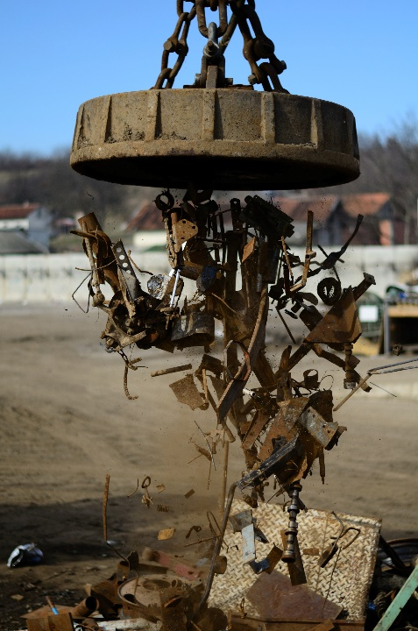

**Electromagnet Websites**

* [How Electromagnets Work](http://science.howstuffworks.com/electromagnet.htm) — howstuffworks.com
* [Electromagnets](http://www.bbc.co.uk/bitesize/ks3/science/energy_electricity_forces/magnets_electric_effects/revision/4/) — BBC Bitesize Science

**Electromagnet Videos**

* [Electromagnet Crane 1](https://youtu.be/N9XoUGxM2h0) —Youtube Video
* [Electromagnet Crane 2](https://youtu.be/XBWy9gzGGd4) —Youtube Video
* [Crushing Can with Electromagnet](https://youtu.be/AXOa66-k9MA) —Youtube Video
* [Using an Electromagnet to Sort Cans](https://youtu.be/ZCjvmiuHpgk) —Youtube Video
* [How Magnets Work Documentary](https://youtu.be/BY1LS10GMkg) —Youtube Video



**Choose your path…   
Will you do the Electromagnet Crane activity Just for Fun, or For School (with a lab)?**

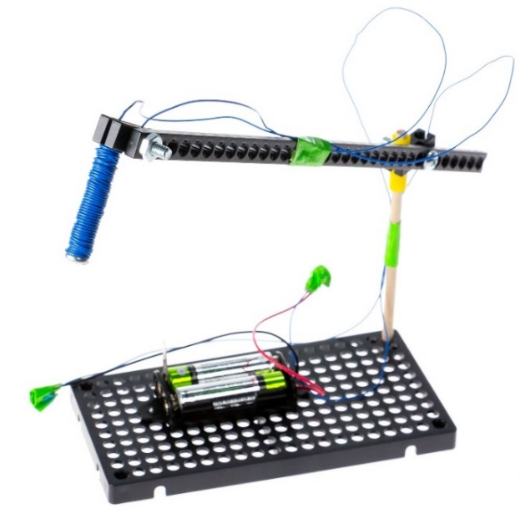**Just for Fun (without the lab)**



**Magnet & Crane Build**

Build the electromagnet and sample crane. During this process, you will learn the basics of construction and gain the understanding to turn it into your own design.

**Design & Engineering Challenge**

It’s time to redesign the crane to solve one or more engineering challenges.

**Challenge #1:** “In The Bucket” — Get as many paper clips into a cup as you can.  
**Challenge #2:** “Clip Hanger” — Hang as many paper clips as you can.  
**Challenge #3:** “Super Sort” — Sort as much magnetic and non-magnetic materials as you can.

**For School (with a lab)**

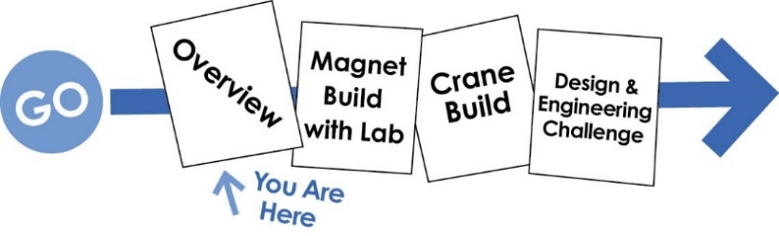

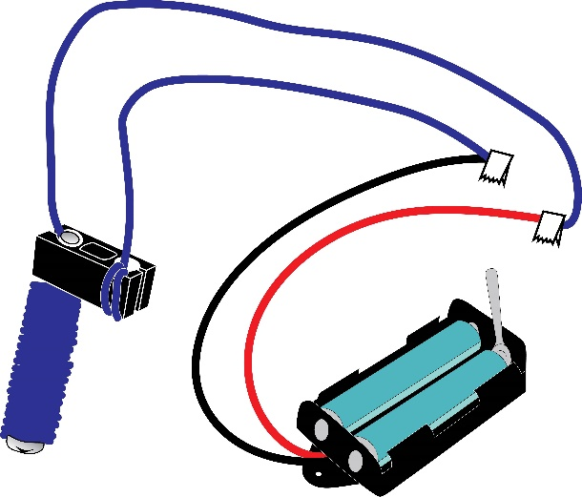



**Overview**

This is where you are. It’s for teacher reference.



**Electromagnet Build with Lab**

Learn about electromagnetism while creating   
an electromagnet. Change wire wraps, and see   
how it affects the power of the electromagnet.

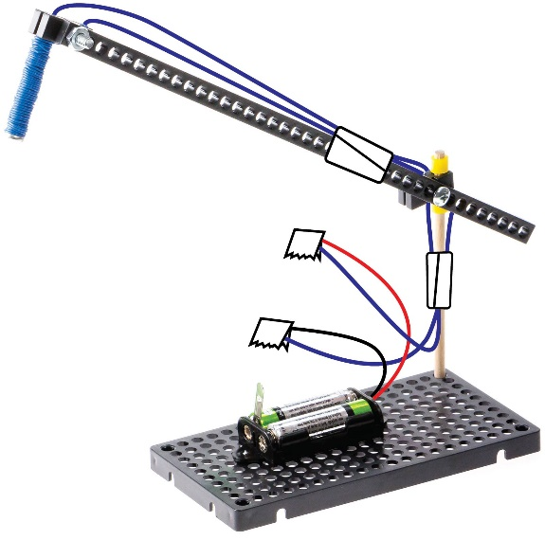**Electromagnetic Crane Build**

During this step you will create the example crane body, and then attach your electromagnet to it.

The example crane works, but not very well. Building it should give you the understanding required to turn it into your own unique design (a better design). Redesign the crane to solve engineering challenges.

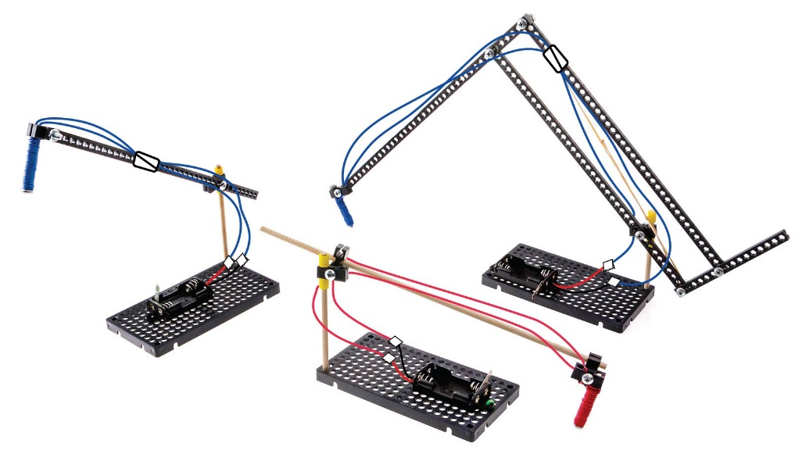



**Engineering Challenges**

It’s time to redesign the crane to solve one or more engineering challenges.

**Challenge #1**

“In The Bucket” — Get as many paperclips into a cup as you can.

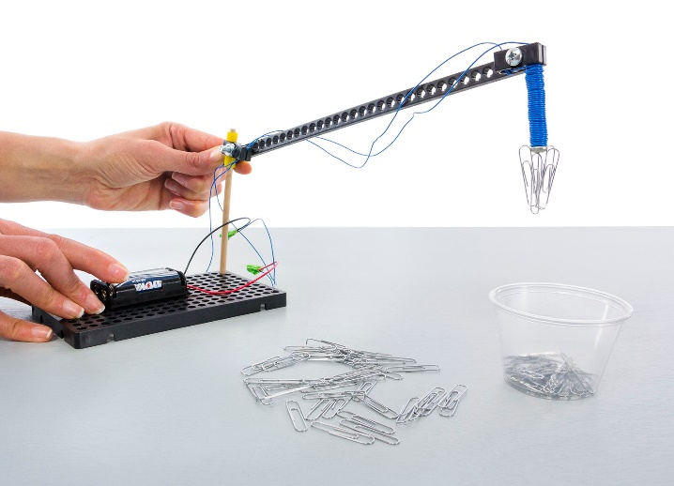

*Optional:*

*Make the challenge more difficult by requiring the crane base stay in one place.  
  
The example crane (from the build guide and pictured on left) is just to get you started. Redesign a crane to reach more areas and pick up more paper clips.*

**Challenge #2**

“Clip Hanger” — Hang as many paper clips as you can.

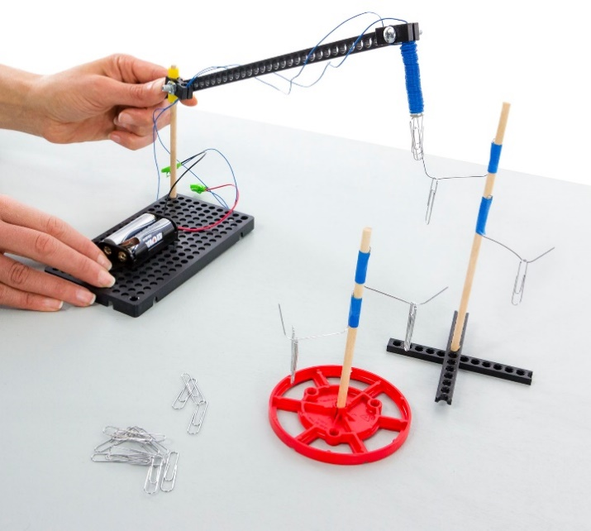

**To make a Clip Hanger “Trees”***Prepare for the challenge by creating a “tree” or structure to hang paper clips on. The tree branches are opened paper clips taped to extra wooden dowels.*

**Challenge #3**

“Super Sort” — Sort as much magnetic and non-magnetic materials as you can.

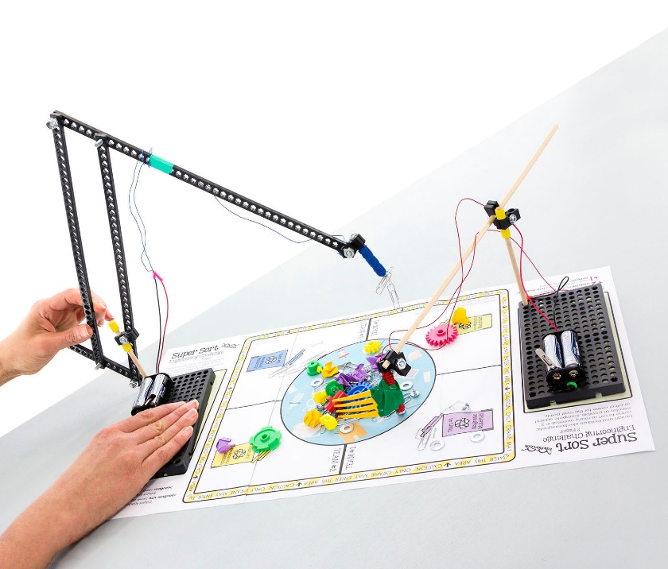

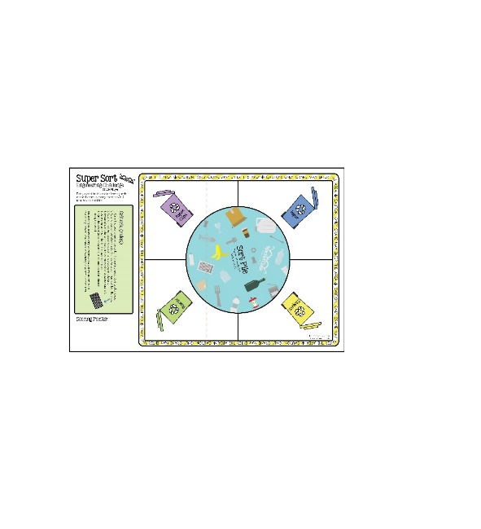**Single Player Challenge:**

Design and build an Electromagnet Crane to sort as many materials in 2 minutes as possible. Compete against another crane for the most points. The example Electromagnet Crane arm will not reach all the sorting areas. You need to redesign the arm so that it will.

**Two Player Challenge:**

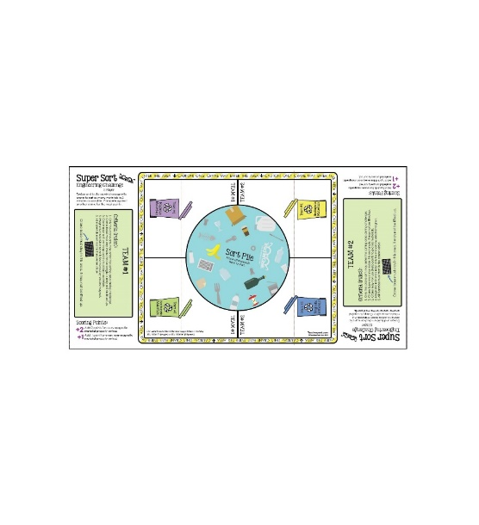Design and build an Electromagnet Crane to sort as many materials in 2 minutes as possible. Compete against another crane for the most points. The example Electromagnet Crane arm will not reach all the sorting areas. You need to redesign the arm so that it will.

**Scoring Points:**

Add 2 points for every magnetic material properly sorted.

Add 1 point for every non-magnetic material properly sorted.

**Constraints:**

(things your design can not, or must, do or be)

1. Only the crane arm may enter the sorting area during the challenge.

2. Crane base must stay inside the designated rectangle. It may not be lifted up.

3. Cranemay not use sharp points to pick up materials.

4. Magnetic materials may only be moved by the electromagnet.

5. All materials must start in the center circle.

6. Only TeacherGeek, recycled, and approved materials may be used.

Add things to the crane to help move non-magnetic materials.

**Supplies:**

Example electromagnet, other TeacherGeek components, recycled and found materials (cardboard, food packaging, etc.), tape, magnetic materials (individual staples, washers, etc.), paper clips, non-magnetic materials (crumbled up paper balls, pencil top erasers, small plastic parts i.e. bottle tops, etc.), TeacherGeek [Tool Set](https://teachergeek.com/products/easy-engineering-tool-set?variant=344866731).

**The Engineering Design Process:**

You will be using the Engineering Design Process. What does that mean?   
Your design is never finished (it can always be improved). There is no such thing as   
a perfect design. Fill out a new *Engineering Notebook* page each time you redesign   
your Electromagnet Crane.

