**Difficulty:** Medium

**The Challenge:** Redesign your crane to hang as many paper clips as possible, in two minutes.

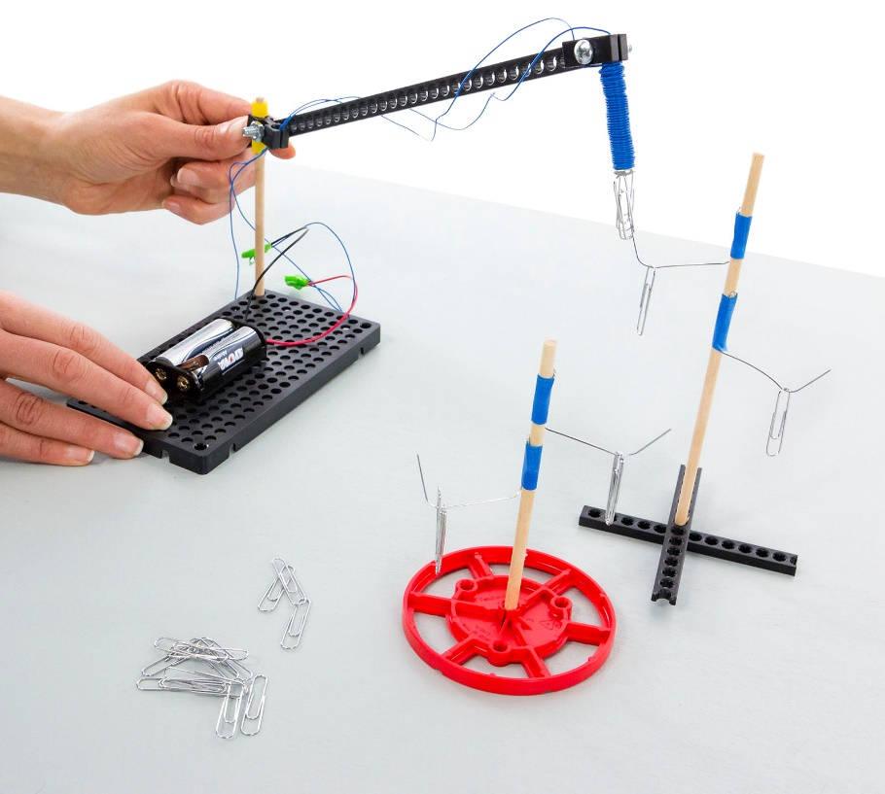



This is not a good crane design (it’s the example). Can you redesign it so it can pick up things near and far away, without moving the crane base?



Optional: Make the challenge more difficult by requiring that the crane base stay in one place.



Prepare for the challenge by creating a “tree” or structure to hang paper clips on. The tree branches are opened paper clips.

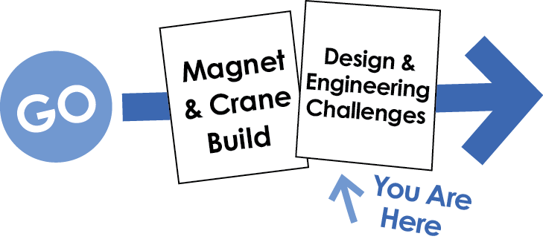

Other documents and activity components at [teachergeek.com](https://teachergeek.com/). © TeacherGeek Inc. 2016