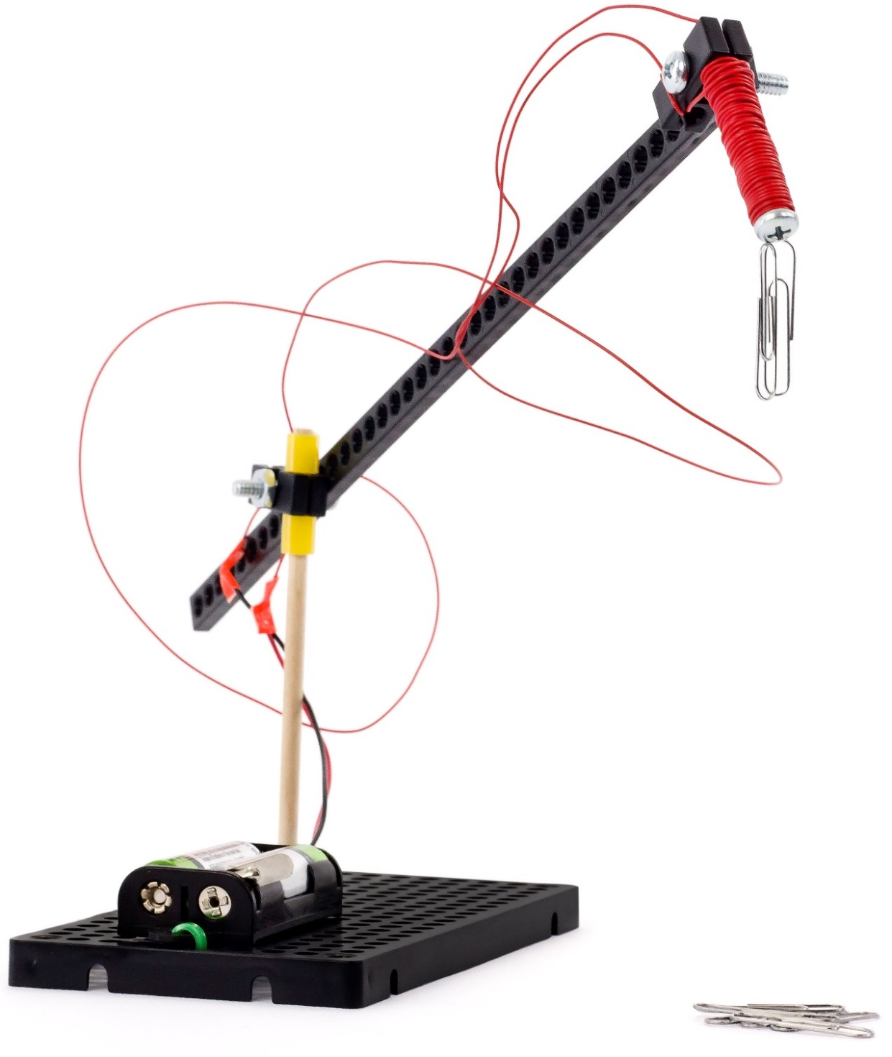



[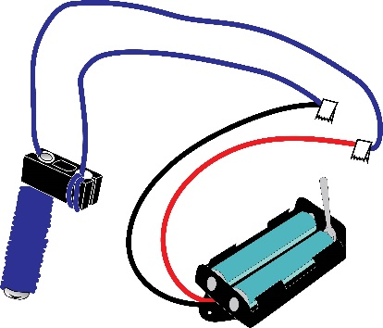](https://teachergeek.com/blogs/projects/electromagnet-crane-activity)

Have you made an **electromagnet**?You will need to make it,before making your crane.Instructions for making the electromagnet are at **teachergeek.com/learn**

***[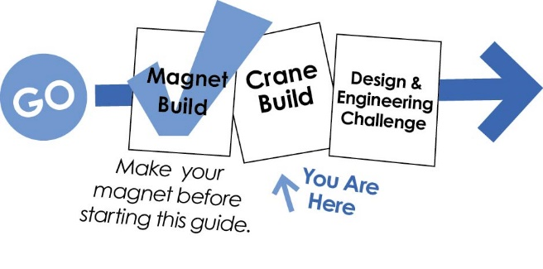](https://teachergeek.com/blogs/projects/electromagnet-crane-activity)***

Other documents available at **teachergeek.com/learn**

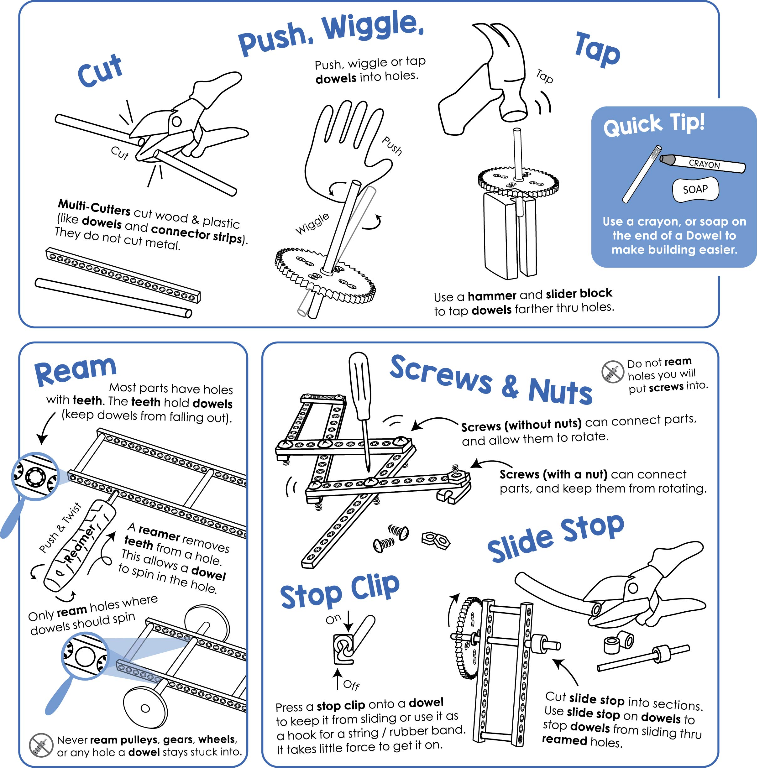

Here’s how you make stuff with TeacherGeek:

Adult supervision required for children 12 and under.



**You will need these TeacherGeek components for the Crane:**

Available in the TeacherGeek [Electromagnet Crane Activity](https://teachergeek.com/products/electromagnet-crane-activity), TeacherGeek [Maker Cart](https://teachergeek.com/products/maker-cart), or at [**teachergeek.com**](https://teachergeek.com/)(activity packs include extra components for further tinkering and innovation).

|  |  |  |  |
| --- | --- | --- | --- |
|  |  |  |  |
| [**1- Connector Strip**](https://teachergeek.com/products/electromagnet-crane-activity) | **[1- Dowel](https://teachergeek.com/products/electromagnet-crane-activity)**  [300mm (12in)](https://teachergeek.com/products/electromagnet-crane-activity) | [**1 - Hole Plate**](https://teachergeek.com/products/electromagnet-crane-activity) | [**1 - Block**](https://teachergeek.com/products/electromagnet-crane-activity) |
|  |  |  |  |
| **[2 - 13mm Screw](https://teachergeek.com/products/electromagnet-crane-activity)**  [#6 (¼in)](https://teachergeek.com/products/electromagnet-crane-activity) | **[2 - 2.5cm Screw](https://teachergeek.com/products/electromagnet-crane-activity)**  [#10 (1in)](https://teachergeek.com/products/electromagnet-crane-activity) | **[1 - Nut](https://teachergeek.com/products/electromagnet-crane-activity)**  [#10](https://teachergeek.com/products/electromagnet-crane-activity) | **[≥ 2cm Slide Stop](https://teachergeek.com/products/electromagnet-crane-activity)**  [(≥ ½in)](https://teachergeek.com/products/electromagnet-crane-activity) |

**You will need these tools, they can be shared:***Tools available at* [***teachergeek.com***](https://teachergeek.com/)

|  |  |  |  |
| --- | --- | --- | --- |
|  |  |  |  |
| [**Multi-Cutter**](https://teachergeek.com/products/1823-81)[SKU 1823-81](https://teachergeek.com/products/1823-81) | [**Screwdriver**](https://teachergeek.com/products/stubby-2-screwdriver)[SKU 1823-90](https://teachergeek.com/products/stubby-2-screwdriver) | [**Pliers**](https://teachergeek.com/products/slip-joint-pliers-6)[SKU 1823-86](https://teachergeek.com/products/slip-joint-pliers-6) | [**Reamer**](https://teachergeek.com/products/teachergeek-reamer)[SKU 1823-87](https://teachergeek.com/products/teachergeek-reamer) |

**You will need these non-TeacherGeek supplies:**

|  |  |
| --- | --- |
|  |  |
| **Tape** | **Magnetic Materials** Erasers, Washers, Stapes, Dimes  Candy, Pennies, etc. |







|  |  |  |  |
| --- | --- | --- | --- |
|  | Cut a 12cm **dowel**.    12cm |  | Tap or push the dowel into a corner of a **hole plate**. |
|  | Ream one hole of a **block**. |  | Cut two 1cm sections of **slide stop**.    1cm  1cm |
|  | Place one of the **slide stop** sections onto the **dowel**. |  | Put the **dowel** through the reamed **block** hole. Use a **slide stop** section to hold it on. |
|  | Use a 2.5cm (1in) **screw** to attach a **connector strip** to the **block**. This will become the crane arm. |  | Use a 2.5cm (1in) **screw** and **nut** to attach your **electromagnet** to the arm. |
|  | Finish your example Electromagnet Crane by attaching the **battery holder** and taping loose **wires**. | | |

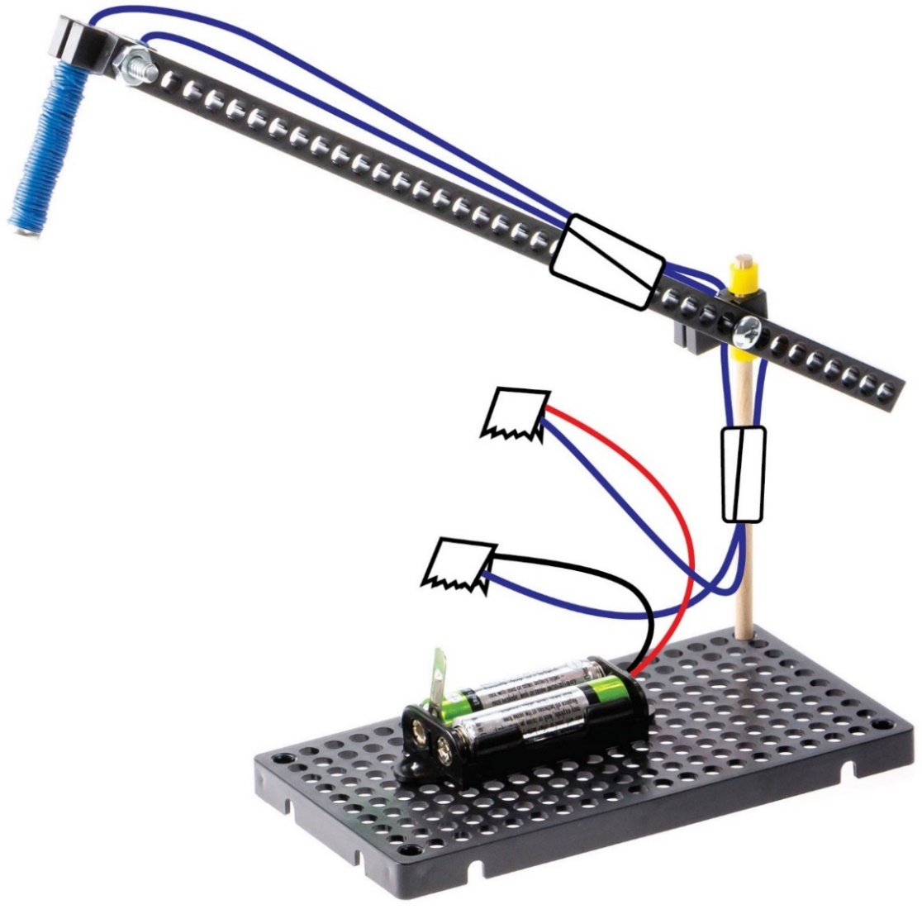

Use **tape** to hold loose wires

[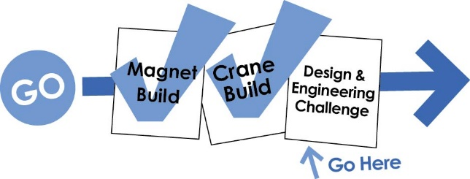](https://teachergeek.com/blogs/projects/electromagnet-crane-activity)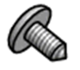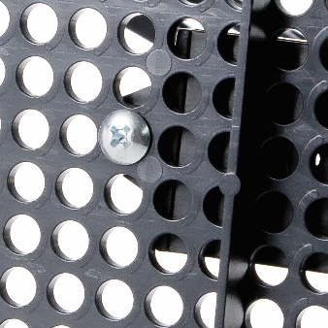

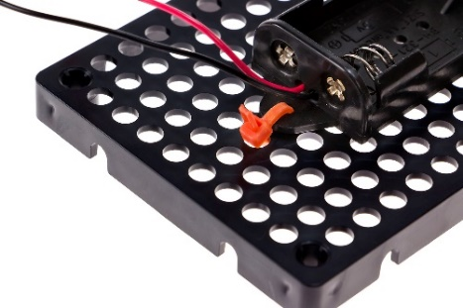

Or use **zip ties**



Documents at **teachergeek.com/learn**

This example crane works okay, but you can make it work much better.   
It is time for you to redesign it.   
Start onto an Electromagnet Crane Engineering Challenge.

**Screw** the **battery holder** to the **hole plate**, from the bottom.