Name: \_\_\_\_\_\_\_\_\_\_\_\_\_\_\_\_\_\_\_\_\_\_\_\_\_\_\_\_\_\_\_\_\_\_\_\_\_\_\_\_\_\_\_\_\_\_\_ Set: \_\_\_\_\_\_\_\_\_\_ Date: \_\_\_\_\_\_\_\_\_



**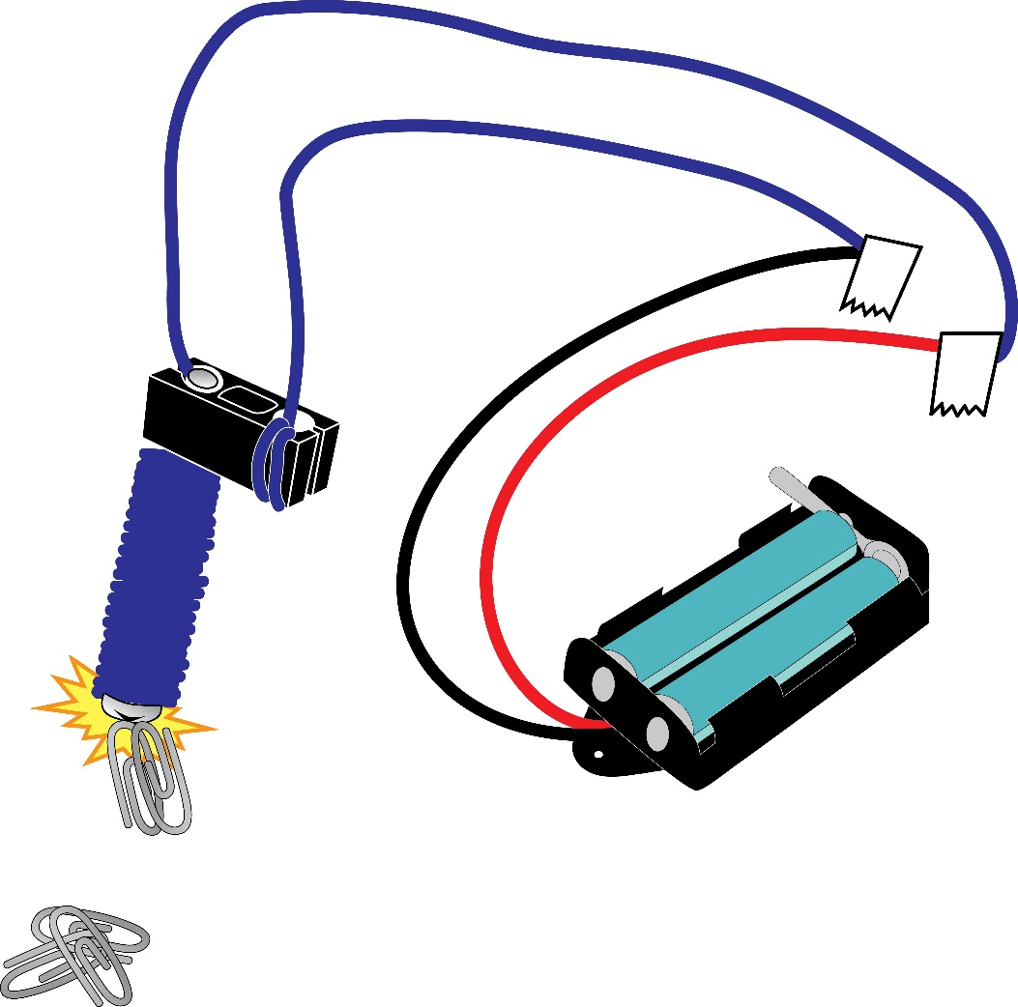**

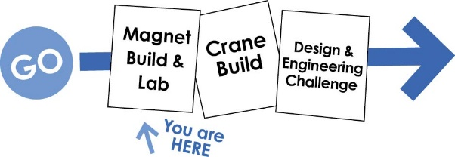

Other documents, including this activity without   
the lab, available at **teachergeek.com/learn**



**You will need these TeacherGeek components:**Available in the TeacherGeek [Electromagnetic Crane Activity](https://teachergeek.com/products/electromagnet-crane-activity), TeacherGeek [Maker Cart](https://teachergeek.com/products/maker-cart), or at [**teachergeek.com**](https://teachergeek.com/)(activity packs include extra components for further tinkering and innovation).

|  |  |  |  |
| --- | --- | --- | --- |
|  |  |  |  |
| **1 - Wire Roll**  colors vary  [SKU: 1821-43](https://teachergeek.com/products/galvanized-colored-wire-rolls-4-pack) | **1 - Battery Holder** w/ Switch & Leads  [SKU: 1821-63](https://teachergeek.com/products/2-aa-battery-holder-w-switch-10-pack) | **1 - Block**  [SKU: 1821-34](https://teachergeek.com/products/perpendicular-blocks-100-pack) | **1 – 50mm Screw**  #10 (2in)  [SKU: 1821-27](https://teachergeek.com/products/10-x-2-machine-screws-100-pack?variant=344048793) |

**You will need these tools, they can be shared:***Tools available at* [***teachergeek.com***](https://teachergeek.com/products/easy-engineering-tool-set?variant=344866731)

|  |  |  |
| --- | --- | --- |
|  |  |  |
| [**Wire Strippers**](https://teachergeek.com/products/adjustable-wire-stripper)[SKU 1823-95](https://teachergeek.com/products/adjustable-wire-stripper) | [**Screwdriver**](https://teachergeek.com/products/stubby-2-screwdriver)[SKU 1823-90](https://teachergeek.com/products/stubby-2-screwdriver) | [**Pliers (optional)**](https://teachergeek.com/products/slip-joint-pliers-6)[SKU 1823-86](https://teachergeek.com/products/slip-joint-pliers-6) |

**You will need these non-TeacherGeek supplies:**

|  |  |  |
| --- | --- | --- |
|  | **C:\Users\Funnest\AppData\Local\Microsoft\Windows\INetCacheContent.Word\AdobeStock_70931743.jpegC:\Users\Funnest\AppData\Local\Microsoft\Windows\INetCacheContent.Word\AdobeStock_70931743.jpeg** |  |
| **Masking Tape** | **2 AA Batteries** | **Small Paper Clips and Other Materials**  Erasers, Washers, Staples, Candy, Pennies, etc. for magnetic testing. |



|  |  |  |  |
| --- | --- | --- | --- |
|  | Turn a 5cm long **screw** into a **block**.    5cm **Screw**  **Block** |  | Uncoil a **wire roll**. |
|  | Measure 60cm from one end of the **wire.** Fold a piece of **tape** there, over the **wire**.    **Quick Tip**  To keep **wire** from unwinding, wrap a few times in the slots.  (24in)  60cm |  | Wrap the **wire**, as shown below, 50 times around the **screw**.  Extra **Wire**  60cm Side of **Wire** |

|  |  |  |  |
| --- | --- | --- | --- |
|  | Strip (remove) 1cm of plastic **insulation** from the **wire** ends.    Stripped **Wires** ends  Yes… one wire should be longer than the other. | | |
|  | Twist the **stripped** **wire** from step 5 with the stripped **battery holder** **wires**. |  | Wrap the twisted **wire** ends with **tape**. This will keep them together, and keep them from touching.      **Don’t Short Circuit**  Keep the red and black wires from touching. The battery will heat up and die (nothing fun). |
|  |  | | |
|  | Put 2 **AA batteries** into the **battery holder**. Turn it on and try to pick up some paper clips.    Turn your magnet on and off with the metal lever**.**    Yes… You should have extra wire on one side. | | |

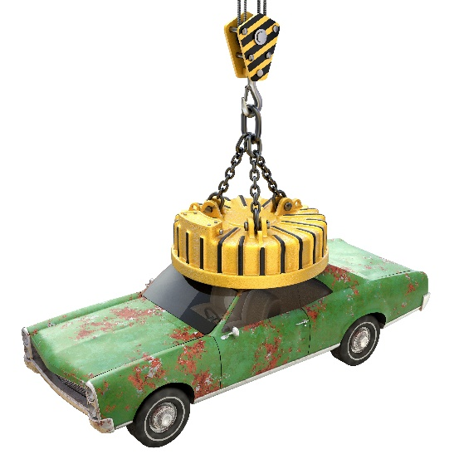

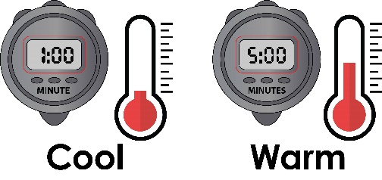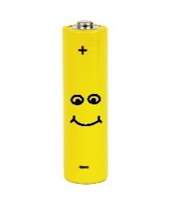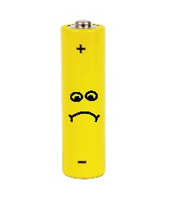

Do not keep your electromagnet turned on. It will get hot and drain your battery.

Let’s see how much your magnet can pick up.

Name: \_\_\_\_\_\_\_\_\_\_\_\_\_\_\_\_\_\_\_\_\_\_\_\_\_\_\_\_\_\_\_\_\_\_\_\_\_\_\_\_\_\_\_\_\_\_\_ Set: \_\_\_\_\_\_\_\_\_\_ Date: \_\_\_\_\_\_\_\_\_\_



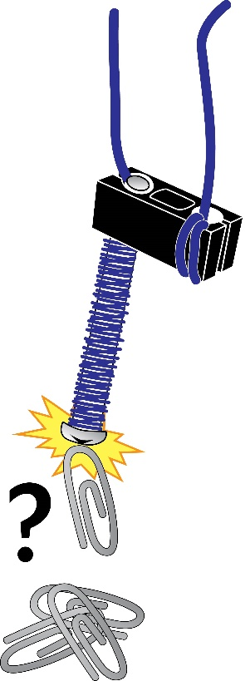



How many small paper clips can your electromagnet pick up?

\_\_\_\_\_\_\_\_\_\_\_\_\_\_\_\_\_\_\_\_\_\_\_\_\_\_\_\_\_\_\_\_\_\_\_\_\_\_\_\_\_\_\_\_\_\_\_\_\_\_\_\_\_

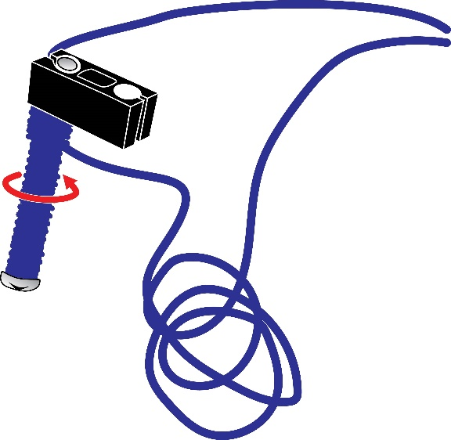

Add 50 more wire wraps around the screw, using the extra wire.

50 More Wraps

How many wire wraps are now on the screw?

\_\_\_\_\_\_\_\_\_\_\_\_\_\_\_\_\_\_\_\_\_\_\_\_\_\_\_\_\_\_\_\_\_\_\_\_

How many paper clips can it pick up?

Extra Wire

\_\_\_\_\_\_\_\_\_\_\_\_\_\_\_\_\_\_\_\_\_\_\_\_\_\_\_\_\_\_\_\_\_\_\_\_

**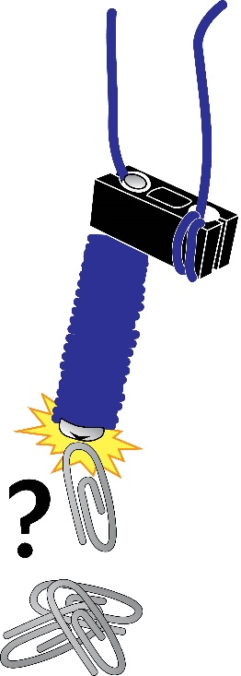**

Add another 50 wire wraps around the electromagnet.

How many wire wraps are now on the screw?

\_\_\_\_\_\_\_\_\_\_\_\_\_\_\_\_\_\_\_\_\_\_\_\_\_\_\_\_\_\_\_\_\_\_\_\_\_\_\_\_\_\_\_\_\_\_\_\_\_\_\_\_\_

How many paper clips can it pick up?

50 More Wraps

\_\_\_\_\_\_\_\_\_\_\_\_\_\_\_\_\_\_\_\_\_\_\_\_\_\_\_\_\_\_\_\_\_\_\_\_\_\_\_\_\_\_\_\_\_\_\_\_\_\_\_\_\_

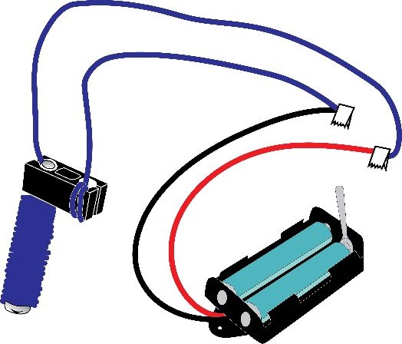

Make the wires the same length by wrapping the extra wire around the screw.

Your electromagnet is done. Put it to work.



Magnetic materials will attract to your electromagnet. Test different materials to see if they are magnetic. Record the results below.



Some things may attract, but be too heavy to pick up.

|  |  |  |  |
| --- | --- | --- | --- |
| **Material** | **Predict:**  **Will it be magnetic?** | **Test:**  **Is it magnetic?** | **How many can it pick up?** |
| Paper Clip |  |  |  |
| Rubber Eraser |  |  |  |
| Penny |  |  |  |
| Dime |  |  |  |
| Staple |  |  |  |
|  |  |  |  |
|  |  |  |  |
|  |  |  |  |
|  |  |  |  |



Find and test more materials



****What was similar about the materials that were magnetic?

\_\_\_\_\_\_\_\_\_\_\_\_\_\_\_\_\_\_\_\_\_\_\_\_\_\_\_\_\_\_\_\_\_\_\_\_\_\_\_\_\_\_\_\_\_\_\_\_\_\_\_\_\_\_\_\_\_\_\_\_\_\_\_\_\_\_\_\_\_\_\_\_\_\_\_\_\_

\_\_\_\_\_\_\_\_\_\_\_\_\_\_\_\_\_\_\_\_\_\_\_\_\_\_\_\_\_\_\_\_\_\_\_\_\_\_\_\_\_\_\_\_\_\_\_\_\_\_\_\_\_\_\_\_\_\_\_\_\_\_\_\_\_\_\_\_\_\_\_\_\_\_\_\_\_

\_\_\_\_\_\_\_\_\_\_\_\_\_\_\_\_\_\_\_\_\_\_\_\_\_\_\_\_\_\_\_\_\_\_\_\_\_\_\_\_\_\_\_\_\_\_\_\_\_\_\_\_\_\_\_\_\_\_\_\_\_\_\_\_\_\_\_\_\_\_\_\_\_\_\_\_\_

****What was different about the materials that were magnetic?

\_\_\_\_\_\_\_\_\_\_\_\_\_\_\_\_\_\_\_\_\_\_\_\_\_\_\_\_\_\_\_\_\_\_\_\_\_\_\_\_\_\_\_\_\_\_\_\_\_\_\_\_\_\_\_\_\_\_\_\_\_\_\_\_\_\_\_\_\_\_\_\_\_\_\_\_\_

\_\_\_\_\_\_\_\_\_\_\_\_\_\_\_\_\_\_\_\_\_\_\_\_\_\_\_\_\_\_\_\_\_\_\_\_\_\_\_\_\_\_\_\_\_\_\_\_\_\_\_\_\_\_\_\_\_\_\_\_\_\_\_\_\_\_\_\_\_\_\_\_\_\_\_\_\_

\_\_\_\_\_\_\_\_\_\_\_\_\_\_\_\_\_\_\_\_\_\_\_\_\_\_\_\_\_\_\_\_\_\_\_\_\_\_\_\_\_\_\_\_\_\_\_\_\_\_\_\_\_\_\_\_\_\_\_\_\_\_\_\_\_\_\_\_\_\_\_\_\_\_\_\_\_

****How could you make the magnet more powerful?

\_\_\_\_\_\_\_\_\_\_\_\_\_\_\_\_\_\_\_\_\_\_\_\_\_\_\_\_\_\_\_\_\_\_\_\_\_\_\_\_\_\_\_\_\_\_\_\_\_\_\_\_\_\_\_\_\_\_\_\_\_\_\_\_\_\_\_\_\_\_\_\_\_\_\_\_\_

\_\_\_\_\_\_\_\_\_\_\_\_\_\_\_\_\_\_\_\_\_\_\_\_\_\_\_\_\_\_\_\_\_\_\_\_\_\_\_\_\_\_\_\_\_\_\_\_\_\_\_\_\_\_\_\_\_\_\_\_\_\_\_\_\_\_\_\_\_\_\_\_\_\_\_\_\_

\_\_\_\_\_\_\_\_\_\_\_\_\_\_\_\_\_\_\_\_\_\_\_\_\_\_\_\_\_\_\_\_\_\_\_\_\_\_\_\_\_\_\_\_\_\_\_\_\_\_\_\_\_\_\_\_\_\_\_\_\_\_\_\_\_\_\_\_\_\_\_\_\_\_\_\_\_

**[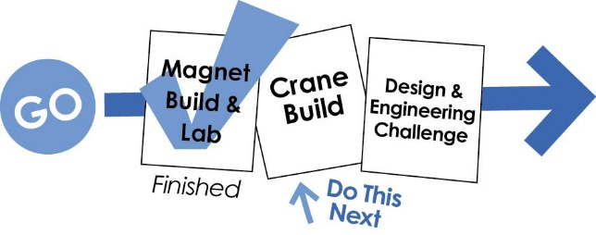](https://teachergeek.com/blogs/projects/electromagnet-crane-activity)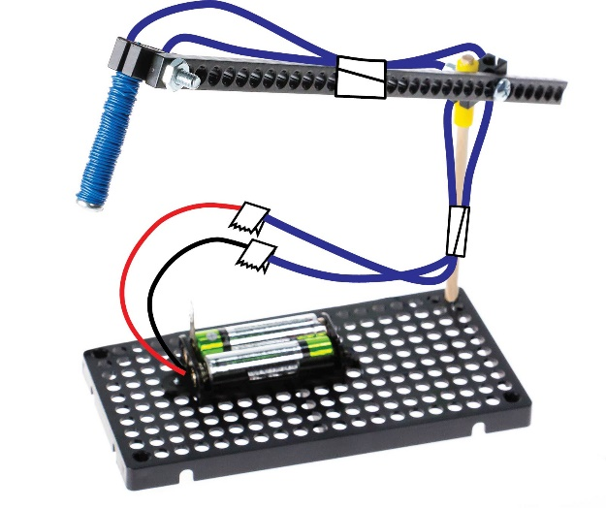**

Documents at **teachergeek.com/learn**

Your electromagnet is finished. It’s time to turn it into a crane.