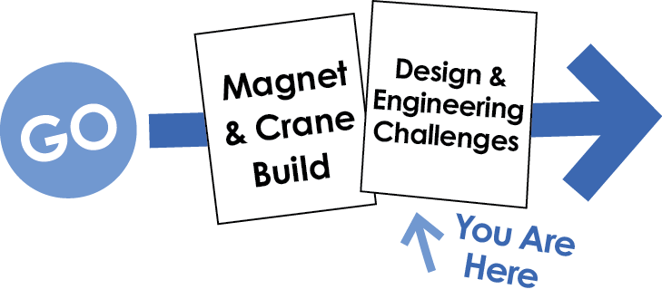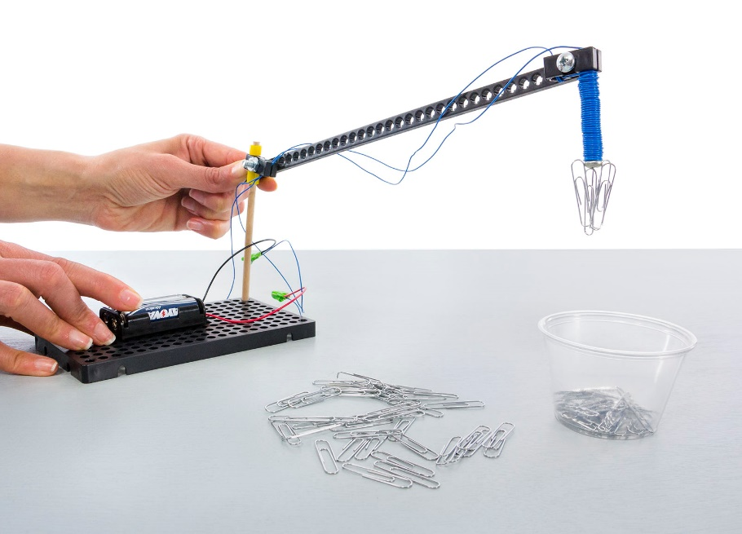

This is not a good crane design (it’s the example). You can redesign it to reach more areas.

**The Challenge:** Redesign your crane to pick up as many paper clips as possible, in two minutes.

**Difficulty:** Easy

Use any cup or container.

Other documents and activity components at [teachergeek.com](https://teachergeek.com/) © TeacherGeek Inc. 2016