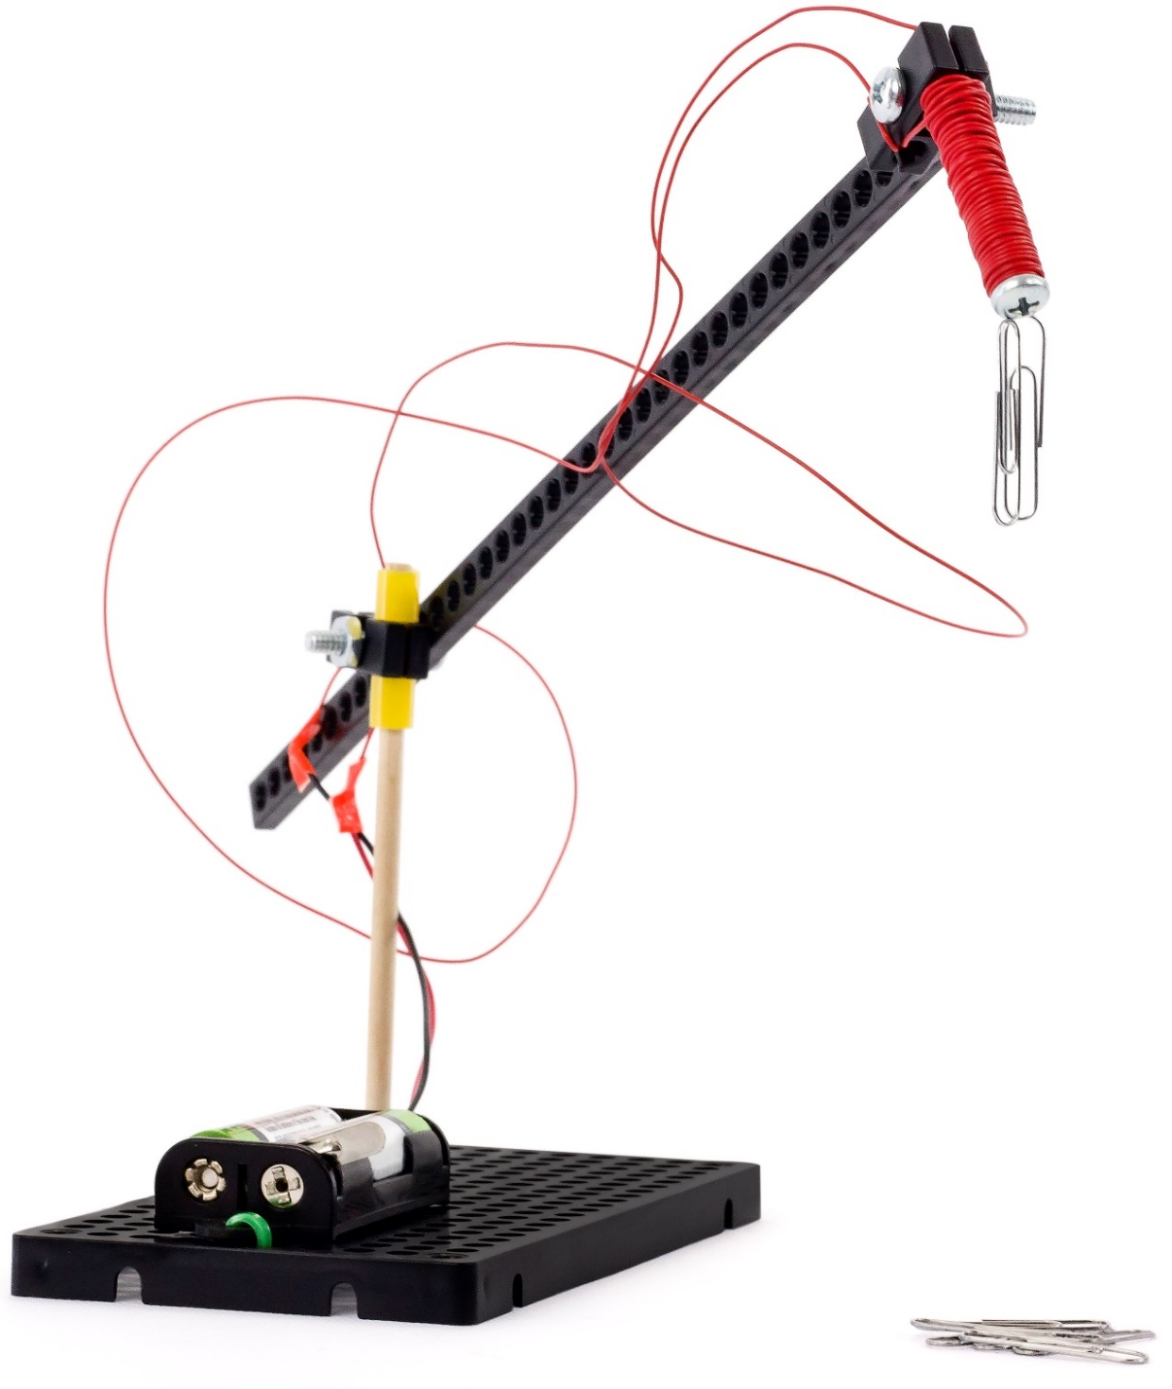



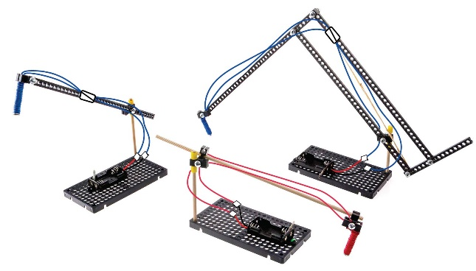

Start by building the example, then

turn it into your own unique design.

For use with TeacherGeek [Electromagnet Activity](https://teachergeek.com/products/electromagnet-crane-activity), or [Maker Cart](https://teachergeek.com/products/maker-cart). Find documents and activity materials at [**teachergeek.com**](https://teachergeek.com/).



**You will need these TeacherGeek components:**Below is the list of “ingredients” you’ll need to build an Electromagnet. It includes some extra components to allow you to create your own unique design.

|  |  |  |  |
| --- | --- | --- | --- |
|  |  |  |  |
| **1 - Wire Roll**  colors vary  [SKU: 1821-43](https://teachergeek.com/products/galvanized-colored-wire-rolls-4-pack) | **1 - Battery Holder** w/ Switch & Leads  [SKU: 1821-63](https://teachergeek.com/products/2-aa-battery-holder-w-switch-10-pack) | **1 - Block**  [SKU: 1821-34](https://teachergeek.com/products/perpendicular-blocks-100-pack) | **1 – 50mm Screw**  #10 (2in)  [SKU: 1821-27](https://teachergeek.com/products/10-x-2-machine-screws-100-pack?variant=344048793) |

**You will need these tools, they can be shared:***Tools available at* [***teachergeek.com***](https://teachergeek.com/products/easy-engineering-tool-set?variant=344866731)

|  |  |  |
| --- | --- | --- |
|  |  |  |
| [**Wire Strippers**](https://teachergeek.com/products/adjustable-wire-stripper)[SKU 1823-95](https://teachergeek.com/products/adjustable-wire-stripper) | [**Screwdriver**](https://teachergeek.com/products/stubby-2-screwdriver)[SKU 1823-90](https://teachergeek.com/products/stubby-2-screwdriver) | [**Pliers (optional)**](https://teachergeek.com/products/slip-joint-pliers-6)[SKU 1823-86](https://teachergeek.com/products/slip-joint-pliers-6) |

**You will need these non-TeacherGeek supplies:**

|  |  |  |
| --- | --- | --- |
|  | **C:\Users\Funnest\AppData\Local\Microsoft\Windows\INetCacheContent.Word\AdobeStock_70931743.jpegC:\Users\Funnest\AppData\Local\Microsoft\Windows\INetCacheContent.Word\AdobeStock_70931743.jpeg** |  |
| **Masking Tape** | **2 AA Batteries** | **Small Paper Clips and Other Materials**  Erasers, Washers, Staples, Candy, Pennies, etc. for magnetic testing. |



|  |  |  |  |
| --- | --- | --- | --- |
|  | Turn a 5cm long **screw** into a **block**.    5cm **Screw**  **Block** |  | Uncoil a **wire roll**. |
|  | Measure 60cm from one end of the **wire.** Fold a piece of **tape** there, over the **wire**.    **Don’t cut the wires!** Use the entire length  or it will overheat.  **Quick Tip**  To keep **wire** from unwinding, wrap a few times in the slots.  (24in)  60cm |  | Wrap the **wire**, as shown below, **150 – 200 times** around the **screw** (this will create several layers).  **More wraps** make a **stronger magnet**, but you need about 60cm of extra wire to mount it to your crane.  Extra **Wire**  60cm Side of **Wire** |

|  |  |  |  |
| --- | --- | --- | --- |
|  | Strip (remove) 1cm of plastic **insulation** from the **wire** ends.    Stripped **Wires** ends  Yes… one wire should be longer than the other. | | |
|  | Twist the **stripped** **wire** from step 5 with the stripped **battery holder** **wires**. |  | Wrap the twisted **wire** ends with **tape**. This will keep them together, and keep them from touching.      **Don’t Short Circuit**  Keep the **red** and **black** wires from touching. The battery will heat up and die (nothing fun). |
|  |  | | |
|  | Put 2 **AA batteries** into the **battery holder**. Turn it on and try to pick up some paper clips.  Yes… You should have extra wire on one side.  Turn your magnet on and off with the metal lever**.** | | |

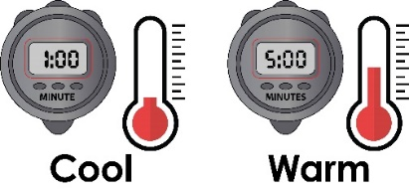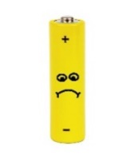

Do not keep your electromagnet turned on. It will get hot and drain your battery.

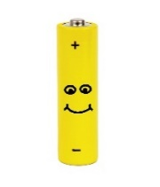

**Congratulations!**

Your electromagnet is finished. It’s time to turn it into a crane on the next page.

**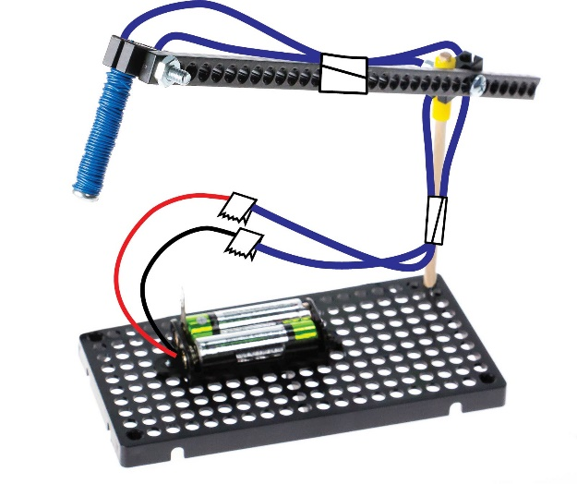**



**You will need these TeacherGeek components for the Crane:**

Below is the list of “ingredients” you’ll need to build an Electromagnet. It includes some extra components to allow you to create your own unique design.

|  |  |  |  |
| --- | --- | --- | --- |
|  |  |  |  |
| [**1- Connector Strip**](https://teachergeek.com/products/electromagnet-crane-activity) | **[1- Dowel](https://teachergeek.com/products/electromagnet-crane-activity)**  [300mm (12″)](https://teachergeek.com/products/electromagnet-crane-activity) | [**1 - Hole Plate**](https://teachergeek.com/products/electromagnet-crane-activity) | [**1 - Block**](https://teachergeek.com/products/electromagnet-crane-activity) |
|  |  |  |  |
| **[2 - 6mm Screw](https://teachergeek.com/products/electromagnet-crane-activity)**  [#6 6mm (¼″)](https://teachergeek.com/products/electromagnet-crane-activity) | **[2 - 25mm Screw](https://teachergeek.com/products/electromagnet-crane-activity)**  [#10 25mm (1″)](https://teachergeek.com/products/electromagnet-crane-activity) | **[1 - Nut](https://teachergeek.com/products/electromagnet-crane-activity)**  [#10](https://teachergeek.com/products/electromagnet-crane-activity) | **[≥ 2cm Slide Stop](https://teachergeek.com/products/electromagnet-crane-activity)**  [(≥ ½in)](https://teachergeek.com/products/electromagnet-crane-activity) |

**You will need these tools, they can be shared:***Tools available at* [***teachergeek.com***](https://teachergeek.com/)

|  |  |  |  |
| --- | --- | --- | --- |
|  |  |  |  |
| [**Multi-Cutter**](https://teachergeek.com/products/1823-81)[SKU 1823-81](https://teachergeek.com/products/1823-81) | [**Screwdriver**](https://teachergeek.com/products/stubby-2-screwdriver)[SKU 1823-90](https://teachergeek.com/products/stubby-2-screwdriver) | [**Pliers**](https://teachergeek.com/products/slip-joint-pliers-6)[SKU 1823-86](https://teachergeek.com/products/slip-joint-pliers-6) | [**Reamer**](https://teachergeek.com/products/teachergeek-reamer)[SKU 1823-87](https://teachergeek.com/products/teachergeek-reamer) |

**You will need these non-TeacherGeek supplies:**

|  |  |
| --- | --- |
|  |  |
| **Tape** | **Magnetic Materials** Erasers, Washers, Stapes, Dimes  Candy, Pennies, etc. |







|  |  |  |  |
| --- | --- | --- | --- |
|  | Cut a 12cm **dowel**.    12cm |  | Tap or push the dowel into a corner of a **hole plate**. |
|  | Ream one hole of a **block**. |  | Cut two 1cm sections of **slide stop**.    1cm  1cm |
|  | Place one of the **slide stop** sections onto the **dowel**. |  | Put the **dowel** through the reamed **block** hole. Use a **slide stop** section to hold it on. |
|  | Use a **25mm** **screw** to attach a **connector strip** to the **block**. This will become the crane arm. |  | Use a **25mm** **screw** and **nut** to attach your **electromagnet** to the arm. |
|  | Finish your example Electromagnet Crane by attaching the **battery holder** and taping loose **wires**. | | |

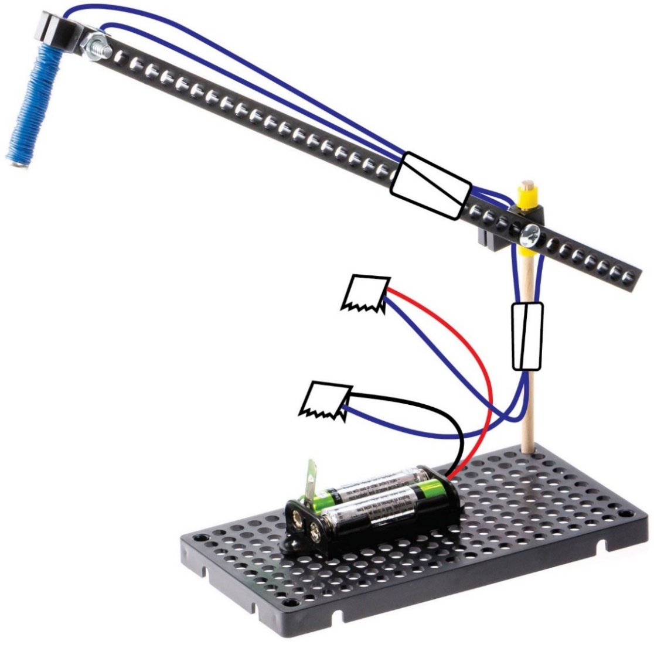

Use **tape** to hold loose wires

[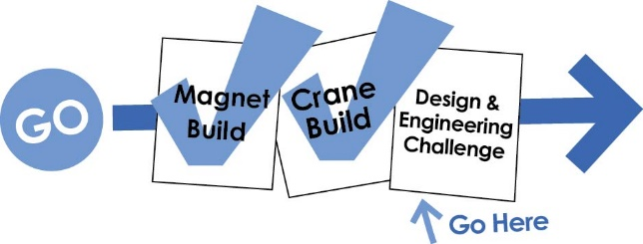](https://teachergeek.com/blogs/projects/electromagnet-crane-activity)**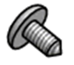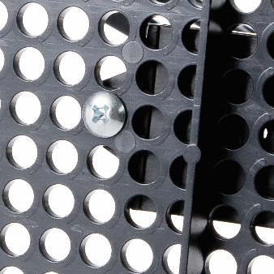**

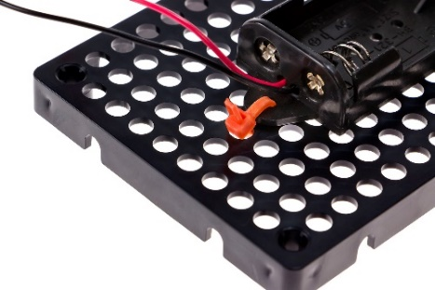

Or use **zip ties**



On the next pages…

This example crane works okay, but you can make it work much better.   
It is time for you to redesign it.   
Start onto an Electromagnet Crane Engineering Challenge.

From the underside,   
use a **6mm screw** to attach the **battery holder** to the **hole plate**.

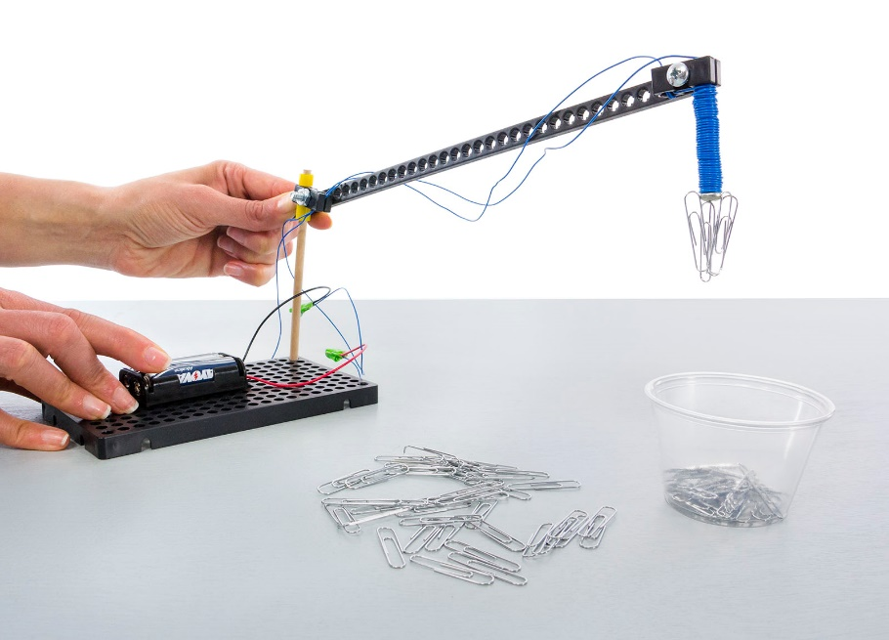

This is not a good crane design (it’s the example). You can redesign it to reach more areas.

**The Challenge:** Redesign your crane to pick up as many paper clips as possible, in two minutes.

**Difficulty:** Easy

Use any cup or container.

Other documents and activity components at [teachergeek.com](https://teachergeek.com/) © TeacherGeek Inc. 2016

**The Challenge:** Redesign your crane to hang as many paper clips as possible, in two minutes.

**Difficulty:** Medium

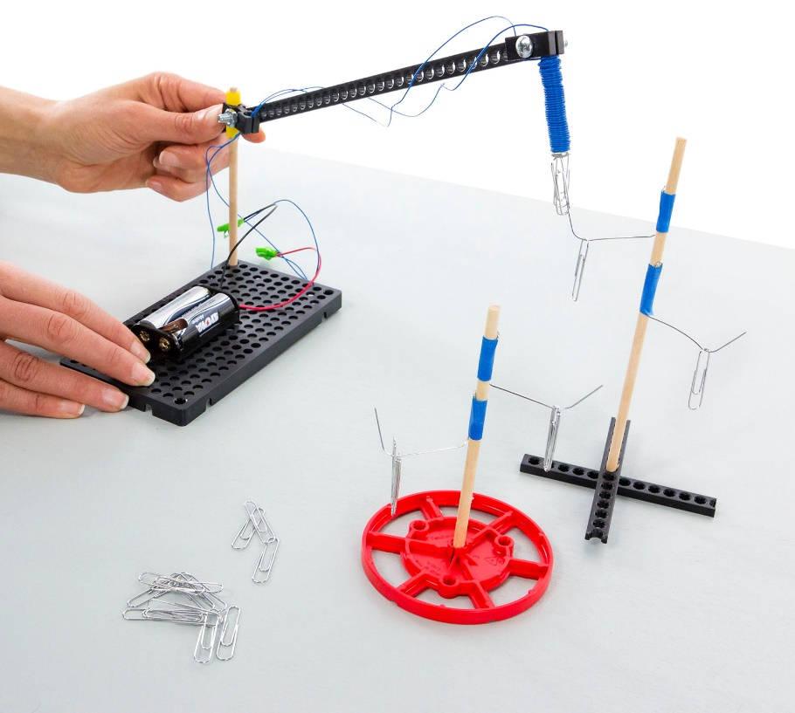



This is not a good crane design (it’s the example). Can you redesign it so it can pick up things near and far away, without moving the crane base?



Optional: Make the challenge more difficult by requiring that the crane base stay in one place.



Prepare for the challenge by creating a “tree” or structure to hang paper clips on. The tree branches are opened paper clips.

Other documents and activity components at [teachergeek.com](https://teachergeek.com/). © TeacherGeek Inc. 2016

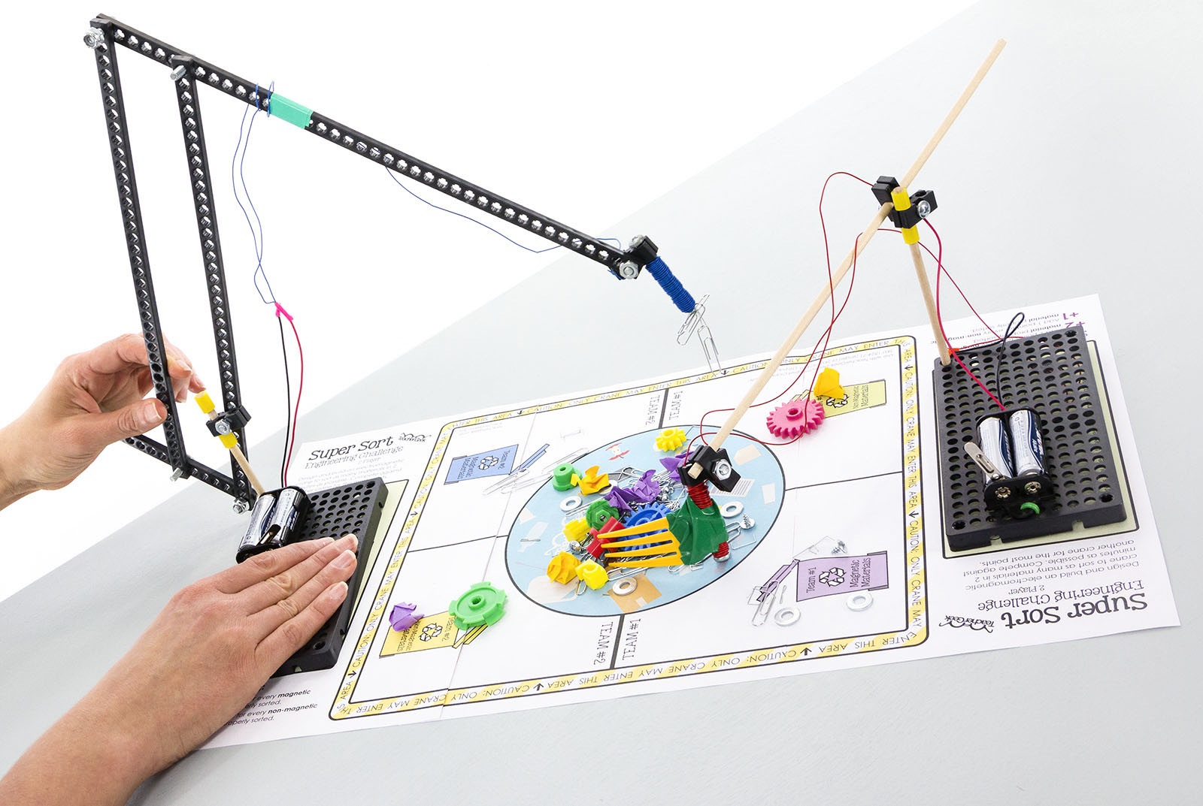

**The Challenge:** Design an Electromagnet Crane to sort as many materials in 2 minutes as possible.

**Difficulty:** Medium

Redesign your crane to reach all the sorting areas. The example crane will not work.

Add parts to your crane to help you move non-magnetic. materials.

Move materials from the pile in the center, to the correct sorting areas.

Other documents and activity components at [teachergeek.com](https://teachergeek.com/) © TeacherGeek Inc. 2016

Single Player Arena

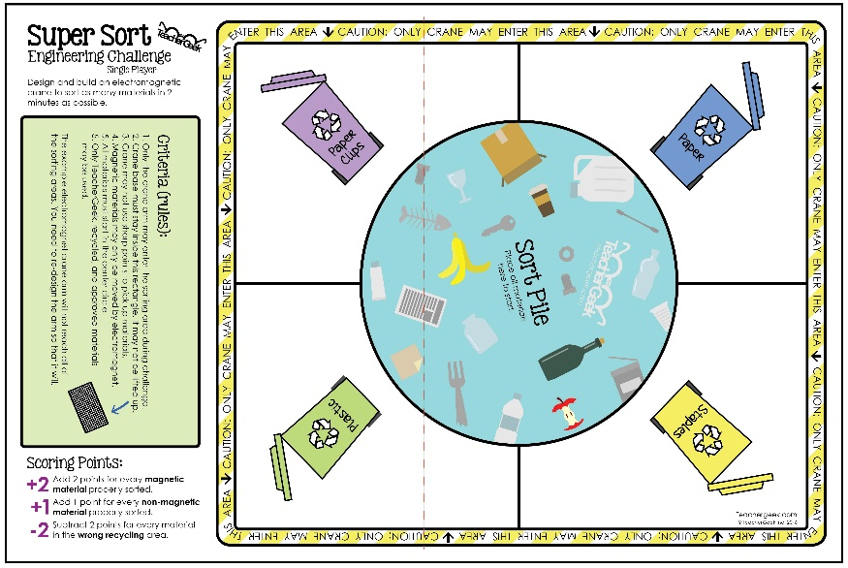

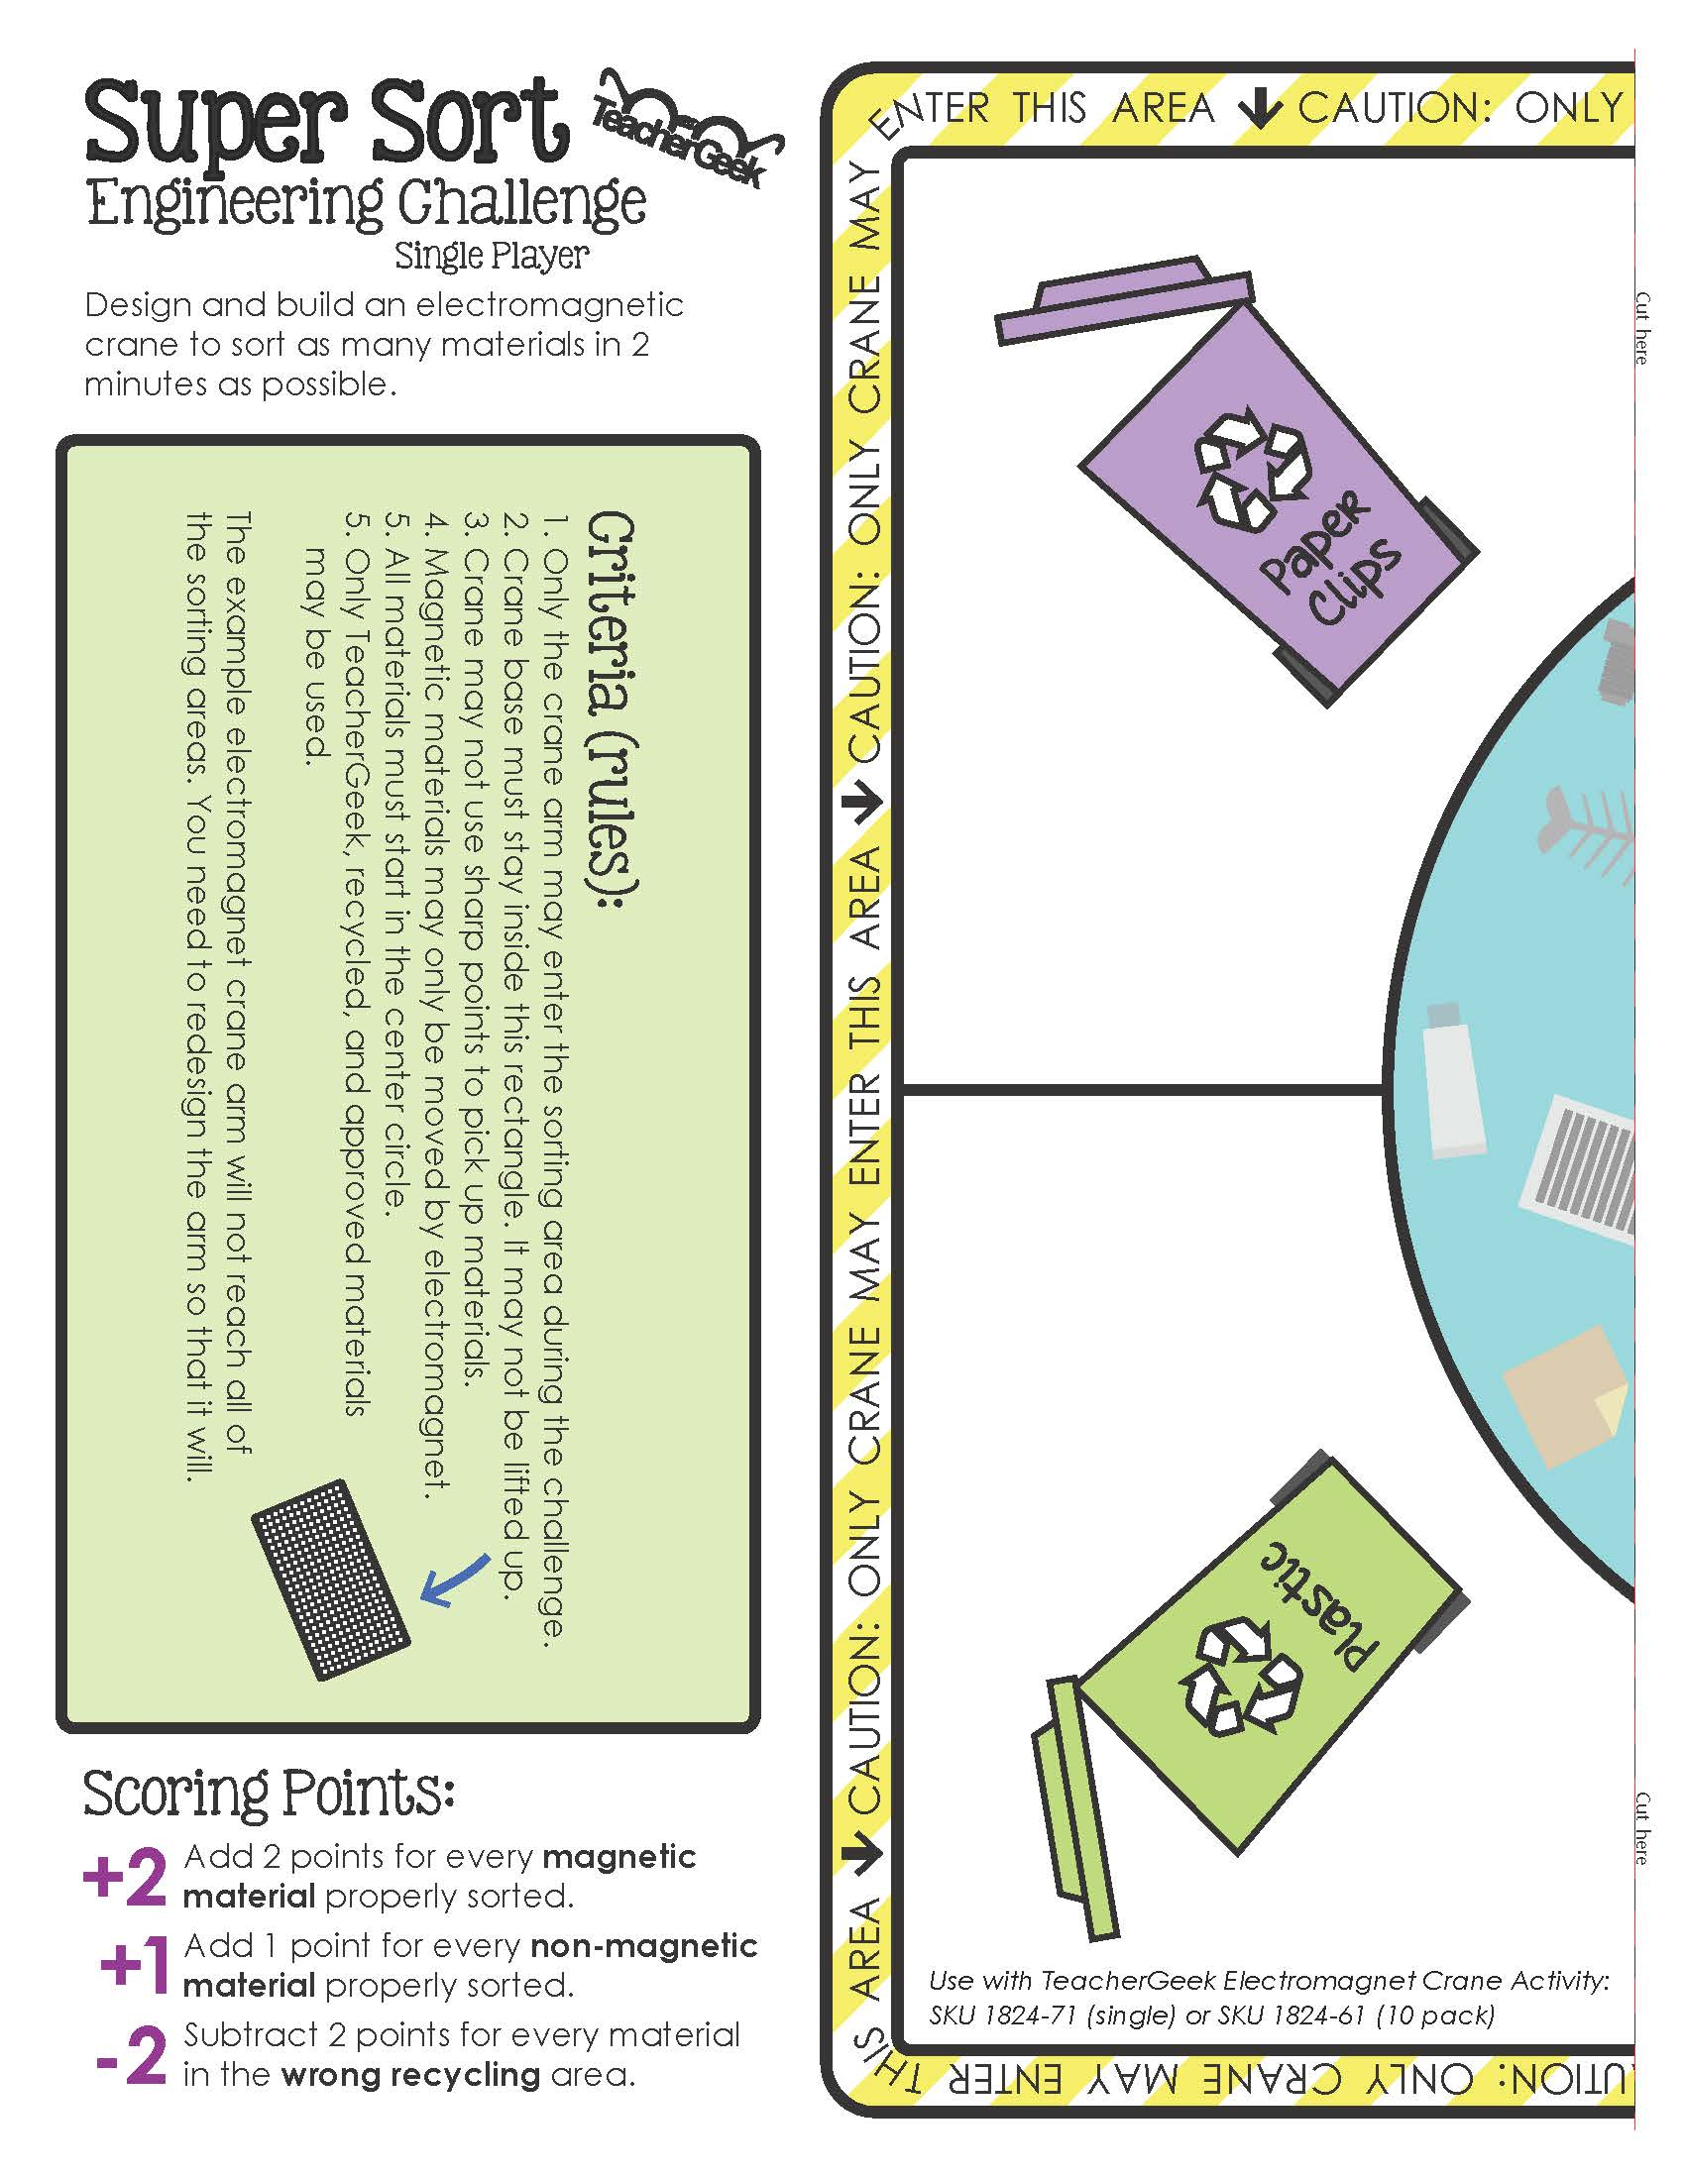

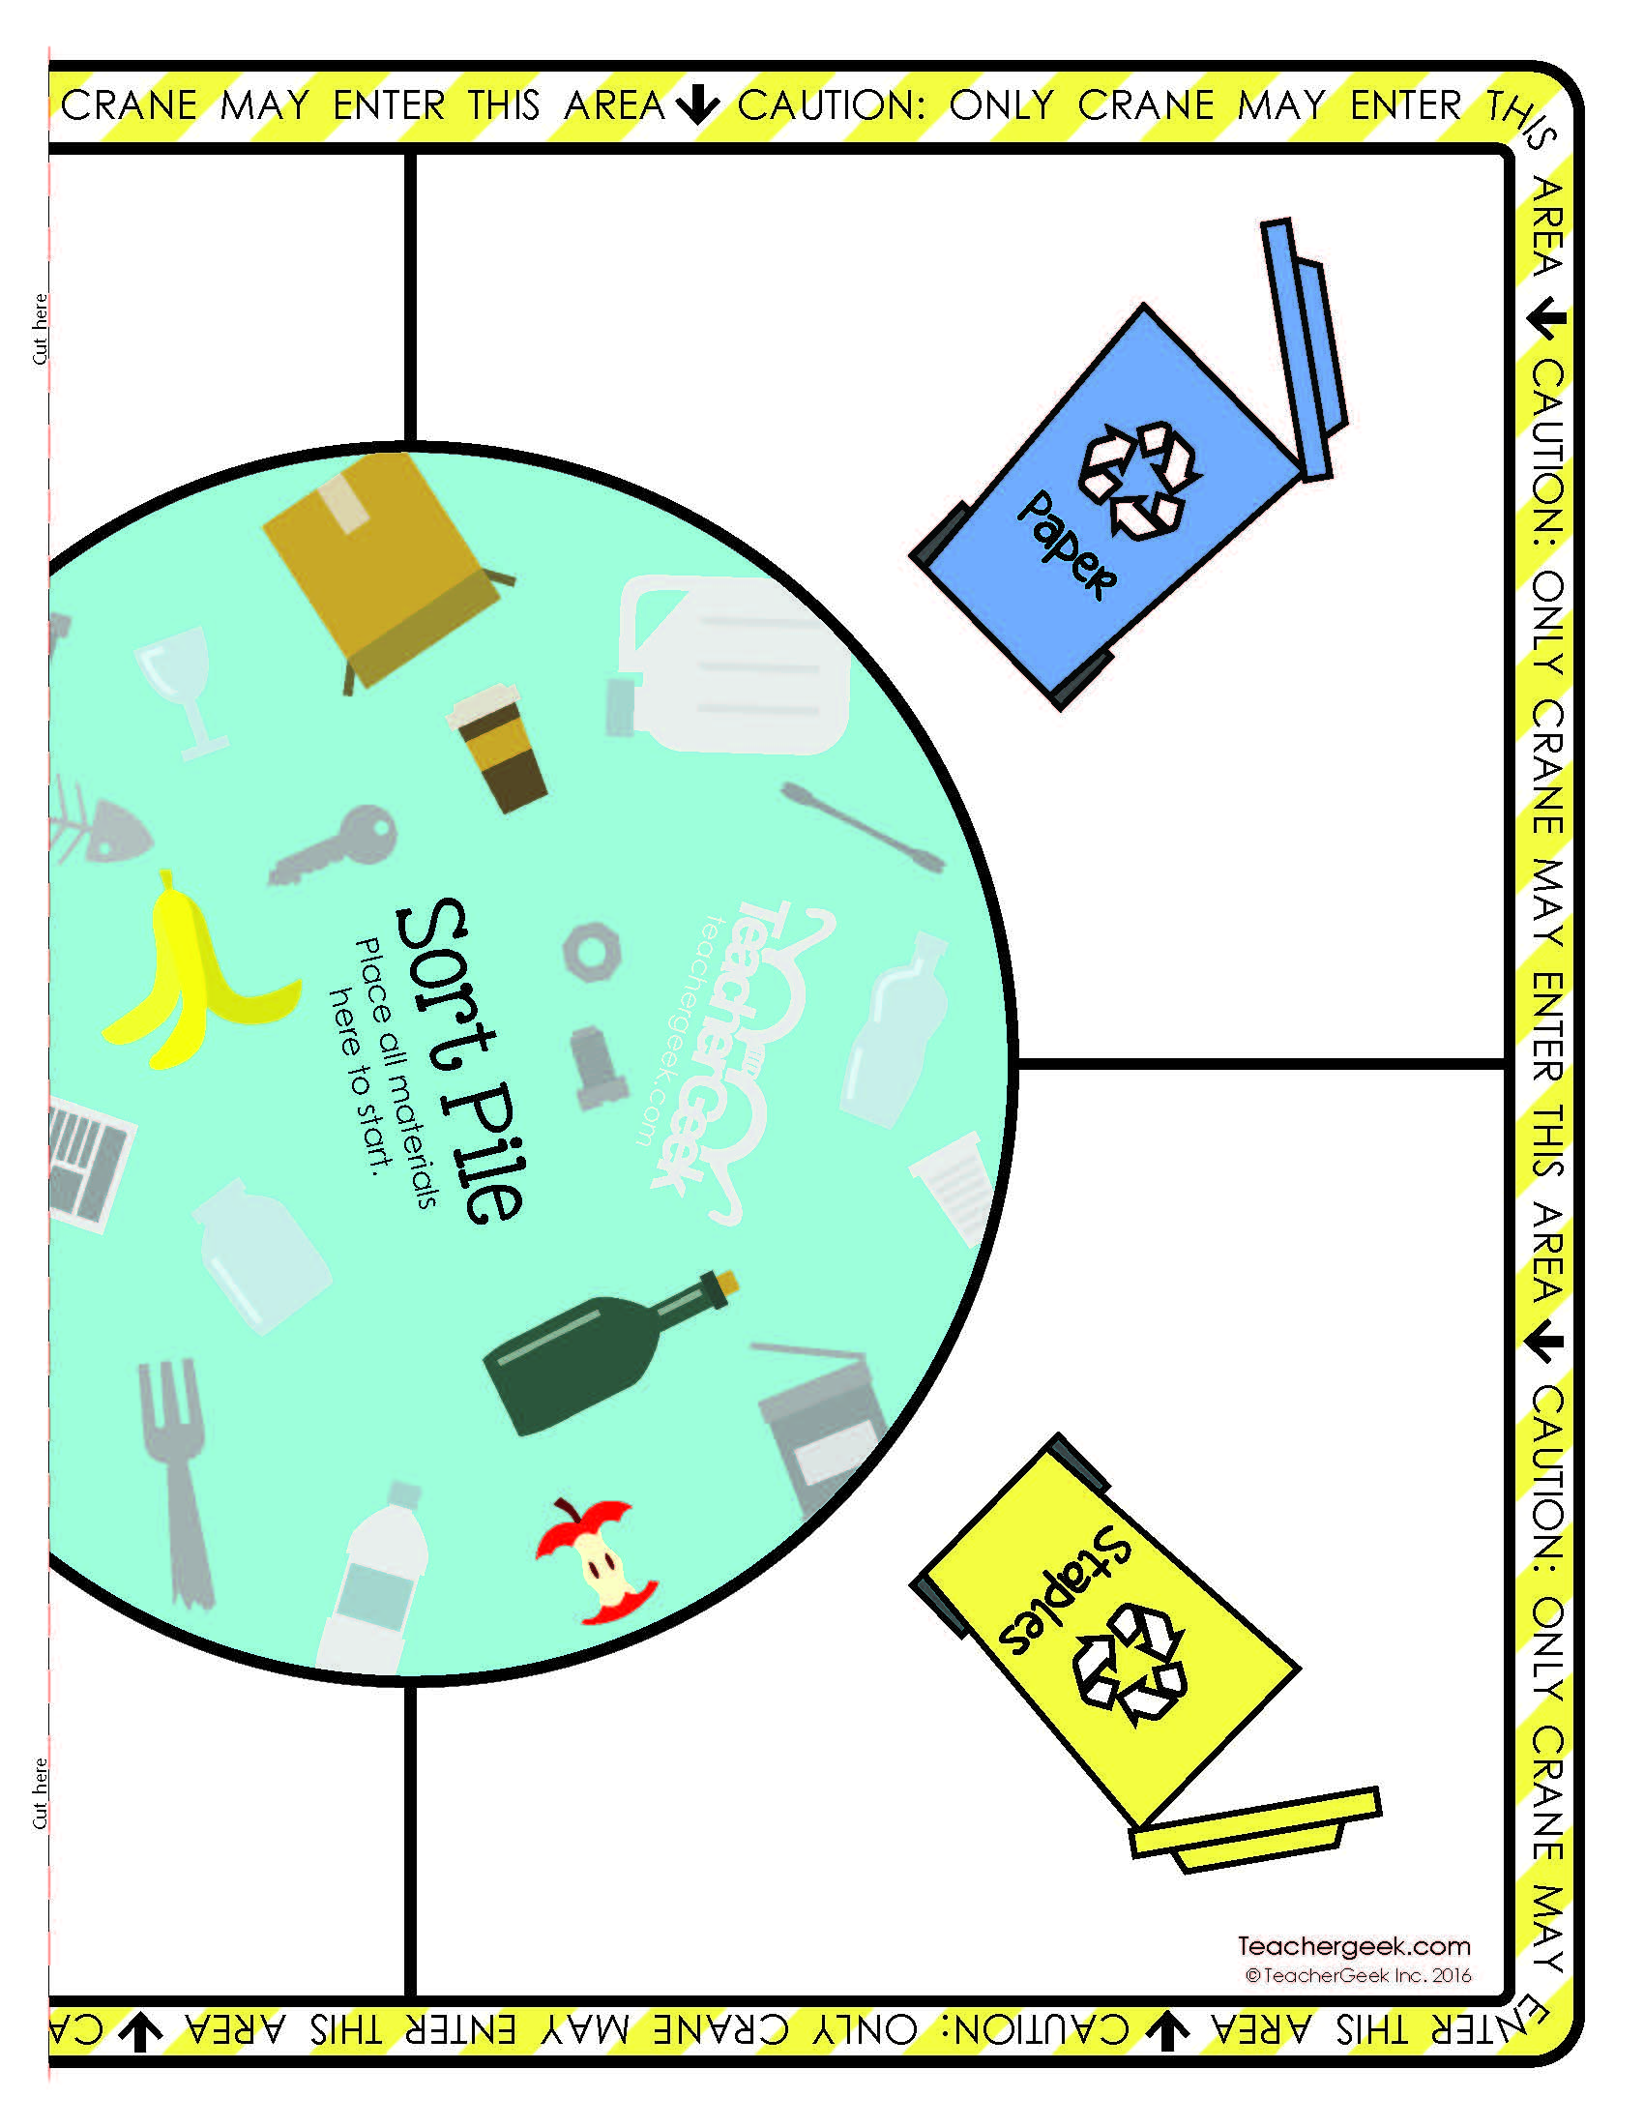

Two Player Arena

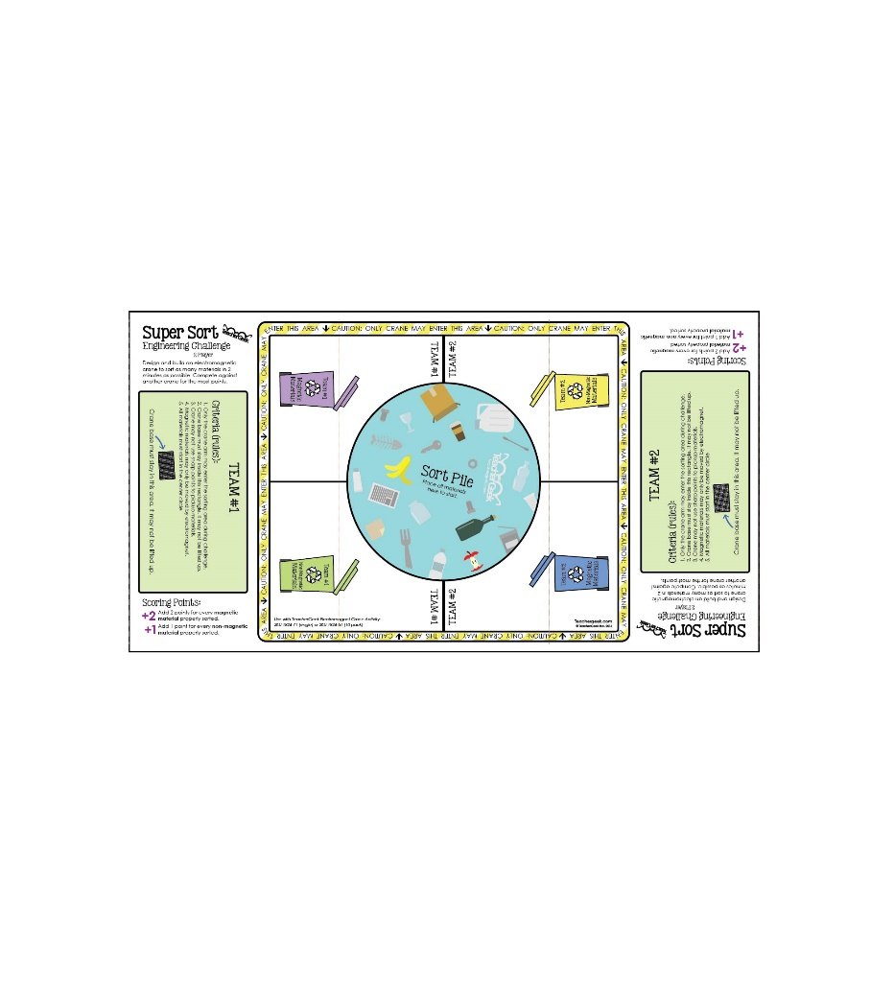

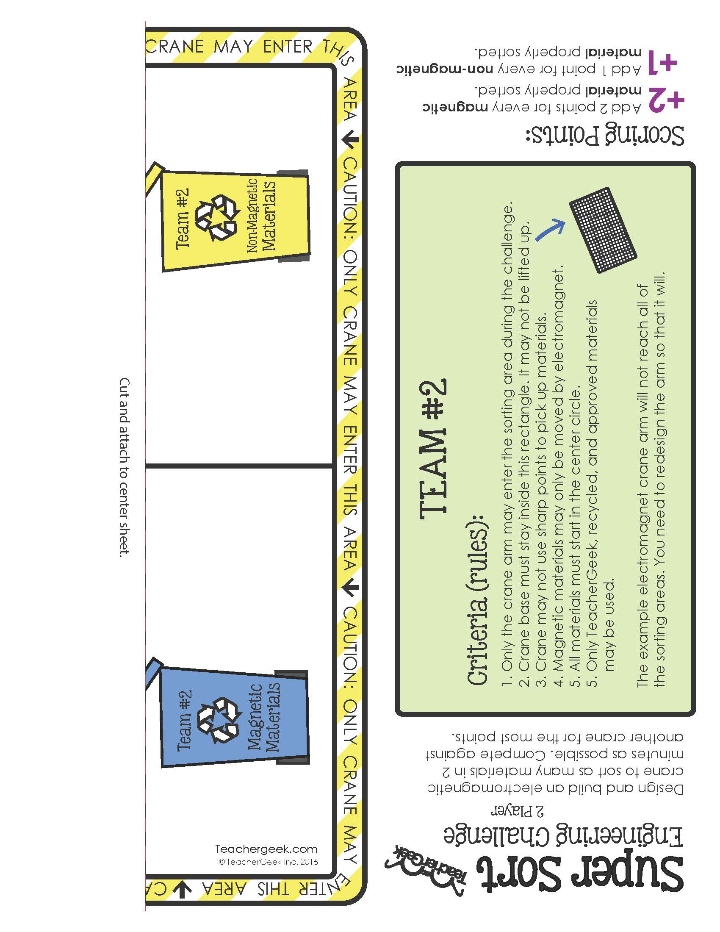

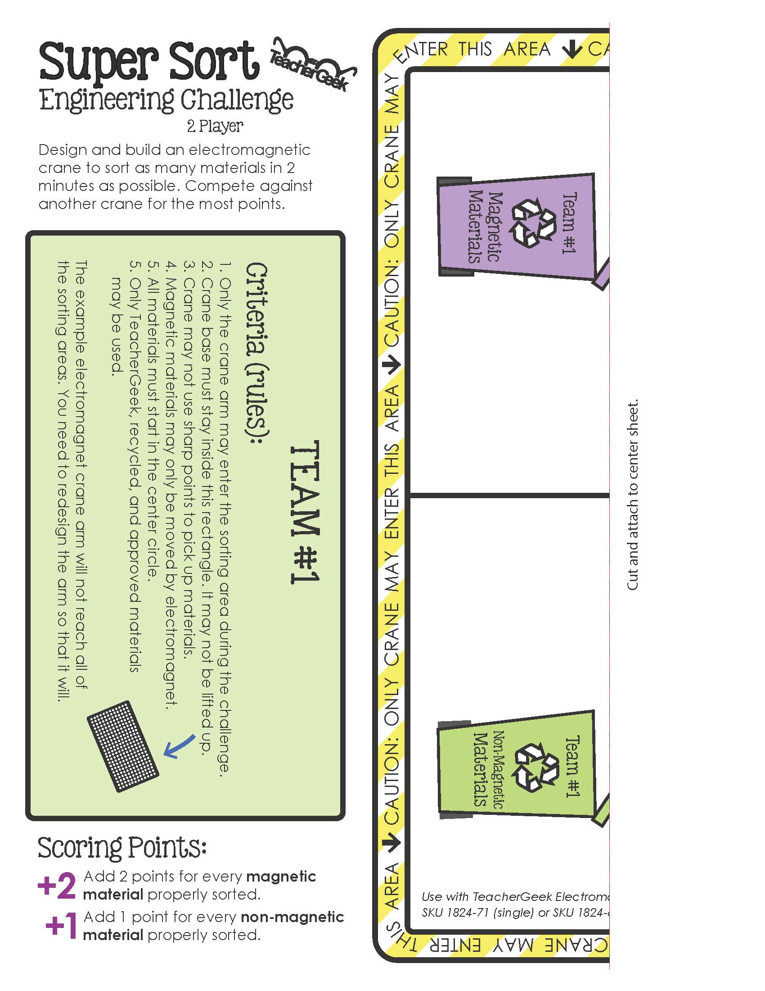

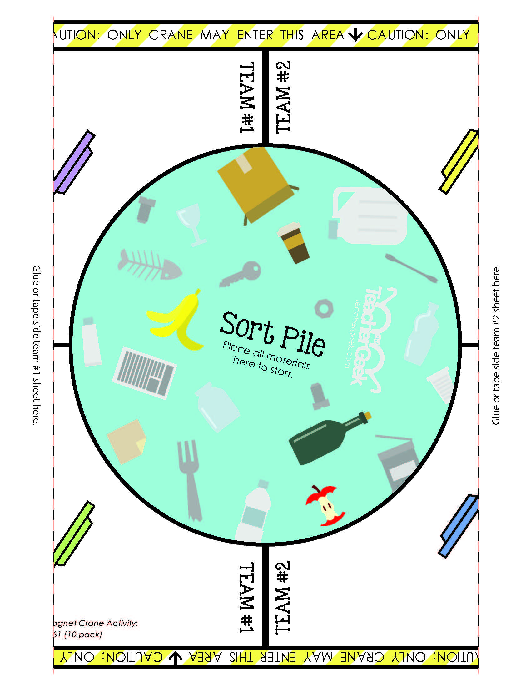

Class: \_\_\_\_\_\_\_\_\_\_\_\_\_\_\_\_\_\_\_\_\_\_\_\_\_\_\_\_\_\_\_\_\_\_\_\_\_\_\_\_\_\_\_\_\_\_\_\_\_\_\_\_\_\_\_   
Set: \_\_\_\_\_\_\_\_\_\_\_\_\_\_\_\_\_\_\_\_\_\_\_\_\_\_\_\_\_\_\_\_\_\_\_\_\_\_\_\_\_\_\_\_\_\_\_\_\_\_\_\_\_\_\_\_\_

**Points Scored**

|  |  |  |  |  |  |  |  |  |  |  |
| --- | --- | --- | --- | --- | --- | --- | --- | --- | --- | --- |
| Group Names | Design  #1 | Design  #2 | Design  #3 | Design  #4 | Design  #5 | Design  #6 | Design  #7 | Design  #8 | Design  #9 | Design #10 |
|  |  |  |  |  |  |  |  |  |  |  |
|  |  |  |  |  |  |  |  |  |  |  |
|  |  |  |  |  |  |  |  |  |  |  |
|  |  |  |  |  |  |  |  |  |  |  |
|  |  |  |  |  |  |  |  |  |  |  |
|  |  |  |  |  |  |  |  |  |  |  |
|  |  |  |  |  |  |  |  |  |  |  |
|  |  |  |  |  |  |  |  |  |  |  |
|  |  |  |  |  |  |  |  |  |  |  |