**Adult supervision required. Not a toy. Educational product.**

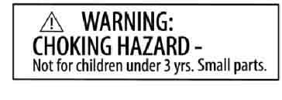

**Warning: To avoid danger of suffocation, keep enclosed bags away from babies and children. Do not use in cribs, beds, carriages, or playpens.**

**Get set up to test your bridge! You can test destructively or non-destructively.**

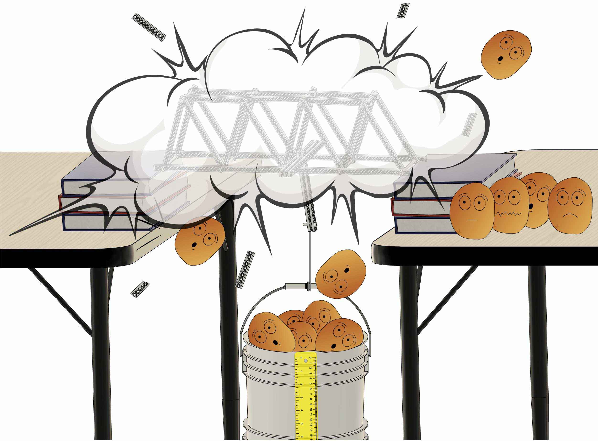



Visit [**teachergeek.com/bridges**](https://teachergeek.com/bridges)for more documents and info.

**Test bridges with everyday supplies…**

**…Or build a wooden station!**

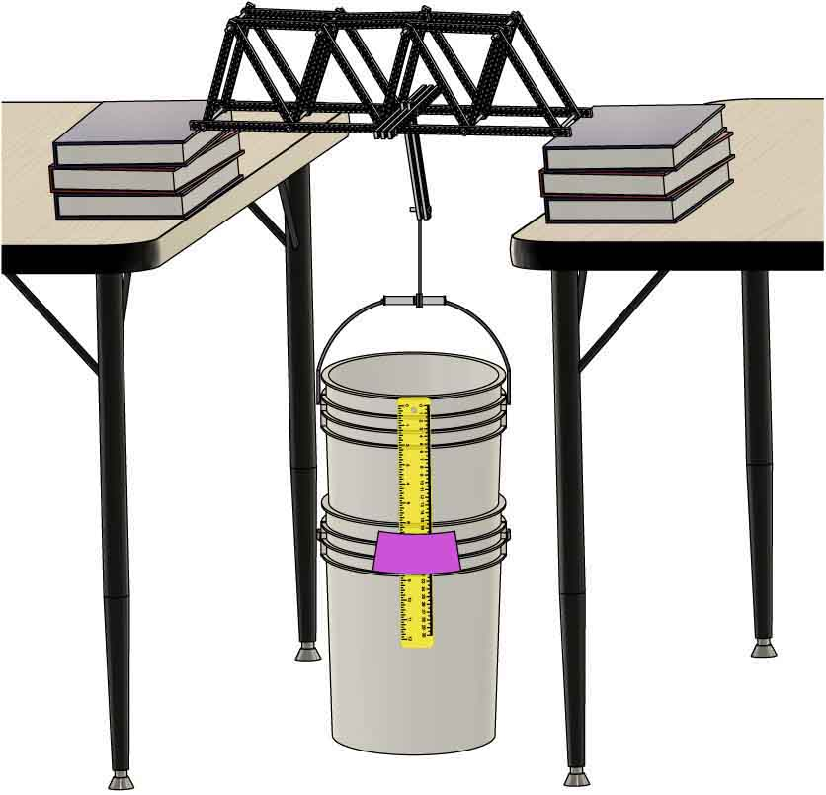

Build a hook to attach weights to your bridge.

Use tables and books as abutments to support your bridge.

*(Optional)*

Nested buckets prevent spilling weights and give a softer landing if a bridge fails.

*(Optional)*  
Use a ruler to measure bridge deflection.

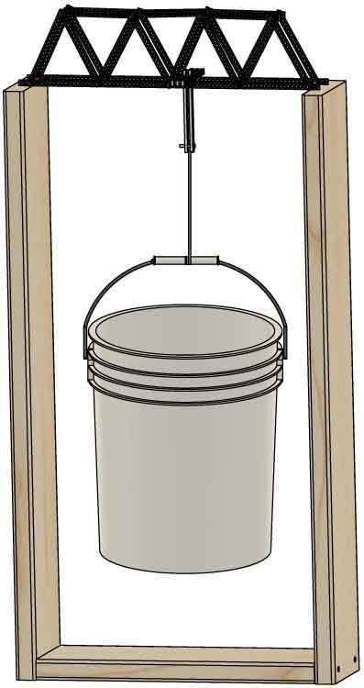



Other Supplies

TeacherGeek Parts

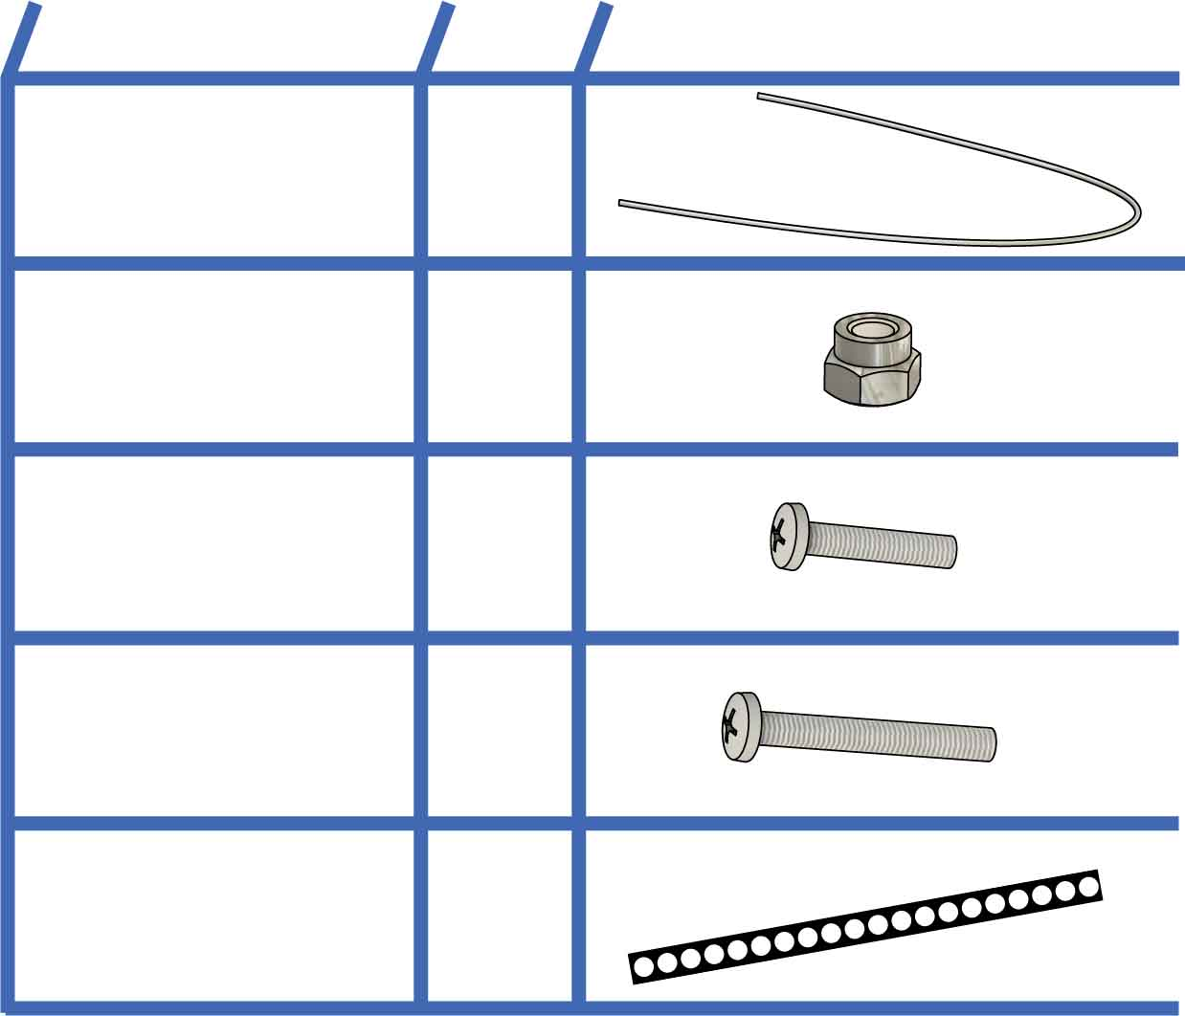

**1**

**17ga. Wire**46cm (18in.)

**NAME**

**QTY**

**PICTURE**

**Half Strips**15cm (6 in.)  
SKU 1821-31

**5**

Half strips can be made by cutting a full 30cm (12in.) strip in half.

**2**

**Short Screws**

25mm(1 in.) #10  
SKU 1821-22

**#10 Lock Nut**  
SKU 1821-26

**2**

**Long Screws**38mm(1½ in.) #10  
SKU 1821-23

**1**

* **2 Buckets** (5 or 7 gal.)
* **30+ lb. of Weights**(potatoes, water bottles, etc.)
* **Tables & Books  
   OR  
  2x8** (12ft.) **& Screws** (3in.)
* **Tape**
* **Safety Glasses**
* **Scale** (optional)
* **Ruler** (optional)

Get extra-large   
7-gallon buckets at

**[teachergeek.com](http://teachergeek.com/products/7-gal-bridge-bucket)**

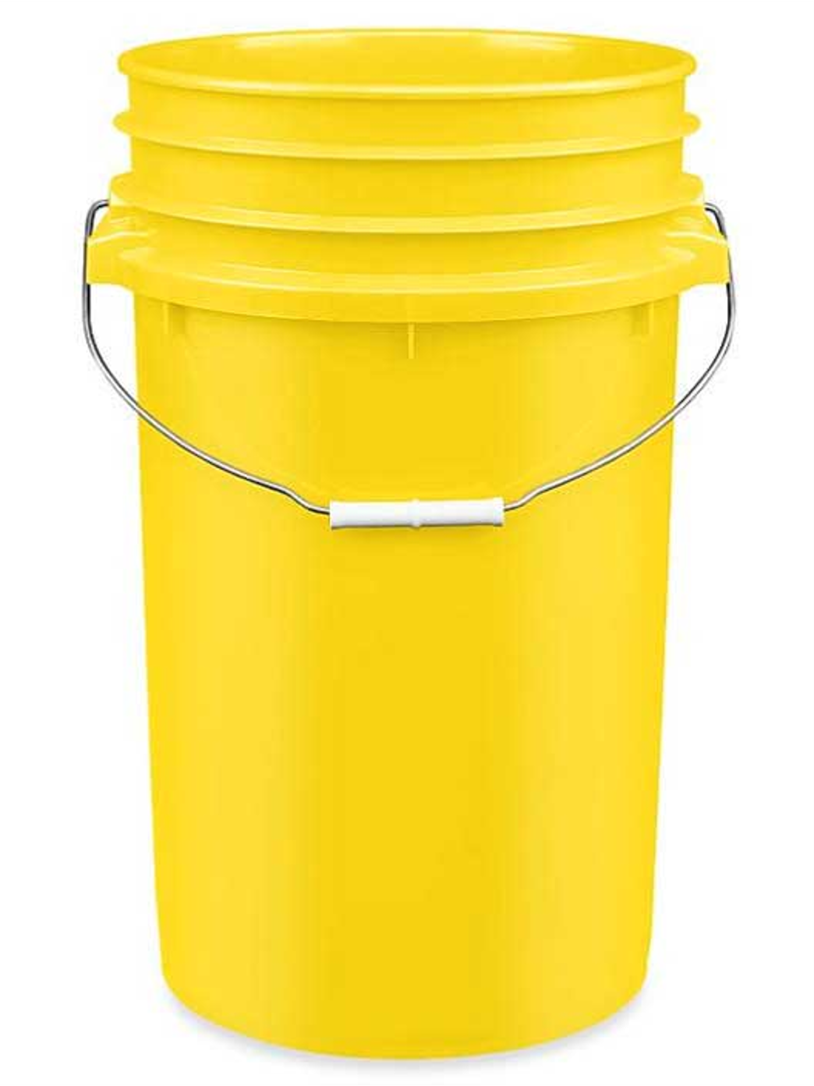

**Need to hold more weight?**

TeacherGeek Tools

**Phillips Screwdriver**

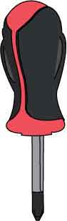

**Pliers**

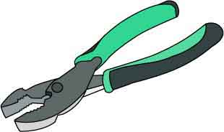

**Multi-Cutter**(for making half strips)

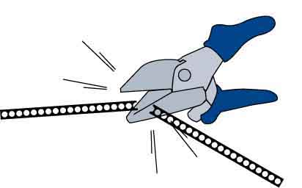

No design is perfect



Build abutments to support bridges during testing. You can make “Table Abutments” with common supplies or “Wooden Abutments” with lumber and deck screws (not provided).

**WHAT ABUTMENTS WILL YOU CHOOSE?**



**OR**

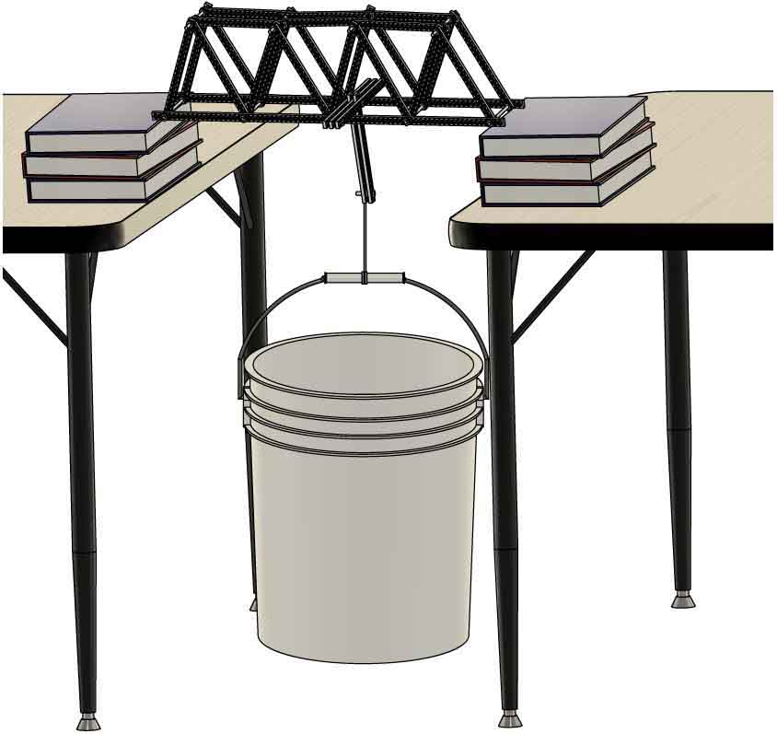

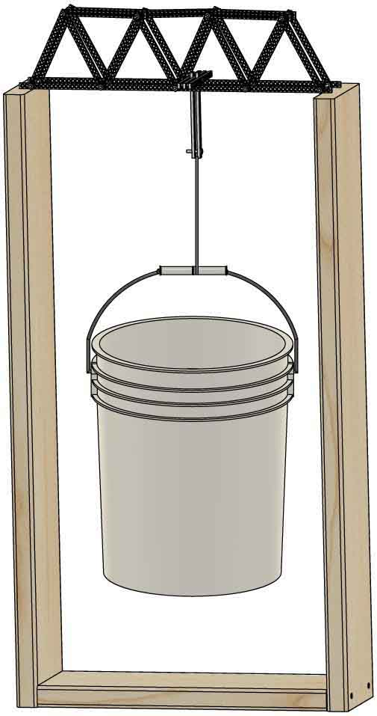

Optional   
brace is   
60.1cm  
(23½ in.)  
 long

**Arrange tables and books using** the **measurements** below**.**

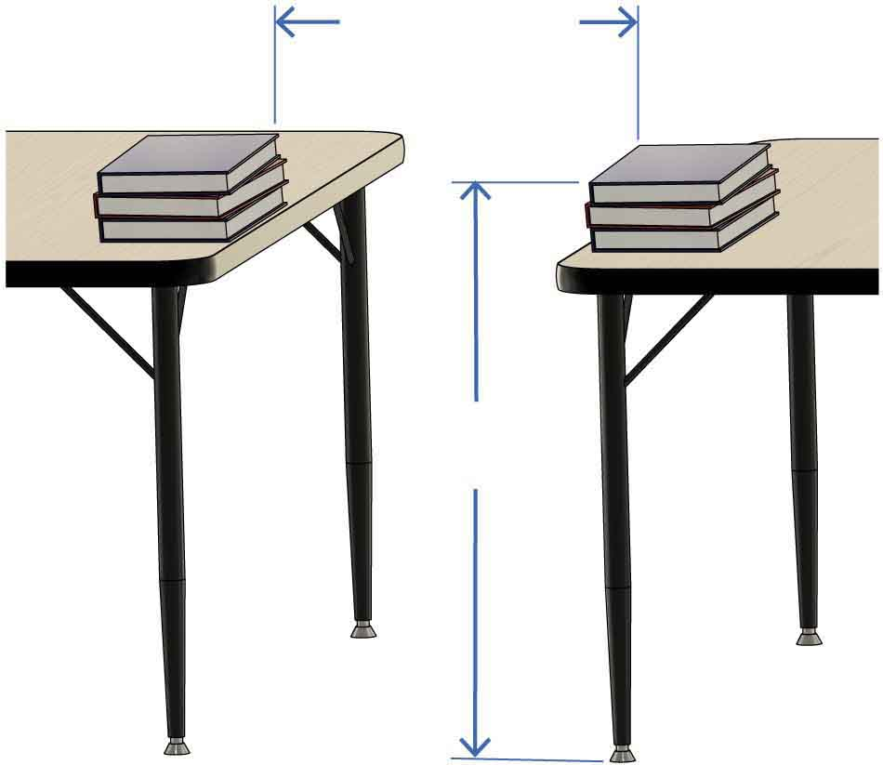

**Build** abutments **using** the **measurements** **below**.

**H**

**H** depends on   
your bucket sizes.

**5 gal**.: H=**105cm**   
 (42in.)  
**7 gal**.: H=**120cm**  (47in.)

**52.5cm**(20½in.)

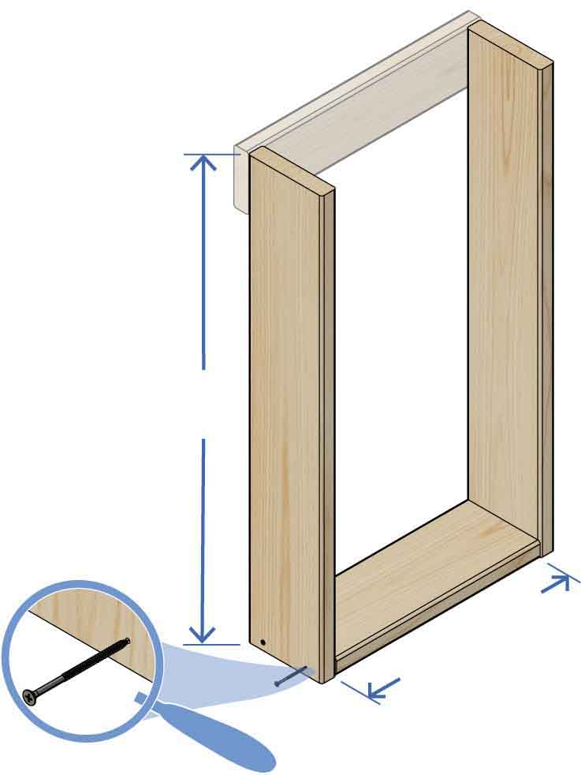

**L**

**52.5cm**(20½in.)

**L** depends on   
your bucket sizes.

**5 gal**.: L=**110cm**   
 (43½in.)  
**7 gal**.: L=**125cm**  (49½in.)

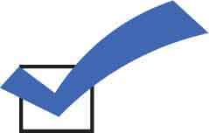

**Your abutments are done!**



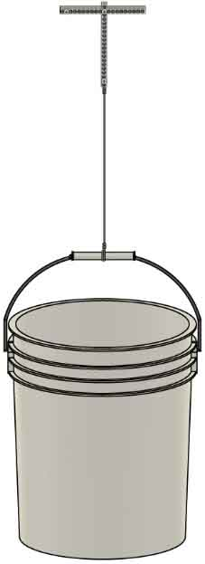

**It’s time to build a weight hanger! To test your bridge, you will hang this from your bridge and load it with weights.**

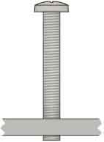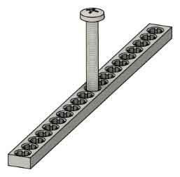

Drivea **long screw near** the **middle** ofa **half strip** so the screw **barely protrudes.**

Barely protrudes

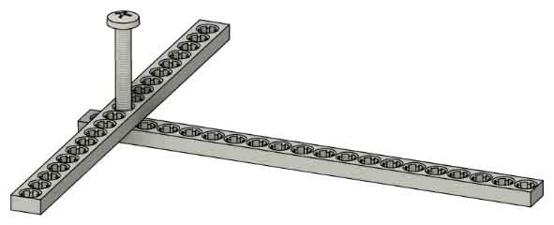

**Screw on** a **second half strip,**as shown.





**Twist two lock nuts onto the ends of the two screws**, as shown.

**Screw on** **three** **more** **half** **strips, then add** **two** **short** **screws**.

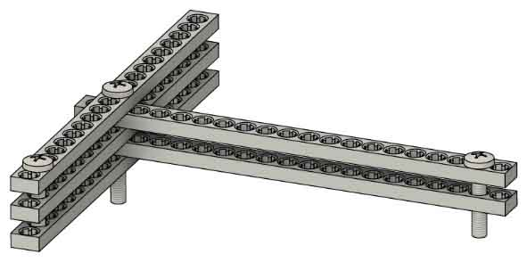

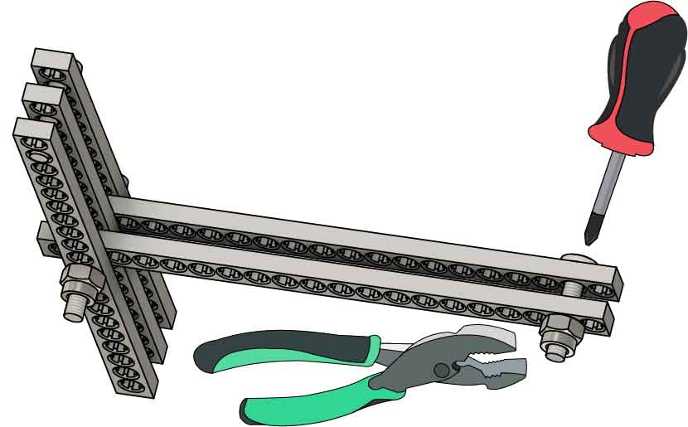

**Then twist** the **wire around itself.**

**Twist** the **wire twice around the handle.**

**Attach** the **hook** **to** the **bucket** so there is **17cm** (7in.) **of** **wire** **between** them.

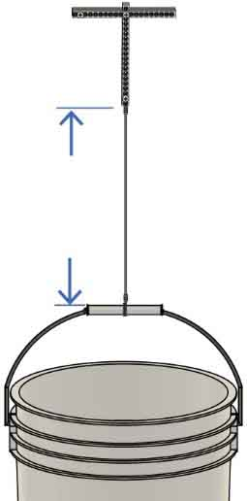

**17cm**(7 in.)

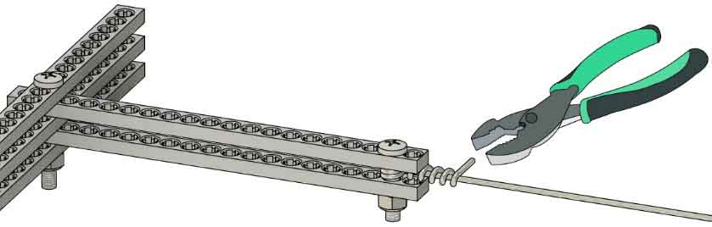

**Twist 17 ga. wire twice** **around** the **screw using pliers**.

**Then twist** the **wire** **around** **itself.**

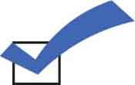

**Your weight hanger is ready** for testing! Read on to make it even better.



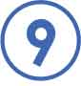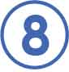

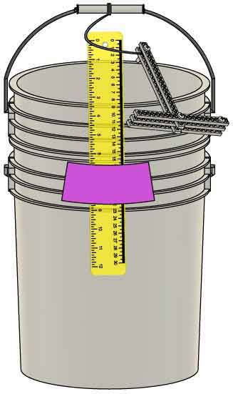

Taped to bottom bucket

**Tape** a **ruler**   
**to** the **bottom** **bucket**.

**Put** the **bucket** from Step 7 **into** another **bucket**.

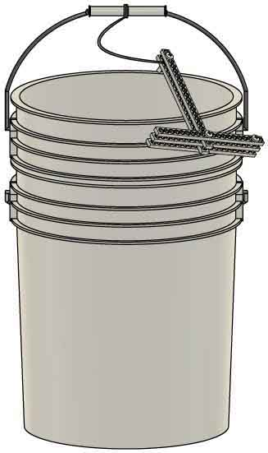

**Non-destructive testing is a great tool to find weaknesses in bridge design. By measuring deflection, you can evaluate bridges without breaking them (that comes next).**

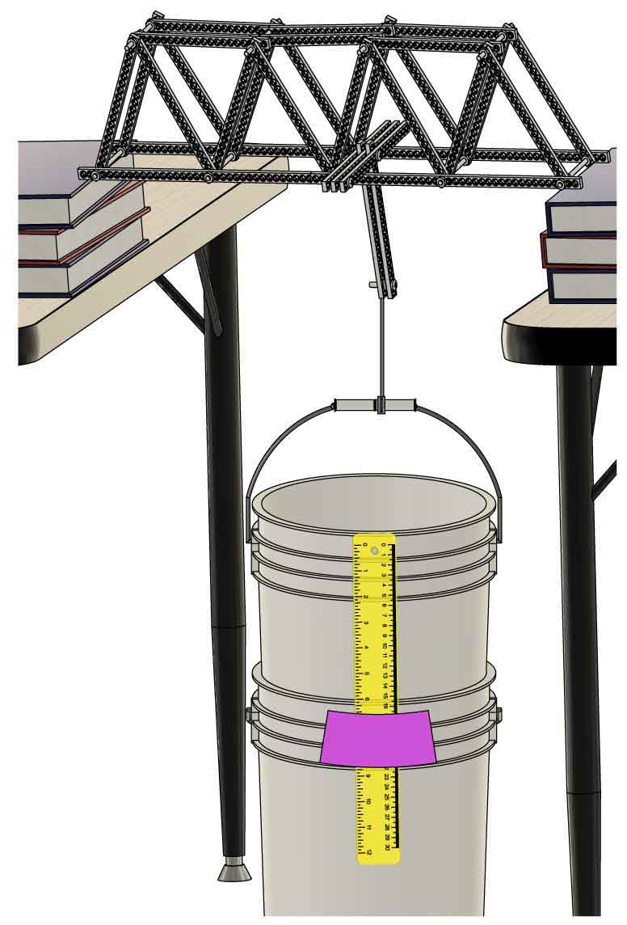

**Set** a **bridge on** the **abutments, then add** the **hook** near the middle of the bridge.

Hanging   
by wire

**Hook**



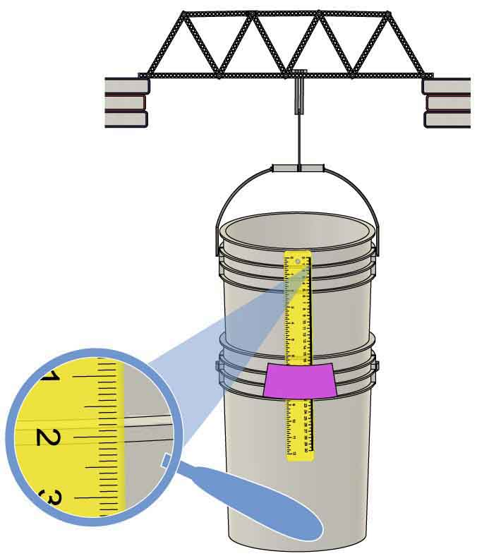

The rib of this bucket lines up with the 2cm mark.

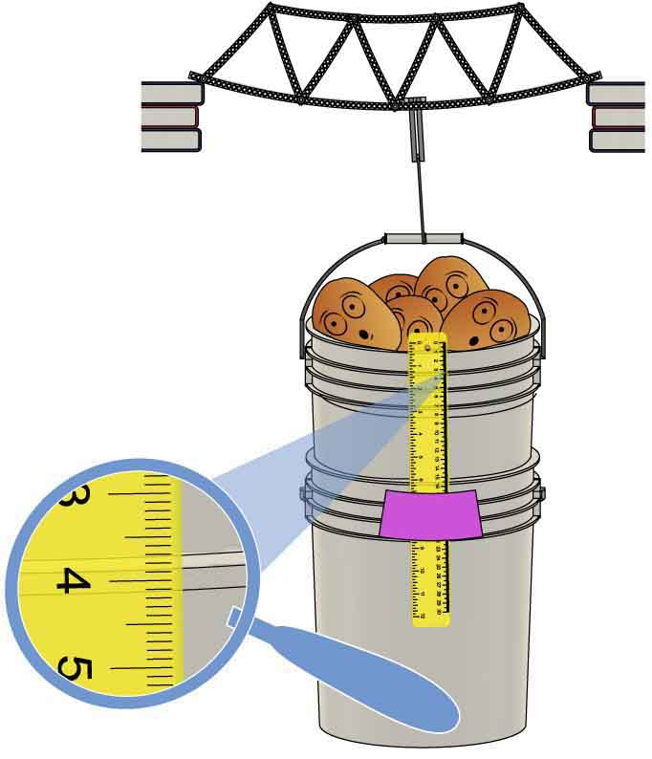

The rib has moved down 2cm on the ruler.

**Add** **weight** **to** the **bucket** until the upper bucket moves down 2cm on the ruler.



Sitting on ground

**Potatoes or Water Bottles**

We like potatoes because they are cheap and fun. Water bottles are cheaper, yet. Use a scale or count them to measure weight.

**Weights**

**What’s in your bucket?**

As you test, you need to add weights to your bucket, and you need to have a way to measure the total weight. Here are some ideas for weights.

**Water or Sand**

Water and sand allow you to measure the height of the material and extend learning with volume/density calculations. Use two buckets (see Step 7) to help avoid spills.

**Other Ideas**

Stones. Metal parts. Oranges. Anything dense and cheap can be used as weights. You want weights that can be added in small increments, not in huge chunks.



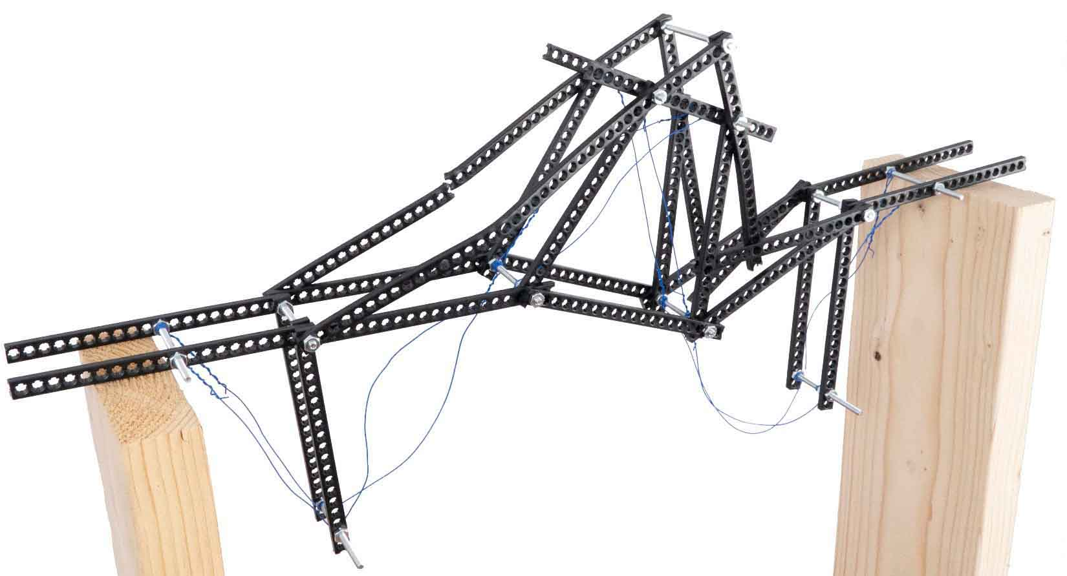

**Are you ready to break a bridge? Realize that some bridge members will permanently break and will need to be replaced if you plan on fixing the bridge after this test.**

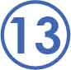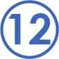[](http://teachergeek.com/bridges)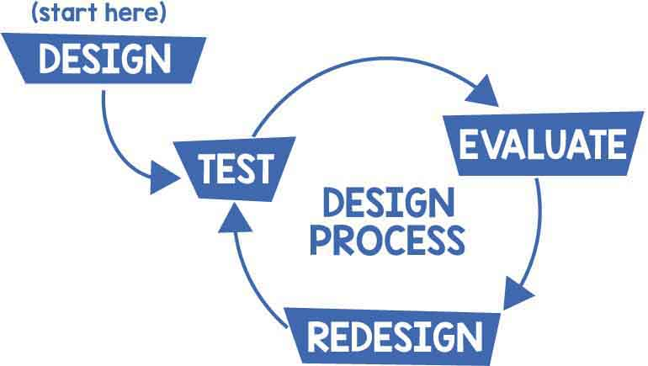

**Add** **weights** to the bucket **until** the **bridge** **breaks!**

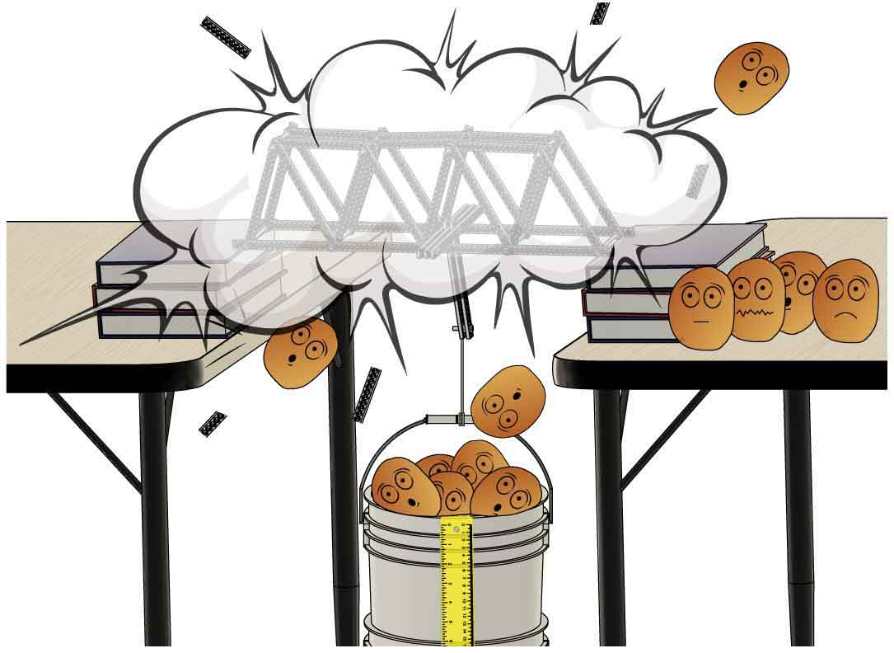

**Set** **up** **the** **bridge** as you did in non-destructive testing.

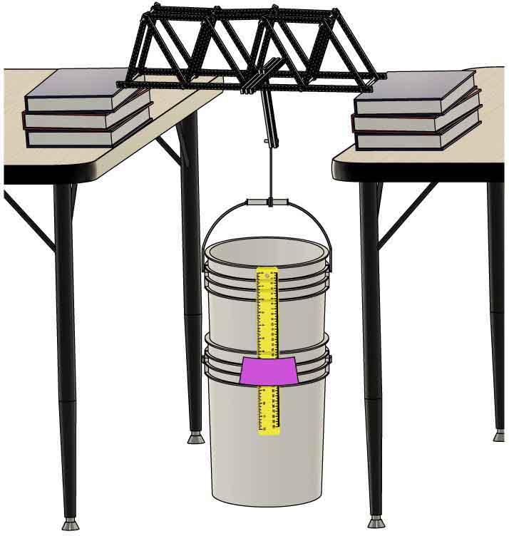

Using two buckets makes the landing softer when bridges break.

Want to bring mathematics into your testing? Before your break your bridge, check out the optional   
[**Hooke’s Law Lab**](http://teachergeek.org/breaking_bridges_hookes_law_lab_v1.0.docx).

Documents available at [**teachergeek.com/bridges**](http://teachergeek.com/bridges)

Done with testing? Redesign stronger bridges! The Design Process never ends – there is no perfect design.