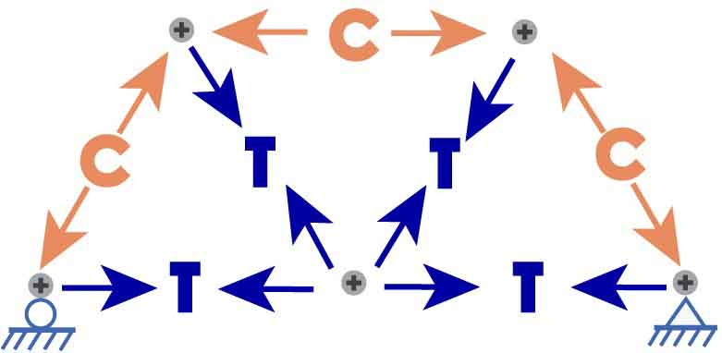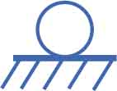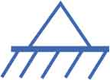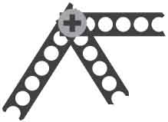

**What does the MD Solids software tell you about your truss?**

**Member Forces**

The MD Solids software will calculate your truss’s reaction forces and member forces. Bridges fail when member forces get too large.

**Reaction Forces**

When your bridge carries a load, it transfers the force of the load to the abutments. As the bridge pushes down on the abutments, the abutments push back – this is called a Reaction Force.

**Load**(weight pulling   
bridge)

**Reaction force** (abutment pushing bridge)

**Reaction force** (abutment pushing bridge)

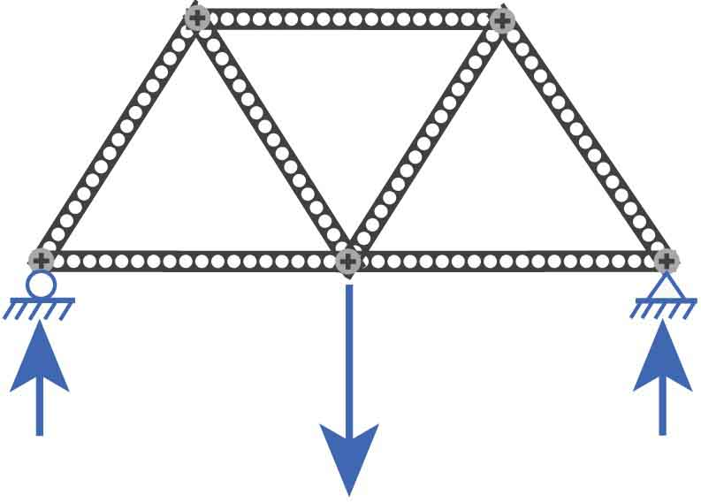

Member forces *within* the truss transfer the load through the bridge to the abutments. Each joint of the truss experiences forces from members that are in **T**ension or **C**ompression.

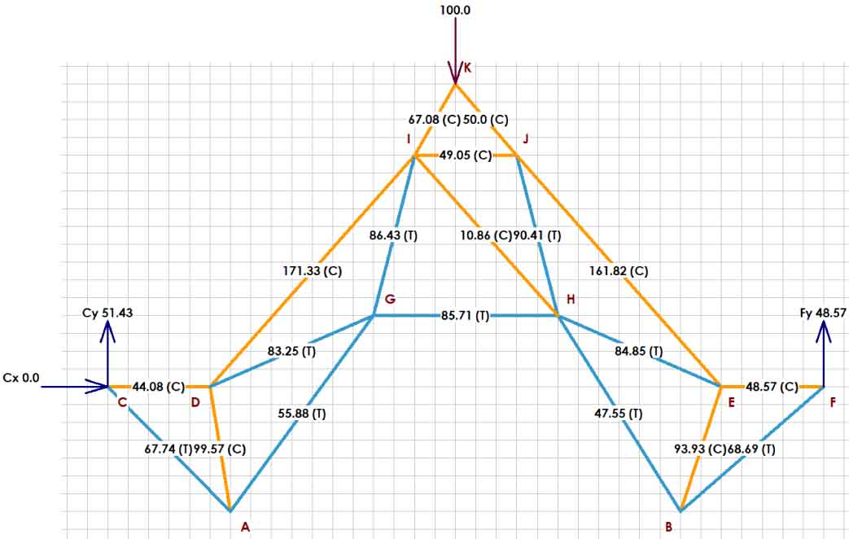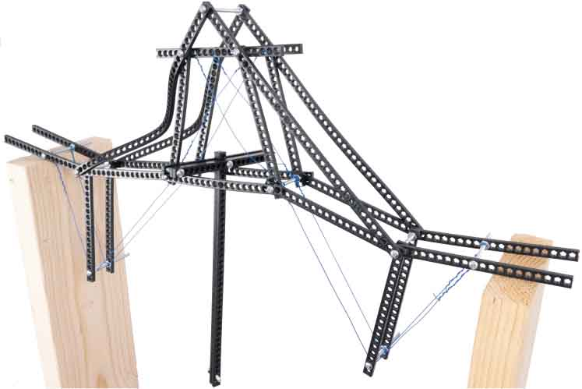

**Make your bridge stronger by using software to find the weakest members!**

**This activity requires:**

* Breaking Bridges Kit
* PC with MD Solids installed (free at [web.mst.edu/~mdsolids](https://web.mst.edu/~mdsolids/))
* Breaking Bridges Design Grid (free at [teachergeek.com/bridges](https://teachergeek.com/bridges))

**Name: ______________________________________________________ Date: _________________**

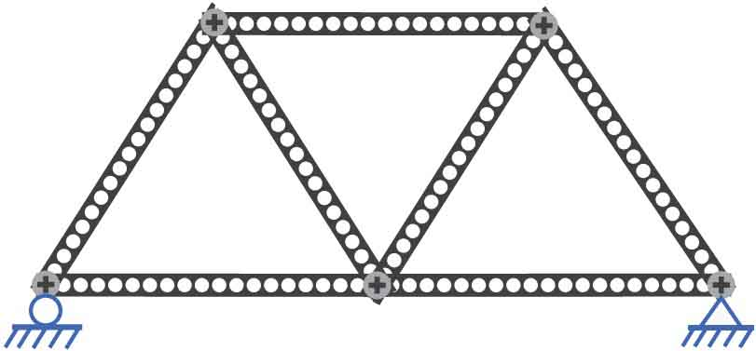

?

?

✔

This truss **CAN** be modeled in MD Solids! It’s statically determinate.

**Example 1:**

This bottom strip has a joint in the middle, so it counts as two members.

$1$**Force**

Roller Support

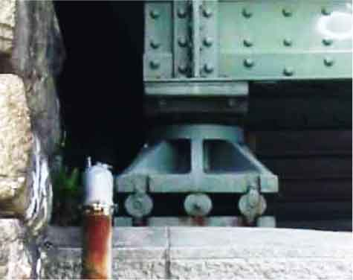

Roller supports let the bridge move horizontally, so they only provide one vertical reaction force.

MD Solids will require you to add supports, which allow a bridge to move slightly on its abutments. Bridges must move as they expand and contract from changing loads and temperatures.

$2$**Forces**

Pin Support

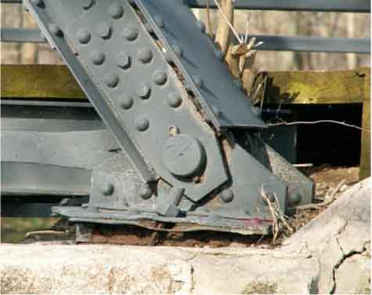

Pin supports provide two reaction forces – one horizontal and one vertical.

**#of possible reaction   
forces**

**#of members**



**#of joints**

**#of joints**

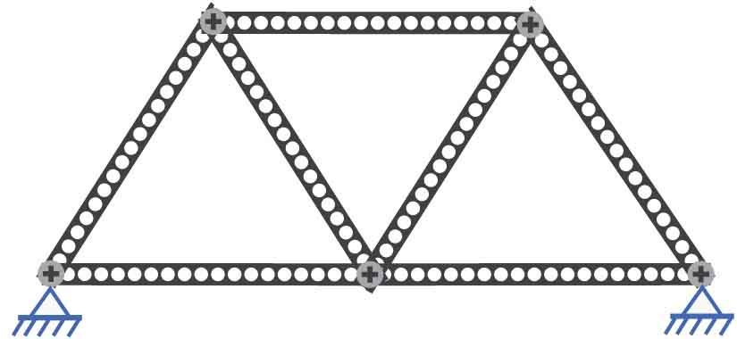

**Ate $2j=m+r$** ?

$2\left(5\right)=7+4$?

$10≠11$**X**

This truss **CANNOT** be modeled in MD Solids! It’s NOT statically determinate.

**Example 2:**

$$2j=m+r$$

**Can MD Solids model your truss?**

The MD Solids software only works ifyour truss is statically determinate (can be solved with basic “laws” of physics). For a truss to be statically determinant, the equation below must be true:





You need the [**Design Grid**](http://teachergeek.org/breaking_bridges_design_grid_v1.0.docx) to model your truss in MD Solids.

Documents available at [**teachergeek.com/bridges**](http://teachergeek.com/bridges)

**Build a truss to model!**



**Sheet  
A**

**Sheet  
B**

**Sheet  
C**

**Sheet  
D**

**Sheet  
E**

**Sheet  
F**

Cut and **assemble** **your** **Design Grid**, as shown.



**Lay** **your** **parts** **on** **the** **grid** **to** **design** **your** **truss**. Make sure your bridge is long enough – it must cross into the shaded abutment areas.

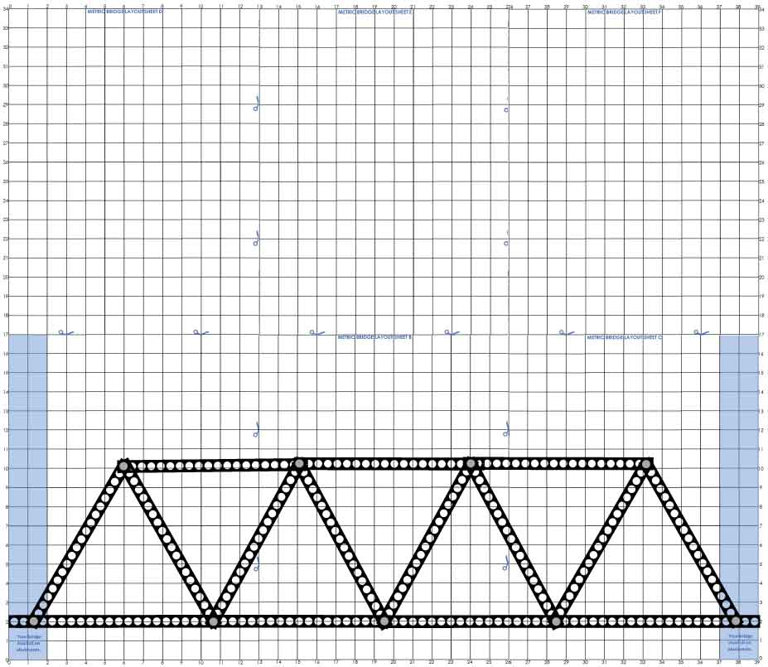

**Abutment areas**

**Make** **sure** your design can be modeled. It must be:

* **made** **of** **triangles**
* **statically** **determinate**   
  (**use r=3** for one pin and one roller support)



**Sketch** **your** **truss** on the grid and remove your parts.

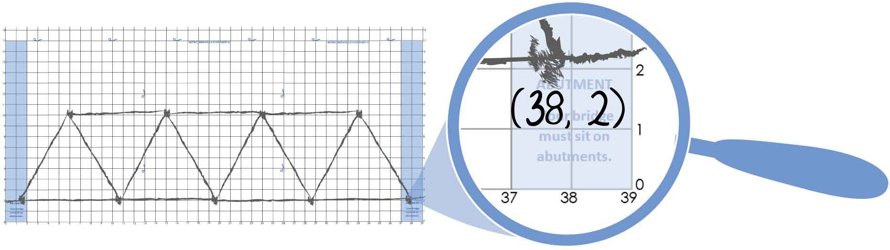

**Add** **coordinates** next **to** **each** **joint**. **Round** to the **nearest** **whole** **number**. MD Solids will need the coordinates.







Next **click** **“New Truss.”**

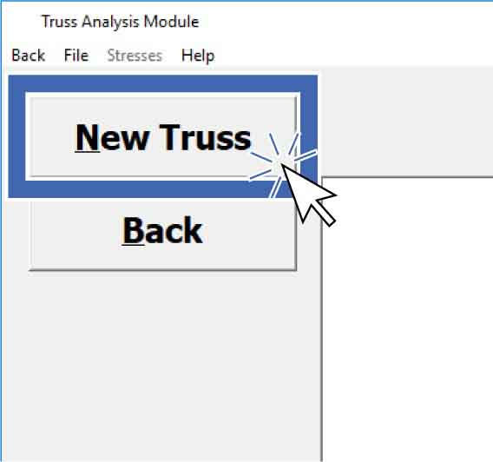

**Make your truss in MD Solids!**

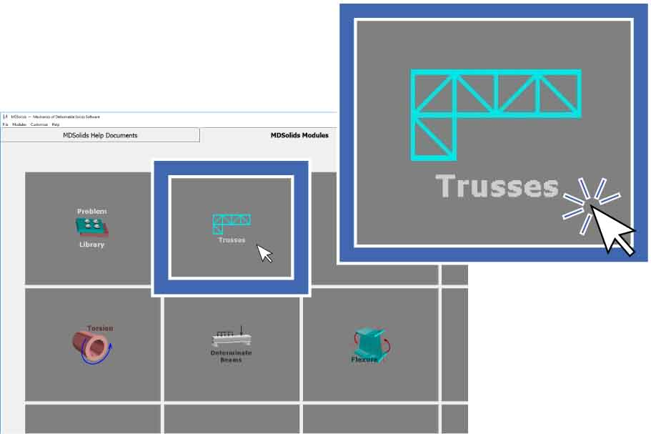

**Open** **MD** **Solids**. **Click** on **“Trusses.”**



Get ready to add members – **click** “**Create**” **and** “**Members**” in   
 the left panel.

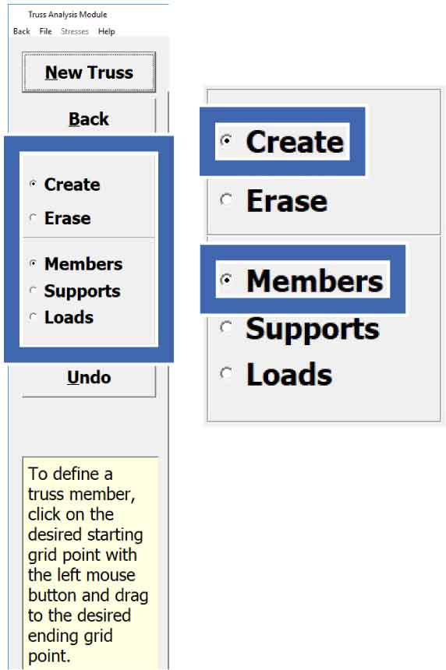

**Set** **the** **intervals** **and** **spacing** as shown.



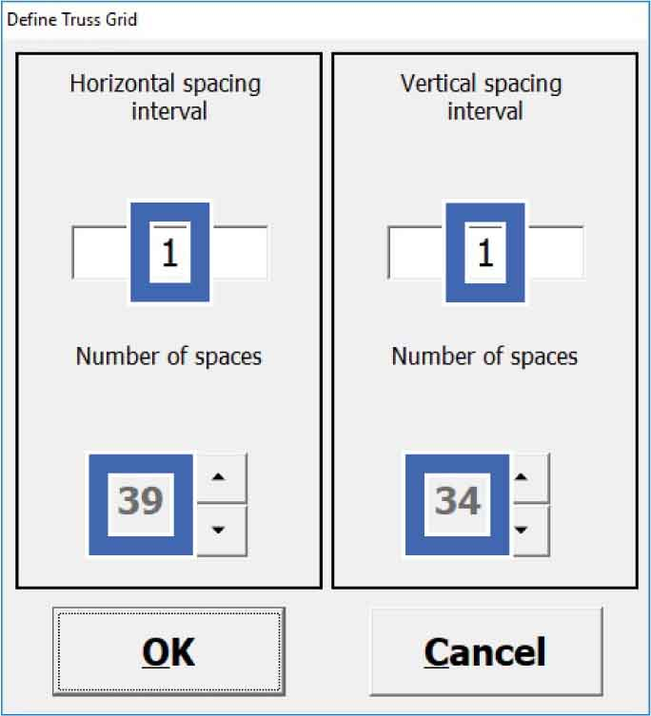

Instructions will appear as you select different options on the left panel.

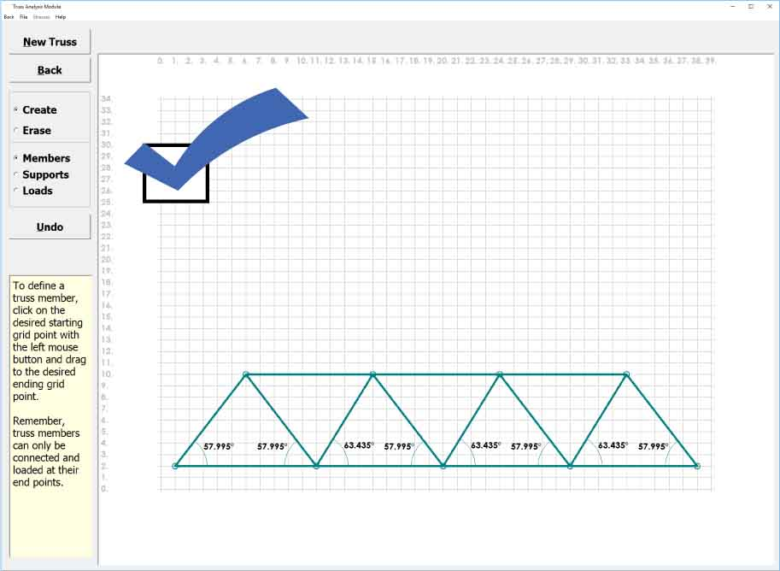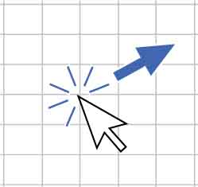

To create your truss, **click** **and** **drag** **from joint to joint**. Use the coordinates from your grid.

**Your truss is done! Now it’s time to add supports.**

Need to erase a member?Select “Erase,”   
then click   
and drag   
from one   
endpoint to another.

**Tip**

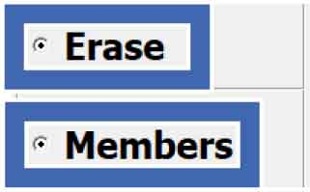



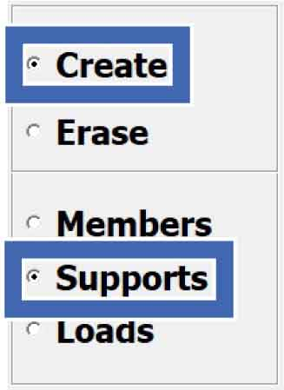

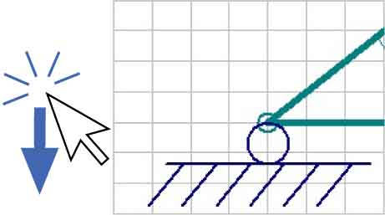

To **add** a **roller** **support**, **click** **and** **drag** **vertically** on a joint that will rest on an abutment.

Prepare to add supports by **selecting** “**Create**” and “**Supports**.”





**Create** **a** **roller** **support** **at the other joint** where your bridge will contact an abutment. It is ok if your supports appear upside down.

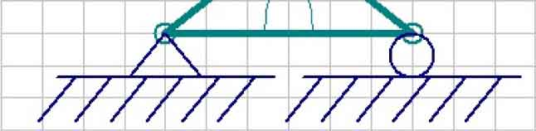



**Make** **a** **pin** **support** by **clicking and dragging horizontally** on   
**the roller**. It is ok if   
the pin appears   
sideways.

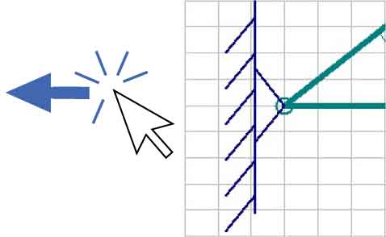





**To add a load:**

* **Select** **“Create”** and **“Loads.”**
* **Click** **and** **drag** **down** at the joint closest to the middle.
* Use a “**Load Magnitude” of 100.**

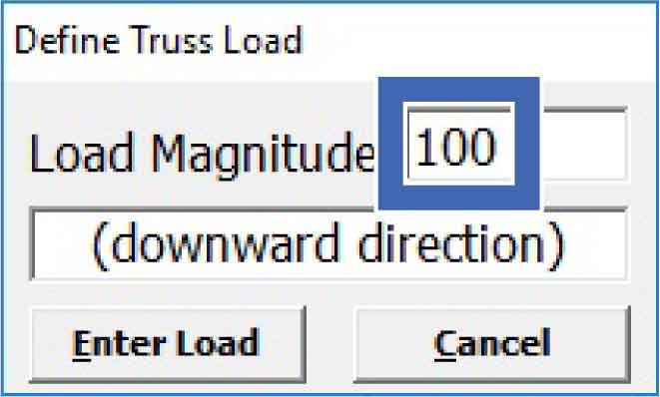

**Click “Stresses”** at the top to view the member forces in a table.

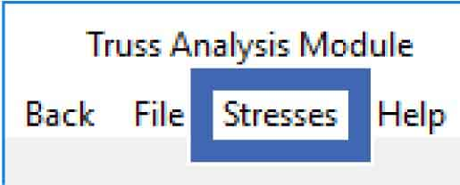

**Click** **“Compute.”**

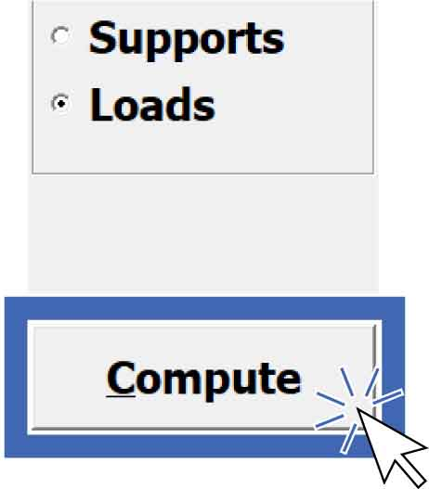

**Save** **your** **truss** as a **.**dat file so you can access it later.

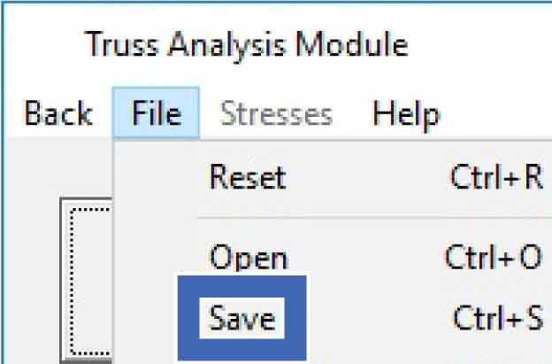

**Click “Print”** to print the table and diagram.

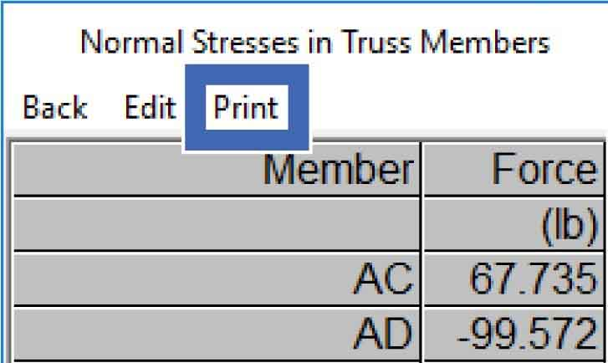

Positive forces are tension.

Negative forces are compression.

Disregard the units. Think of the member forces as a percent of your total load (100).



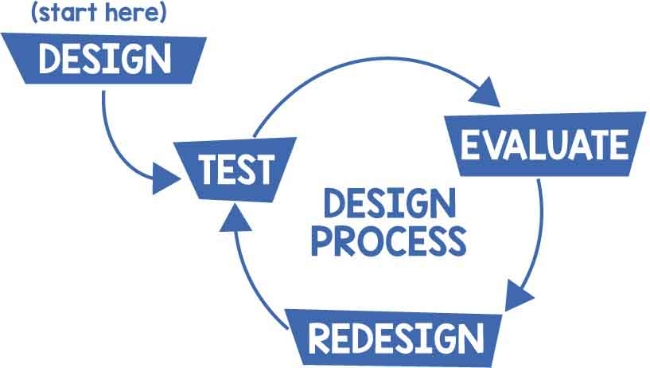

**Keep refining your design in MD Solids, then build it for real!**

**Move joints!**

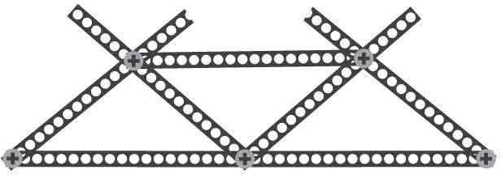

**Reinforce it!**

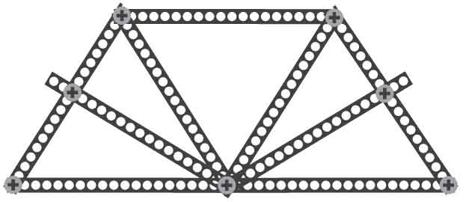

Find out how the software works with the   
[**Physics Analysis Activity**](http://teachergeek.org/breaking_bridges_physics_analysis_v1.0.docx)!

Documents available at [**teachergeek.com/bridges**](http://teachergeek.com/bridges)

**Explore entirely different designs!**

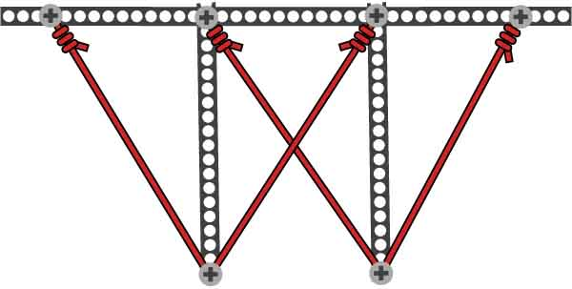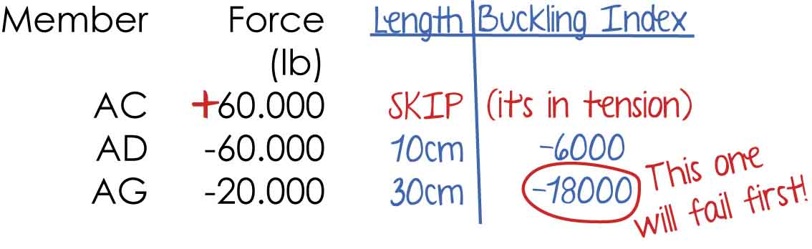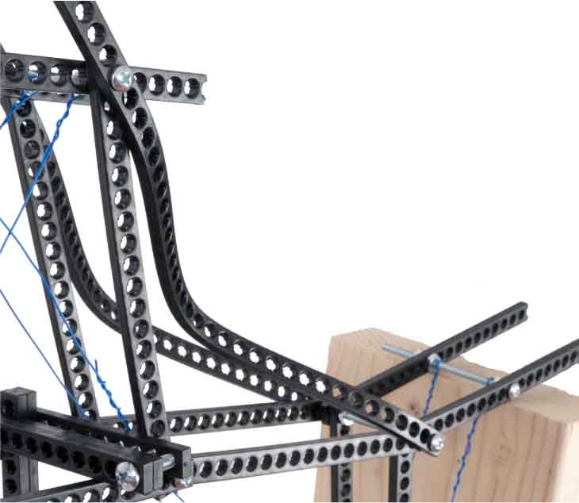

Members usually fail more readily in compression than in tension. This is because members in compression can *buckle*, especially if they are long and thin.

To find the members most likely to buckle, multiply each member’s compressive force by the square of its length (you will have to measure it). This quantity has no official name, but it can be called the “buckling index.”

The greater the magnitude of the buckling index, the more likely a member is to buckle.

Find the buckling index for your bridge’s compression members to see where you need to reinforce your bridge!

**Buckling**

Two members on this bridge are buckling in compression. They will cause this bridge to fail.

$B=FL^{2}$**,** where

$B$ is the **buckling index $F$** is **member force $L$** is the **member length**

**Example:**

BUCKLE UP!

OPTIONAL

**Don’t let buckling break your bridge!**