[](http://teachergeek.com/bridges)

**Are you ready to calculate the member forces for a truss? You need a solid understanding of static equilibrium, forces, torques, and basic trig.**

This activity is designed to follow [**Software Analysis**](http://teachergeek.org/breaking_bridges_software_analysis_v1.0.docx).

Documents available at [**teachergeek.com/bridges**](http://teachergeek.com/bridges)



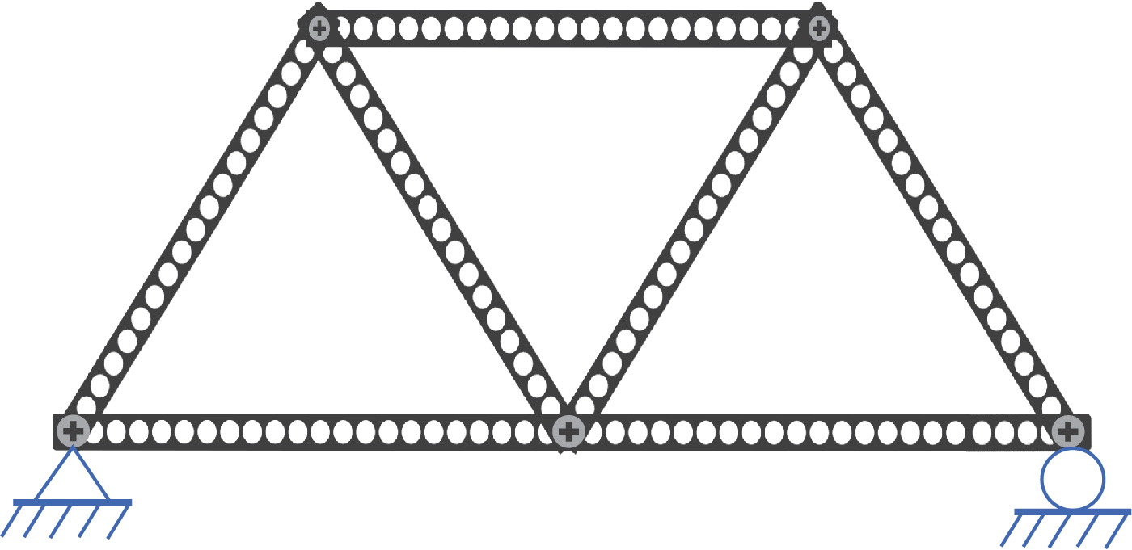

**Follow the example, then calculate the member forces of your truss!**

**Make sure your design is statically determinate!** Otherwise, you will not be able to solve for all the forces in your design.

**Is it statically determinate?**

$m+r=2j$?

$7+3=2\left(5\right)$?

$10=10$ ✔

**Yes!**



$m$ is the number of members

$r$ is the number of reaction forces

$j$ is the number of joints

**Draw a free body diagram of the whole truss**, labeling all joints with capital letters, the lengths of all members, and all angle measures. **Add the reaction forces** at abutments, **and** **a load of 100N**. All external forces must be located at joints.



$R_{Ax}$ is the reaction force at Joint A in the x-direction.

$R_{Ay}$ is the reaction force at Joint A in the y-direction.

$R_{C}$ is the reaction force at Joint C. It is in the y-direction because it is from a roller abutment.

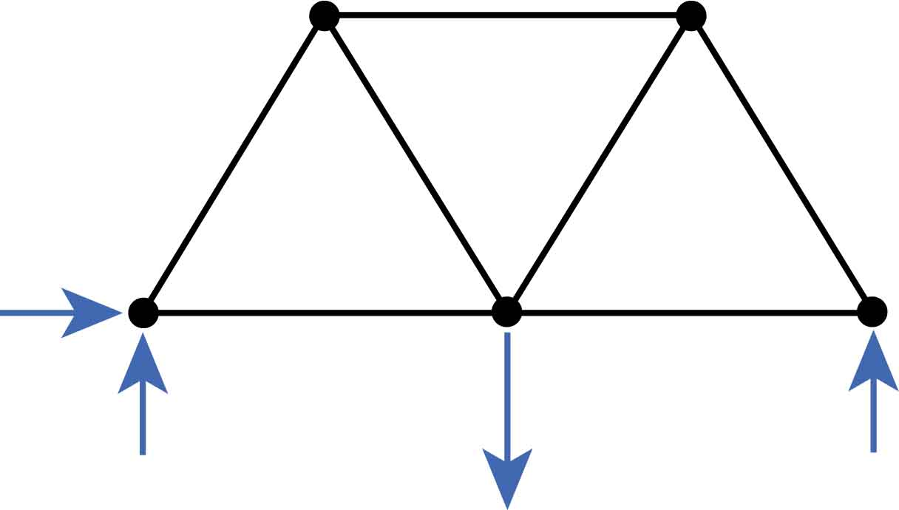

**A**

**B**

**C**

**D**

**E**

$$60°$$

$$60°$$

$$60°$$

$$60°$$

$$60°$$

$$60°$$

$$60°$$

$$60°$$

$$60°$$

$$0.135m$$

$$0.135m$$

$$0.135m$$

$$0.135m$$

$$0.135m$$

$$0.135m$$

$$0.135m$$

$$R_{Ax}$$

$$R_{Ay}$$

$$R_{C}$$

$$Load=100N$$

**Use the equations of static equilibrium to solve for the reaction forces**.



The sum of the forces is zero.

$$∑F=0$$

$$∑F_{x}=0$$

$$R_{Ax}=0$$

$$∑F_{y}=0$$

$$R_{Ay}+(50N)+\left(-100N\right)=0$$

$$R_{Ay}=50N$$

The sum of the torques (or moments) is zero.   
Use Joint A as the center of the torques.

$$∑τ=0$$

$$\left(0m\right)R_{Ax}+{(0m)R}_{Ay}+(0.135m)(-100N)+{(0.27m)R}_{C}=0$$

$$R_{c}=50N$$

**Choose a joint with the most information**. You need at least one known force on the joint. You can solve for up to two unknown forces.  
  
**Draw a free body diagram of this joint**. **Assume all unknown forces are** from **tension** members – they pull away from the joint. If you solve for the force and it is negative, then the assumption of tension was wrong, and the member exerting the force was under compression.

**Use the $∑F=0$ in the x and y directions to find the missing forces**, keeping in mind that downward and leftward forces are negative.



$AD$ is the force between joints A and D.

$AB$ is the force between joints A and B.

$$∑F_{y}=0$$

$$R_{Ay}+{AD}_{y}=0$$

$$50N+ADsin\left(60°\right)=0$$

$AD=-57.7N$ (Tension)

$AD=57.7N$ (Compression)

$$∑F_{x}=0$$

$${AD}_{x}+AB=0$$

$$\left(-57.7N\right)\cos\left(60°\right)+AB=0$$

$AB=28.9N$ (Tension)

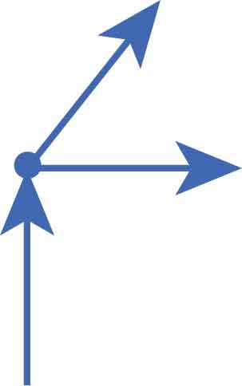

**A**

$$AB$$

$$AD$$

$$R_{Ay}=50N$$

$$60°$$

**Transfer your forces to a free body diagram for your truss**. Making a new diagram is recommended so the original doesn’t become too cluttered. You should include angles in your diagram if drawing a new one; measurements of members are not necessary.

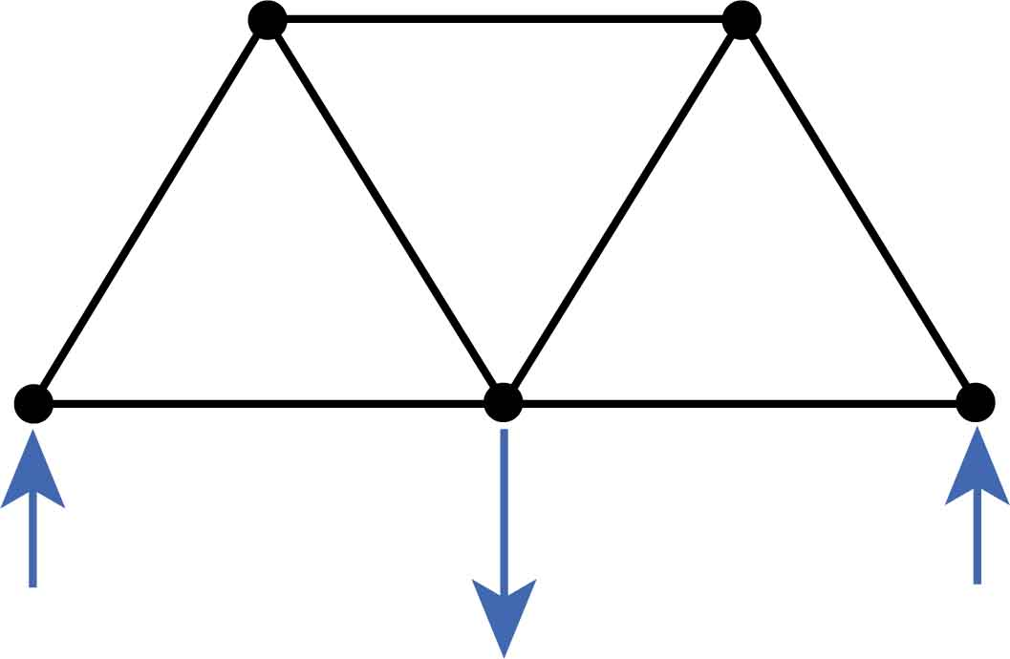

**A**

**B**

**C**

**D**

**E**

$$60°$$

$$60°$$

$$60°$$

$$60°$$

$$60°$$

$$60°$$

$$60°$$

$$60°$$

$$60°$$

$$R_{Ay}=50N$$

$$R_{C}=50N$$

$$Load=100N$$

$$57.7N (C)$$

$$28.9N (T)$$

**Finish the calculations for this truss on your own. The answers are on the next page.**

**Choose the next joint** with the most information **and repeat this process** until you have solved for all the forces!





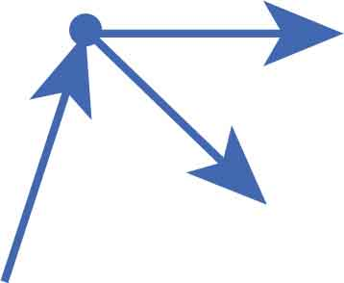

**D**

$$AD=57.7N (C)$$

$$DB$$

$$DE$$

$$60°$$

$$60°$$

$$60°$$

$$∑F_{y}=0$$

$${AD}_{y}+{DB}_{y}=0$$

$$(57.7N)sin(60°)+-DBsin\left(60°\right)=0$$

$DB=57.7N$ (Tension)

$$∑F_{x}=0$$

$${AD}_{x}+{DB}_{x}+DE=0$$

$$\left(57.7N\right)\cos\left(60°\right)+\left(57.7N\right)\cos\left(60°\right)+DE=0$$

$DE=-57.7N$ (Tension)

$DE=57.7$ (Compression)

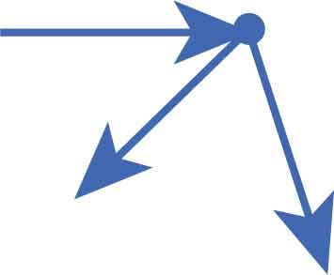

**E**



$$DE=57.7N(C)$$

$$EB$$

$$60°$$

$$60°$$

$$∑F_{x}=0$$

$$DE+{EB}_{x}+{EC}_{x}=0$$

$$\left(57.7N\right)-EBcos\left(60°\right)+ECcos(60°)=0$$

$$EB=115.4N+EC$$

$$∑F_{y}=0$$

$${EB}_{y}+{EC}_{y}=0$$

$$-EBsin\left(60°\right)-ECsin(60°)=0$$

$$-(115.4N+EC)sin\left(60°\right)-ECsin(60°)=0$$

$EC=-57.7N$ (Tension)

$EC=57.7N$ (Compression)

$$EB=115.4N+EC$$

$$EB=115.4N+\left(-57.7N\right)$$

$EB=57.7N$ (Tension)



$$∑F_{x}=0$$

$$-28.9N+\left(-57.7N\right)\cos\left(60°\right)+\left(57.7N\right)\cos\left(60°\right)+BC=0$$

$BC=28.9N$ (Tension)

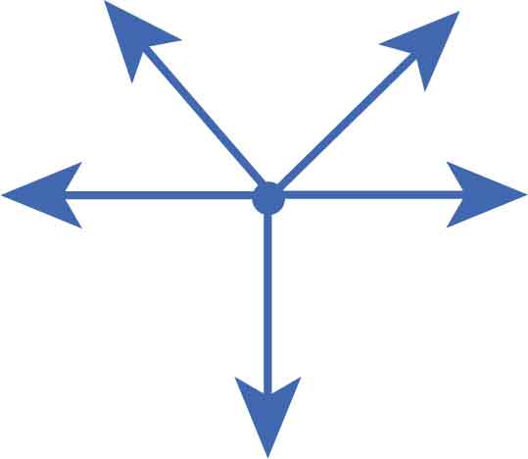

**B**



$$BC$$

$$EB=57.7N (T)$$

$$Load=100N$$

$$AB=28.9N (T)$$

$$60°$$

$$60°$$

$$60°$$

$$DB=57.7N (T)$$

**A**

**B**

**C**

**D**

**E**



$$60°$$

$$60°$$

$$60°$$

$$60°$$

$$60°$$

$$60°$$

$$60°$$

$$60°$$

$$60°$$

$$R_{Ay}=50N$$

$$R_{C}=50N$$

$$Load=100N$$

$$57.7N (C)$$

$$28.9N (T)$$

$$57.7N (C)$$

$$57.7N (T)$$

$$57.7N (T)$$

$$28.9N (T)$$

$$57.7N (C)$$

**Now calculate the member forces for *your* truss!**