6-12+ version available at teachergeek.com/bridges
Grades
3-5

Getting Started
At TeacherGeek, we strive to make our activities as simple as possible for you to implement, while giving you the flexibility to cater the activity to your class. All of our documents are available on our website, TeacherGeek.com, in both PDF and Microsoft Word so that you can customize them and make them your own!

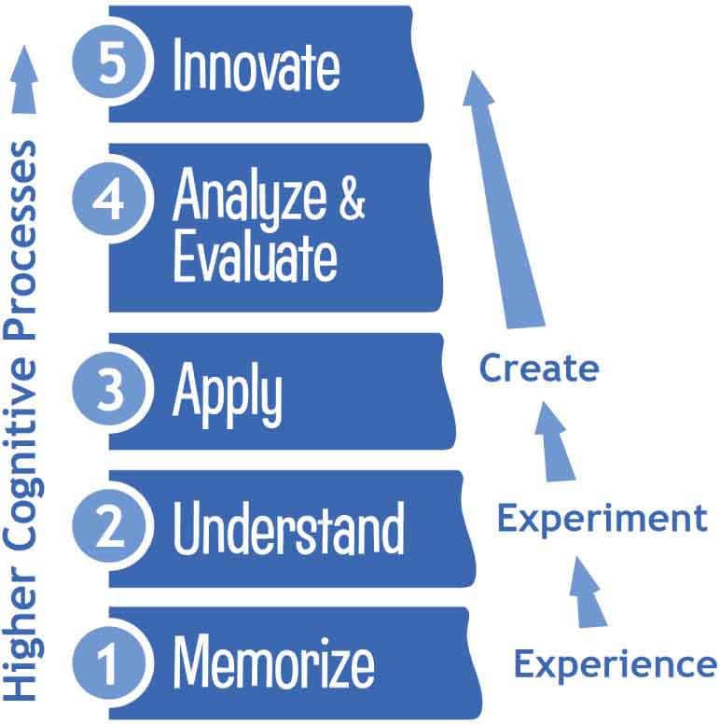
Standards
Go Guide
NGSS p. 2
CCSS Math p. 3-4
CCSS ELA p. 4
Distance Challenge
NGSS p. 5
CCSS ELA p. 6
The parts of the standard we address are bold, the rest isn’t.
Activities & Documents
Recommended Group Size: 2-3 students
Testing Guide – You need to make a testing station so students can test their bridges. This guide walks you through setting up your testing station using common, inexpensive supplies, and provides instructions for how to test bridges.
Go Guide – Give it to your students and go! This is the essential document to get students started, and it culminates in an engineering challenge.
Optional Distance Challenge – Students must build the longest bridge possible.
Optional Engineering Notebook – Students document and reflect on their use of the engineering design process. Students also calculate efficiency of their bridge.
Optional Market-It Sheet – Students turn their design into a retail product with the
4 Ps of Marketing.

TeacherGeek is designed to bring your students to higher cognitive domains while addressing standards.

3-5-ETS1-1. | Define a simple design problem reflecting a need or a want that includes specified criteria for success and constraints on materials, time, or cost.
3-5-ETS1-2. | Generate and compare multiple possible solutions to a problem based on how well each is likely to meet the criteria and constraints of the problem.
3-5-ETS1-3. | Plan and carry out fair tests in which variables are controlled and failure points are considered to identify aspects of a model or prototype that can be improved.

Science and Engineering Practices | Disciplinary Core Ideas | Crosscutting Concepts
Asking Questions and Defining Problems  Define a simple design problem that can be solved through the development of an object, tool, process, or system and includes several criteria for success and constraints on materials, time, or cost. (3-5-ETS1-1)  Planning and Carrying Out Investigations  Plan and conduct an investigation collaboratively to produce data to serve as the basis for evidence, using fair tests in which variables are controlled and the number of trials considered.  (3-5-ETS1-3)  Constructing Explanations and Designing Solutions  Generate and compare multiple solutions to a problem based on how well they meet the criteria and constraints of the design problem.  (3-5-ETS1-2) | ETS1.A: Defining and Delimiting Engineering Problems  Possible solutions to a problem are limited by available materials and resources (constraints). The success of a designed solution is determined by considering the desired features of a solution (criteria). Different proposals for solutions can be compared on the basis of how well each one meets the specified criteria for success or how well each takes the constraints into account. (3-5-ETS1-1)  ETS1.B: Developing Possible Solutions  Research on a problem should be carried out before beginning to design a solution. Testing a solution involves investigating how well it performs under a range of likely conditions. (3-5-ETS1-2)  At whatever stage, communicating with peers about proposed solutions is an important part of the design process, and shared ideas can lead to improved designs. (3-5-ETS1-2)  Tests are often designed to identify failure points or difficulties, which suggest the elements of the design that need to be improved. (3-5-ETS1-3)  ETS1.C: Optimizing the Design Solution  Different solutions need to be tested in order to determine which of them best solves the problem, given the criteria and the constraints. (3-5-ETS1-3) | Influence of Science, Engineering, and Technology on Society and the Natural World  People’s needs and wants change over time, as do their demands for new and improved technologies.  (3-5-ETS1-1)  Engineers improve existing technologies or develop new ones to increase their benefits, decrease known risks, and meet societal demands. (3-5-ETS1-2)

Math Standards
Reason with shapes and their attributes.
CCSS.Math.Content.3.G.A.1
Understand that shapes in different categories (e.g., rhombuses, rectangles, and others) may share attributes (e.g., having four sides), and that the shared attributes can define a larger category (e.g., quadrilaterals). Recognize rhombuses, rectangles, and squares as examples of quadrilaterals, and draw examples of quadrilaterals that do not belong to any of these subcategories.
Represent and solve problems involving multiplication and division.
CCSS.Math.Content.3.OA.A.3
Use multiplication and division within 100 to solve word problems in situations involving equal groups, arrays, and measurement quantities, e.g., by using drawings and equations with a symbol for the unknown number to represent the problem.
Use place value understanding and properties of operations to perform multi-digit arithmetic.
CCSS.Math.Content.4.NBT.B.4
Fluently add and subtract multi-digit whole numbers using the standard algorithm.
CCSS.Math.Content.4.NBT.B.5
Multiply a whole number of up to four digits by a one-digit whole number, and multiply two two-digit numbers, using strategies based on place value and the properties of operations. Illustrate and explain the calculation by using equations, rectangular arrays, and/or area models.
Generalize place value understanding for multi-digit whole numbers.
CCSS.Math.Content.4.MD.A.2
Use the four operations to solve word problems involving distances, intervals of time, liquid volumes, masses of objects, and money, including problems involving simple fractions or decimals, and problems that require expressing measurements given in a larger unit in terms of a smaller unit. Represent measurement quantities using diagrams such as number line diagrams that feature a measurement scale.
Perform operations with multi-digit whole numbers and with decimals to hundredths.
CCSS.Math.Content.5.NBT.B.5
Fluently multiply multi-digit whole numbers using the standard algorithm.
CCSS.Math.Content.5.NBT.B.7
Add, subtract, multiply, and divide decimals to hundredths, using concrete models or drawings and strategies based on place value, properties of operations, and/or the relationship between addition and subtraction; relate the strategy to a written method and explain the reasoning used.

Math Standards (continued)
Apply and extend previous understandings of multiplication and division.
CCSS.Math.Content.5.NF.B.3
Interpret a fraction as division of the numerator by the denominator (a/b = a ÷ b). Solve word problems involving division of whole numbers leading to answers in the form of fractions or mixed numbers, e.g., by using visual fraction models or equations to represent the problem. For example, interpret 3/4 as the result of dividing 3 by 4, noting that 3/4 multiplied by 4 equals 3, and that when 3 wholes are shared equally among 4 people each person has a share of size 3/4. If 9 people want to share a 50-pound sack of rice equally by weight, how many pounds of rice should each person get? Between what two whole numbers does your answer lie?
ELA Standards
Craft and Structure:
CCSS.ELA-Literacy.RI.3.4
Determine the meaning of general academic and domain-specific words and phrases in a text relevant to a grade 3 topic or subject area.
CCSS.ELA-Literacy.RI.3.5
Use text features and search tools (e.g., key words, sidebars, hyperlinks) to locate information relevant to a given topic efficiently.
CCSS.ELA-Literacy.RI.4.4
Determine the meaning of general academic and domain-specific words or phrases in a text relevant to a grade 4 topic or subject area.
CCSS.ELA-Literacy.RI.5.4
Determine the meaning of general academic and domain-specific words and phrases in a text relevant to a grade 5 topic or subject area.
Integration of Knowledge and Ideas:
CCSS.ELA-Literacy.RI.3.7
Use information gained from illustrations (e.g., maps, photographs) and the words in a text to demonstrate understanding of the text (e.g., where, when, why, and how key events occur).
CCSS.ELA-Literacy.RI.4.7
Interpret information presented visually, orally, or quantitatively (e.g., in charts, graphs, diagrams, time lines, animations, or interactive elements on Web pages) and explain how the information contributes to an understanding of the text in which it appears.

3-5-ETS1-1. | Define a simple design problem reflecting a need or a want that includes specified criteria for success and constraints on materials, time, or cost.
3-5-ETS1-2. | Generate and compare multiple possible solutions to a problem based on how well each is likely to meet the criteria and constraints of the problem.
3-5-ETS1-3. | Plan and carry out fair tests in which variables are controlled and failure points are considered to identify aspects of a model or prototype that can be improved.

Science and Engineering Practices | Disciplinary Core Ideas | Crosscutting Concepts
Asking Questions and Defining Problems  Define a simple design problem that can be solved through the development of an object, tool, process, or system and includes several criteria for success and constraints on materials, time, or cost. (3-5-ETS1-1)  Planning and Carrying Out Investigations  Plan and conduct an investigation collaboratively to produce data to serve as the basis for evidence, using fair tests in which variables are controlled and the number of trials considered.  (3-5-ETS1-3)  Constructing Explanations and Designing Solutions  Generate and compare multiple solutions to a problem based on how well they meet the criteria and constraints of the design problem.  (3-5-ETS1-2) | ETS1.A: Defining and Delimiting Engineering Problems  Possible solutions to a problem are limited by available materials and resources (constraints). The success of a designed solution is determined by considering the desired features of a solution (criteria). Different proposals for solutions can be compared on the basis of how well each one meets the specified criteria for success or how well each takes the constraints into account. (3-5-ETS1-1)  ETS1.B: Developing Possible Solutions  Research on a problem should be carried out before beginning to design a solution. Testing a solution involves investigating how well it performs under a range of likely conditions. (3-5-ETS1-2)  At whatever stage, communicating with peers about proposed solutions is an important part of the design process, and shared ideas can lead to improved designs. (3-5-ETS1-2)  Tests are often designed to identify failure points or difficulties, which suggest the elements of the design that need to be improved. (3-5-ETS1-3)  ETS1.C: Optimizing the Design Solution  Different solutions need to be tested in order to determine which of them best solves the problem, given the criteria and the constraints. (3-5-ETS1-3) | Influence of Science, Engineering, and Technology on Society and the Natural World  People’s needs and wants change over time, as do their demands for new and improved technologies.  (3-5-ETS1-1)  Engineers improve existing technologies or develop new ones to increase their benefits, decrease known risks, and meet societal demands. (3-5-ETS1-2)
ELA Standards
Craft and Structure:
CCSS.ELA-Literacy.RI.3.4
Determine the meaning of general academic and domain-specific words and phrases in a text relevant to a grade 3 topic or subject area.
CCSS.ELA-Literacy.RI.3.5
Use text features and search tools (e.g., key words, sidebars, hyperlinks) to locate information relevant to a given topic efficiently.
CCSS.ELA-Literacy.RI.4.4
Determine the meaning of general academic and domain-specific words or phrases in a text relevant to a grade 4 topic or subject area.
CCSS.ELA-Literacy.RI.5.4
Determine the meaning of general academic and domain-specific words and phrases in a text relevant to a grade 5 topic or subject area.
Integration of Knowledge and Ideas:
CCSS.ELA-Literacy.RI.3.7
Use information gained from illustrations (e.g., maps, photographs) and the words in a text to demonstrate understanding of the text (e.g., where, when, why, and how key events occur).
CCSS.ELA-Literacy.RI.4.7
Interpret information presented visually, orally, or quantitatively (e.g., in charts, graphs, diagrams, time lines, animations, or interactive elements on Web pages) and explain how the information contributes to an understanding of the text in which it appears.

