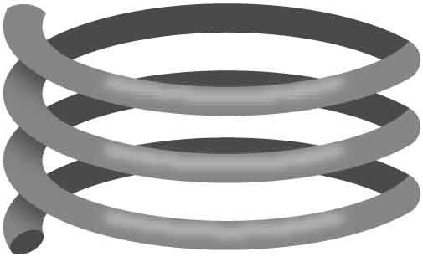

**Name: ______________________________________________________ Date: _________________**

**Physicist Robert Hooke used math to model springs – he said that deflection is proportional to load. His model, called Hooke’s Law, also works for bridges deforming elastically.**

As you load a bridge, it deflects, or bends, then fractures. The way a bridge deflects changes as the load increases, going through a few different phases. The phases are pictured below.

Some bridges will fracture more predictably than others. One bridge may fail just after its proportional limit, while another will undergo significant plastic deformation first. Safe bridges must be both strong and predictable.

**How safe is your bridge?**

**Deflection**

**Load**

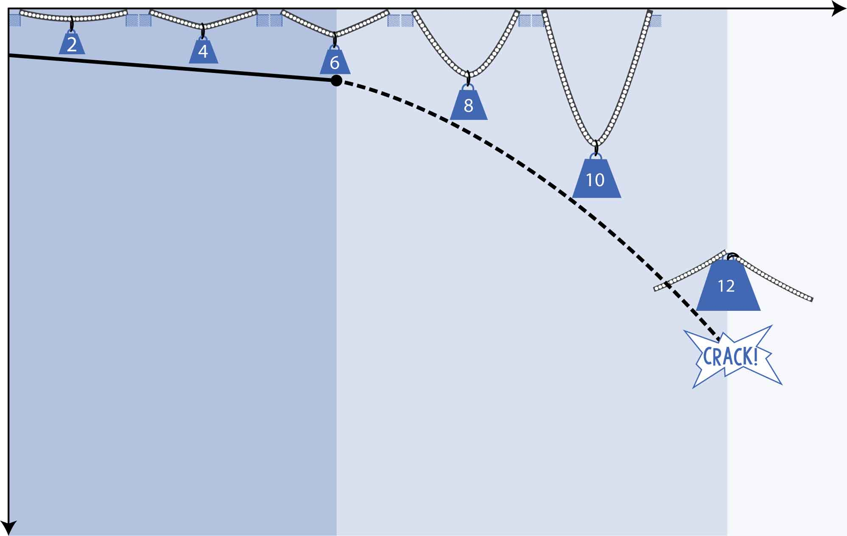

**Elastic Deformation**  
First, your bridge will deflect (bend) in proportion to the load. When the load is removed, the bridge will go back to its original shape, like a spring.

**Proportional Limit** Then it will reach a point where it stops bending proportionally.

**Plastic Deformation**  
After that point, it won’t go back to its original shape.

**Fracture Point** Finally, members will crack, detach, or break.

**You are going to collect data to see how predictable your bridge is!**

[](http://teachergeek.com/bridges)

Make sure you’ve built a testing station. See the [**Testing Guide**](http://teachergeek.org/breaking_bridges_testing_guide_v1.0.docx) for help.

Documents available at [**teachergeek.com/bridges**](http://teachergeek.com/bridges)

**There’s only one way to get data – you need to break your bridge!**



Test your bridge to **get** **deflection** **data** **and** **record** **it** in the table below.

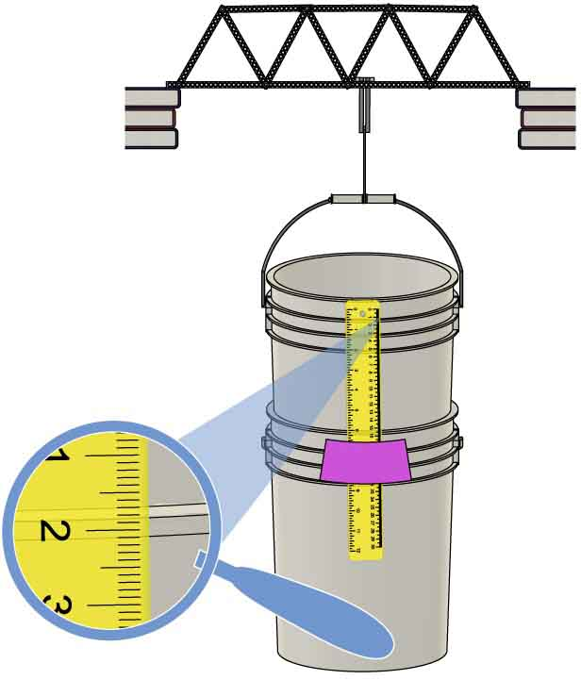

**Set up** your bridge **and get** the **initial reading** on the ruler.



The rib of the upper bucket lines up with the 2cm mark.



**Record the weight** inthetable.

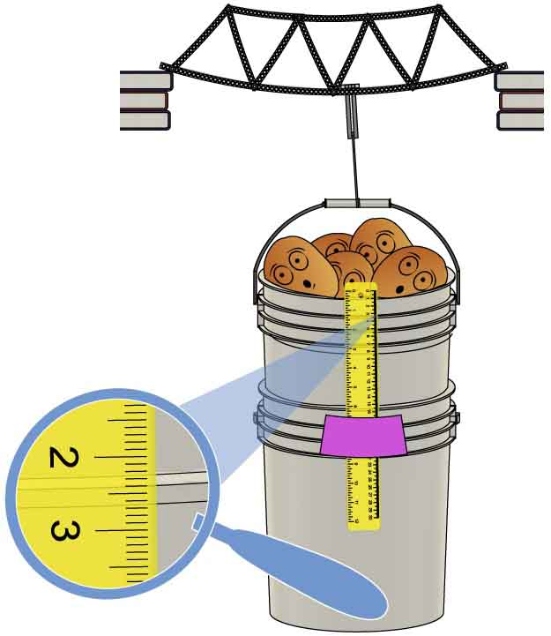

**Add weight until** the   
upper **bucket** **drops**   
**0.5cm** on the ruler.

The rib has moved down 0.5cm on the ruler.

* Hook sliding
* Wires tightening
* Bridge twisting
* Bucket tilting
* Members breaking



**Note anything** youobserve **that might affect your data,** like**:**

**Repeat until your bridge fractures!**



|  |  |  |  |  |  |  |  |  |  |  |
| --- | --- | --- | --- | --- | --- | --- | --- | --- | --- | --- |
| **LOAD** |  |  |  |  |  |  |  |  |  |  |
| **DEFLECTION** | **0.5cm** | **1.0cm** | **1.5cm** | **2.0cm** | **2.5cm** | **3.0cm** | **3.5cm** | **4.0cm** | **4.5cm** | **5.0cm** |

**OBSERVATIONS:**

________________________________________________________________________________________________________________________________________________________________________________________________________________________________________________________________________________________________________________________________________________________________________

**If your bridge isn’t broken, you need more data! Continue testing until your bridge breaks and record your data on an extra sheet of paper.**

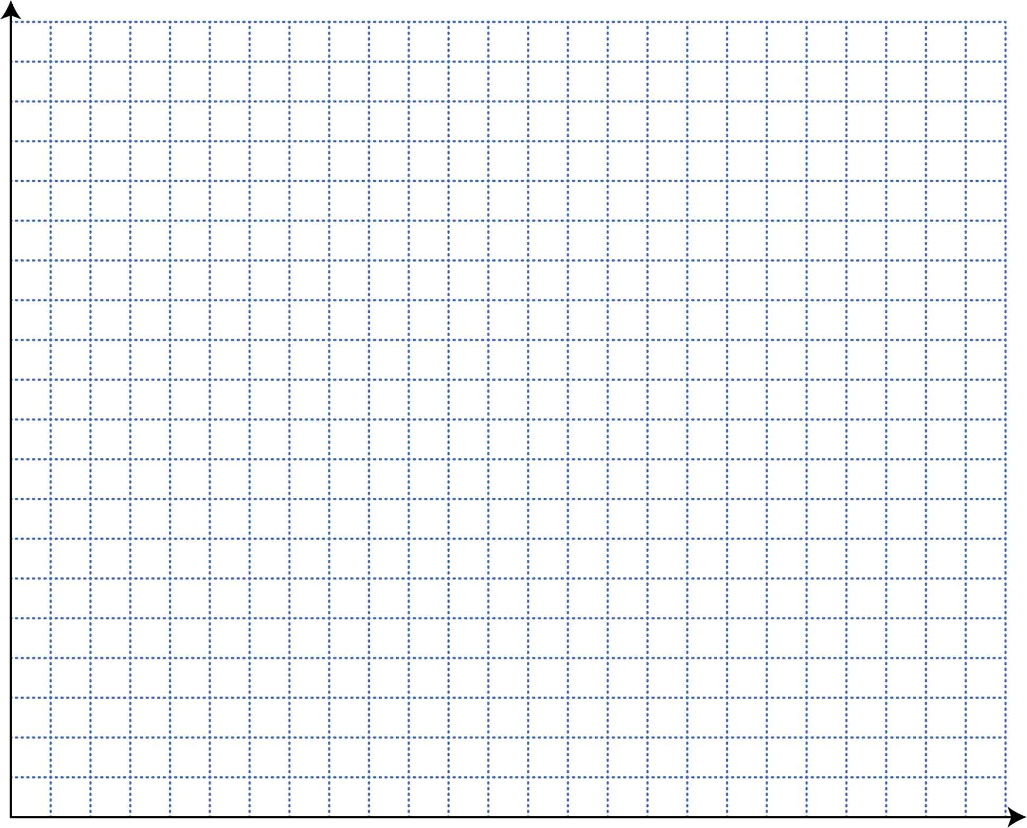

**It’s time to make yourgraph!**



Part of your graph should be linear, and part of it should not. **Draw a best fit line for the linear part and a best fit curve for the non-linear part**.

**Plot** **the** **data** **from your table** on the grid below. Be sure to label your axes and units.



**Proportional Limit**This is the point where your graph stops being linear.

**Elastic Deformation**This is the linear part of your graph.

**Plastic Deformation**This is the non-linear   
part of your graph.

**Fracture Point**This is the point where your bridge breaks (or the last point before   
it breaks).

**Label the following features** on your graph. Some bridges will have plastic deformation so small that it won’t appear on your graph.

______________________  
Independent Variable

______________________  
Dependent Variable



**What does your graph tell you about your bridge?**

Using your data from testing, how could you improve your bridge? Be specific.

__________________________________________________________________________________________________________________________________________________________________________________________________________________________________________________________________________________________________________________________________________



Brittle objects fracture with little plastic deformation. Ductile objects have a large amount of plastic deformation before fracture. Was your bridge brittle or ductile, and how does that make your bridge more/less safe?

__________________________________________________________________________________________________________________________________________________________________________________________________________________________________________________________________________________________________________________________________________



__________________________________________________________________________________________________________________________________________________________________________________________________________________________________________________________________________________________________________________________________________

How well did your bridge show elastic and plastic deformation? Did you notice anything that may have affected your data? Reference your notes from Step 1.



**Create a mathematical model using equations and inequalities!**

What is the y-intercept of your graph? What does it tell you about your bridge?

________________________________________________________________________________________________________________________________________________



________________________________________________________________________________________________________________________________________________

What is the slope of your graph’s best fit line? What does it tell you about your bridge?



If your bridge had no proportional limit (deformation would always be elastic, never plastic), what load would cause your bridge to deflect exactly 12.3cm (4.84in.)? Show all work.



Create an equation to model your bridge’s elastic deformation.



$$y=______x+______$$

Does your y-intercept make sense? Why or why not?

__________________________________________________________________________________________________________________________________________________________________



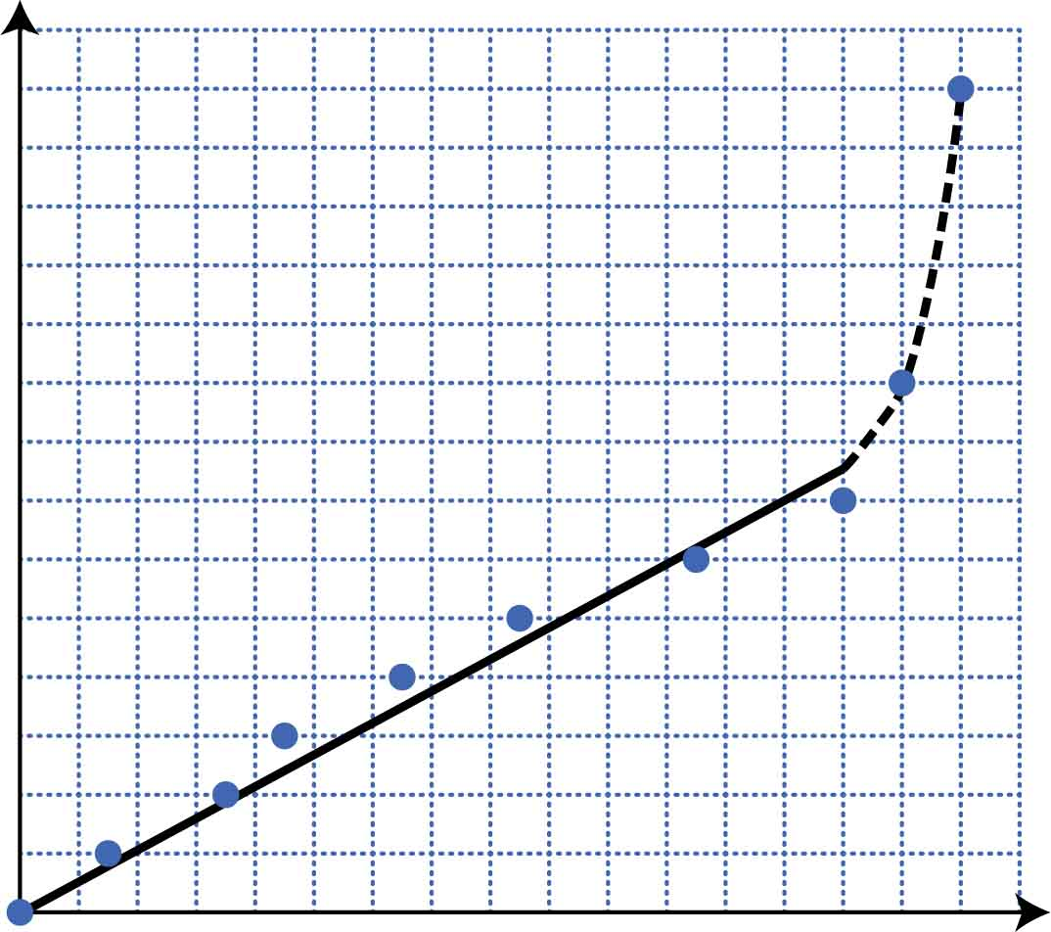

Fill in the inequality to show where the elastic region of your graph is.



$$______ ≤ x ≤ ______$$

$$y=0.15x$$

**Luanne’s Elastic Deformation   
Equation**

Where $y$ is deflection (cm) and $x$ is load (potatoes).

$$0 ≤ x ≤ 32$$

This equation applies when

**Deflection** (cm)

**Load** (potatoes)

7

6

5

4

3

2

1

0

0 4 8 12 16 20 24 28 32

**Mike’s Deflection vs Load**

**Fracture Point**

Whose bridge is safer? Why?

________________________________________________________________________________________________________________________________________________

Whose bridge is stiffer when both bridges are deforming elastically? Justify your answer and show all work.

Whose bridge can hold more weight? Justify your answer and show all work.

Mathematical models for two students’ bridges are shown below. Mike’s bridge is modeled by the graph, and Luanne’s bridge is modeled by the equation. Use Mike’s and Luanne’s models to answer the questions below.