[**6-12+ version**](http://teachergeek.org/breaking_bridges_go_guide_secondary_v1.0.docx) available at [**teachergeek.com/bridges**](http://teachergeek.com/bridges)

**Grades**

**3-5**



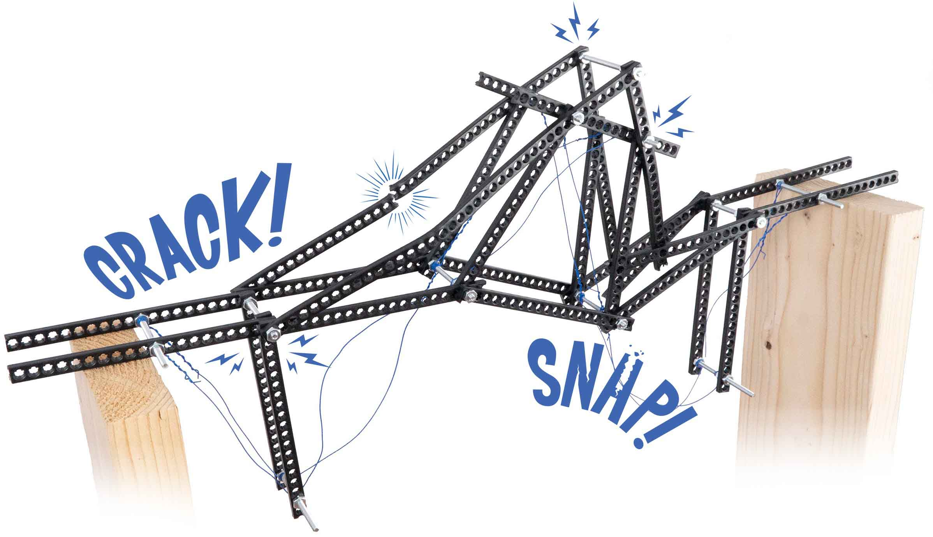 

You Are Here

Go Guide

Start here! Build your example bridge, evolve your design, and begin the Distance Challenge!

Optional Challenges

-Distance Challenge*  
-Strength Challenge*

*See Page 8

**Choose how you would like to complete this activity.  
Download documents & videos at** [**teachergeek.com/bridges**](http://teachergeek.com/bridges)

Other Resources

-[Strength Testing Guide](http://teachergeek.org/breaking_bridges_testing_guide_v1.0.docx)  
-[Engineering Notebook](http://teachergeek.org/breaking_bridges_engineering_notebook_v1.0.pdf)  
-[Design Grid](https://teachergeek.org/breaking_bridges_design_grid_v1.0.docx)

**Learn how structures react to forces by designing, testing, and improving your own unique bridge!**

What parts will you need to create your bridge? The list below includes extra parts so you can experiment and develop your own unique designs.

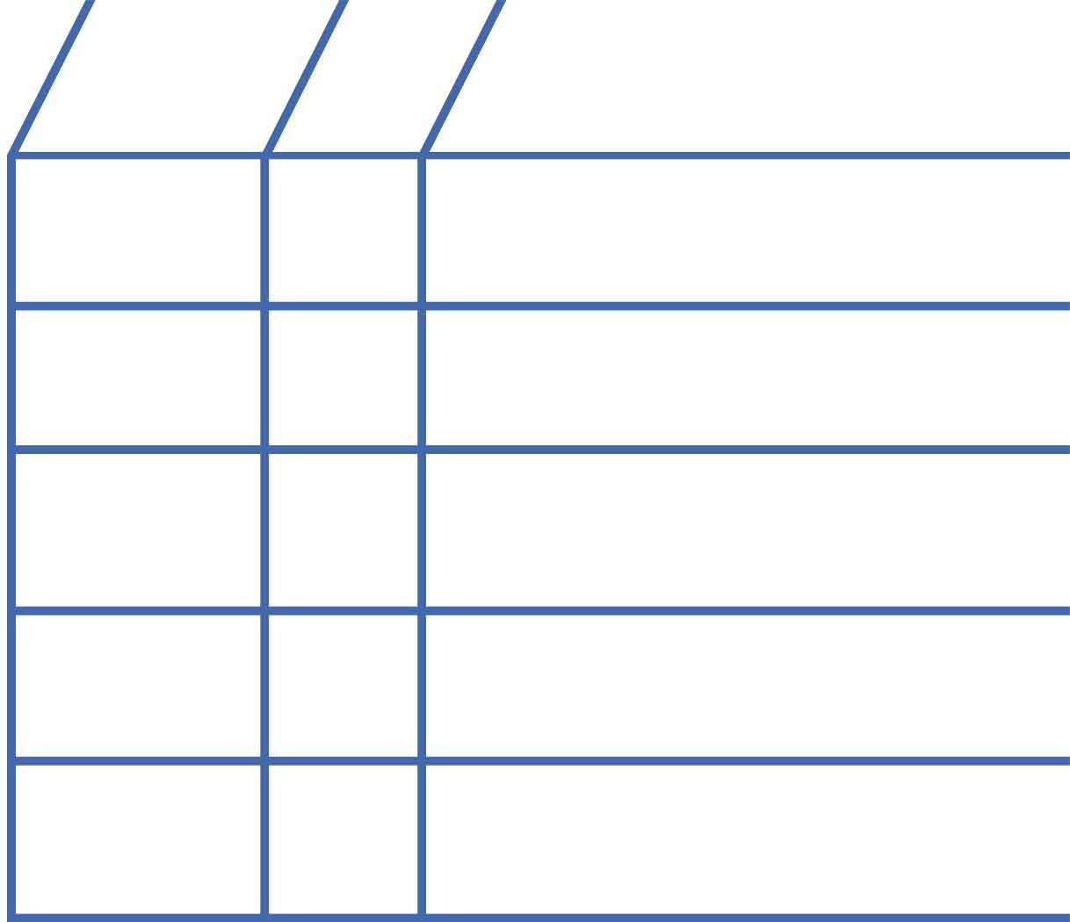

**Strips**30cm (12in.)  
SKU 1821-31

**Half Strips**15cm (6in.)  
SKU 1821-31

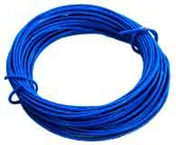

**Colored Wire**SKU 1821-43

**NAME**

**QTY**

**6**

**20**



**1**

**Bridge Nuts**size #8SKU 1824-80

**33**

**Bridge Screws**#8 76mm (3in.)  
SKU 1824-78

**11**

Wire can be used, just like strips, as parts of your bridge.

Note: These are not the usual #10 nuts and screws used on TeacherGeek projects. They are thinner (#8), so they can slide through strip holes.

**PICTURE**

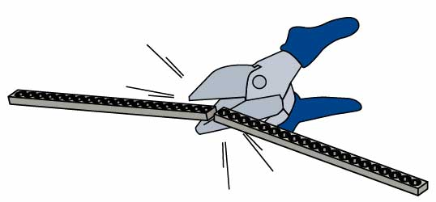

If you do not have half strips, cut or snap them from full strips.

**Roll**

­



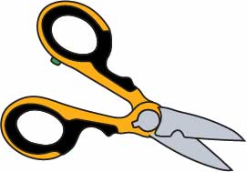

OTHER MATERIALS

**Scissors**

**Tape**duct tape preferred

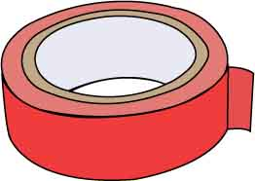

**2 Markers**

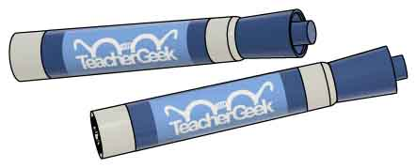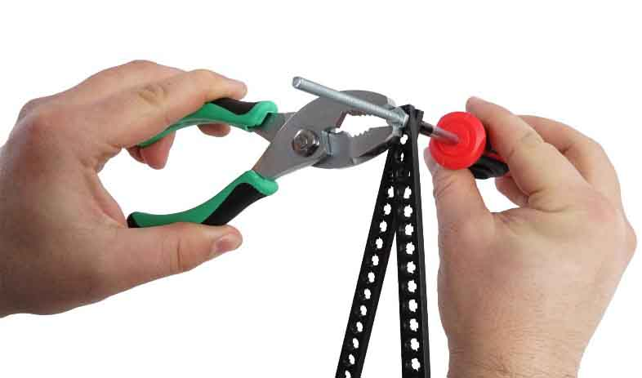

**Phillips Screwdriver**

to tighten the screws that make the bridge joints

**Pliers**

to hold the nuts while tightening screws.



**How do you connect   
bridge parts?**



**Spin** a **nut** onto the **screw** to create a **joint**.

Slide a **screw** through two **half** **strips**.

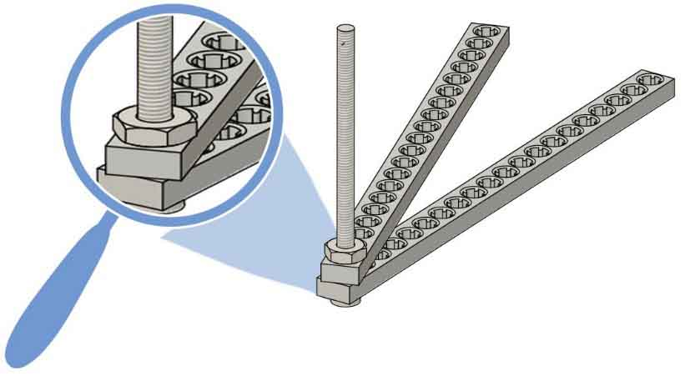

**Half Strips**

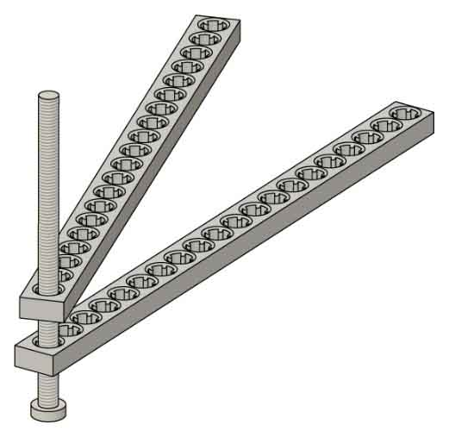

**Screw**

**Nut**

**Joints**

**Members**

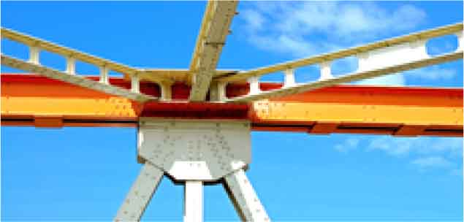

**What shapes should your bridge use?**



**Joints are the points on the structure where members connect.**



**Make** **a** **triangle** by adding more parts. Attach it with screws and nuts.

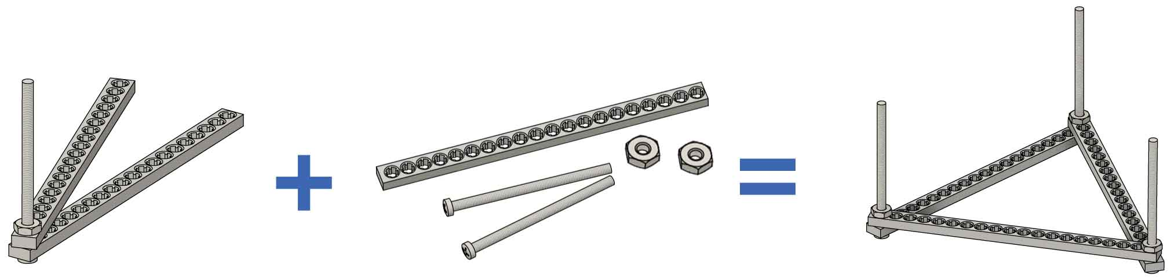

**2 Nuts**

**1 Half Strip**

**2 Screws**

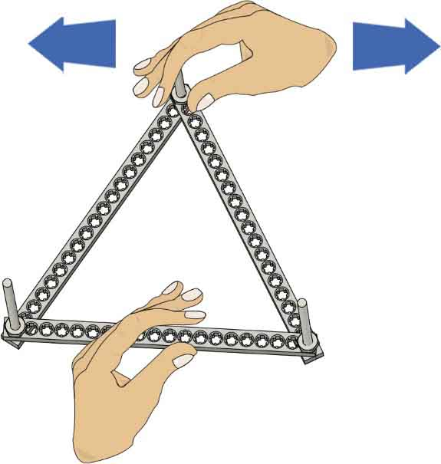



**Push** and **pull** on the **triangle**. Is it **stable?** Can it hold its shape?



Yes! **Triangles** are **stable**. They can holdtheirshape.

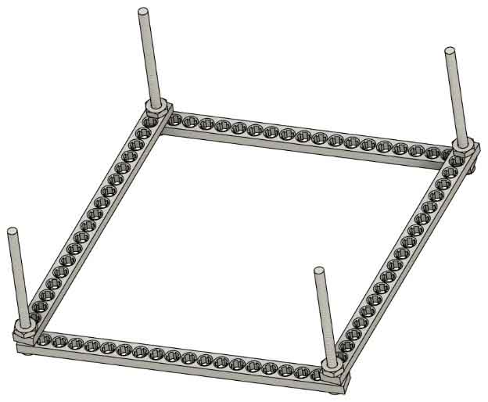



**Make** a **square out of** your **triangle** fromStep 3. You will need another half strip, screw and nut to do this.

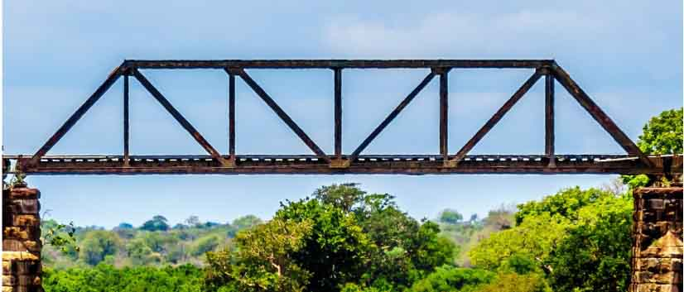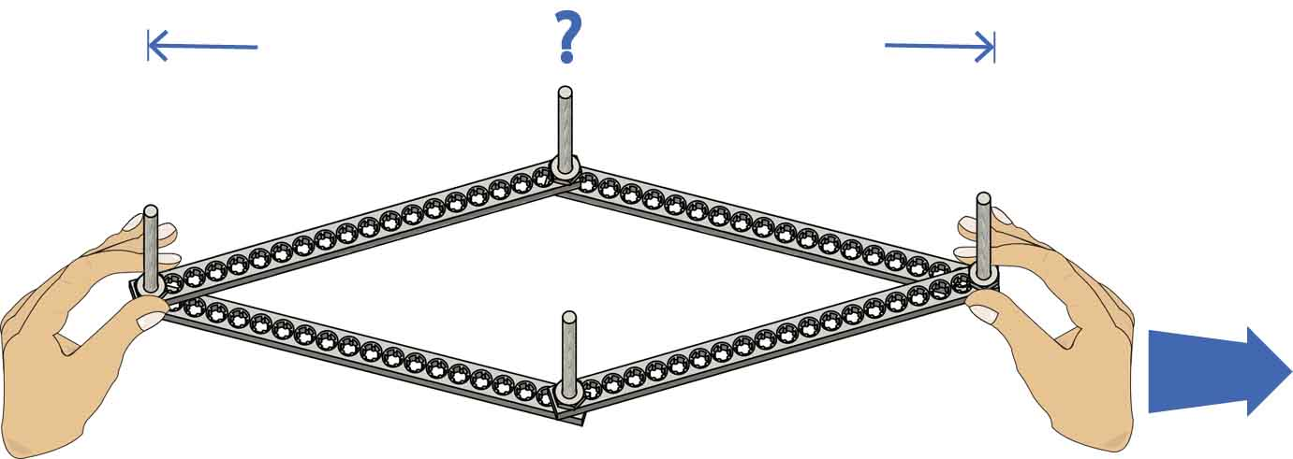

Nah… **Squares** are **not stable**. The square changed shape to a rhombus.

Can a **diagonal** strip **stabilize** the **square**? Try adding one   
(you don’t need to   
match the picture).

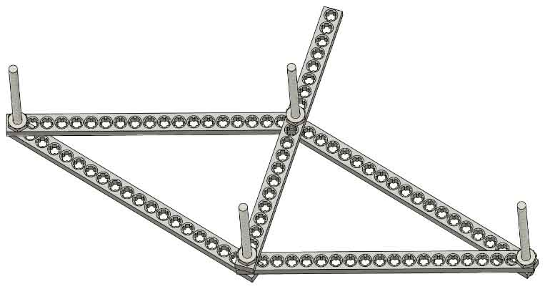

**Diagonal Strip**

**Push** and **pull** on the **square**. Is it **stable?** Can it hold its shape?

**Yes! Diagonals** divide the square into triangles and **make it stable**.

**This bridge is stabilized with diagonals.**

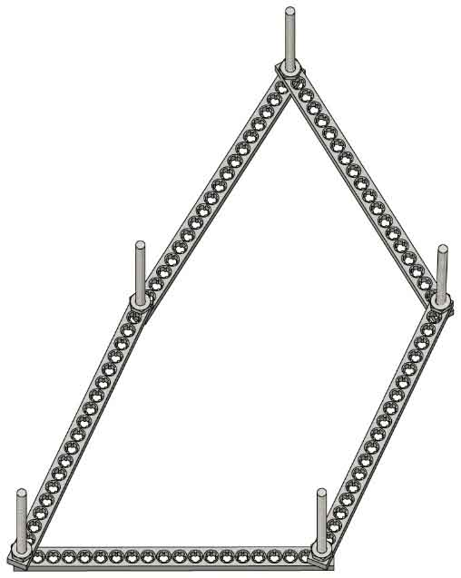

**Turn** the **parts** from Step 7 **into** a **pentagon**. You will need to remove the diagonal from Step 7 and add more parts.



Nope… **Pentagons** are

**unstable** shapes.



**Make** the pentagon **stable** by adding two **diagonal strips**. How does it react?





**Take** **apart** your stabilized **pentagon**.



**Get ready to test bridge designs!**

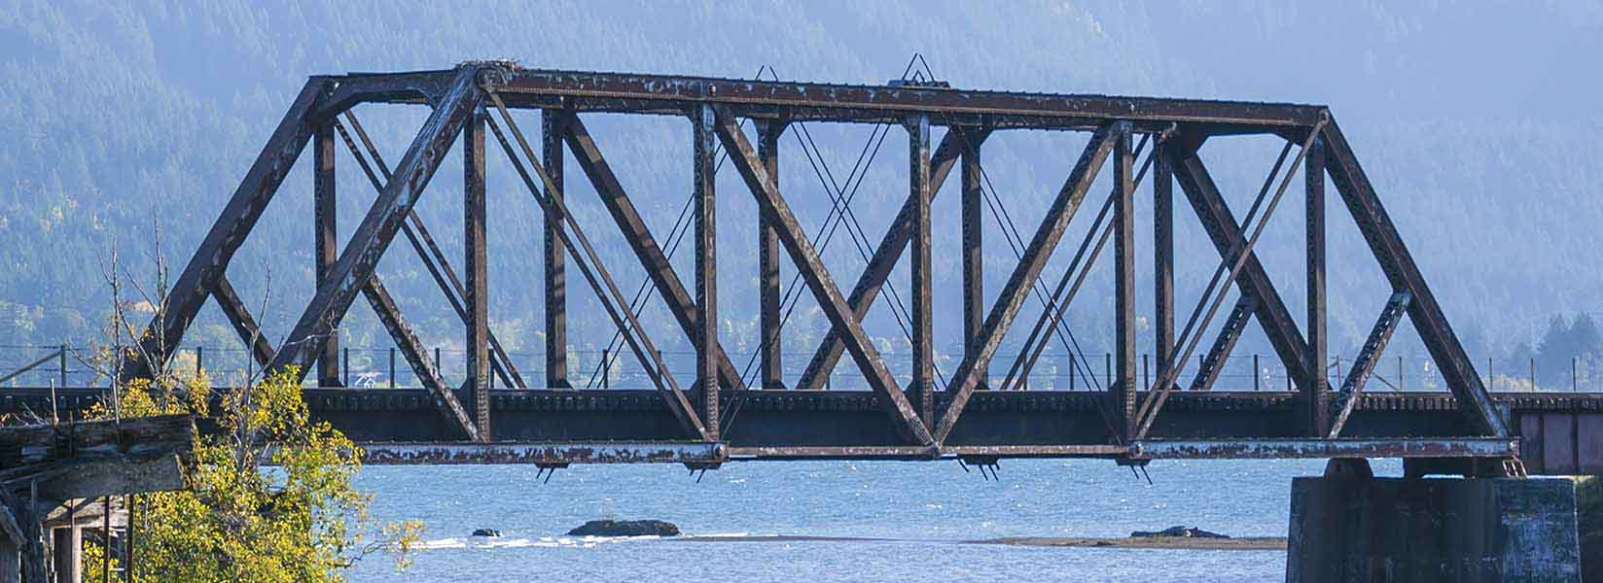

**Abutments**

**Abutments**: The structures that hold up the ends of a bridge.



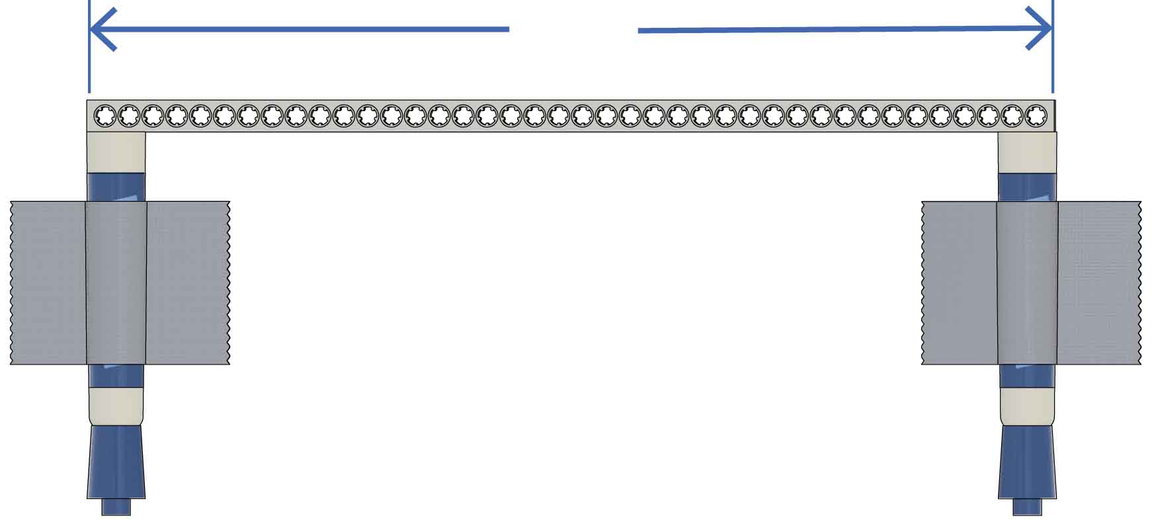

Create **abutments** by **taping** two **markers** **to** the top of a **table** so they are 30cm (12 in.) apart.

**Abutments**

**You can measure the gap with a full strip.**

**30cm**(12in.)



**Load**: The weight carried by a bridge, which pushes or pulls the bridge downward.

**Time to test some designs!**

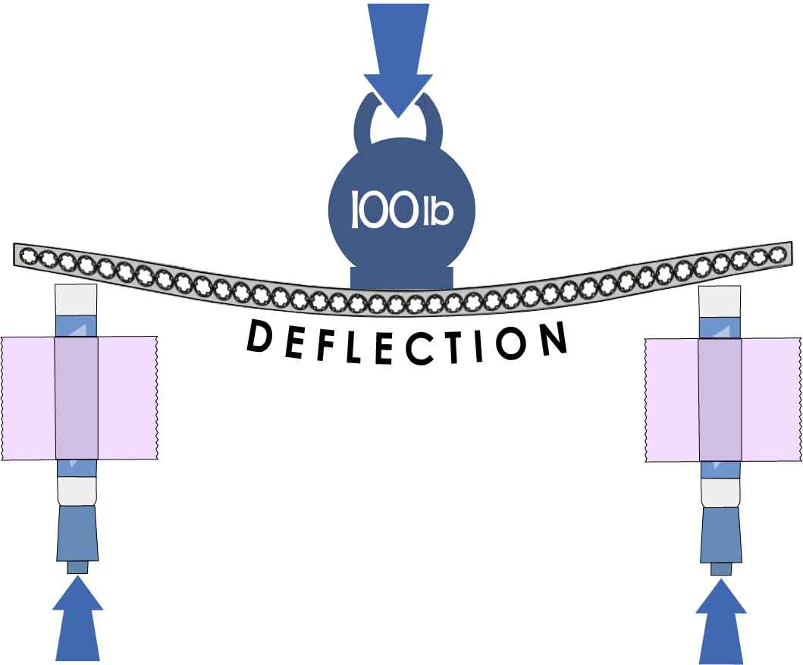

**Deflection**: When a bridge bends as it carries a load. Even the strongest bridges will deflect.



Place a **full** **strip** on your abutments. **Gently pull** the middle down. Does it **flex**, or is it **stiff?**

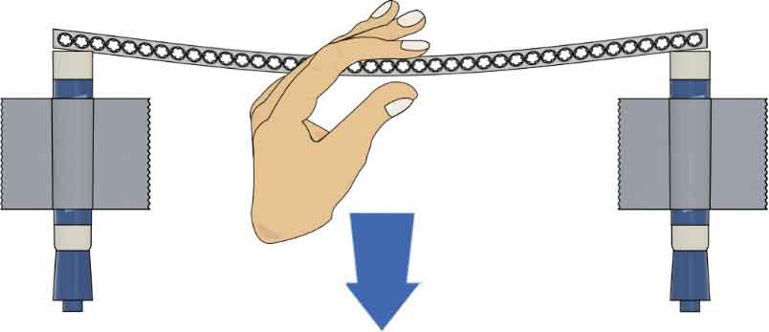

**Pull**

**Gently**

The strip is **flexible**. It **deflects** (bends) **easily**. Let’s try and make it deflect less.

**Abutments**: Structures that transfer the force of the load from the bridge to the ground.

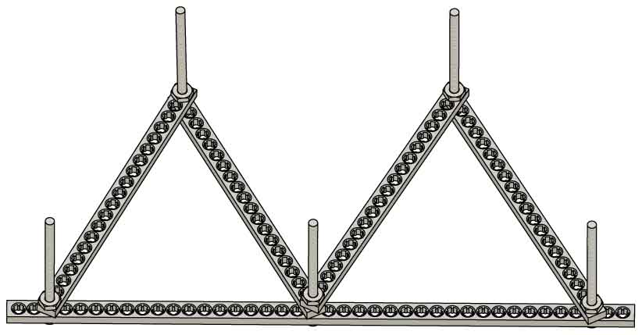



Try **reinforcing** the strip **with** **triangles**.

**Full Strip**

Is it **stiff?**

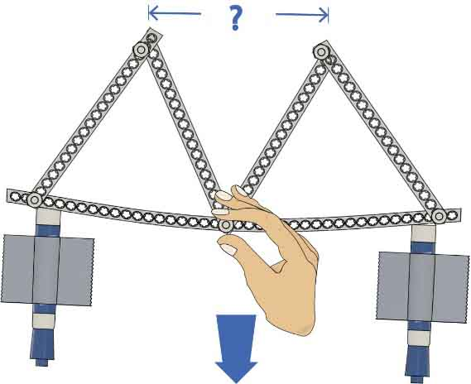

**Pull**

**Gently**

It’s **stiffer**, but the **middle deflects**.What happens to the tops of the triangles?

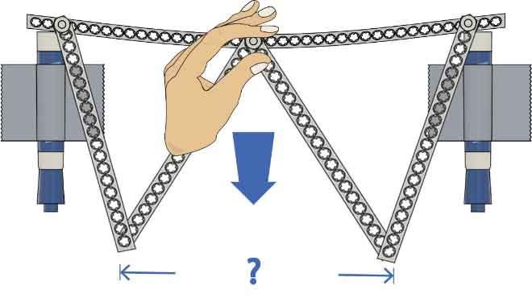

**Pull**

**Gently**

How does the **deflection** **change** if we turn it upside down?



What’s happening to the bottom points of the triangles?



**How can you use wire in your design?**

**Compression:** a member is in compression when it is **squeezed** or pushed inward.

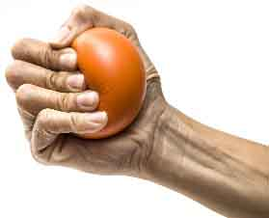

*Molecules**push back, trying to stay apart.*

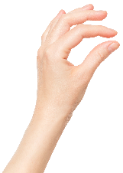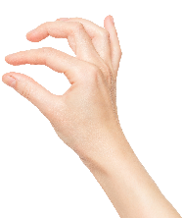

**Tension:** a member is in tension when it is   
**pulled** outward.



*Molecules pull on each other, struggling to stay together.*

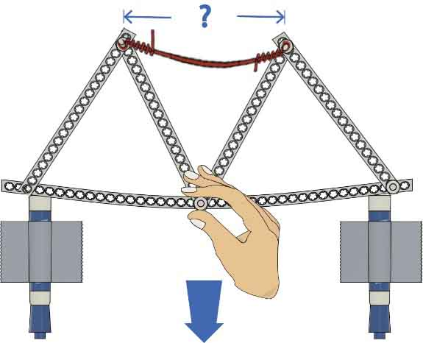

**Nope**… The **wire** is under **compression**, and wire bends instead of pushing back.

**Add** **wire** to reinforce your structure. Does the **wire** **stiffen** **it?**

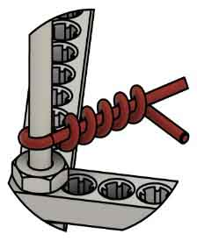

**Tip**

**To attach wire,   
wrap it around   
a screw, then   
twist the wire   
around itself.**

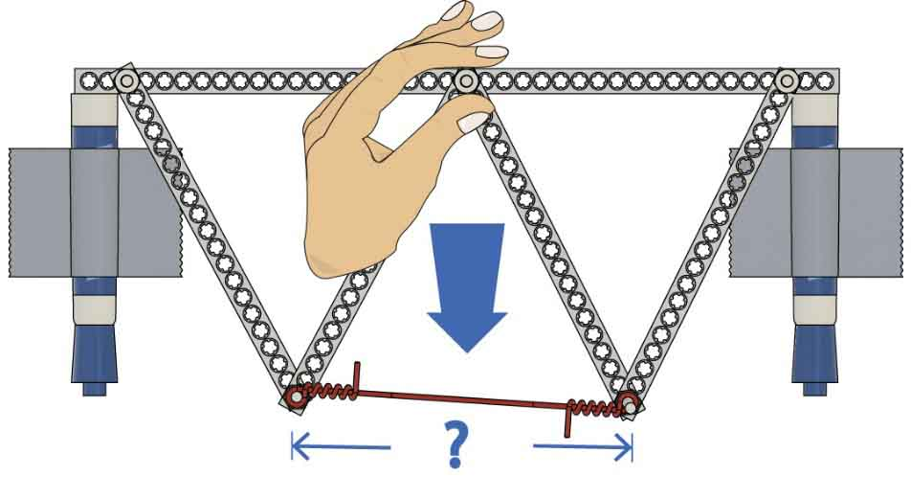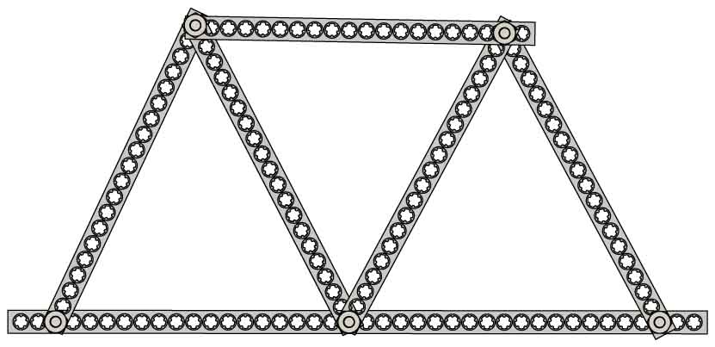

**Strips** are **strong** **under** **both** compression and tension.

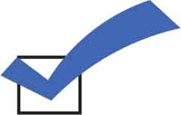

**You created a truss (half a bridge)!**

**Pull**

**Gently**

**Pull**

Turn your structure **upside** **down**. Does the **wire** **stiffen** **it?**

**Yes**. The **wire** is under **tension** this time, and it pulls back to stiffen the structure.

**Gently**

**Replace** the **wire** with a **half** **strip**. **Test** **it** upside down and right side up.



**Trusses**: structures that make bridges stiff and stable.

**Deck**: the surface cars, trains, people, and pipelines use to cross a bridge.

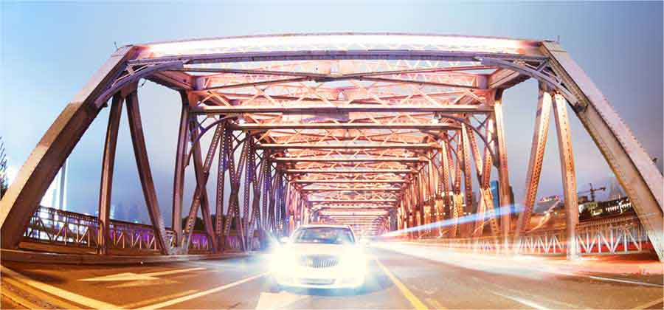

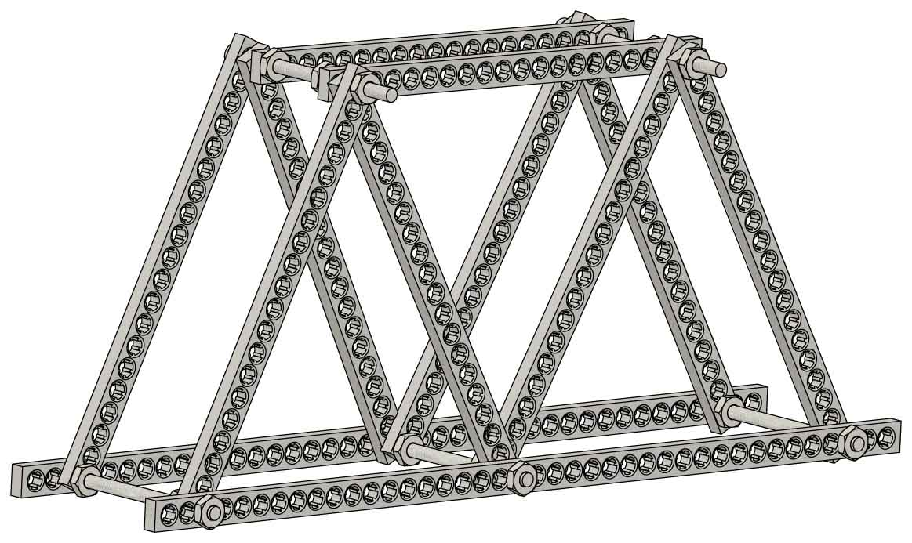

**You’re *almost* ready to design your own bridge! Follow these last few steps to turn your truss, from Step 17, into a bridge.**

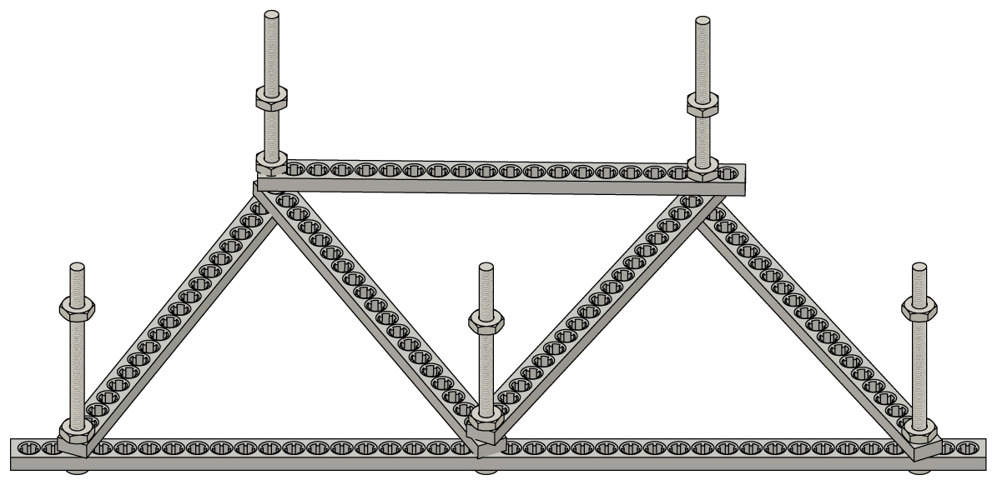

Your second truss will need nuts to rest on; **add** a **nut** **to** **each** **screw**.



You may need to adjust your nuts so that your trusses stay parallel.

**Create** the second **truss** by placing **half** **strips** on the nuts.

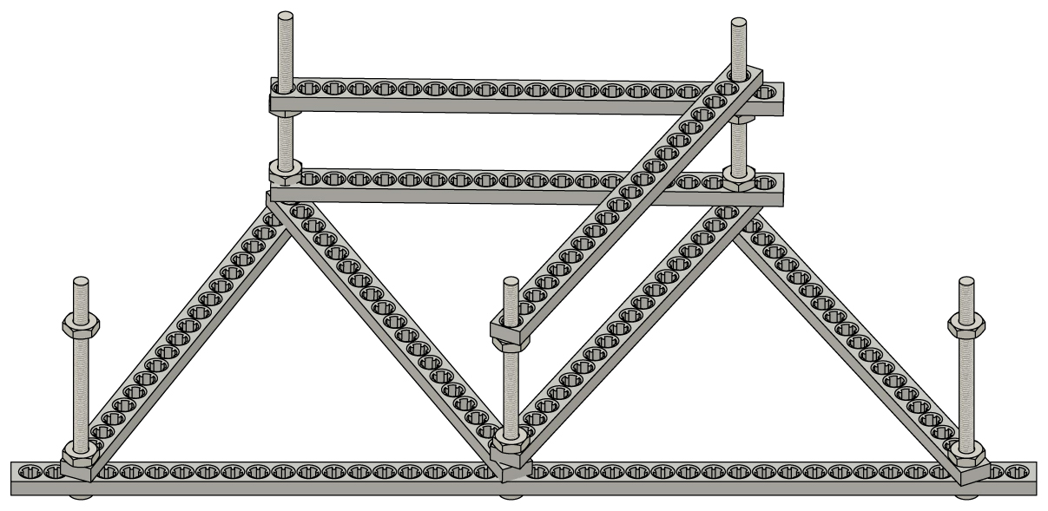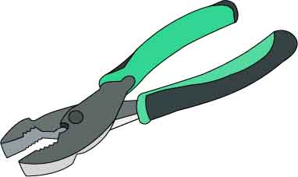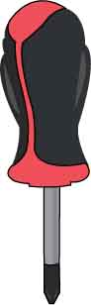

**You can use a screwdriver   
and pliers to make your   
joints tighter.**

**Tip**

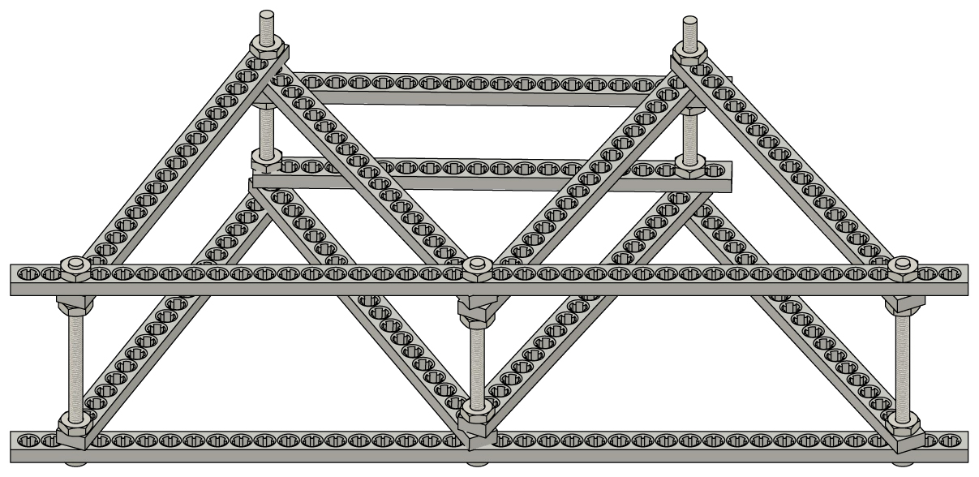

Finish the bridge by **tightening nuts onto** the **screws.**



DISTANCE CHALLENGE

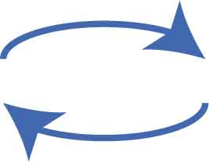

Test it, change it, and repeat!

**Redesign your bridge** to make it as long as possible.The bridgewith **the longest span wins!**

CRITERIA:  
(what your design must do)

Use chairs or desks as abutments on each end of the bridge. Piers (middle supports) are not allowed.

Nothing may be used to hold the bridge on the abutments (e.g., no tape, weights, etc.).

**Span**

(distance between abutments)

Your bridge must support a shoe (or teacher-approved weight) above the ground.

CONSTRAINTS:  
(rules and limits for your design)

**Components**: You may only use the components listed on Page 1 – you can’t add extra parts. Connector strips can be cut or left whole.

[](http://teachergeek.com/bridges)

Use the optional [**Design Grid**](http://teachergeek.org/breaking_bridges_design_grid_v1.0.docx) and [**Engineering Notebook**](http://teachergeek.org/breaking_bridges_engineering_notebook_v1.0.pdf) to plan and document your designs! Documents available at [**teachergeek.com/bridges**](http://teachergeek.com/bridges)

STRENGTH CHALLENGE

**(optional)**

CRITERIA:

**Redesign your bridge** to hold the most weight possible.

The bridgethat holds the **most weight wins!**

Hang a bucket near the middle of your bridge, then fill with water bottles or other weights.

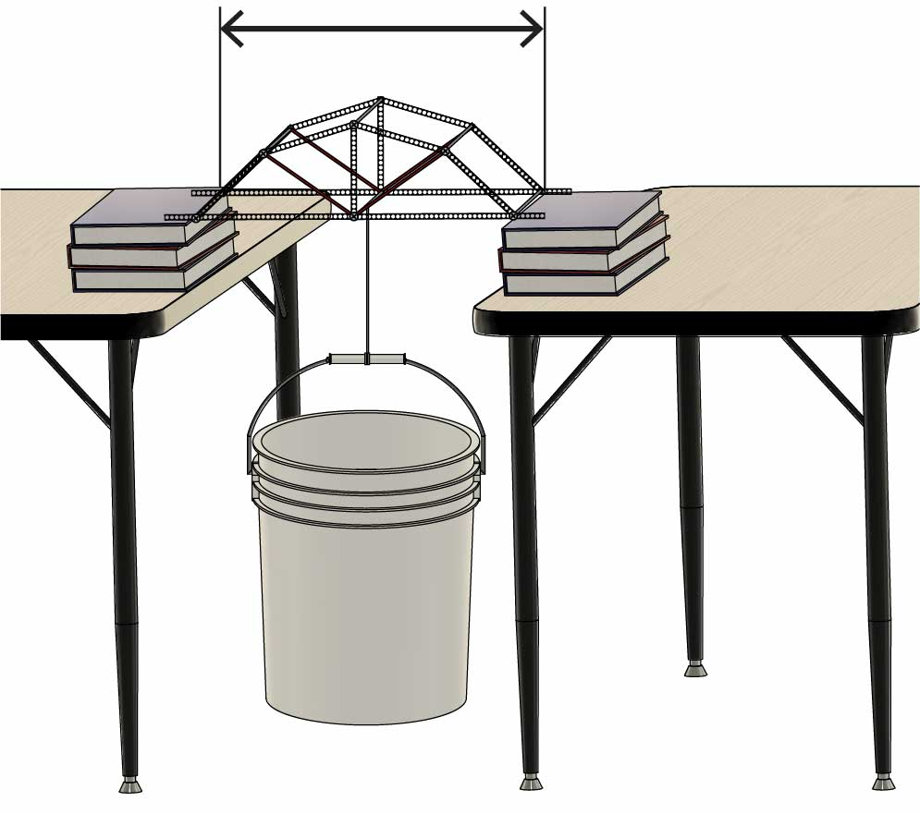

**52.5 cm**(20.5 in)

CONSTRAINTS:

Your bridge must hold the weight over a **span** of **52.5 cm** (20.5 in).

All other constraints   
are the same as the Distance Challenge (above).

[](http://teachergeek.org/breaking_bridges_testing_guide_v1.0.docx)

Want more guidance for Strength Testing? Get the [**Testing Guide**](http://teachergeek.org/breaking_bridges_testing_guide_v1.0.docx) at [**teachergeek.com/bridges**](https://teachergeek.com/bridges)

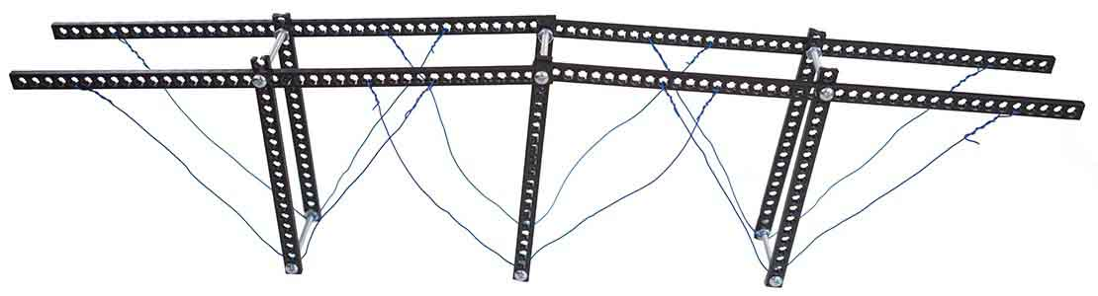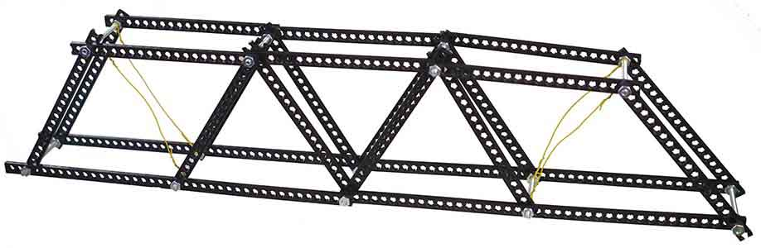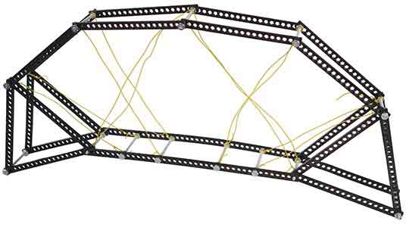

These types of bridges can be built with TeacherGeek components, but they cannot be tested on a normal testing station.

**What type of bridge will you build?**



**Cantilever Bridges –** Use cantilevers – structures that are supported on one side, like a diving board. A cantilevered bridge would be built like two diving boards, which are connected in the middle after each side is built.

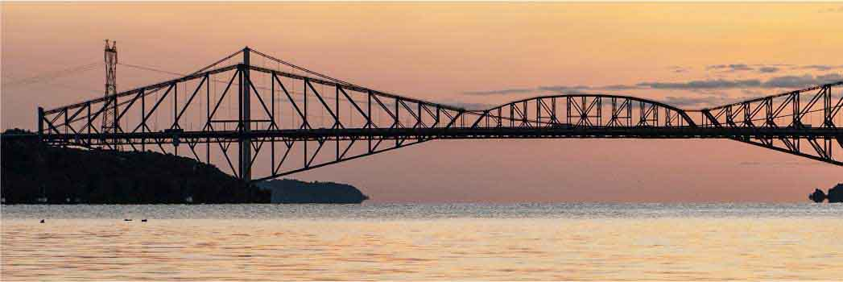

**Suspension Bridges –** Use cables to support the deck. Main cables are connected to towers and anchored to the ground. Suspension cables support the deck from the main cables.



**Truss Bridges –** Use trusses to carry a load. Trusses are typically made of triangles. Other bridge types may incorporate trusses, too.



**Arch Bridges –** Use arches, or circular shapes, to carry a load. Arches are very strong in compression, and can go over, under, or through the bridge deck.

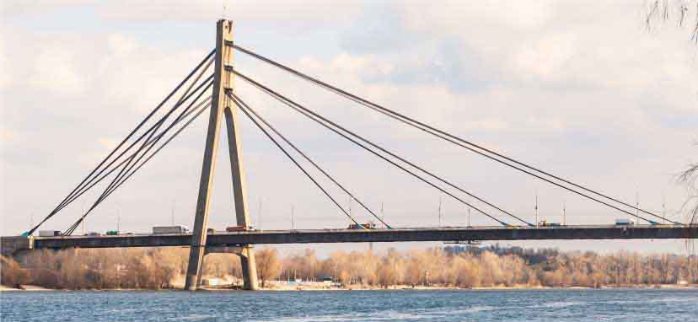

**Cable Stayed Bridges –** Use cables (called   
“stay cables”) attached to towers to carry a load.