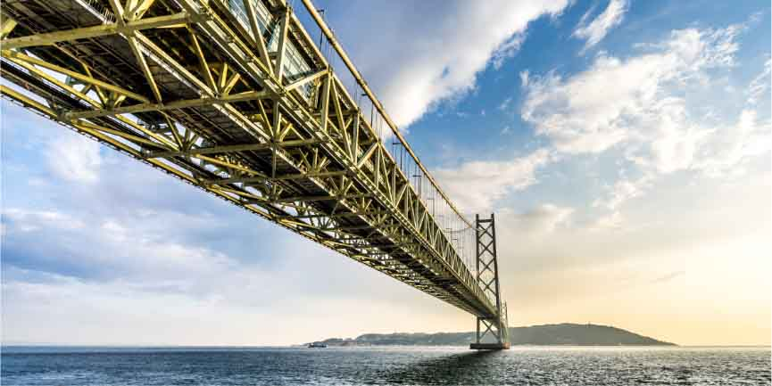

Create the **LONGEST BRIDGE!**(that supports an empty bucket)

Add recycled materials to your bridge to make it more fun and better looking! These materials cannot be used to make your bridge stronger.

**Load**: This is the minimum weight your bridge must support.

**1 Empty Bucket**

c

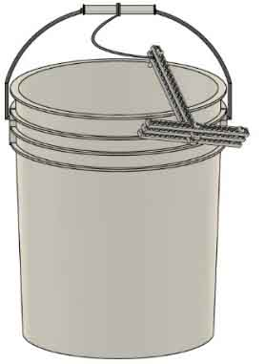

**Components**: The maximum number of components that can be use on your bridge design.

* **4 Full Strips** (30cm/12in.)
* **20 Half Strips** (15cm/6in.)
* **3.2m** (17ft.) **Colored Wire**
* **10 Bridge Screws**
* **30 Bridge Nuts**

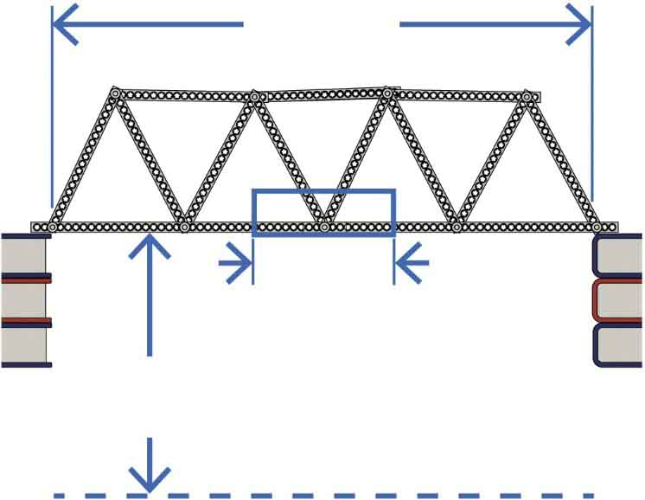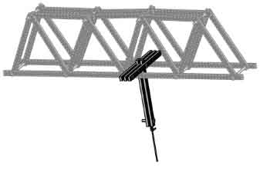

Make this as long as you can!

**Span**

**Hook Zone**

**25cm**(10in.)

**Lower Limit**

The **hook**   
must rest within   
8cm (3in.) of the   
center of your bridge.

Your bridge cannot go below this.

**Abutment**

**Abutment**

**16cm**(6in.)

(rules and limits for your design)

The Akashi Kaikyō Bridge has the longest span in the world – 1991 meters (6532 feet). That’s almost 22 football fields!